Summary
Tuesday 11th May 2021 was a busy day at Main Library by recent standards with 2,358 gate entries, the highest daily number so far since the Main Library re-opened in the summer of 2020. The number of people in the building at any one time reached a high of 699, very close to the study space bookings capacity per session of 700. This report looks at occupancy levels and the number of loans, returns and enquiries on that day and compares them with an equivalent day from pre-pandemic 2019 - the second Tuesday in May. It also provides details of which groups of students booked a study space on Tuesday 11th May 2021.

- Occupancy
On Tuesday 11th May 2021, occupancy levels at Main Library had reached 50% of study space capacity by 9:58 a.m. and reached 75% of study space capacity by 11:08 a.m. The highest level of occupancy was reached at 2:49 p.m.
Figure 1 Occupancy levels at Main Library throughout the day of Tuesday 11th May 2021
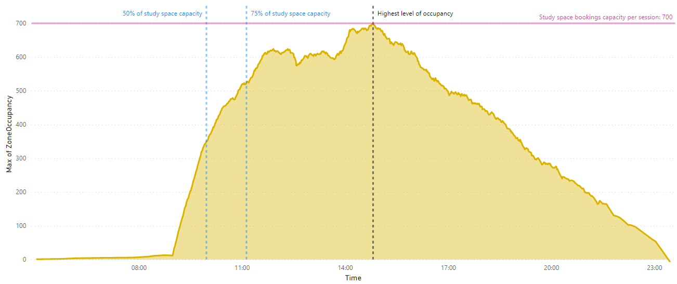
Note: the total study space bookings capacity per session is 686 at Main Library and 14 at Main Library Learning, the former group study rooms repurposed for individual use. Occupancy numbers are measured by Sentry and will include a number of Library staff and those using the library for purposes other than occupying a study space.

How does this compare with an equivalent day in pre-pandemic May 2019? Back in 2019, the second Tuesday in May was May 14th 2019. On that day there were 8,982 gate entries at Main Library and the occupancy level reached as high as 2,043. No social distancing measures were in place at the time.

- Loans and returns
There were 185 loans of physical books on Tuesday 11th May 2021 from Main Library. This compares with 401 book loans on the equivalent day in May 2019 (the second Tuesday in the month, Tuesday 14th May 2019), which is a decrease of 54%.
There were 502 returns of books on Tuesday 11th May 2021, compared with 1,147 book returns on Tuesday 14th May 2019. This represents a fall of 56%.

- Enquiries
On Tuesday 11th May 2021 there were 1,139 face-to-face enquiries recorded by Customer Services staff at Main Library. Of these, 1,058 were about access to library spaces. This compares with 265 face-to-face enquiries at Main Library that were recorded on Tuesday 14th May 2019, an increase of 330%.

- PC cluster logins
On Tuesday 11th May 2021 there were 176 PC cluster logins.

- Which groups of students booked a study space on Tuesday 11th May 2021?
Figure 2 Bookings for study spaces at Main Library, by academic career and academic level, on Tuesday 11th May 2021
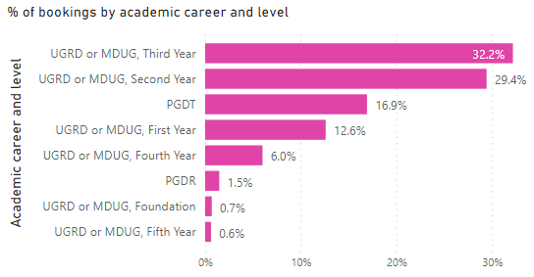

Figure 3 Bookings for study spaces at all libraries, by library and by academic career, on Tuesday 11th May 2021 (100% stacked bar)
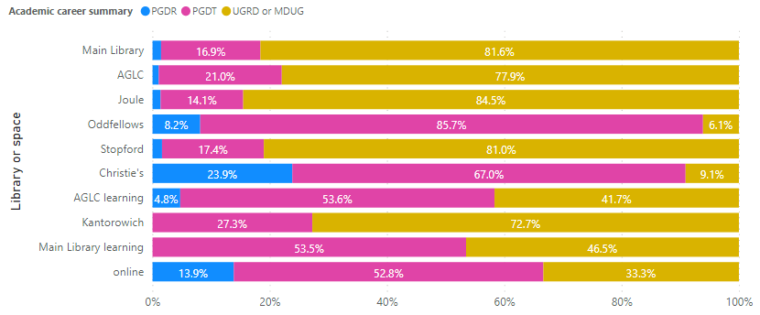

Figure 4 Bookings for study spaces at all libraries, by library and by faculty, on Tuesday 11th May 2021 (100% stacked bar)
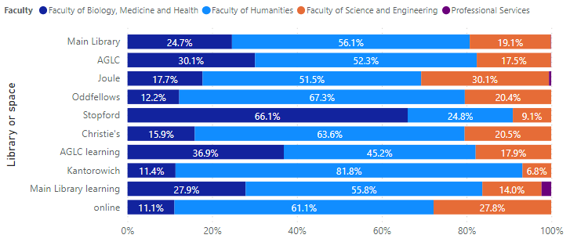

Data sources: occupancy data is from Sentry; loans and returns data is from Alma Analytics; enquiries data is from the LibAnswers CS transactions Power BI report in the Library Planning app; PC cluster login data is from Martin O’Dwyer; study space bookings data is from the Study Space Bookings Power BI report on the Library Planning app which takes data from the LibApps booking system. Note that ‘MDUG’ = medical undergraduate.

