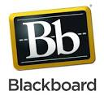
Blackboard: Course units and enrolments
Blackboard (Bb) is the web-based platform that we use across the institution to deliver our teaching, learning and assessment online. All of your course units and programme-wide spaces (where relevant) are delivered via Bb.
Access Bb via My Manchester http://my.manchester.ac.uk/. In Blackboard you will find:
- a list of all the course units you are registered to take, under the ‘Course List’,
- a list for Programme spaces or other ‘Organisations’, in the ‘My Communities’ list.
Your Bb course units will contain different elements, depending on how your tutor(s) have set them up. They may be used for hosting teaching materials, lecture handouts; for assessment including coursework submission, quizzes; for communication such as class announcements; for collaboration with your fellow students e.g. discussion boards or blogs; or other. If you have any queries about the content in your Bb spaces, please check with your tutor first.
You can find guidance on the various Bb tools as well as other eLearning tools we use at Manchester e.g. Turnitin, accessing the Manchester video portal or other in this page: https://sites.manchester.ac.uk/humteachlearn/student-support
If you like you can access Bb on your smartphone using the Bb Mobile Learn app. For guidance, see: https://help.blackboard.com/Mobile_Learn

When can I access the Blackboard sites for the units I am studying?
Courses become available to students one week before the start of teaching. For most courses in 2021/22 this is:
- Semester 1 and all-year courses: Monday, 20 September 2021
- Semester 2 courses: Monday, 31 January 2022
To ensure that you have access to all of your courses within Blackboard, you must be enrolled on them through the Student Records system. Once enrolled, your courses should appear on Blackboard from the dates above mentioned.

What can I do if I cannot find in Bb a course(s) unit I am enrolled on?
If you cannot see a course you expect to see, it may be because your tutor has not ‘activated’ the Blackboard site for that course unit, or it may be that your enrolment is not completed:
- contact your School Administrator to check that you are fully enrolled;
- check with your tutor that the Bb site has been activated (made available to students);
Note: If you decide to change your course enrolments (from one unit to another) there will also be a delay of up to 24 hours in acquiring your new courses and removing those you are no longer taking. If after enrolment or changing your enrolments your courses are not correctly listed in Bb after 24 hours, please contact the eLearning Team via the Support Portal ttps://www.itservices.manchester.ac.uk/help/elearning/

What if at some point during the year I cannot access Blackboard or Turnitin?
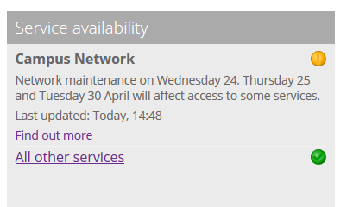
If during the duration of your studies you experience interruptions in IT or eLearning services such as Blackboard, Turnitin, or other,
- Check the Service Availability information on IT services homepage: http://www.itservices.manchester.ac.uk/ The Service Availability portlet will display whether there is any known disruptions and flag issues with a red or an orange circle (see image).
- If you experience an issue that is not notified in the Service Availability portal contact your eLearning team via the Support Portal https://www.itservices.manchester.ac.uk/help/elearning/

