1. Student numbers by faculty, school, academic career and level

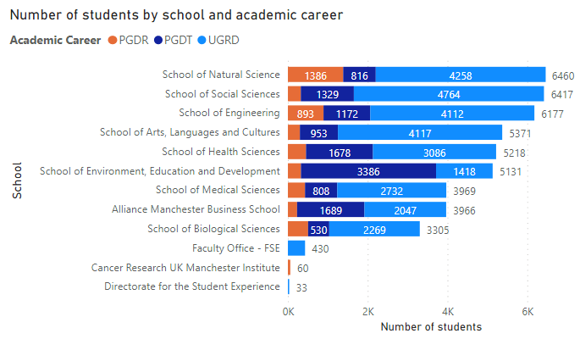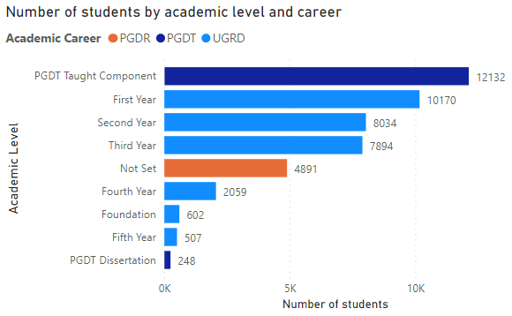

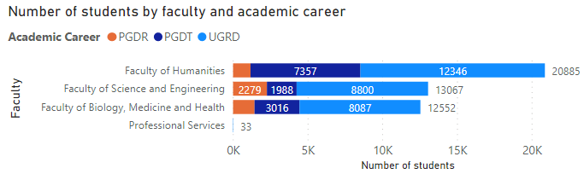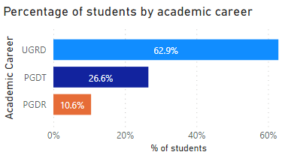

Data source: Student Records: Student Numbers by Organisation, from the SR: Student Records Power BI app. Default filters are applied: Academic Career Code is not 'CEPD'; Student Status is 'Active in Program'; Current Term Record is 'Y'; Outside Registration Period is 'N'; Fully Registered is 'Y'. Numbers may not match the official university figures available from the Directorate of Planning website. Data as at 19/04/2021. This report is available on the Library Planning app.

2. Student numbers by faculty, school, level 4 (department) and by academic career (FSE only)
This page is filtered to the Faculty of Science and Engineering as an example. To see data for other faculties go to the Student Numbers by Organisation report on the Library Planning app.

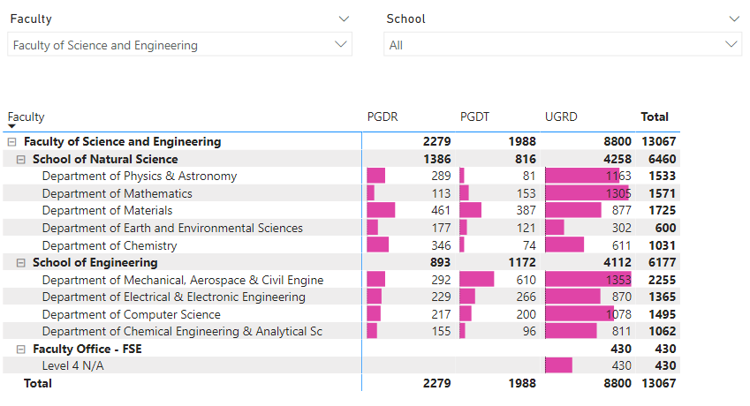

Data source: Student Records: Student Numbers by Organisation, from the SR: Student Records Power BI app. Default filters are applied: Academic Career Code is not 'CEPD'; Student Status is 'Active in Program'; Current Term Record is 'Y'; Outside Registration Period is 'N'; Fully Registered is 'Y'. Numbers may not match the official university figures available from the Directorate of Planning website. Data as at 19/04/2021. This report is available on the Library Planning app.

3. Decomposition tree of student numbers by level
This decomposition tree lets you visualise data across multiple dimensions. In the example below, the Department of Computer Science has been highlighted, showing that in terms of student numbers it is the second largest department within the School of Engineering, with 1,495 students. This visual can be used to find answers to questions such as 'Which departments have the highest number of PGDR students?' or 'Which schools have the largest share of part-time students?'. To find answers to these questions or to explore other schools or departments by level, career or mode of attendance (e.g. FT/PT etc.), go to the Student Numbers by Organisation report in the Library Planning app.

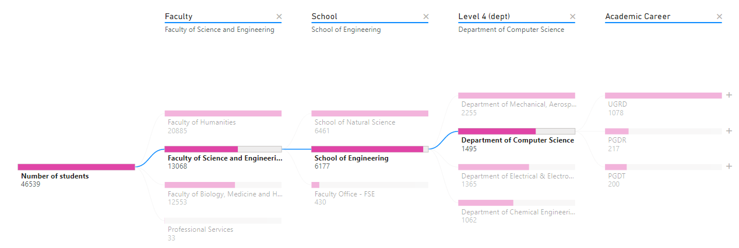

Data source: Student Records: Student Numbers by Organisation, from the SR: Student Records Power BI app. Default filters are applied: Academic Career Code is not 'CEPD'; Student Status is 'Active in Program'; Current Term Record is 'Y'; Outside Registration Period is 'N'; Fully Registered is 'Y'. Numbers may not match the official university figures available from the Directorate of Planning website. Data as at 19/04/2021. This report is available on the Library Planning app.

