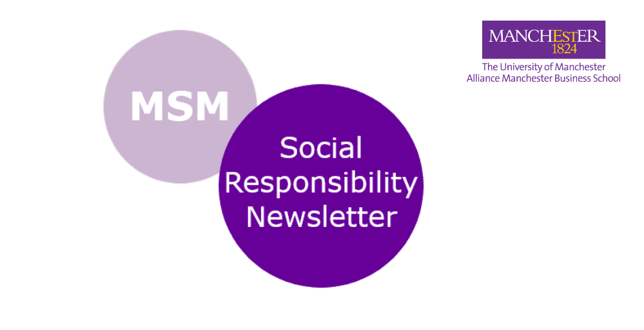
Issue 1 | Sep-Dec 2020

Welcome to the MSM division's Social Responsibility Newsletter!

This tri-annual update will highlight how colleagues are promoting/implementing social responsibility across their research, teaching and engagement activities.

Message from Professor Hongwei He,
Director for Social Responsibility (SR)

Many thanks to Ilma for inviting me to contribute to this inaugural MSM SR newsletter, which is a great initiative. At school level, the most important task now is to review our existing SR initiatives and listen to our colleagues. The SR initiatives I inherited from my predecessor were in great shape, although we face new challenges, caused by the Covid-19 pandemic.

In 2020, the University of Manchester started a new five-year strategic circle with the development of a new SR strategy. The new SR strategy has reinstated SR as one of the three core goals of the university alongside research and discovery and teaching and learning. Other factors that we need to consider include (not exclusively): external SR-related rankings (e.g., FT MBA ranking; Times HE ranking on SDGs achievement), AACSB accreditation standards change (more emphasis on societal impact).

Against this background, we launched the AMBS SR strategic consultation in September 2020, with the aims to identify the purpose and nature of SR for AMBS; capitalise on these strengths and identify and fulfil its full potentials of social responsibility; and develop recommendations on the SR programme and plan for AMBS.

Over the last few months, I interviewed our colleagues (predominantly those who have research/teaching expertise and interest in the areas of CSR and sustainability). Additional data was collected from an open-ended online survey, and feedback and suggestions gathered from colleagues via email. This has proved an extremely productive exercise. As a result, I have produced a draft of SR initiatives and recommendations. Hopefully there will be some new SR programmes coming your way in the not-too-distant future. The school and the division are counting on you to advance our SR agenda.

Having served as the Associate Head of Social Responsibility for the MSM division myself, I have sufficient knowledge and confidence to feel proud of the SR activities already being undertaken by our MSM divisional colleagues. To name only a few examples: Duncan’s research and policy engagement relating to Covid-19 response and recovery, Yu-Wang’s research on Covid-19 risk, Markos’ research on Fintech, Panos’ research on AI, the Data Visualisation Lab led by Nikolay, Magda’s research on the use of big data for societal good, Emma and Anna’s research and teaching on social marketing, Antony, Ilma and Fahian’s research on sustainable operations and supply chain management…and the list goes on! Last but not least, the research and business engagement activities undertaken by Decision and Cognitive Science Research Centre (DCSRC) led by Jian-Bo, Dong-Ling and Julia has had enormous social and policy impacts. Undoubtedly, the MSM division has made, is making, and will continue to make enormous contributions to AMBS’s SR agenda.

One of the most significant developments of our agenda is our commitment to PRME (Principles for Responsible Management Education) as an advanced signatory.

PRME has six principles:

- Purpose
- Values
- Method
- Research
- Partnership
- Dialogue

Find out more about the six principles here.
We are fully committed to these principles and will apply them as much as we can in our teaching and research. Being an advanced signatory, we are required to submit a report of Sharing Information on Progress (SIP) to PRME.

Similar to completing the AMBS SR strategic review, the process of preparing this report has also been extremely useful, helping me reflect on what we are doing already, feeding back to the strategic review process, and providing us with a useful framework to organise the wide range of excellent SR-related activities that we are doing.

Finally, I hope we can make this newsletter an important “home”; an indispensable platform for knowledge sharing and populate it with great news and information. I look forward to reading all the issues in the years to come.

Teaching

MSM Project Management students raise money!

As part of the Strategic Project Organising Course Unit led by Dr Chris Smith, 20 groups of MSc students ran small charity projects to add value to a charity of their choice.
Given constraints caused by Covid-19 and a geographically dispersed cohort, this was not a typical fundraiser.

Groups had to engage with charities to identify what would add value to their selected charity and what could be achieved in a Covid-secure manner.
In total they raised nearly £2000 for UK charities and 7700RMB for Chinese charities. In addition, one group also donated the equivalent of 106 meals to Manchester Food Bank. Another group raised enough money to fund one girl’s school tuition and stipend in China for a term. 2000 masks were donated to those affected by the pandemic in Wuhan China. Many groups ran digital marketing campaigns raising the profile of charities with a combined digital footprint of nearly 60,000 live streams/retweets/views/impressions.

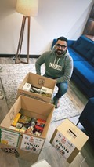
This project directly links to UN Sustainable Development Goals 8 and 17. But the charities students partnered with contribute to at least SDGs 1, 2, 3, 4,5,6,8,9,10,11,12,13 &16.

Top tips: This is a charity project and links to SR - make sure what you do is cognisant of this, and plan the Health and Safety sign off (it can get complicated). Remember this is an experience to practice and learn from, so do not get carried away with the project without using the tools taught and critically reflecting upon them. Or else the learning opportunity is lost!

Refugee Executive Education Programme in the works!

The Refugee Executive Education Programme (REEP) was recently presented to SLT at AMBS, and it is envisaged that once the pandemic is over it will be reconsidered. The REEP aims to combine formal education in applied management with a focus on digital skills with an internship for professionals who have been granted refugee status. It will seek to use current course offerings at AMBS and leverage industry partnerships within the digital sector where shortfall of skills exists to place refugees into professional work.

The programme has been in development for two years. During this period, we have worked closely with community stakeholders and businesses to determine the requirements for an accredited Postgraduate programme.

REEP will focus on developing skills within three distinct areas. The first will seek to reskill and validate academic and technical skills. Second, employability and cultural skills needed to support integration into UK society and the workplace will be developed. Third, there will be a focus on developing the language skills of the students to support development within the first two areas. This programme is linked to SDGs: 4.Quality Education and 10. Reduced Inequalities. If you are interested in supporting this programme, please contact: Ali.Owrak@manchester.ac.uk

Lesson learnt: Working closely with Jane Crombleholme, academics within the MSM division, and refugee centres across Manchester has been fundamental to developing this programme, Dr Ali Owrak stated that he had not fully envisaged the hurdles that awaited him when he started the project. Being able to call upon the expertise of his partners has taught him the value that a diverse group of colleagues can bring to a project.

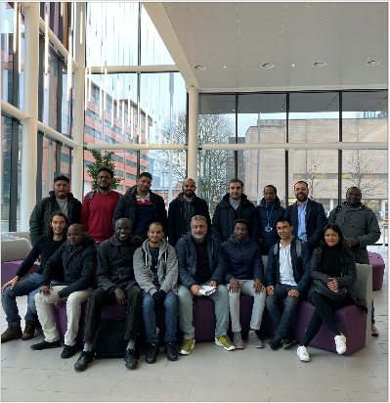

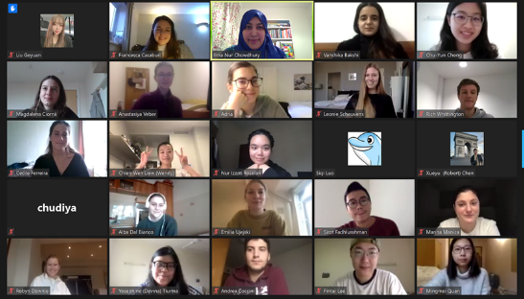
Top tips: To motivate and engage students, Ilma linked their group projects to a real-life advertising campaign brief from ClimateConnect, for which students needed to provide input through evidence-based consumer insights. It is important to review and provide feedback on groups’ interview guides; phrasing and sequence are crucial to avoid leading the participants!
MSc Marketing students delve into sustainable consumption behaviours

The new MSc Marketing course: Professional Qualitative Marketing Research Skills, led by Dr Ilma Nur Chowdhury gets students to conduct online qualitative research and combine in-depth interviews, focus groups and netnography to explore behaviours related to reuse, recycling and saving energy/water.

Marketing students coded and triangulated their data from the three research methods and recommended managerial tactics to support and encourage socially responsible behaviours. This course is aligned with the UN Sustainable Development Goal 12: Responsible consumption and production.

Research

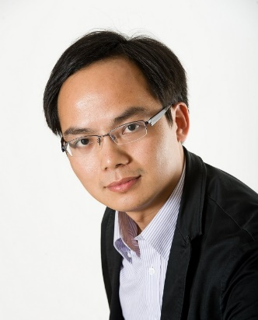
Zero-waste retailing

One movement that is trying to prevent the creation of more plastics is the zero-waste movement. Oliver Hastings’ dissertation project in retail marketing under the supervision of Professor Heiner Evanschitzky investigates what prevents customers from adopting a zero-waste approach and what the retail industry can do about that.

While the typically higher prices and smaller assortments in zero-waste stores are an obvious factor that hinders customer adoption, Oliver finds that going to zero-waste stores is intimidating for many customers. It seems like the perception of zero-waste stores is that of a niche format with a very specific clientele that other customers do not feel they can belong to. This psychological reactance clearly offers scope for an improved communication. The research also finds that once customers have tried the format, their perception changes, they are likely to come back and even recommend it to others.
The research makes contributions to a portfolio of COVID-19 related research at AMBS on digital futures, social responsibility and equality, resilience and recovery in the UN Sustainable Development Goal 3. Ensure healthy lives and promote well-being for all at all ages, and also Goal 10. Reduce inequality within and among countries.

Lesson learnt: The findings can provide policymakers with insights into evidence-based and data-driven cost-effectiveness of COVID-19 pandemic responses, including vaccination, and recovery strategies. Find out more.
AI modelling and data analytics for COVID-19 response and recovery

During the COVID-19 pandemic, AI modelling and data analytics has drawn significant attention as an effective tool to support many of the COVID-19 public health mandates, and government responses and recovery strategies. “Modelling, AI, digital and data approaches to understanding of the COVID-19 pandemic and mitigating its effects” was also listed as one of the key priority areas for UKRI Funding for COVID-19 research.

Since the outbreak began, a group of academics in the Decision and Cognitive Sciences Research Centre (DCSRC) of the MSM division including Dr Yu-Wang Chen have been researching on the use of AI modelling and data analytics technologies to analyse the regional disparities of COVID-19 at different phases of lockdown in England and evaluate the effectiveness of government responses and recovery strategies.


This research links to SDGs: 12. Responsible consumption and production and 15. Life on Land.

Lesson learnt: Better communication can help the zero-waste movement to go mainstream.

Implementing socially responsible supply chain practices by adopting Industry 4.0 technologies

Dr Chris Smith and Dr Fahian Huq have been awarded full funding for the AMBS Targeted PhD Scholarship. Their PhD student Deepak Asokan joined the project team to explore the impact of Industry 4.0 technologies on socially responsible supply chain management.

A better understanding of Industry 4.0-enabled socially responsible supply chain transformations could offer organizations a unique competitive advantage and enable them to build better systems and processes. This is particularly important as post-COVID-19 supply chain recovery and performance requires keeping people at the core. Focal firms in supply networks will not only have to consider internal employees, but also ensure the safety, security, and livelihoods of their suppliers. They are developing a framework for socially responsible supply chain performance and integrating that with established Industry 4.0 technologies for their initial qualitative data collection phase.

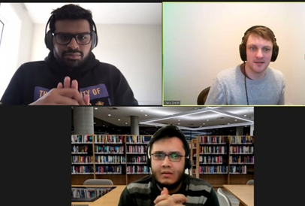
Lesson learnt: By embedding socially responsible practices in core organisational strategies through technology implementation and supply chain innovation, firms are able to adopt effective decent work policies in accordance with SDG 8 - Decent Work and Economic Growth.

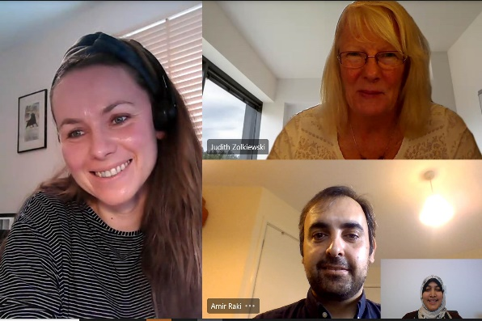
Lessons learnt: Four of the tactics recommended for enhancing human touch were:
- Having Zoom sessions open for 10 minutes before sessions
- Replacing text messages with video or audio messages on Whatsapp
- Having facilitators who provide personalised support in virtual breakout rooms
- Calling students by their names at least once during each online session.

Digital services for refugees

Professor Judy Zolkiewski, Dr Ilma Nur Chowdhury, Dr Marzena Nieroda and their doctoral student Amir Raki are working on an EPSRC funded, DEAS Network project: “Using a bricolage strategy to enhance the human touch in digitally enhanced provision for refugee service users: a response to COVID-19”. Vulnerable groups such as senior citizens, migrants, people with disabilities and those on lower incomes often rely on charity services to meet their basic needs such as subsistence, mental and emotional support and life skills training. Moving such services fully online, which happened during this pandemic, has threatened the wellbeing of these groups. The greatest challenge has been to maintain the “human touch” in digital charity services. This team has partnered with Caritas, a charity providing educational services to refugees, to explore how the social and psychological support that F2F services offer can be reflected in digital services too. Their aim is to come up with a toolkit for charities that can help enhance the human touch in digital services. This research project is aligned with the UN Sustainable Development Goals: 4. Quality Education and 10. Reduced Inequalities.

Engagement

National resilience capability development

The Cabinet Office has asked Professor Duncan Shaw to write the new community resilience section of the UK government’s National Risk Register (NRR). The NRR is the government’s approach to understanding the major risks that threaten the country so that appropriate capabilities can be created to protect us from these risks. The NRR was published in December 2020.

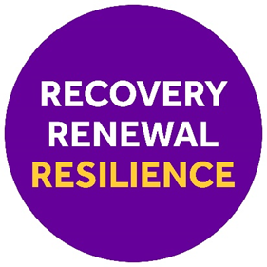
Professor Shaw also presented at the House of Lords Select Committee on Risk Assessment and Risk Planning which began on 15 October 2020 to: “consider risk assessment and risk planning in the context of disruptive national hazards”. His presentation concerned establishing a new national resilience capability based on the importance of community resilience during the last year. His team has been working in this space during the entire Covid response across a number of national and local government departments.

Now, in recovery and renewal, Professor Shaw and his team are working to support the creation of community resilience as a local resilience capability in cities in England, Scotland, Canada, Palestine, and Chile. Their work links to several SDGs including 3. Good health and well-being and 11. Sustainable cities and communities.

Nuffield Future Researchers 2020 programme students
paired with AMBS researchers

AMBS is one of the first business schools to support the Nuffield Future Researchers 2020 programme. Its team, which was led by business engagement lead Dr Richard Allmendinger, provided students with one-to-one guidance throughout their summer placements and included PhD researchers Chris Rhodes and Andreea Avramescu.

Nuffield Future Researchers 2020 is a national initiative that provides more than 1,000 students across the UK with the chance to work alongside professional scientists, technologists, engineers and mathematicians as they take their next steps towards their careers. It aims to give young people from disadvantaged backgrounds the opportunity to gain skills and confidence in science and research.

Sixth-form students from The Blue Coat School in Oldham have thanked the AMBS team for an “intellectually stimulating and insightful” placement. Nahian Ahmed, aged 17, described the experience as “a valuable and unique way of exploring subjects of interest in detail.”


This activity is linked to SDGs: 4.Quality Education and 10.Reduced Inequalities.

Top tip: Get out of your comfort zone by working with teenagers on a research project. It is a fun and rewarding experience!

Management Sciences and Marketing

Social Responsibility

Please contact the Associate Head for Social Responsibility and Engagement, Dr Ilma Nur Chowdhury with any enquiries relating to this newsletter.
