- Loans of physical items by school (or equivalent) from July 2020 to February 2021
Loans of all physical items are shown, covering the period 1st July 2020 to 28th February 2021. In-house loans are not included; renewals are not included. The data source is Alma Analytics and further details can be found on the Loans by school Power BI report on the Library Planning app. Data are as at 18th March 2021.

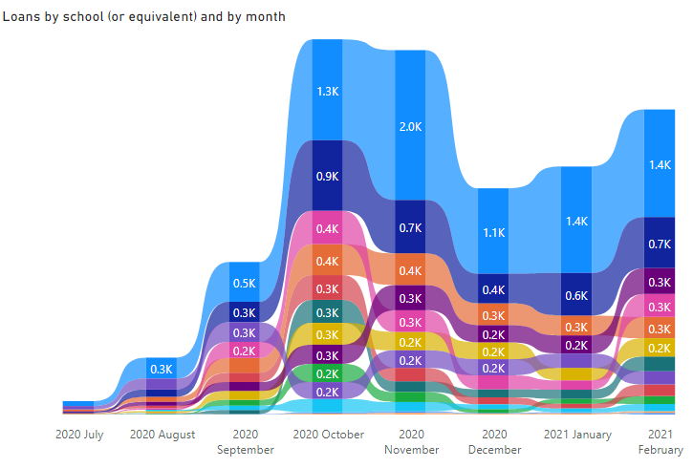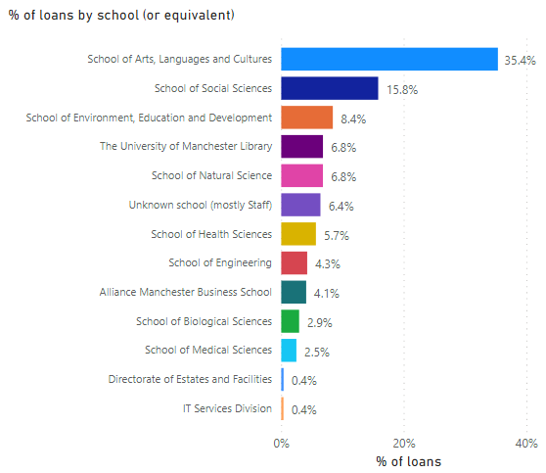

Notes: Those schools (or equivalent level 3 units) with fewer than 100 loans in the period July 2020 to February 2021 have been excluded from the charts on this page. Loans are included from all user types including students and staff. School affiliations of borrowers are taken from the Alma statistical categories recorded in Alma user records, but for a small percentage of users the school affiliations are not known. The bar chart on the right acts as a legend for the ribbon chart on the left.

- Loans of physical items by user group from July 2020 to February 2021
Loans of all physical items are shown, covering the period 1st July 2020 to 28th February 2021. In-house loans are not included; renewals are not included. The data source is Alma Analytics and further details can be found on the Loans by school Power BI report in the Library Planning app. Data are as at 18th March 2021.

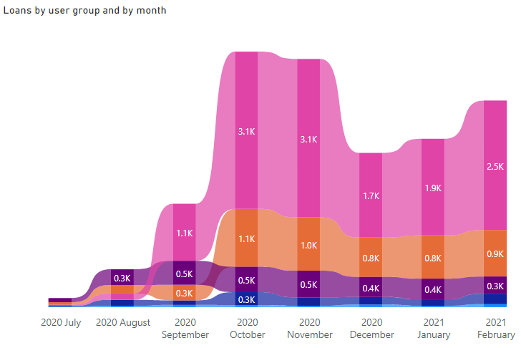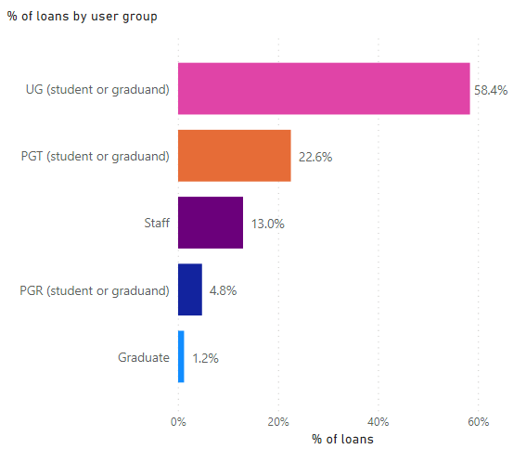

Notes: Those user groups with fewer than 100 loans in the period July 2020 to February 2021 have been excluded from the charts on this page. User groups are taken from the Alma user record. The bar chart on the right acts as a legend for the ribbon chart on the left.

- For context: percentage of students by school
Student percentages by school (or the equivalent level 3 unit) are provided below for context, in order to make it easier to see which schools are over-represented in loans of physical items. Note that staff numbers are not included on this page, but Alma users do include students, staff and external members. Thus this page does not provide perfect contextual data for the loans data but should prove useful, given that the vast majority of loans are to students.

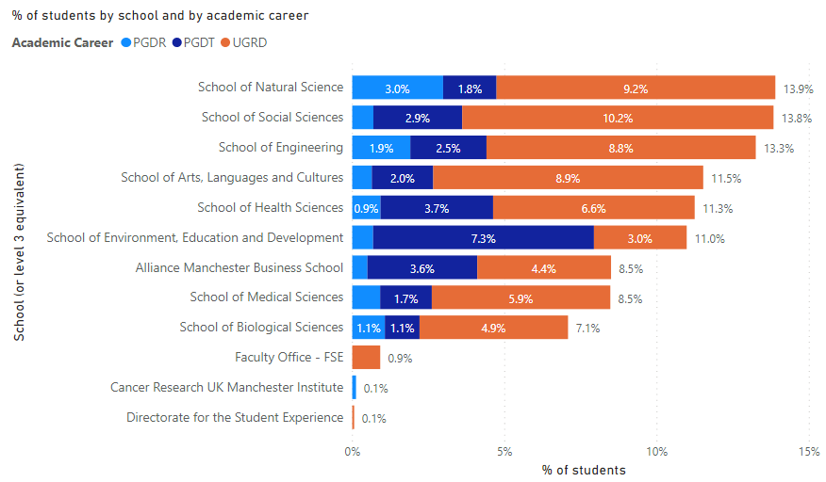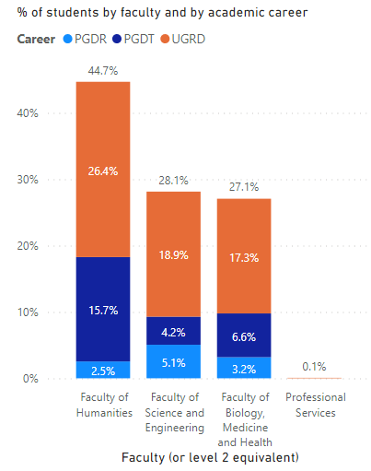

Notes: Numbers are taken from the Power BI report Student Numbers by Organisation (in the Student Records app provided by the Student Data, Analysis and Records team). The report's default filters have been applied: current term record = Yes, fully registered = Yes, student status is 'Active in Program', outside registration period is No, academic career code CEPD has been excluded. Numbers represent headcount rather than FTE and may differ from the university's official Dec 1st student numbers. Data are as at 18th March 2021. Report author: Katie McGrother

