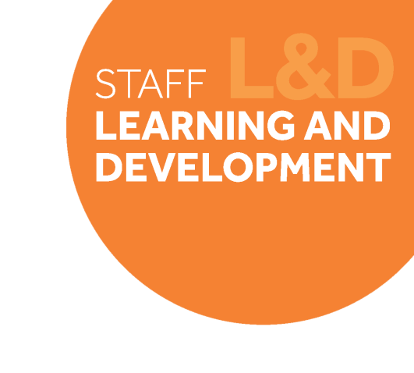

Change Leadership Skills Framework: Planning, Projects and Organisation Skills

Definition
Planning, project and organisation skills is all about thinking in advance about future needs and risks and putting plans in place to address them. It’s about having the skills to effectively organise and manage project plans to monitor change implementation and overall success. A key element is around the management of budgets and resources, ensuring they are used effectively to deliver change which is on time and in budget.
Behavioural indicators
- I think in advance about future demands and put effective plans in place to meet these.
- I can develop realistic and achievable plans for change projects using milestones and performance measures to monitor overall success.
- I can effectively manage the resources I need to deliver change, using them effectively keeping within budget and timescales.
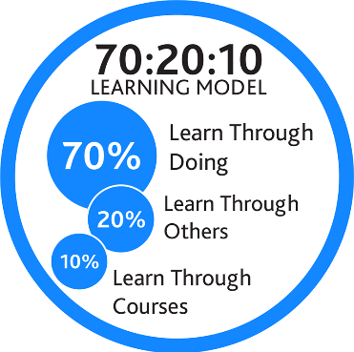
- I can anticipate future challenges or risks and put plans in place to address them.

Example on-the-job development activities (70)
- Look at the processes within the Technical Review for evaluating the success of projects and disseminating lessons learned. Identify ways of improving these processes and integrate within the team.
- Review the overall objectives for the Cohort 2 and map out the project milestones and performance measures. Establish what the blockages/challenges there may be and create an action plan to address them.
- Map out all of your personal deliverables to support the Technical Review, and use a tracker to monitor your progress on these. Where there are dependencies on other people completing tasks, prompt them where needed to ensure activities stay on schedule.
Capture your notes here:

Suggested reflection / discussion questions (20)
Q: How could you improve your existing practices by adopting a project management approach? How will this help you to deliver the Technical Review?
Q: How can you use technology to facilitate planning and organising?
Q: What are the potential blockers (personal and external) to effective project management and organisation? How might you overcome them?
Capture your notes here:

Recommended learning resources (10)
 | Read: Developing Your Project Management Capabilities  SL&D Resource Guide – (various)  Access: Project Manager Development  Staffnet Page – 1 hour

Capture your notes here:

