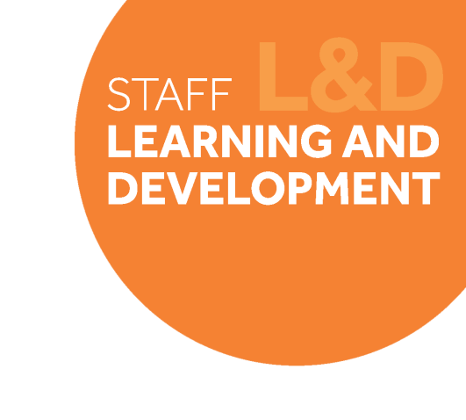

Change Leadership Skills Framework: Collaboration

Definition
Collaboration is about being able to work effectively with others (peers, senior leaders and direct reports) to successfully bring about change. It’s about being able to put collective results above your individual or team benefit, and fully contributing and committing to the direction and decisions made.
Behavioural indicators
- I encourage my colleagues (peers and direct reports) to work together to successfully bring about change.
- I communicate upwards to influence how decisions are made using my local knowledge and experience
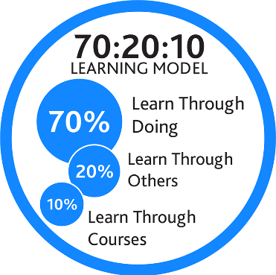
- I communicate and implement University/Faculty decisions with energy and commitment, even if I do not fully agree with them.
- I am able to put collective performance and outcomes over my individual results.

Example on-the-job development activities (70)
- Encourage shadowing and attending team meeting for other technical teams and be curious about ways of working in other areas.
- Investigate where there is longstanding collaboration or communication issues and seek mechanisms for starting a fresh. Challenge any parties resistant to collaboration to overcome barriers.
- Conduct a stakeholder mapping exercise with your team to explore people/groups that you need to be effectively consulting with or involving to deliver the Technical Review. Encourage individuals to consider their role in building and maintaining these connections.
Capture your notes here:

Suggested reflection / discussion questions (20)
Q: How do you work effectively collaborate effectively as a team of leaders to successfully impact change?
Q: How will ensure individuals in your team are all able to contribute to the Technical Review?
Q: How will you ensure your own priorities or the priorities of your area don’t take president over collective priorities?
Capture your notes here:

Recommended learning resources (10)
 | Watch: Collaboration Affect/Possibility  TED Talk - 16mins
 | Read: From Silo’s to SMART collaboration  L&D Toolkit - 5mins
 | Watch: Creating a Culture of Collaboration  LinkedIn Learning – 26mins

Capture your notes here:

