DO YOU HAVE SPECIAL EDUCATIONAL NEEDS
OR A DISABILITY?
THINKING OF GOING TO UNIVERSITY?
HERE'S WHAT YOU NEED TO KNOW

My First Year at University
My name is Oliver Moores and I started a degree in Business Management with Marketing at Edge Hill University in September 2019.
I live on campus in halls and have a ground floor room with a hoist and roll in shower room and adjoining assistant’s room.

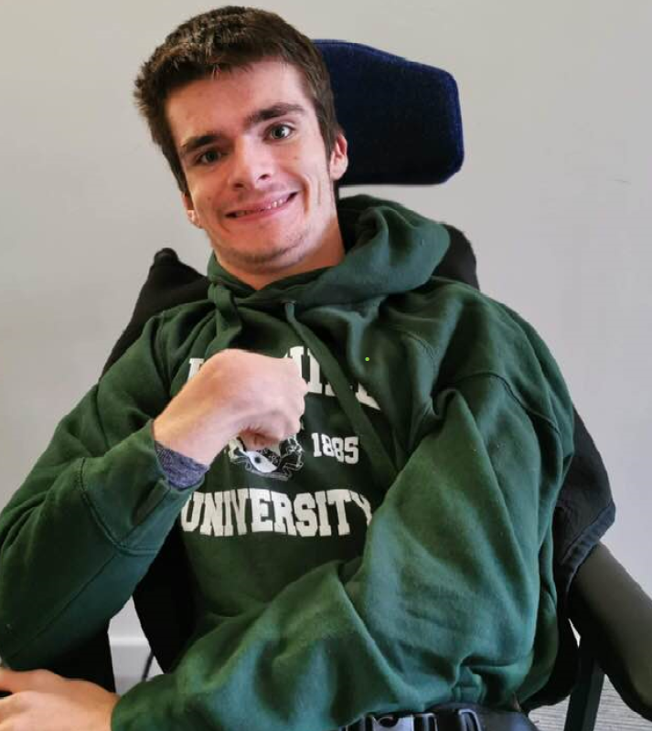

Moving away for the first time was a bit daunting, especially being on my own on the first night, but it is a very exciting new adventure which has enabled me to meet new people and showed me that I can live independently.

I enjoy going to the student bar, taking part in the weekly quiz, planning and making meals, watching sport with friends and being a representative on the Student Council for my Department.

My first year at university has provided me with the right surroundings and given me the confidence that I can achieve my aims and live independently in the future.

I would encourage anyone with additional needs who is thinking of
going to university to try it and I hope that it is such a positive experience for you too.

Ensure that support is set up as early as possible so it’s in place ready for your start date.
There are different types of support you may be eligible for including: note takers, mentors, study skills sessions, student services and an assigned buddy to help you settle in.
If you need help with personal care or have medical needs, you will need a carer, as university staff will not be able to support you with non-educational needs.
Local Authority Social Care Support Services in the area where you live before you go to university is responsible for arranging any social care needs and is obliged to fund this, including 24 hour support from a carer, if you require it. Contact them as early as possible to discuss and arrange this.
A carer may be provided by a care agency. You can ask the university for recommendations for an agency, and then meet with the agency to check that they can meet your needs while you're at university.
Support At University
The support that Universities offer people with disabilities varies so you'll need to do your research about different ones before you apply.
Look into how accessible the facilities are and the local area, including the public transport network.
Universities have open days and transition days so you can visit and spend some time there to see what it's like before you apply.
Speak to the support teams and ask them what kind of support and
facilities are on offer, and if there are any clubs or groups which meet your needs.
When you apply to university it is important to tell the university about your conditions.
Before You Apply

Adaptations
There are different adaptations which can be made to enable you to be successful on your course, for example: Extra time for exams and assessments, adapted rooms for individual needs and free parking.
Some courses don’t involve exams and you might be able to do alternative assessments. Some courses can be completed part time over 5 years. You will need to check with each individual university to see what they can offer, as they will not all be the same.
Once you have decided on a university, make sure you confirm your disability on the UCAS form. Your university will be alerted to this and you can start discussing all your requirements, including any
accommodation adaptations you may need. Some halls of residence may have adapted rooms with hoists and an adjacent carer’s room, if you require 24 hour care.

Financing Your Course

Your Local Authority Social Care Support Services should provide funding for carers or support workers if needed whilst you are living at university. You may be entitled to a grant called the Disabled Students Allowance (DSA), this can be used to pay for items such as assistive technology, a laptop, a height adjustable desk and note takers, dependent upon your disability. You don't have to repay DSA.
At the same time as you apply for your student tuition fee loan, apply for Disabled Student Allowance, also through Student Finance England or Student Finance Wales, dependent upon where you live. Make sure that you apply for your student tuition fee loan and DSA as early as possible as this can be quite a lengthy process and you will need to provide evidence of your disability including a letter from a healthcare professional. You will be required to attend an assessment where your
needs will be reviewed and a report will be provided with
recommendations on what assistance you require.

More Information

www.snowdontrust.org
Snowdon Trust provides
grants for disabled students in the UK

www.ucas.com
Universities and Colleges
Admissions Service

www.gov.uk/disabled-students-allowances-dsas
Information about Disabled Students
Allowance (DSA)

www.thecompleteuniversityguide.co.uk
Independent UK university rankings, course
information and expert advice for students

www.nus.org.uk
National Union of Students


Designed by Oliver Moores
In conjunction with Lancashire's
Council for Young People with
SEND – POWAR
To contact me directly please email: olivermoores95@gmail.com

