Numeracy Skills Audit, Evidence Page and Workbook

Within this document you will find
- the numeracy skills audit that all students should complete
- the evidence page (only include evidence for any topics that you score 1 or 2 in for the numeracy skills audit)
- the workbook, this is provided as one way of demonstrating competence, and is not compulsory.

Contents

Numeracy Skills Audit 2

Numeracy Skills Evidence Page 4

Numeracy Skills Workbook 5

Numeracy Skills Audit

Name: |  | Date:
Subject: | Tutor:

Topic list covering a variety of numeracy skills, click on each topic for more information.

Please indicate your knowledge of each of the following on a scale of 1-3.

1 little or no knowledge/ do not understand
2 some knowledge, but would benefit from reviewing how to use accurately
3 strong knowledge/ confident of using these skills

 | Workbook link | SepT 2020 | in-course changes  8/1/21 | June 2021
- Eg. Mental calculations |  | - 2 | - 2 | - 3

NUMBER
- Mental calculations | - 5
- Multiplication and division | - 6
- Four operations using positive and negative integers | - 11
- Order of operations | - 11
- Measures | - 11
- Percentages, fractions and decimals | - 7
- Rounding | - 11
- Estimating answers | - 11

Ratio, Proportion and RATES OF CHANGE
- Ratio in context | - 8
- Ratio: simplifying | - 11
Percentage change | 11
Proportion | 8

GEOMETRY AND MEASURES
- Perimeter and area of shapes | - 11
- Surface area and volume | - 11

STATISTICS
Averages and range | 8
Representing and interpreting data/ graphs | 9
Correlation | 11

OTHER
- Mathematical vocabulary | 10
- Time | 9
- Analysing pupil data | 9

Numeracy Skills Evidence Page
Only include evidence for any topics that you scored 1 or 2 in the audit above.

Numeracy skill | Date | Evidence (independent work eg. use of workbook/ websites, or on school placement)
Place value
Multiplication and division
Four operations: positive and negative numbers
Order of operations
Measures
Percentages, fractions and decimals
Rounding
Estimating answers
Ratio in context
Ratio: simplifying
Percentage change
Proportion
Perimeter and area of shapes
Surface area and volume
Averages and range
Representing data and interpreting data/graphs

Correlation

Mathematical vocabulary

Time
Analysing pupil data

Numeracy Skills Workbook

Contents

Introduction 4
Mental calculations 5
Multiplication and Division 6
Fractions, Decimals, Percentages 7
Ratio and Proportion 8
Data and Averages 8
Interpreting graphs 9
Time 9
Mathematical Language 10
Useful links 11
Answers 12

Introduction

This workbook has been developed to support you with some of the numeracy skills that you may need as a subject teacher and form tutor.

We hope that considering these tasks, associated web links and development on placement will support you with your numeracy skills. Complete the sections of this workbook that are relevant to you, using the links at the end for additional support and remember to evidence your development over the course of the year within the evidence page of your RoAD.

Mental calculations

Do the following calculations mentally and, in each case, show how you did it and reflect on how you can be sure the calculation is correct.

27 + 56

81 - 38

7 x 15

68 $÷4$

£0.99 + £1.45

£5 - £2.37

3 x £1.99

$$\frac{3}{4} of £5.60$$

19 x 21

600 $÷75$

Multiplication and Division

Multiplication
We know that 7 x8 = 56 and 8 x 7 = 56. For some children (and adults!) they find recalling this fact difficult. Some rely on counting up in eights: 8, 16, 24, 32, 40, 48, 56, or in sevens: 7, 14,21,28,35,42,49,56. However there are a variety of other strategies that can be used:

- Counting up from 5 x 8: 40, 48, 56
- Starting from a known fact: 7 x 7 = 49, so 8 x7 = 56
- Multiplying by 8 is doubling, doubling and doubling, so 7 x2 x2 x2 so14, 28, 56
- Adaption of known facts 5 x7 =35 and 3x7=21 so 8x7= 35+21=56
- Doubling and halving: 8x7 is the same as 4x14 which is the same as 2x28 which is 56.

Give several alternative approaches for 9 x 12.

When multiplying larger numbers many students are encouraged to use the area (grid) method for multiplication, see video for an example.

Try this method to calculate 245 x 16.

Division
Students can find dividing more challenging than multiplying. Some strategies that are helpful include using known facts and adapting the calculation, as above.
So for 9000 $÷3$, we know that 9 $÷3=3,$so 9000 $÷3=3000$
For 270 $÷5$, we can change to 250 $÷5=50$ and 20 $÷5=4$, so 270 $÷5=54$

Fractions, Decimals, Percentages

Year 10 (350 students) will be invited to participate in the Duke of Edinburgh scheme; the school only has capacity for 1/5 of the year group to take part. How many are able to participate?

Which is larger $\frac{3}{5} or \frac{4}{7}$ ?

Order the following decimals from smallest to largest

0.12, 0.7, 1.2, 0.21, 7.2, 1.02, 1.21

Correct the following calculations

0.9 + 0.3 = 0.12

0.2 x 0.3 = 0.6

4 $÷$0.2 = 2

Find 17 out of 20 as a percentage

Calculate £525.50 plus 20% VAT

17% of 1500 students are entitled to FSM in school A, 35% of 800 students are entitled to FSM in school B. Which school has more students entitled to FSM and what is the difference between the two schools?

Ratio and Proportion

The ratio of adults to children for a school trip is 4:32, how many adults are needed for a group of 120 students?

On a visit to France, a teacher took a group of pupils to a theme park. The exchange rate at the time was 1 pound equal to 1.1 euro. It cost 22 euros for a child entrance ticket and teachers were allowed in for free. How much in pounds did it cost for the group of 30 children?

There are 60 pupils in year 6 in a local primary school, 54 pupils will go to the local secondary school. What proportion of the year 6 pupils will go to the local secondary school, give your answer as a percentage?

Data and Averages

In a science lesson, students are attempting the ‘catch a ruler’ experiment to gauge reaction times. Each student is tested 5 times, the catch distance recorded and the mean average calculated. What is the mean and range for student A and B?

Student | Attempt 1 | Attempt 2 | Attempt 3 | Attempt 4 | Attempt 5
A | 23cm | 25cm | 19cm | 19cm | 17cm
B | 24cm | 28cm | 21cm | 26cm | 18cm

Test results from a Geography class of 30 students show that ten students have a mean score of 80% and the rest of the students had a mean score of 65%. What is the average score for the whole class?

Interpreting graphs

Scatter graphs (analysing pupil data) – 4 worked examples, pause the video and try to see if you can answer the question first. https://www.youtube.com/watch?v=yXIXsi4xIrI

This line graph shows the percentage of students getting an A*-C grade at GCSE in English, mathematics and science over a five-year period.
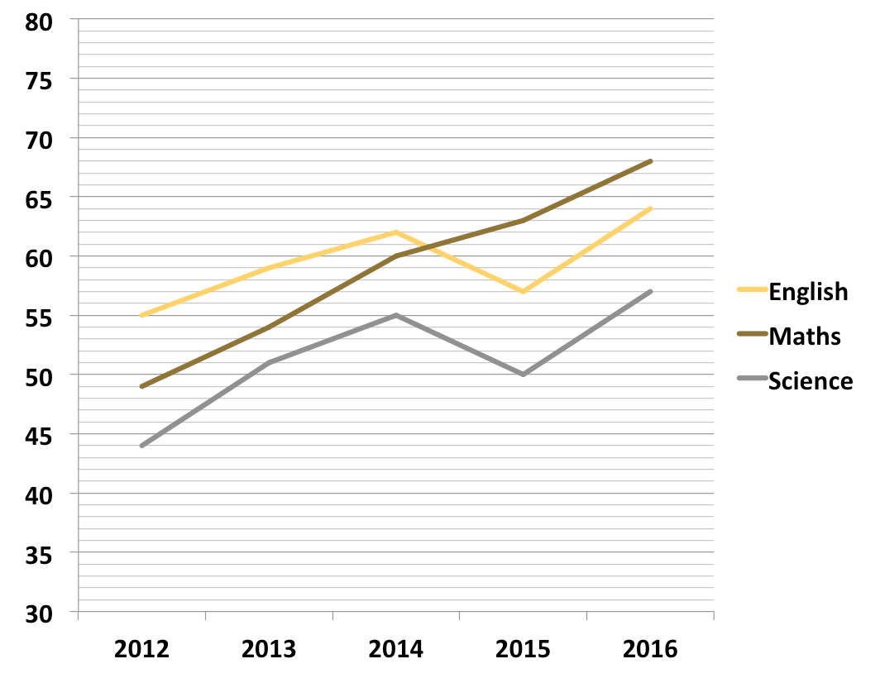 https://qtsskillstests.com/linegraphs/

Are the following statements true or false?
- None of the subjects showed a trend of continual increase.
- Each year there was a lower percentage of students that got A*-C in science than in English or mathematics.
- In 2015, the percentage of students getting A*-C was less than in 2014 for all three subjects.

Time

A school day starts at 8:50 for a 15 minute registration, there are four 1 hour lessons and a 20 minute break before lunch, what time does lunch start?

Here is part of a train timetable for five trains from Manchester to London Euston.
Train | A | B | C | D | E
Manchester | 05:55 | 06:10 | 06:35 | 06:43 | 07:01
London | 08:10 | 08:20 | 08:46 | 08:57 | 09:00
(a) Which train takes less than 2 hours to go from Manchester to London?
(b) Work out the number of minutes taken by train A to go from Manchester to London.
(c) Alicia has to go to a meeting in London and intends to catch one of these five trains from Manchester. She has a 20 minute walk from the station and needs to be at her meeting for 9am. Assuming the trains are running on time, what train should she get from Manchester?

Mathematical Language

Reflect on the following words; what is their everyday use and what is their meaning within mathematics?

Word | Everyday use | Mathematical use
Reflect
Even
Power
Similar
Series
Volume
Factor
Multiply
Sum
Mean
Difference
Value
Round

Useful links

Areas of numeracy - Professional skills tests
A booklet with guidance on areas that were tested on the numeracy professional skills test.

National Numeracy Challenge
This website helps you improve your confidence and competency in numeracy skills.

GCSE Maths - BBC Bitesize
Good revision website

Corbettmaths – Videos, worksheets, 5-a-day and much more
Another good revision site

Skillswise - BBC Teach
Support for developing particular numeracy skills.

http://www.mathcentre.ac.uk/resources/Refresher%20Booklets/numeracy%20refresher/mathcentreNumeracy1.pdf
A useful numeracy refresher booklet on a number of different topics with examples, questions and answers

Answers

Mathematical Language

Brief meanings/definitions below (not all everyday uses of the word are included):

Word | Everyday use | Mathematical use
Reflect | Think carefully about something | Transform in a given mirror line
Even | Smooth (adjective); equal (adjective); emphasise something surprising (adverb) | An integer that can be divided exactly in two.
Power | Ability to control people or things; energy; strength | How many times a number is multiplied by itself, also known as exponent and index
Similar | Like somebody/something but not exactly the same | When two figures are similar, the ratios of the lengths of their corresponding sides are equal and corresponding angles are equal.
Series | Set of television/radio programmes; several events; an electrical circuit | The sum of the numbers within a sequence.
Volume | Amount of sound/ something; issue of a book/ magazine | The amount of space that an object fills.
Factor | One of several things that influence something | A number that divides into another number exactly with no remainder
Multiply | To increase something; to produce young animals | Repeated addition
Sum | An amount | The result of adding two or more numbers together
Mean | Represent something; a purpose; not generous; not kind | Total of a set of numbers divided by how many numbers there are
Difference | How people/ things are not like each other; a change | The result of subtracting one number from another
Value | How much something is worth; importance | A number
Round | Circular/curved in shape | Replace a number by an approximate value. Usually shorter or simpler

