Equality and Diversity Staff Network Group Digest
September 2020
Another month has passed and so it’s time for a roundup of some things of interest!
Brilliant and Black
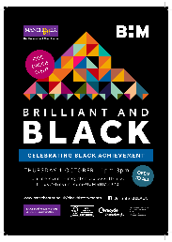
Our BAME staff Network Group have put together a great online programme to start celebrations for Black History Month.
Featuring a panel discussion with Nalin Thakker, Gary Younge, Naa Acquah and Andy Burnham it’s bound to be an excellent couple of hours.
You can find out more details here: Brilliant and Black Event
And reserve your place via Eventbrite

SAVE THE DATE 1 OCTOBER 2pm-4pm
BiVisibility Day
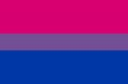
We have celebrated BiVisibility day at the University every year since 2012 and this year is no different!
There’s a whole host of things you can do: have a special Zoom background; take part in our Wikiediathon; watch TED talks; Update your data in MyView; and a whole bunch of other things.
Full details are on our dedicated BiVis2020 pages
Whatever you do, don’t forget to tweet @BiVisibilityDay using #BiVisibility
COVID Reporting process & Vulnerability Guidance
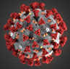
There is new University-wide process for reporting positive COVID-19 cases or self-isolation.
https://www.staffnet.manchester.ac.uk/news/display/?id=24865
Please share as appropriate. The message is particularly important for anyone with line management responsibility, or who works directly with students.
The guidance for Vulnerable Staff has also been updated to include pregnancy. It can be accessed via this link: GUIDANCE FOR STAFF ON VULNERABILITY TO COVID-19

Counselling Service Training
The Counselling Service will be offering the following online training sessions for staff: Life Line: Offering help to students who may be struggling with their mental health, losing hope or experiencing thoughts of suicide.
For booking your place please follow click on the link: https://app.manchester.ac.uk/LLCS0001
Next session date:
Friday 18/09/2020 10.00 - 11:30am Online via Zoom

If you have any issues with booking, send an email to our office administrator, Paul Duffy: pauledward.duffy@manchester.ac.uk


FREE Inclusivity Webinars – NEXT WEEK
Pern Kandola have put together a series of FREE webinars which are taking place next week.
They look at various aspects of being an inclusive organisation, including Positive Action, Inclusive selection and Creating an inclusive Culture.
Full details and booking can be found here: Pern Kandola Webinar Series

GDPR Announcement

Please read this important reminder on StaffNet:
GDPR Announcement

Talking Bodies at Chester
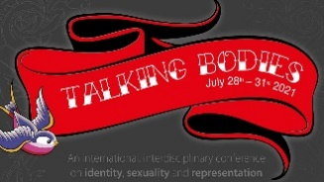
Our colleagues at Chester have recently put out a call for papers for their talking Bodies Conference in July 2021
Full details can be found at the following link:
http://documents.manchester.ac.uk/display.aspx?DocID=51128

That’s all for September – should you want any news featuring for October, then please send to equalityanddiversity@manchester.ac.uk before 20th October.

Keep Safe!

Equality, Diversity & Inclusion | G.035 John Owens Building | The University of Manchester| Oxford Road | Manchester M13 9PL | T: 0161 306 5857

