Opportunity to publish, enhance your CV and be paid…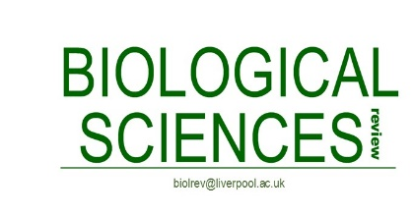

Looking to develop your writing skills? Add something to your CV and publication list? Want to showcase your research? Then writing for Biological Sciences Review might be just the ticket!

The Biological Sciences Review (BSR) is a readable, highly visual magazine published in full colour. It has a readership of over 10 000. The magazine contains a lively mix of authoritative articles and topical columns, all directly relevant to A-level, Scottish Higher and first year undergraduate students.

We are on the look-out for new features to consider for publication, so what better way to develop your writing skills, get published and add something different to your CV. You don’t have to focus on your research, as the magazine features a mix of careers pieces, images of biology, the use of biology in our everyday lives and a ‘What is?’ column, which can be anything from ‘What is a mitochondrion?’ to ‘What is cell biology?’

Age and experience are immaterial. All they are looking for is well-written and interesting articles that are relevant to the A-level specification. Original images are highly valued, as are data sets to explain a particular point. However, don’t think you have to create schematics and images yourself; BSR help with images and figures and can turn your pencil sketches into beautiful digital schematics.

Bear in mind, however, submission of an article is not guaranteed publication. The standard is high and articles are rejected if they are not of sufficient quality. With this in mind, we have offered to the Editorial Board that those of you interested in this opportunity send a brief blurb and/or bullet points (no more than a side of A4) explaining what it is you’d like to write about, how it is relevant to A-level specification and what images/data you plan to include. We will pitch these to the BSR Editorial Board and they will decide which ones they would like to see written.

Authors that are published will be paid for their piece.

The A level specification can be found here: https://www.aqa.org.uk/subjects/science/as-and-a-level/biology-7401-7402

We are happy to advise on whether your proposed topic would be suitable. Just drop one of us an email.

Ceri Harrop ceri.harrop@manchester.ac.uk
Cathy McCrohan cathy.mccrohan@manchester.ac.uk
Editors, Biological Sciences Review

