Hello all

Hope you are all well! We know that many of you are starting to explore now that you can exercise further afield. One of our walking members shared that they had been to Rudyard Lake. Some of us had never heard of this spot so were quick to google!

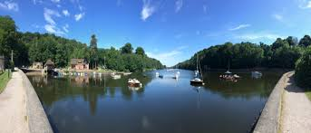
The Lake was built as a reservoir in 1797 and is the place where Rudyard Kipling’s parents first met, where Captain Webb, the first channel swimmer, came to demonstrate his skills and where The African Blondin (Carlos Trower) appeared several times amazing the crowds 30m above the Lake on a tightrope. Little wonder it became known as the ‘Blackpool of the Potteries’ in its heyday.


Chatsworth have opened their car parks (main house and garden centre) and you can walk in the grounds – but the house and garden are not open. You just need to prebook your parking space the day before. There are lovely walks in this area. You can do easy walks from the car parks to Beeley or from the estate to Baslow (very family friendly) mostly along the Derwent.

We’ve had good feedback that the Goyt Valley and Bakewell were quiet and good for social distancing. However, flexibility may be needed for days out as visitor numbers can be erratic in most places. The rule of thumb we have received is that people head somewhere on the basis if it’s too busy they will head somewhere else or home. Keep safe is the message!

Gardening
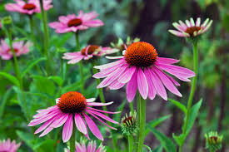
We know that many of you love gardening or have really enjoyed learning more during lockdown. So here are a few garden centres that have been tested in the past week, have good social distancing and were not busy!
Bud Garden Centre – Burnage
Golden Days Garden Centre - Cheadle
Hulme Community Garden Centre

Cheery and cute

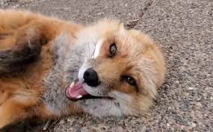
Finnegan Fox (and his cat friends) becoming a foster dad to a baby fox! He lives at Save a Fox in the US. This same rescue has a video of Scotch and Shiloh experiencing their paws on land for the first time (they were rescued from a fur farm ☹).

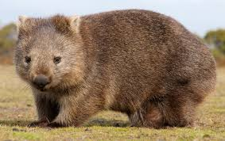
Who doesn’t think that wombats are cute! Here is an orphan wombat's journey back to the wild. There are some fantastic wombat pages to follow on Facebook and Instagram including Sleepy Burrows and the Wombat Awareness Association.
Here is a great video of wombat baby George!

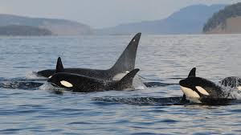
Orcas seem to follow rules that go beyond basic instinct and border on culture. Individual pods forage, communicate and navigate differently, much the way different cultures of people do. Researchers have witnessed “greeting ceremonies” between pods. It may very well be that within “orca culture” there is a social norm not to go after people.” The only known attacks on humans have been those orcas in captivity.

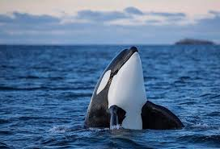
Here are two stunning videos of Orcas happily interacting with humans.
Drone footage of person swimming with Orcas tailing along at a beach in NZ! The swimmer, Judy, doesn’t lose her cool at all and talks about the event afterwards. Lucky lady!

This second video is of some dudes (very Bill & Ted whoops) in New Zealand who swim with orcas


For over 25 years Kenya-born Daphne Sheldrick lived and worked alongside her husband, during which time they raised and successfully rehabilitated many wild species. Since the death of her husband, Daphne, and her family, lived and worked in the Nairobi National Park where they built The David Sheldrick Wildlife Trust and its pioneering Orphans’ Project into the global force for wildlife conservation that is today. Daphne's daughter Angela worked alongside her mother running the Trust for twenty years, and since Daphne’s passing in 2018 continues the mission. Here is a film about Daphne’s and the Orphanage.
Virtual Walks

Beautiful Virtual Walk to Godrevy Lighthouse, Cornwall (1hr 16mins)

Virtual Tropical Beach Walk in Amazing Thailand with Sea Sounds (30 mins)

Finally……

You may need tissues for this one. This lady personifies caring for all little creatures. She discovered a bee with no wings. Look what happened next….

Have a safe and happy week. ☺

Hawys, Marjorie, Michelle, Pen & Vanessa
MCR Strollers Walk Leaders
Tel: 0161 306 1994
Like us on Facebook at MCR Strollers
Twitter @MCRStrollers
Instagram @themcrstrollers/
Email us: MCRstrollers@manchester.ac.uk


Follow us on: Facebook: https://www.facebook.com/theMCRstrollers/ Twitter: https://twitter.com/MCRStrollers

