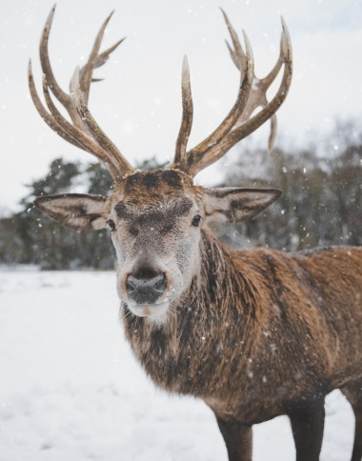
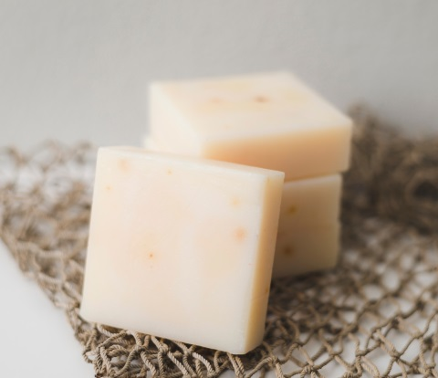
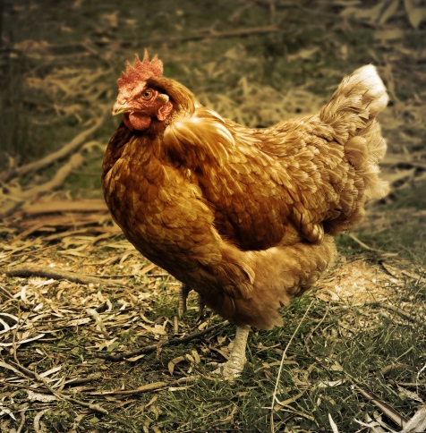
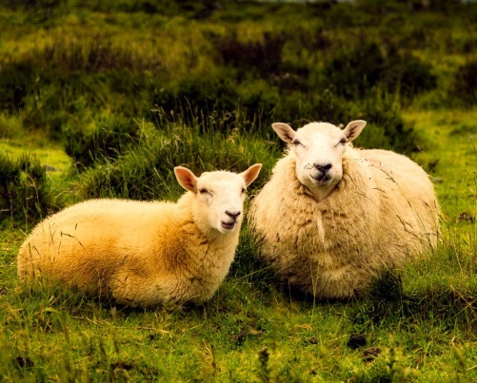
Red deer
Cheese
Chicken
Sheep

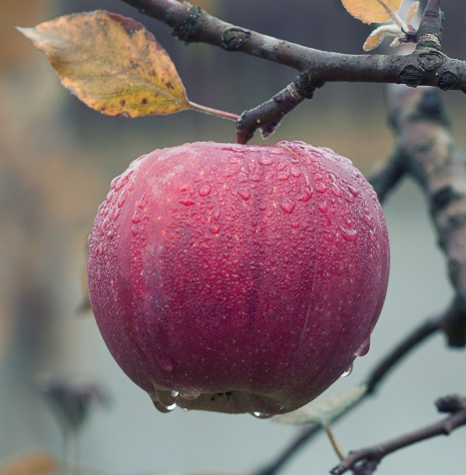
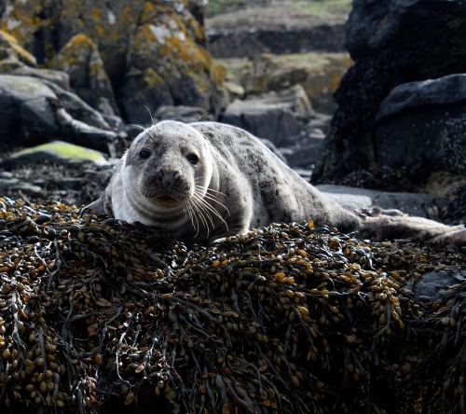
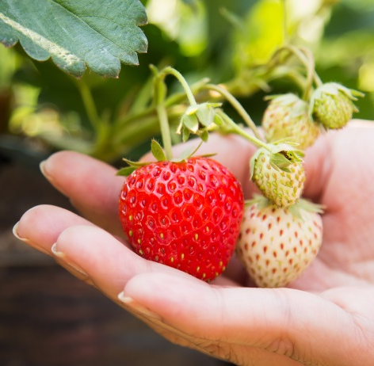
Potatoes
Seals
Apples
Strawberries
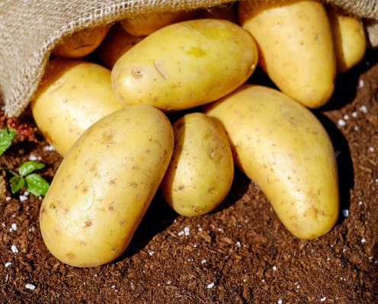

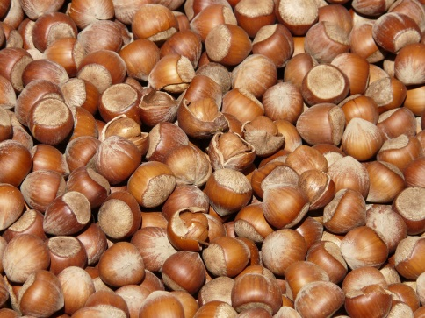
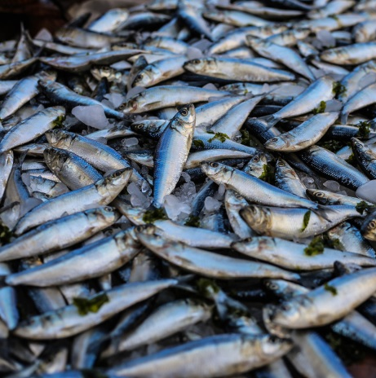
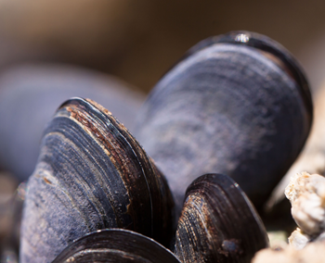
Shellfish
Fish
Bread
Hazelnuts
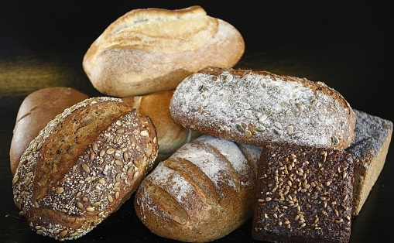

Red Deer
Yes!
In the Mesolithic, Britain had large areas of woodland and lush river valleys, which were perfect to hunt for red deer, and other big mammals like wild boar and elk.

Cheese
No!
To make cheese we need milk from cows or sheep, but people didn’t bring them into Britain until the Neolithic period (about 6000 years ago).

Chicken
No!
Chickens do not live in the wild in Britain. Chickens come from Asia originally, and were brought to Britain in the Iron Age (about 2100 years ago).

Sheep
No!
The Mesolithic was before people started farming or keeping animals, so there were no sheep, cows or pig in Britain-they arrived later, in the Neolithic (about 6000 years ago).

Potatoes
No!
Potatoes come from South America, and were only brought to Britain around 500 years ago.

Seals
Yes!
Seals that live in the seas around Britain would have been another important food source for Mesolithic people living near the coast.

Apples
Yes!
As you walked through Mesolithic woodlands in autumn, you could find apples growing wild. These would be ‘crab apples’, which are smaller than our apples today.

Strawberries
Yes!
Amazingly, if you were living in the Mesolithic, you would be able to pick wild strawberries, which were smaller than the strawberries we get today.

Hazelnuts
Yes!
The forests and woodlands in Mesolithic Britain would be full of tasty plant foods to gather and eat. Hazelnuts, from the Hazel tree, would be a really important part of your diet.

Bread
No!
To make bread you need flour made from wheat, but people only started growing that on farms in the Neolithic (about 6000 years ago).

Fish
Yes!
In the Mesolithic, you would fish in lakes, rivers and the sea for fish to eat.

Shellfish
Yes!
If you lived near the coast in the Mesolithic, gathering shellfish like oysters, limpets and cockles would have been really important for your diet.

