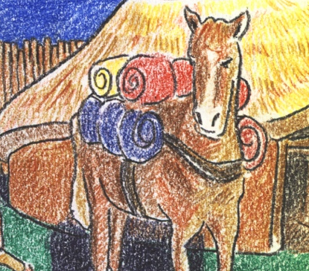
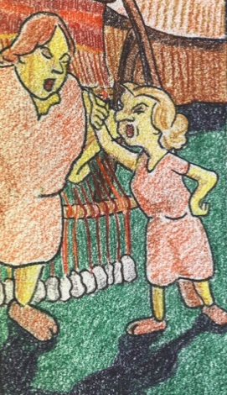
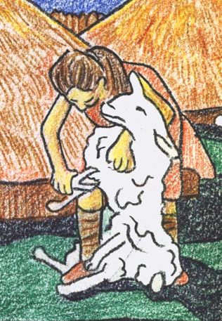
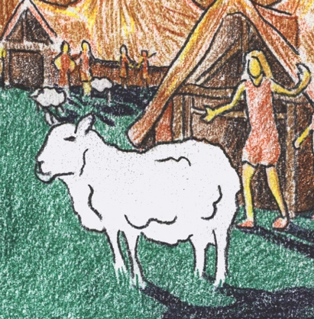

Horse
Weavers
Shearer
Shepherd

Family
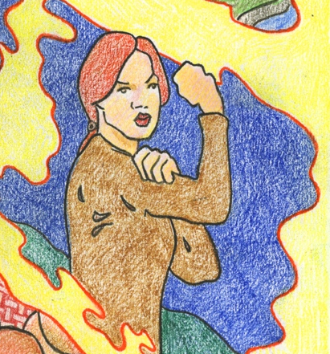
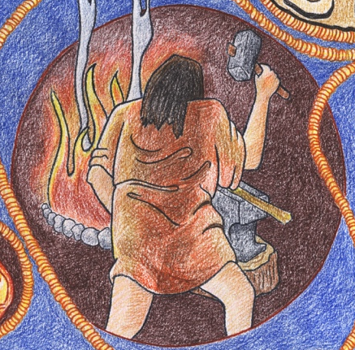
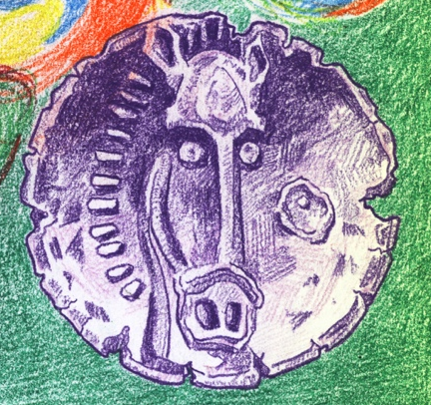
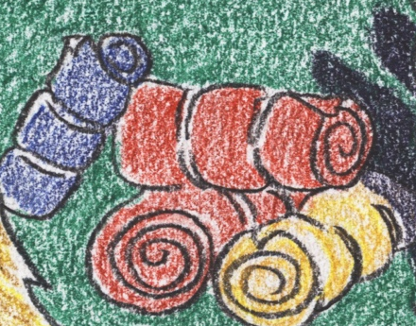

Children
Smith
Trader
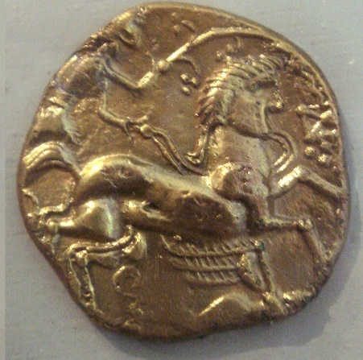

Horse
I am a horse and I help my family move heavy things like cloth to the market so we can trade with the trader.
What I take: | Cloth from the weavers
What I give: | Cloth to the trader

Weavers
Our job is to wash, comb and weave sheep wool into beautiful cloth to trade at the market. But to get it there we need help from our horse!
What I take: | Wool
What I give: | Cloth

Shearer
My job is to shear woolly sheep and then give all the wool to the weavers.

What I take: | Sheep
What I give: | Wool

Shepherd
I look after sheep, and in the spring give the woolly sheep to the shearer.

What I give: | Sheep

Smith
I make iron tools, and sometimes trade these for other things. Today I need woollen cloth to make winter clothes for my family.
What I give: | Iron tools to the trader
What I take: | Cloth for my family

Children
Winter in the Iron Age is cold, so my elders have made us all new clothes from warm woollen cloth. But where did it come from?
What I need: | Clothes
What I ask: | Questions!

Family
We are the family of the Smith. Winter is coming and it is getting cold. We need some woollen cloth to make some winter clothes for the children.
What I take: | Cloth from the smith
What I give: | Clothes

Trader
I trade with people at the market. I want to trade one of my coins for some woollen cloth. I can then trade the woollen cloth with my friend the smith.
What I take: | Cloth from the weaver
What I give: | Cloth to the smith

