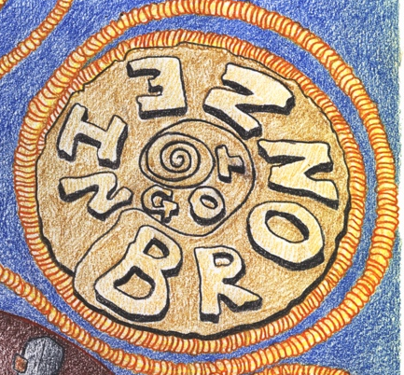
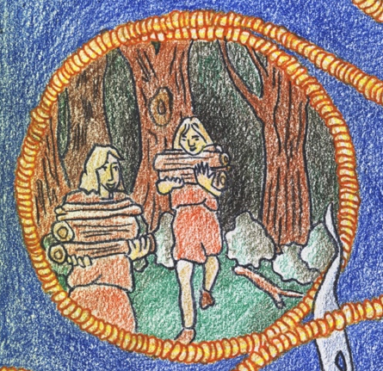
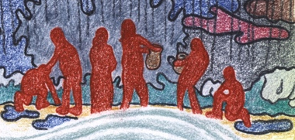
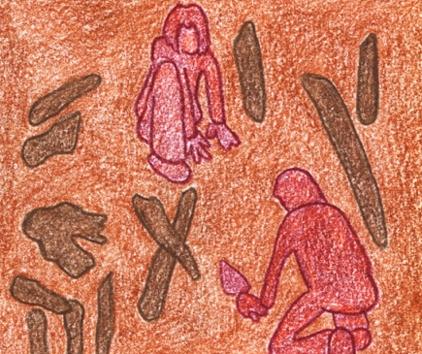
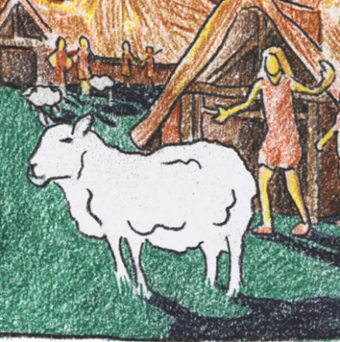
Wood collectors
Copper ore movers
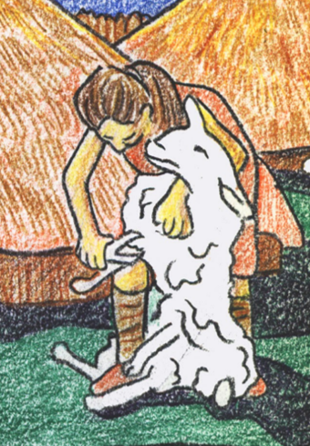

The smelter
Miners

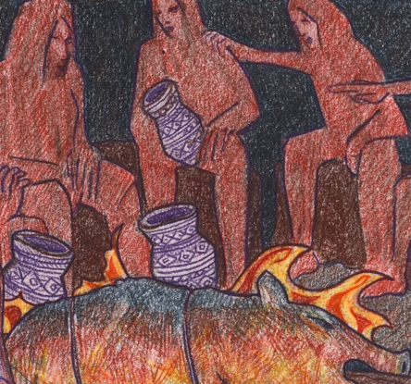
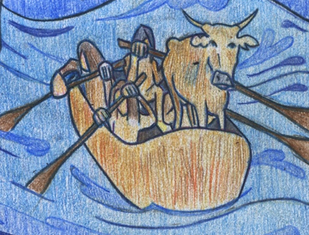
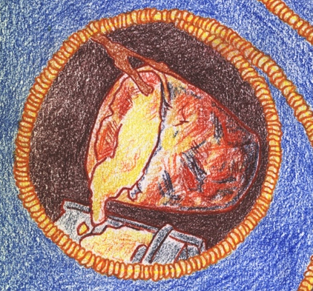

The family
The farmer
The smith
The trader
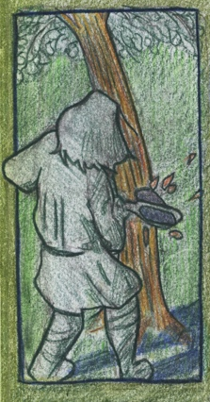
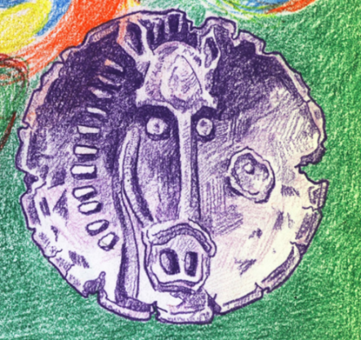

Copper ore movers
We travel down copper mines, bringing copper ore from deep in the ground and into the daylight. We give the copper ore to the smelter.
What I take: | Copper ore from the miners
What I give: | Copper ore to the smelter

The smelter
I crush up copper ore and burn wood in my furnace. The heat from the fire smelts the ore and makes a pure metal copper ingot. I can give this to the trader.
What I take: | Copper ore
What I take: | Wood
What I give: | Copper ingot

Wood collectors
We collect lots of wood from deep in the forest that can be used as fuel to melt copper ore. We give our wood to the smelter.
What I give: | Wood

The miners
We work in mines deep in the earth harvesting the precious copper ore. We pass it onto the copper ore movers.
What I give: | Copper ore

The trader
I take special things like copper ingots and trade them with people in distant places who need them, like my friend the smith.
What I take: | Copper ingot from the smelter
What I give: | Copper ingot to the smith

Friends and family
We are the friends and family of the farmer, and he has promised to throw a feast – but where will all the meat come from?
We need: | Fat animals

The farmer
I look after animals on my farm, but I need an axe to chop down trees to make grazing space. Then my animals can get fat and I can feed my friends and family.
What I take: | Bronze axe
What I give: | Fat animals

The Smith
I take exotic copper ingots from the trader and melt it with tin and fire to cast a sharp bronze axe for my friend the farmer.
What I take: | Copper ingot from the trader
What I give: | Bronze axe

