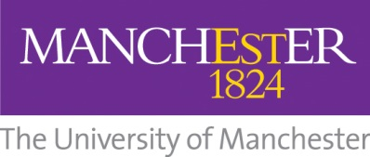

University of Manchester Community Survey 2018
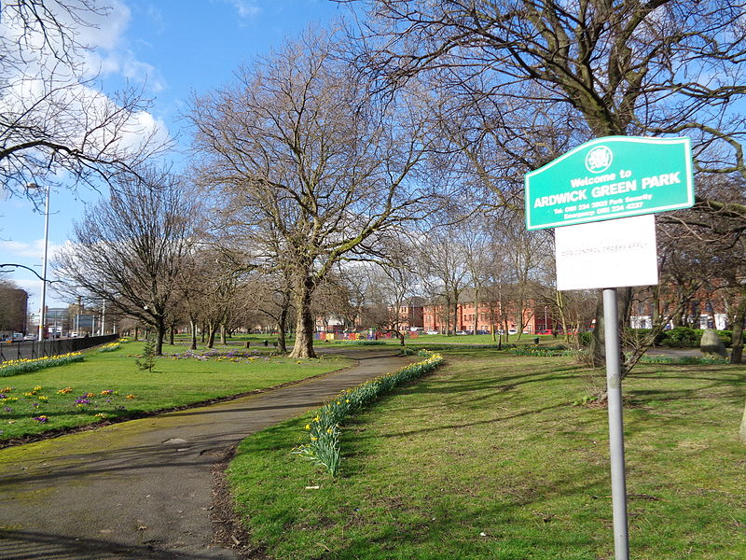

Dr Carl Emery, Research Fellow, Manchester Institute of Education
Ola Demkowicz, PhD Researcher, Manchester Institute of Education
Choel Cartwright, Local resident

University Ardwick Partnership

‘The survey aimed to discover the local communities’ opinions and awareness of the University’s activities’.

Background
The University of Manchester identifies social responsibility as one of its three core strategic goals. Within the University’s Inspiring Communities community engagement plan 2016-19 one of the high-level outcome measures is ‘more people in the community becoming aware of key activities and having a positive perception of these’ (Office for Social Responsibility, 2016). There is a need, then, to develop our understanding of the way that people in the local communities perceive the University’s activities. To date, this has only been fed back anecdotally to the University – often through ‘outlying’ forms of informal feedback, where local residents offer up either praise or dissatisfaction with the University’s activities. As a result, this project sought to gain a deeper understanding of local community knowledge and perceptions of University activity through a formal survey. To do so, we developed and delivered a survey to local residents across key local wards to the University’s main campus. In development with the University’s support of the newly emerging University Ardwick Partnership, a team of local Ardwick residents and community members were contracted and trained in social research to carry out the survey. The community team also helped shape the survey design and questions originally developed through the Office for Social Responsibility.
Over the summer of 2018, 341 individuals completed the community survey.
The Project Team
The project was led by Dr Carl Emery, Research Fellow, Disadvantage and Poverty, Manchester Institute of Education - SEED. Carl was supported on the development and analysis of the survey by Ola Demkowicz, PhD Student/Research Assistant, Manchester Institute of Education - SEED. The Community Team was led by Choel Cartwright, a local resident and also part of the University Brunswick Urban Village project.
The Community team were trained in Social Research Methods by Dr Sarah-Marie Hall, Senior Lecturer in Human Geography, Geography - SEED. The community team consisted of six Manchester residents and community members who have been working with the University Ardwick Partnership in Brunswick over the past two years. The community team already had a relationship with the Office for Social Responsibility and were engaged to conduct the survey. The project team was supported by Dr Julian Skyrme and Marie Conaghan from the Office for Social Responsibility.
Survey Design
The survey was designed around the key themes drawn from previous activity undertaken across the University, current literature on community surveys, and examples of surveys undertaken by other HE institutions. Specifically, the survey had three key sections:
Part 1: Perception of the University of Manchester and wider organisations in Greater Manchester
Part 2: Community spaces and involvement
Part 3: Direct opinions on the University and its research, teaching, and social responsibility

An initial survey was developed with the Office for Social Responsibility and the Division of Communications and Marketing. This was then shaped with the community team and through a piloting stage. The final survey included a total of 36 questions around these three themes. The questions were built around multiple choice and sliding scale responses with respondents being asked to indicate their agreement or otherwise with a series of statements or images. We used the Quick Tap Survey (https://www.quicktapsurvey.com/) software package to design and deliver the online survey. We used a range of types of questions, including multiple choice questions (e.g., “Which of these organisations do you think employ the most people in Greater Manchester?”), Likert scale questions (e.g., “Local businesses and organisations help in my neighbourhood” with response options from “strongly disagree” to “strongly agree”) and rating questions (e.g., “How would you rate the University of Manchester?”, with a rating scale from 1 to 10). We also gathered basic demographic data on sex, ethnic group, age bracket and qualification level.
The online survey was delivered through hand held digital tablets and took around 10-15 minutes to complete. Respondents could either use the tablet independently and select the responses they agreed with, or ask the community team to talk through the survey with them and select their chosen responses for them.

Objectives and Key Performance Indicators (KPIs)
A number of objectives and KPIs of the project were developed in order to ensure the research was completed as efficiently as possible and provided the most useful data. The research aimed to:
- Provide baseline benchmarking information on awareness and perceptions of the University’s work in local communities;
- Inform future communications and engagement strategies for local residents;
- Identify current levels of engagement between local residents and the University;
- Enable repeat surveying to identify and map trends and improvements in current work.

In order to meet these objectives and ensure the project was worthwhile, a number of KPIs were set for the research. These were:
- To develop a survey template that could be utilised and could be reused every two years to enable comparisons to be made;
- To complete the distribution, return and analysis of the first survey in the 2017/18 academic year;
- To target ten key wards surrounding the University;
- To have as representative a sample as reasonably possible of the populations of these wards.

The ward breakdown allowed a comprehensive picture of differing attitudes and enable further work to identify and resolve differences between engagement levels in the areas surrounding the University. These wards are identified as the ten where the University has the largest physical footprint and student impacts. They are Ardwick, City, Hulme, Fallowfield, Levenshulme, Longsight, Moss Side, Old Moat, Rusholme and Withington (Office for Social Responsibility, 2016).

Participants
In order to ensure that our sample represented the desired group of people, we had a number of inclusion criteria. In order to take part, participants needed to be:
- Local residents within Greater Manchester
- Over the age of 18
- Not currently studying or working at the University of Manchester
It should be noted that we were focused on “near neighbours” of the University, and so we carried out data collection across the ten wards near the campuses. However, our inclusion criteria of living in Greater Manchester as a wider area reflected our recognition that there are individuals who may live elsewhere but are present or active in these wards, such as through vocation or community involvement. To facilitate understanding perspectives across these neighbouring areas, we set out key parameters that the survey would only be delivered within a triangular district of Manchester starting from the Mancunian way and running along the Wilmslow Rd and London Rd corridors through to the Withington/Didsbury border.
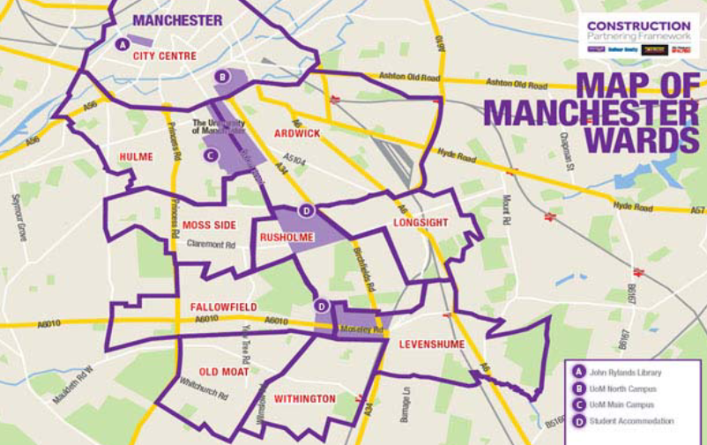
Figure 1. Map demonstrating the ten key wards targeted in the survey.

In total, 341 individuals who met this inclusion criteria completed the survey. 67% of the sample were residents in the ten wards, while the remainder of the sample was spread across Greater Manchester (note that a small number of wider postcodes were provided, however this may be due to factors such as home and term-time addresses). The demographics of this sample are shown below, specifically sex, ethnic group, age bracket, and qualification level, alongside approximate Greater Manchester norms (note that this does not show respondents who chose not to disclose this information). As can be seen, the sample had a higher than average representation of females, those from some ethnic minority backgrounds, and those from the 45-64 age bracket.
Table 1: Sample demographics
Characteristic | Subgroup | n | % | GM norm %
Sex | Male | 123 | 36 | 49*
Sex | Female | 210 | 62 | 51*
Ethnic group | White | 130 | 38 | 66*
Ethnic group | Mixed/multiple ethnic groups | 28 | 8 | 5*
Ethnic group | Asian/Asian British | 49 | 14 | 17*
Ethnic group | Black/African/Caribbean | 103 | 30 | 9*
 | Any other ethnic group | 16 | 5 | 3*
Age bracket | 18-24 | 43 | 13 | 12*
 | 25-44 | 146 | 43 | 41*
 | 45-64 | 101 | 30 | 12*
 | 65+ | 38 | 11 | 18*
Qualification level | No qualifications | 41 | 12 | 11†
Qualification level | 1-4 GCSEs or equivalent 1 | 25 | 7 | 9†
Qualification level | 5+ GCSEs or equivalent 2 | 37 | 11 | 13†
Qualification level | Apprenticeship | 3 | 1 | 3†
Qualification level | 2+ A Levels or equivalent 3 | 39 | 11 | 21†
Qualification level | Degree level or above | 116 | 34 | 39†
Qualification level | Other qualifications (e.g. vocational qualifications or qualifications gained outside the UK) | 54 | 16 | 6†
Notes.
* Calculated from figures released by Manchester City Council (2016). Retrieved from https://secure.manchester.gov.uk/downloads/download/4220/public_intelligence_population_publications
† Calculated from figures released by Manchester City Council (2016). Retrieved from https://www.manchester.gov.uk/download/downloads/id/25488/i06_annual_population_survey_2016.pdf

Development and Data Collection
Training
Following University guidance, the community team delivering the survey were trained in research methods. This was a six-hour programme delivered over two sessions. The aim of this programme was to ensure the community team had both the skills and awareness to deliver the survey whilst also developing a professional training programme that could be used in future university/community relationships. The research team was made aware of potential psychosocial barriers associated with class, socio-economic group, ethnicity, gender, sexual orientation connected to survey delivery.

We also devoted time and resources to safety issues, namely raising awareness, clarifying responsibilities and lines of accountability, and creating and implementing procedures. The community team followed the University lone worker policy and utilized a ‘buddy’ programme whilst out delivering the survey. We assessed the risk connected to the fieldwork site and asked a number of questions regarding safety, personal knowledge of the community and the community teams experiences of the districts they were operating in.

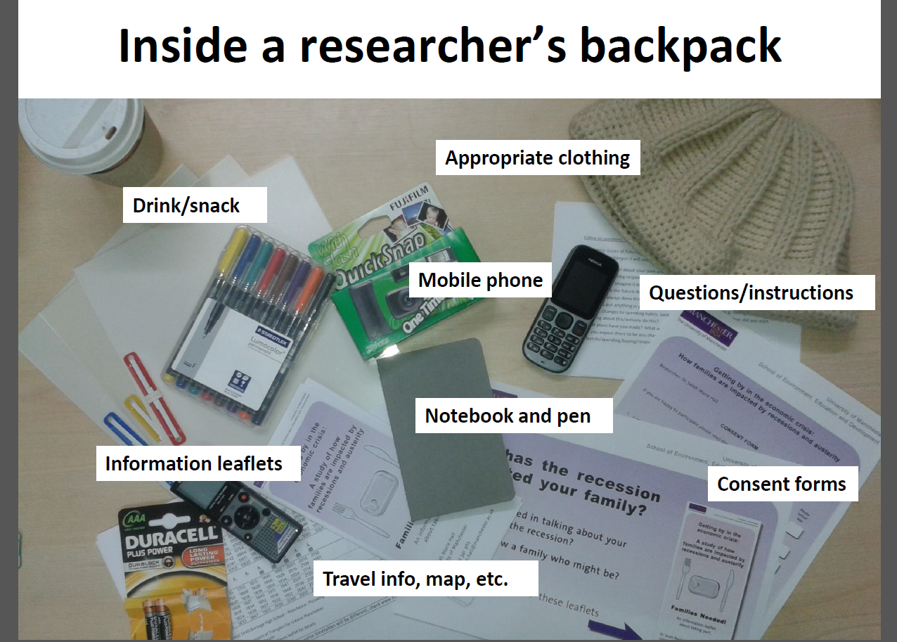

Figure XX. A slide from the training, showing the equipment that team members needed with them during data collection.
The community team worked in pairs and wore name badges throughout the survey delivery. We spent time studying maps of the area to plan collection across different areas. We made it a priority to identify schools, post offices, railway stations and other hubs of activity that would ensure both higher response rates and offer higher levels of safety for the community team.
Piloting
The draft survey was piloted by the community team with local residents and members of community groups at the Brunswick Parish Church on Brunswick Street, Ardwick. The piloting process revealed a number of issues regarding the length and language of the survey and following discussions with the Office for Social Responsibility a number of significant changes were made, including removal and simplification of some questions. This process was invaluable to ensuring the success of the programme.

Ethics and Consent
We followed the SEED Code of Practice for the Safety of Social Researchers and The Data Protection Act 2018. Participants were provided with an information sheet that explained the purpose of the survey and outlined processes around confidentiality, consent, and the right to withdraw, along with the contact details of the research manager and who to contact with any questions or complaints. This information was also explained verbally to confirm understanding and to address any questions. Participants were then asked to provide consent by ticking a checkbox at the start of the survey.
All participants were informed that the data collected would be recorded and stored in accordance with the Data Protection Act. Data was stored on the password protected tablets and then downloaded to University of Manchester computers in a password protected directory that could only be accessed by the research team listed.

Delivery
The community team worked in pairs, with each pair assigned a certain district or sub-district. We prioritised busy public areas such as schools, local supermarkets, cafes and parks. The community team went out to these areas at different times of the day to target different types of people, although all survey activity stopped at 8pm for safety reasons. The team also linked with local community groups and known groups of residents, which was an advantage of using active members of the community to deliver the survey. There was also a number of street approaches where the team working in pairs surveyed along a busy high street within the district. Throughout the delivery period the community team leader met with the University team and together evaluated responses on an ongoing basis to allow targeting of low response areas and groups. The survey was delivered between May 19th and 31st July, 2018.
In order to maximise response rates during data collection and as a token of thanks for those who took part, an incentive was offered. Specifically, everyone who completed the survey was invited to enter a prize draw to win a digital tablet. It is not possible to assess the extent to which this underpinned some individuals’ participation; however, only 48% of participants (n = 163) chose to enter the prize draw, suggesting that for at least half of the sample this was not a central concern.

Findings
Part One: Perceptions of the University of Manchester and wider organisations in Greater Manchester
For this section, we showed participants several different logos for Greater Manchester organisations, including the University of Manchester and neighbouring institutes. Specifically, participants were shown the logos for:
- Manchester United and Manchester City football clubs
- Kellogg’s
- University of Manchester
- McVitie’s
- University of Salford
- Co-op
- Manchester Metropolitan University (MMU)
- Boohoo.com
Participants were asked to respond to several statements regarding their use and perceptions of these organisations by selecting logos. Participants could choose as many organisations as desired for each question. Table 2 shows a summary of responses to these questions; the percentage of responses selecting the University of Manchester are shown in boldface. These responses are then illustrated in the context of each question.
Table 2
Summary of participants’ responses to local organisation questions (shown in percentages)
 | Organisation
Statement | Football clubs | Kellogg’s | UoM | McVitie’s | University of Salford | Co-op | MMU | Boohoo.com
Products and services used regularly | 25 | 49 | 18 | 46 | 12 | 33 | 18 | 24
Organisations perceived to employ the most people | 24 | 32 | 36 | 25 | 14 | 27 | 32 | 7
Organisations perceived to benefit local people the most | 28 | 28 | 32 | 22 | 15 | 32 | 29 | 7
Organisations perceived to be the most well-known | 55 | 54 | 33 | 42 | 16 | 36 | 25 | 15

Question 1: Please select the organisations logos whose products/services you use regularly.

Question 2: Which organisations do you think employ the most people in Greater Manchester?

Question 3: Which organisations do you think benefit local people the most?

Question 4: Which organisations do you think are the most well-known?

Part One: Summary
These findings indicated that the majority of respondents did not identify themselves as regular uses of the University’s services. However, the University was considered to employ the most people relative to the other organisations listed, and tied with the Co-op as to the organisation that was thought of as local people the most. In terms of how well-known the University was perceived to be, around a third of people rated the University as among the most well-known, which was below most of the consumer goods organisations but higher than neighbouring universities.

Part Two: Community spaces and involvement
First, participants were asked to respond to a series of statements around their perceptions of their local community and wider organisation involvement in their community. Participants were asked to respond using a Likert scale with five response options, ranging from “strongly agree” to “strongly disagree”. Table 3 shows participants’ responses to these questions.

Table 3
Participants’ responses to community statements (shown in percentage)
 | Percentage of respondents (%)
Statement | Strongly agree | Agree | Neither agree nor disagree | Disagree | Strongly disagree
“Local businesses and organisations help in my neighbourhood” | 10 | 40 | 26 | 20 | 4
“I am proud of my community” | 24 | 50 | 17 | 7 | 2
“I am proud of living in Greater Manchester” | 36 | 47 | 11 | 4 | 1

To understand specific recognition and use of cultural spaces, participants were shown images of eight venues within Greater Manchester/Cheshire, some of which are owned by the University of Manchester. Specifically, participants were shown images of:
- University owned:
  - The John Rylands Library
  - Manchester Museum
  - Jodrell Bank Observatory
  - Whitworth Art Gallery
- University Students’ Union-owned: Manchester Academy
- Non-university owned:
  - Manchester Art Gallery
  - Museum of Science and Industry
  - HOME
Participants were asked to respond to several statements regarding their recognition and use of these community spaces, including whether or not they are owned by the University of Manchester. Participants could select as many options as desired. Table 4 shows a summary of responses to these questions, which are also illustrated in the context of each question below. Spaces owned by the University are shown in boldface.
Table 4
Summary of participants’ responses to local community spaces questions (shown in percentages)
 | Space
Statement | Manc Art Gallery | John Rylands | MOSI | Museum | Jodrell Bank | Whitworth | Academy | HOME
Spaces recognised | 50 | 32 | 37 | 37 | 44 | 40 | 42 | 31
Spaces visited in the last year | 25 | 11 | 18 | 17 | 11 | 19 | 19 | 14
Spaces believed to be owned by the University | 28 | 31 | 20 | 39 | 23 | 35 | 35 | 24

Part Two: Summary
The findings suggest that participants appeared slightly prouder of Greater Manchester than of the local community, while only 50% felt that local businesses and organisations help in their neighbourhood. In terms of recognition of cultural spaces from images, this was between 30 and 50% overall, with most University-owned spaces appearing higher than non-University owned ones. The Whitworth and Museum were more likely to have been visited in the past year than John Rylands or Jodrell Bank, which mirrors the University’s own internal data on visitor numbers. Understanding ownership and running of cultural spaces was fairly weak overall. The Manchester Museum, The Whitworth, Manchester Academy and John Rylands were the most likely to be associated with ownership by the University, although in each case only 30-40% of people were aware of this. More people believed Manchester Art Gallery and Home were owned by the University than Jodrell Bank and this may reflect its more distant location from the communities targeted in the survey.

Part Three: Direct opinions on the University and its research, teaching, and social responsibility
This last part of the survey was directly focused on participants’ opinions and perceptions of the University of Manchester. We aimed to understand how often participants had visited University campus or buildings, levels of involvement and connection with the University, and the way in which participants perceived the university and its activity.
Question One: Participants were asked when, if ever, was the last time they visited the University of Manchester (e.g., the campus or a university building).
31%
10%
14%
9%
7%
19%
10%

Question Two: Participants were presented with a number of descriptive words and were asked to select those that they felt applied to the University.

Table 5
Participants’ responses to words to describe the university
Word | n | Percentage
Traditional | 184 | 54
Famous | 179 | 53
Selfish | 23 | 7
Diverse | 123 | 36
Caring | 46 | 14
Elitist | 74 | 22
Innovative | 96 | 28
Accessible | 79 | 23

Question Three: Participants were asked to rate the University of Manchester, Manchester Metropolitan University, and the University of Salford on a scale of 1 to 10, with 10 representing the best possible reputation.

Table 6
Participants’ rankings of Greater Manchester universities
Institute | M | SD
University of Manchester | 7.71 | 1.84
Manchester Metropolitan University | 7.29 | 1.85
University of Salford | 6.70 | 1.89

Question Four: Participants were provided with a number of statements related to the University’s community involvement and engagement. Participants were able to respond on a five-point Likert scale from “strongly agree” to “strongly disagree”. Responses are summarized in Table 7 and are then illustrated in the context of each statement.
To what extent do you agree or disagree with the following statements?
Table 7
Participants’ responses to university community-oriented statements
 | Percentage of respondents (%)
Statement | Strongly agree | Agree | Neither agree nor disagree | Disagree | Strongly disagree
The University of Manchester is involved with the local community. | 10 | 36 | 31 | 17 | 4
The University of Manchester contributes positively to me and my family/friends. | 7 | 26 | 36 | 24 | 5
The University of Manchester has improved its contribution to the community. | 9 | 28 | 40 | 17 | 2
The University of Manchester is a key part of the social and cultural life of Greater Manchester. | 14 | 41 | 26 | 13 | 1
The University of Manchester serves Greater Manchester, not just its students and academics. | 11 | 33 | 33 | 15 | 3
I am involved with the University of Manchester. | 2 | 12 | 17 | 43 | 21
I would recommend the University of Manchester. | 15 | 45 | 26 | 8 | 2
I feel connected to the University of Manchester. | 6 | 18 | 28 | 28 | 15
I am proud of the University of Manchester’s contribution to Greater Manchester. | 14 | 28 | 36 | 14 | 2

Question Five: Participants were presented with a list of different aspects of the University and were asked to select which (if any) they thought were good for Greater Manchester. Participants were able to select as many options as desired. Responses are summarized in Table 8.

Table 8
Participants’ responses to aspects of the university in relation to Greater Manchester
Word | n | %
Research | 251 | 74
Culture (e.g. museums, galleries) | 186 | 55
Students | 237 | 70
Employment opportunities | 171 | 50
Training professionals | 166 | 49
Talks and events | 112 | 33
None of these | 9 | 3

Question Six: Finally, participants were asked to respond “true” or “false” to a series of statements regarding their own and others’ involvement with the University. Responses are shown in Table 9.
Table 9
Relationship to university
Statement | True (%)
I have studied at the University of Manchester in the past | 14
I have worked at the University of Manchester in the past | 8
Someone in my family has studied or worked at the University of Manchester | 54
I know other people who have studied or worked at the University of Manchester | 77
I live within a five minute walk of university buildings or student halls | 33

Part Three: Summary
Findings from this section show mixed perceptions. In terms of accessing university spaces, a third of participants had made visited campus or a University building in the last year; however, almost a fifth have never visited. The University rated similarly to neighbouring institutes, though slightly higher, and was considered to be “famous”, “traditional”, and “diverse” by many participants. Two-thirds of participants agreed that they would recommend the University to others and many said they felt proud of the University’s contribution. The University’s research and its student body were recognised as good contributors to Greater Manchester, though talks and events were less noted for this. However, less participants identified the university as “caring” or “accessible”, and many participants did not consider the University to be positively contributing to them personally and did not consider themselves involved with or connected to the University.

Next steps and recommendations
This research has fulfilled the aim to providing the University with a broader knowledge of community perceptions than was currently available and is the first large-scale survey of local residents in relation to the University. It met a key goal set out in the University’s Inspiring Communities plan to assess knowledge and perceptions of the University among the local community. It has provided quantitative measurements that will allow improvements and changes to be tracked through repeat surveying in the future and will also provide immediate information to allow current activities to be more closely tailored towards local requirements. Responses will also help to identify the most appropriate messages and communications channels to guide activities. In asking the UAP to deliver this survey the University also committed to empowering and training local residents to undertake social research, encouraging local procurement of services and building on partnership activities with local communities.
There are now opportunities to:
- Feedback the findings to those who took part (Research team)
- Feedback findings within the University (Research Team / OSR)
- Ensure key findings on lower levels of awareness and perception of activities help inform the development of public/community engagement, marketing and broader UoM strategies.
- Run a similar repeat survey again in 24 months
Contact
carl.emery@manchester.ac.uk

