

A navigation guide for the PGR Supervisor Toolkit

The toolkit is compatible with all major browsers on PC and Mac. It will also display on tablets and smart phones on Android and iOS.

The toolkit is also available as a PDF for use with screen readers.

We have produced the toolkit to be intuitive and easy to use. Below is a brief guide on navigating the toolkit.

From the front page of the toolkit, click Launch Toolkit to open the resource.
If you wish, you can browse the available sections from the front page too.
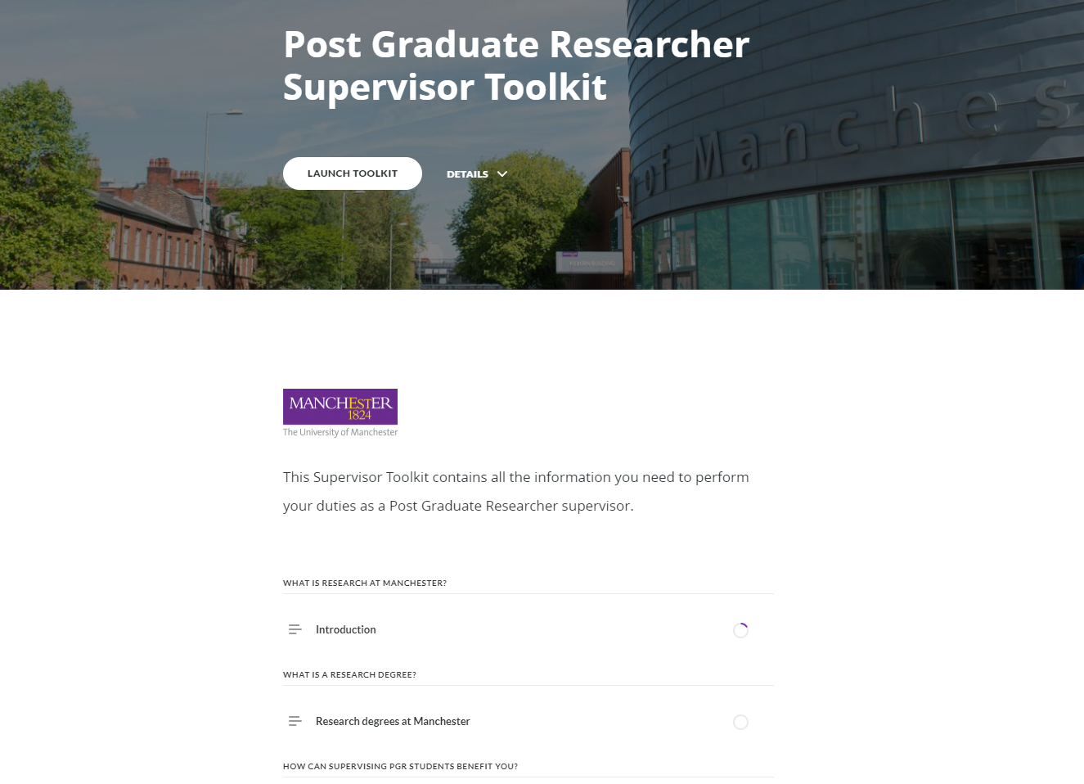
Once you click Launch Toolkit, you will see the first page of the toolkit.

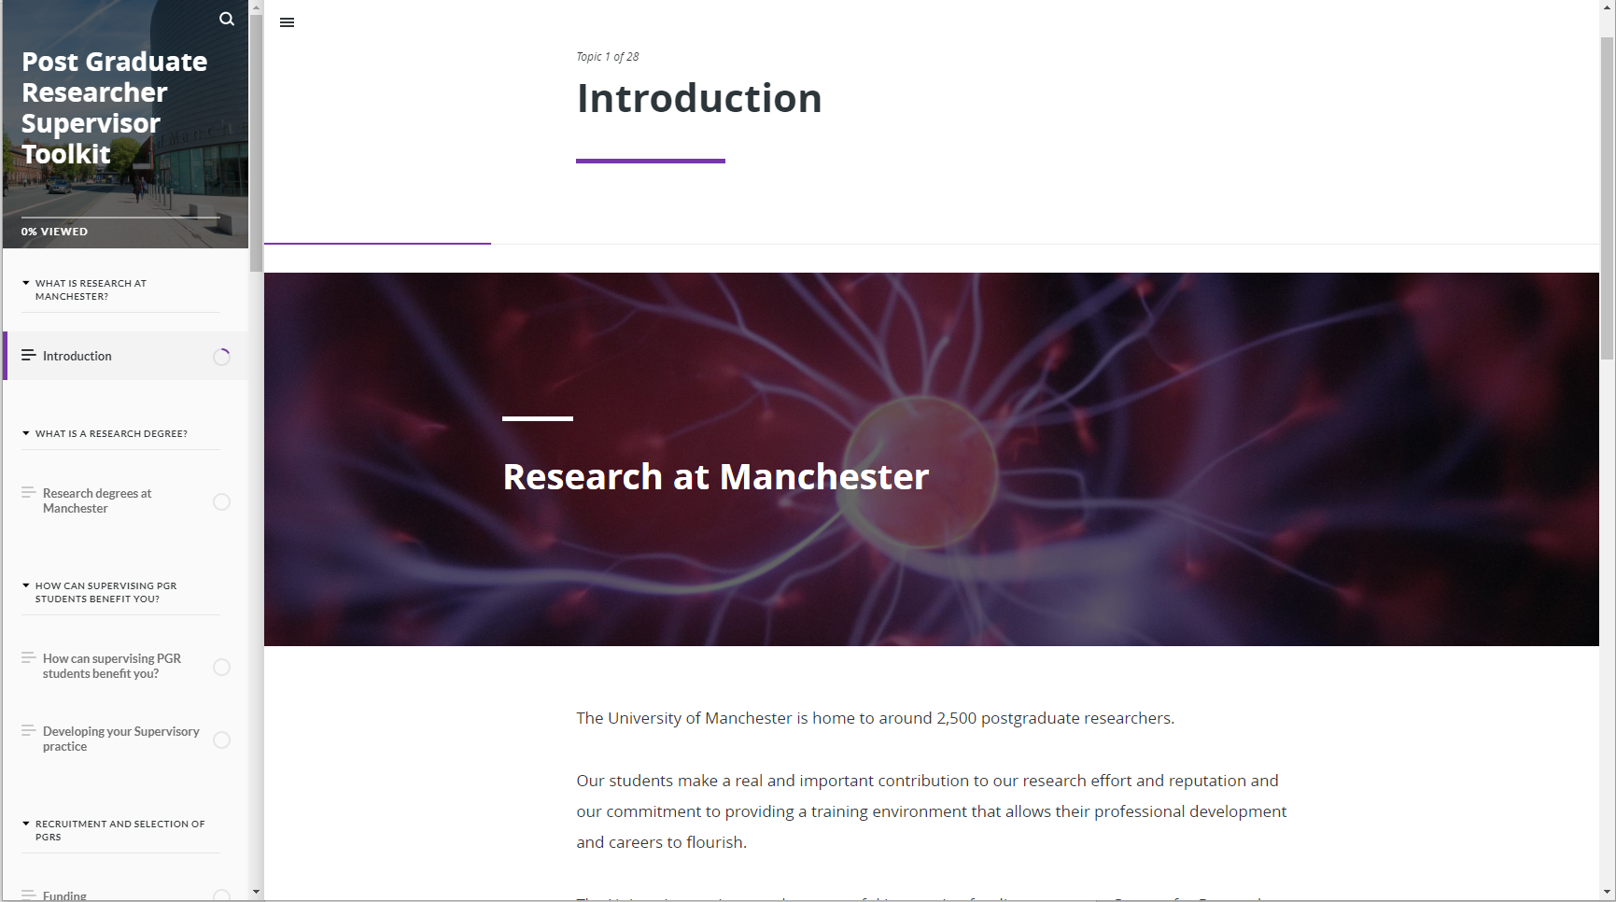

Again, you can navigate to sections by using the menu down the left side. This menu may be collapsed by default. If so, click the three horizontal lines in the top left to expand the menu.
You can also search the toolkit for key words you wish to find. Click the magnifying glass in the top left corner and type in your search terms. The toolkit will return a list of sections where your key word has been found as you can see in the screen shots below.

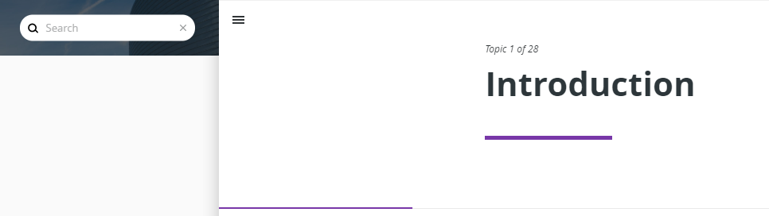
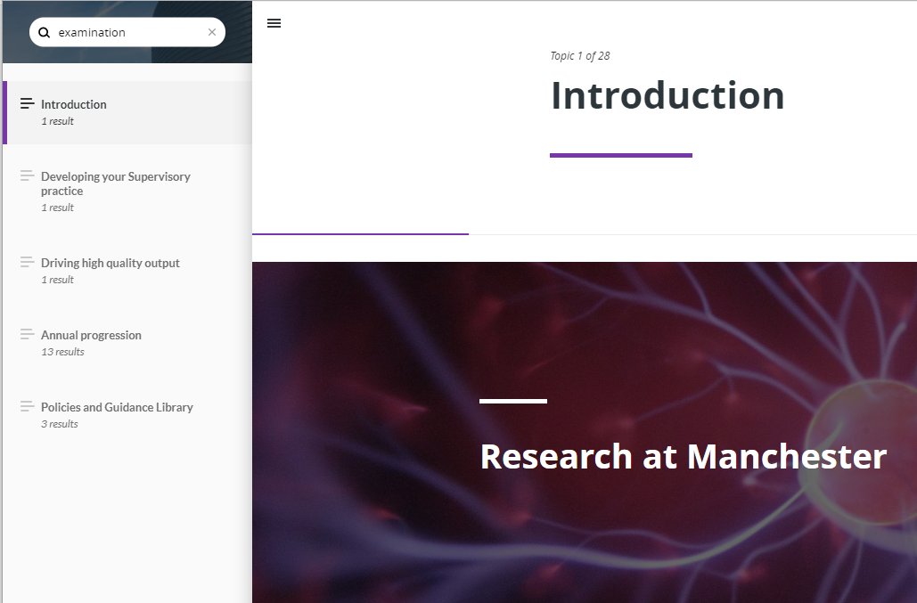
As you progress through the toolkit, the completion tracking circle icon will fill.

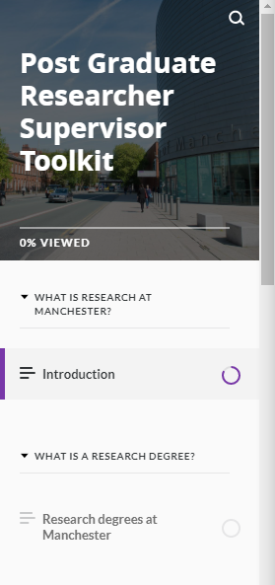
When you reach the end of a topic, if it is part of a section with multiple topics, you will need to click the button with the downward or upward facing arrow depending on if you are navigating forwards or backwards in the toolkit.

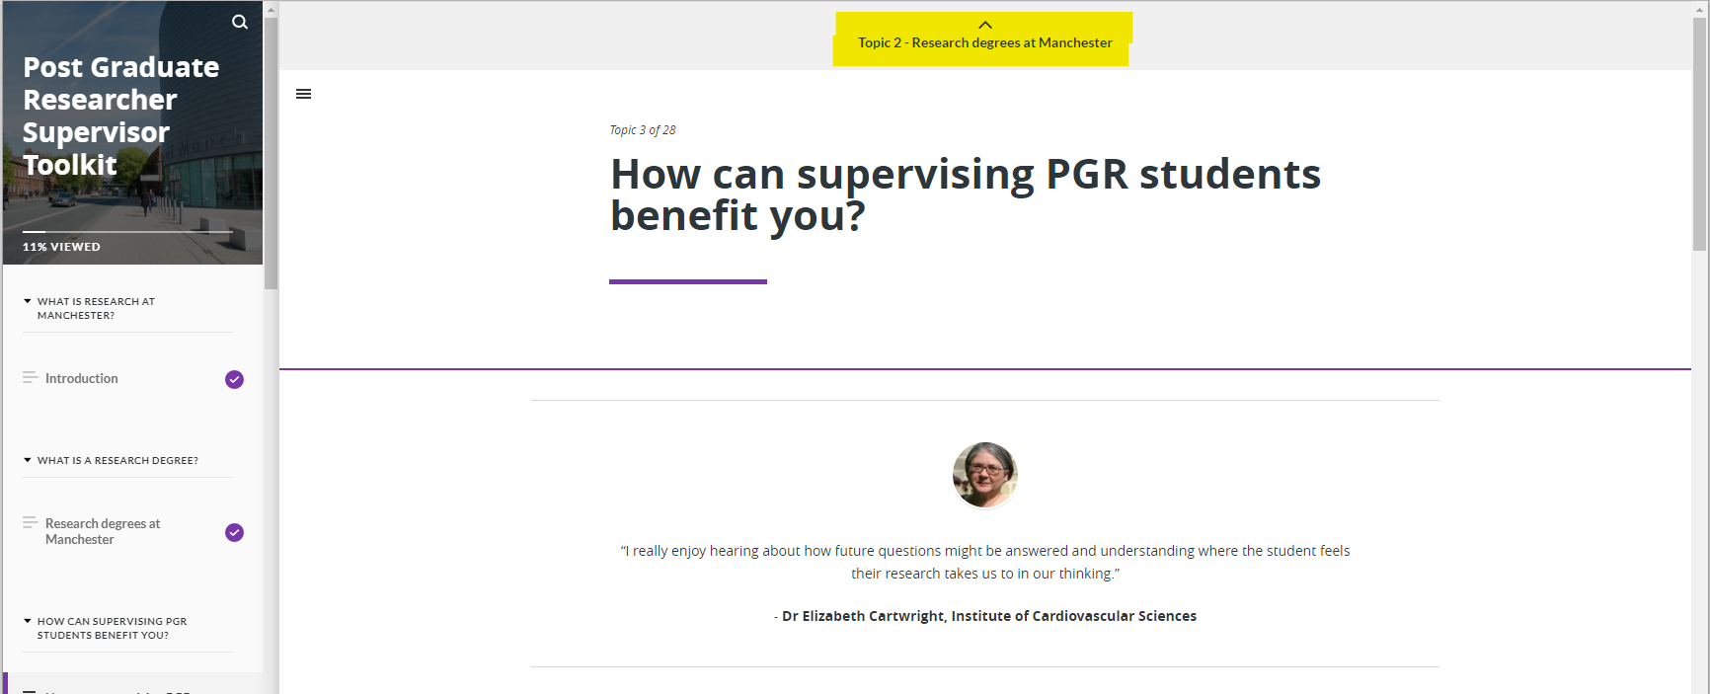
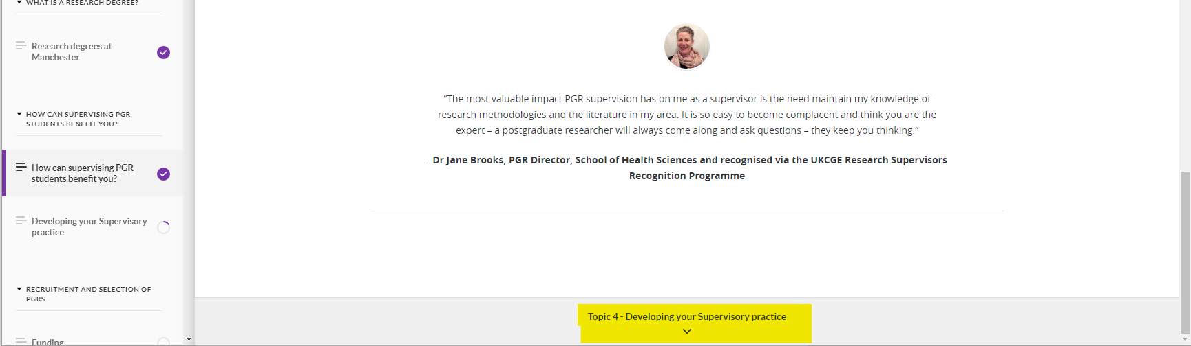
If you have reached the end of a section, you will need to click the purple button with the name of the next section on it.
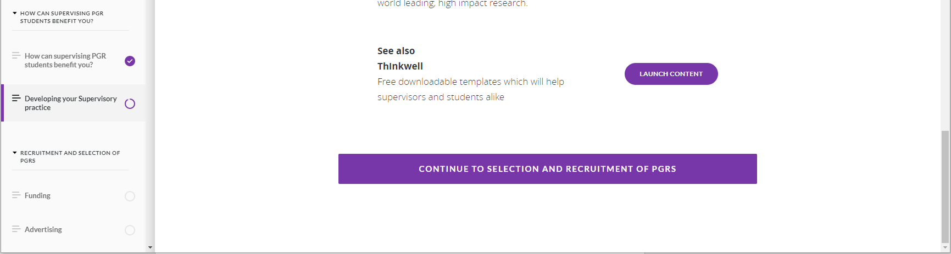
You will see links out to external content frequently throughout the toolkit. These will open a new window for you to view the website, document or content separately. You will need to switch windows back to the toolkit to continue using it.
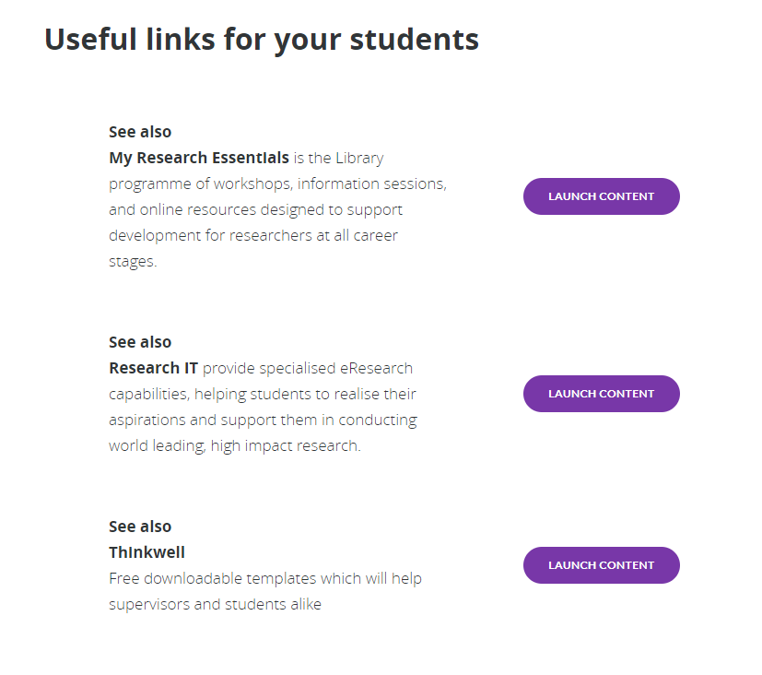

There are also internal links in the toolkit. These will take you to a different section of the toolkit to see related content and will not open a new window.

There are a variety of assets and different methods of displaying information used in the toolkit. They are all designed to be intuitive to use.
Once you have finished using the toolkit, simply close the window using the x button.

For any help and support with the toolkit please contact staffLD@manchester.ac.uk

