

Structural | Civil | Geo-Environmental

Jodrell Bank Site Drainage
June 2013

Jodrell Bank, Drainage Quality Management

Quality Management

Job No | ZMCR/SS/018706 | Client | Manchester University
Title | Report on Tower Surveys Drainage Survey
Project | Jodrell Bank
Location | Bomish Lane,
Document Ref | SS/18706 | Issue / Revision | V1.0
File reference | P:\SS018706 Jodrell Bank Drainage Surveys\ Reports\
Date | June 2013
Prepared by | S. Holt | Signature (for file) | 
Checked by | J. Smith | Signature (for file)
Authorised by | J. Smith | Signature (for file)

This document has been prepared by Capita Symonds (Structures) Ltd (“CSS”) for the titled project (or named part thereof) and should not be relied upon or used for any other project without prior written authorization being obtained from CSS. CSS accepts no responsibility or liability for the consequences of the use of this document, wholly or in part, for any other purpose than that for which it was commissioned. Any persons so using or relying upon this document for such other purpose do so at their own risk.
This report was prepared for the sole use of the Client named above, and shall not be relied upon or transferred to any other party without the express written authorisation of CSS. It may contain material subject to copyright or obtained subject to license; unauthorised copying of this report will be in breach of copyright/license.
The findings and opinions provided in this document are given in good faith and are subject to the limitations and constraints imposed by the methods and information sources described in this report. Factual information, including, where stated, a visual inspection of the site, has been obtained from a variety of sources. CSS assumes the third party data to be reliable, but has not independently confirmed this; therefore, CSS cannot and does not guarantee the authenticity or reliability of third party information it has relied upon.
The findings and opinions presented in this report are relevant to the dates when the assessment was undertaken, but should not necessarily be relied upon to represent conditions at a substantially later date. Further information, ground investigation, construction activities, change of site use, or the passage of time may reveal conditions that were not indicated in the data presented and therefore could not have been considered in the preparation of the report. Where such information might impact upon stated opinions, CSS reserves the right to modify the opinions expressed in this report. Where opinions expressed in this report are based on current available guidelines and legislation, no liability can be accepted by CSS for the effects of any future changes to such guidelines and legislation.
The limitations of liability of CSS for the contents of this document have been agreed with the Client, as set out in the terms and conditions of offer and related contract documentation.

Revision Status / History

Rev | Date | Issue / Purpose/ Comment | Prepared | Checked | Authorised
A | Nov. 2013 | Additional survey data | S. Holt

Jodrell Bank Drainage Survey June 2013
Contents

Contents
- Introduction 1
  - Appointment and scope of service provision 1
- Existing Drainage System 2
  - Surface water drainage 2
  - Foul drainage 6
- Drainage defects and proposed remediation 8
  - Table of defects 8
  - Summary of major defects 9
- Drainage ditches and ponds 11
  - Condition summary 11
  - Summary of major defects 11
- Conclusions and Recommendations 12

Appendices

Appendix A Existing Drainage Layout Drawings and Proposed Remedial works.Drawings SS018706/200-209

Jodrell Bank Drainage Surveys June 2013
1/ Introduction

- Introduction
  - Appointment
    - Capita Property and Infrastructure Ltd has been appointed by Manchester University to commission and supervise a drainage investigation survey of all existing drainage within the Jodrell Bank site boundary. This report summarises the findings of the survey work undertaken by Tower Surveys Ltd. in April/May 2013 and additional survey work undertaken in October 2013 and outlines recommendations and costings for remedial works required.

Jodrell Bank Drainage Surveys June 2013
2/ Existing Drainage System

- Existing Drainage System
  - Surface Water Drainage

    - Surface water drainage from the site discharges to a number of drainage ditches and ponds to the site periphery which carry water away from the site. Ground conditions at the site are generally unsuitable for soakaways to function. Piped drainage from hardstanding and roof areas are directed towards the various ponds and ditches. The main drainage outfall locations and the areas of the site which are served by these can be summarised below:
    - Bomish Lane entrance area.

A 225mm square brickwork surface water drain is located flowing north from manhole MH1 which is located within the eastern verge of the entrance road. The outfall route downstream of this manhole was found to discharge towards the Network Rail compound and railway. It is assumed that this drain connects to existing drainage within Network Rail land and then into the trackside drainage. The cctv survey was abandoned 15 metres downstream of MH1 due to an intruding connection into the channel but flows were running freely and in the direction of the railway cutting. Land drainage from the field to the east of the entrance road also connects to this manhole. A road gully to the west of MH1 discharges directly to the adjacent pond.
    - Planet Pavilion area.

The café roof and the car park area drainage, together with treated effluent from the Planet Pavilion sewage treatment plant discharges to the drainage ditch to the rear of the building. The drainage ditch flows in a westerly direction to the corner of the field/ hedge where a 225mm diameter pipe then connects via a junction to a 300mm diameter surface water drain which runs in a southerly direction adjacent to the main access road to the east of the telescope control building as described in 2.1.4 below.
    - Discovery Centre and Control Building Area.

Drainage from this area discharges into a 300mm diameter surface water sewer which flows in a southerly direction within and adjacent to the main access road to the control building. The sewer appears to originate at an open ended 300mm diameter pipe in a shallow depression at the southern end of the traffic island to the north of the Planet Pavilion bike shed and bin store. Flows are intercepted from the Planet Pavilion building and car park via a 225mm diameter junction connection as described in 2.1.3 above. Further south, surface water drainage from the Space Pavilion and main control building connect to the 300mm diameter sewer. Further south the pipe discharges into a ditch to the south of Old Moon Hut and adjacent to the former Wardle Hut. The ditch runs south along the field and site boundary to a point to the south west of the Old Observatory Store building where it meets with a ditch flowing north along the field and site boundary. At this ditch junction flows are piped in a south westerly direction across the field for approximately 70 metres where it emerges as a tributary of Crow Brook flowing in a south westerly direction.

Jodrell Bank Drainage Surveys June 2013
2/ Existing Drainage System

    - Lovell Telescope area.

Drainage from under the telescope footprint discharges via an oil interceptor at MH83 into a pond to the west of the telescope within a heavily wooded area. A 225mm diameter outlet from the pond runs in a north westerly direction to a catchpit chamber MH96 located directly under the boundary barbed wire fence. The 300mm diameter outlet from this chamber, which is at a depth of 2.5 metres, flows in a north westerly across the adjacent field. Due to the heavily overgrown nature of this area it proved largely inaccessible for jetting and surveying equipment to establish the precise outfall route across the field and dye testing also proved inconclusive. No suitably sized outfall pipes were noted within the ponds in the adjacent field and it would appear that levels of the respective ponds and the depth of the outfall pipe at MH96 make this point of outfall unlikely. The conclusion is that the outfall from this area runs across the field towards the railway which is in a deep cutting through this area and most likely connects to the railway trackside drainage system beyond the field boundary.
    - North of Lovell Telescope area.

Drainage in this area discharges to the fire pond located to the west of the Planet Pavilion and the Control Building access road. A septic tank and associated pumping chamber at MH94 & 95 discharges treated effluent to the fire pond via a 300mm diameter outfall pipe. The septic tank predominantly served the former Planetarium and Science Centre which was located in this area. The pump and tank appear to be serviceable. A number of redundant drainage runs are also present in this area which should be formally abandoned.
The other main inlet to the fire pond is from the ditch to the east via a 300mm pipe under the control building access road. The pipe inlet under the road is located within the same shallow depression at the southern end of the traffic island as the head of the 300mm surface water system which flows south as described in 2.14. It would appear that this pipe may be linked to an outfall from the pond within the traffic island directly to the north although this was unable to be proved conclusively. To the north west of the pond within the traffic island, a drainage ditch originates at the western site boundary where the main site access road from Bomish Lane divides into a one way system. The ditch flows in a southerly direction and receives incoming flows from another ditch which runs in a westerly direction along the northern field boundary with the arboretum and northern end of the visitor’s car park and is piped under the access roads (outlets 2 & 3, survey sections 197 & 198) to this ditch. The southerly outfall from this ditch (outlet 1, survey section 196) is a 300mm diameter pipe which was surveyed for a distance of approximately 20m downstream (as it was not possible to survey further due to a change in pipe material and possible buried chamber) in the direction of the pond within the island. No inlet or outlet to the pond was visible although these may be buried within the extensive undergrowth and tree roots. Alternatively the pipe may bypass the pond and connect directly to the depression at the south end of the island. It would appear that exposing the pipework within the island area may be the only way to conclusively prove the connectivity in this area although it would appear that this area ultimately discharges to the fire pond.

Jodrell Bank Drainage Surveys June 2013
2/ Existing Drainage System

    - SKA Building

The majority of drainage from this area discharges to the attenuation pond to the south east of the building. The outfall from the pond connects to the existing 300mm diameter sewer which serves the Control Building area just to the north of the old Radiant building/archive store at MH107 as described in 2.14. Drainage from the north western area of the building discharges to a local soakaway. The area of car parking and highway in the area of the mini roundabout which connects the SKA building and the southern end of the Control building discharges to a depression within the wooded area to the north east of this area with an open 100mm diameter outfall pipe from manhole MH24.
    - MSC Control Building

Roof drainage from these buildings discharges to a surface water sewer to the rear (north) of these buildings which flows in a westerly direction to connect to the main 300mm surface water sewer at manhole MH106 as described in 2.14.
    - Mechanical and Electrical Workshops

Surface water drainage serving this area discharges to a surface water sewer which runs in a southerly direction to the east of the buildings and outfalls to a pond to the south of the Electrical Workshop building. A series of ponds and interlinking ditches are located within this wooded area. A 150mm diameter piped outfall from the most easterly pond takes flow through a stone filter bed and then in a due easterly direction via manholes MH101, 102, 103 & 104 off site. The outfall route from MH104 at the site boundary and field corner adjacent to the track from the vehicle shed is a 150mm diameter pipe which heads across the field in an easterly direction towards Beech Tree Farm buildings and the Highway garage on the A535. It is assumed that the drainage ultimately discharges to a tributary of Dingle Brook in fields to the east of the A535. The surveyed length of downstream pipework (47.5m) from MH104 off site exhibited root ingress at pipe joints which may compromise the capacity and efficiency of this outfall.
    - Mark II Telescope area.

The drainage system from the mark 2 telescope discharges to an interceptor at MH152 & 153 within the telescope compound. The 225mm diameter outfall from the interceptor discharges to a ditch to the north east of the Park Royal building which connects to the interlinking ponds which discharge as described in 2.1.9 above.
    - Power House, Vehicle shed, Telescope workshop and dormitory block areas.

Surface water drainage from the vehicle shed area runs in a northerly direction to an oil interceptor at MH67&68 prior to discharge via a 150mm diameter outfall to the interlinking ponds as described in 2.1.9 above. Foul drainage discharges to a septic tank and treated effluent is discharged via a pumping chamber (MH69) with a gravity connection to the existing 150mm pipe immediately downstream of manhole MH66. Manhole 66 appears to be redundant.
    - Jodrell Bank cottages.

Surface water drainage from these properties drains in a southerly direction towards the A535. The precise outfall route has not been verified due to a collapsed pipe downstream of MH99. These properties are presently abandoned and all drainage is presently assumed redundant.

Jodrell Bank Drainage Surveys June 2013
2/ Existing Drainage System

    - Arboretum area.

A number of ponds and drainage ditches are located within the arboretum area together with a system of land drains which generally discharge to and from the ponds. A number of the land drains and pond inlets and outlets could not be located on site due to vegetation and have been taken from existing record drawings held by the Arboretum gardener. The main drainage features and outfalls in this area can be summarised as follows:
      - A ditch runs along the north western boundary to the north of the existing Planet Pavilion car park. The ditch flows in a westerly direction and is culverted under the two access roads (outlets 2& 3) to join another ditch which runs parallel with the site entrance road along the western site boundary as described in 2.1.6.
      - Two main outfalls were identified from drainage ditches to the east of the arboretum. The northerly outfall takes flows from drainage ditches which run along the northern and western field boundary of the north easterly area of the arboretum. The ditch flows in an easterly direction to discharge via a 300m diameter pipe under the A535 to the south of the former Cheshire Hunt building which is presently derelict. The outfall is assumed to ultimately discharge to a tributary of Dingle Brook to the east of the A535.
      - The other outfall from the eastern area of the arboretum originates from a drainage ditch to the south of the large pond and bird watching hide. The ditch flows in an easterly direction with short pipe culverted sections beneath walkways to discharge via a 300mm diameter pipe under the A535 immediately to the north of Daisybank Farm. The outfall is assumed to ultimately discharge to a tributary of Dingle Brook to the east of the A535.
      - A further piped outfall to the east of the arboretum is indicated on the existing records from the pond in the south east. This is shown to discharge across the A535 between Daisybank Farm and Daisybank Cottage. No record of this could be located at the time of inspection.
      - Along the southern boundary of the arboretum a drainage ditch runs in an easterly direction along the field boundary in the direction of Daisy Bank Cottage but appears to have no positive outfall. Further to the south west a drainage ditch flows in a westerly direction to discharge into the ponds to the south east of the Planet Pavilion. Record drawings also show a system of land drains connecting to these but they were unable to be identified during the survey.
      - Inlets and outlets to the pond to the north east of the Planet Pavilion are indicated on the record drawings but could not be identified during the survey. The 150mm diameter pond outlet flows west across the Planet Pavilion car park to discharge to the north eastern area of the pond within the island to the west of the car park and was identified during the survey.

Jodrell Bank Drainage Surveys June 2013
2/ Existing Drainage System

  - Foul Drainage

    - Foul drainage from the various buildings around the site discharge to either local sewage treatment plants or septic tanks. The main foul drainage collection or treatment plant locations can be summarised below:
    - Planet Pavilion.

The Planet Pavilion is served by a packaged sewage treatment plant located to the rear of the building. Treated effluent discharges to the adjacent drainage ditch, as described in 2.1.13, under consent from the Environment Agency permit No.EPR/FP3822GN
    - Discovery Centre.

Foul drainage discharges to a ’Klargester’ sewage treatment plant located within the landscaped area to the east of the building and access road. Treated effluent connects to the adjacent 300mm surface water sewer which runs in a southerly direction as described in 2.1.4.
    - Control Building.

Foul drainage from the control building discharges to a septic tank at MH22 at the south eastern corner of the building. Treated effluent discharges via a 100mm outlet towards the adjacent wooded area adjacent to the oil tanks. The outfall pipe is in need of remediation due to tree roots and pipe fractures which require remediation. This restricted the extent of the survey possible to determine the precise outfall location.
    - North of Lovell Telescope area.

A septic tank and adjacent pump is located immediately by manhole MH93 as described in
2.1.6. The tank served the science centre and planetarium which were formerly located in this area. No foul drainage was found serving the buildings immediately to the north of the telescope. The septic tank and pump are believed to be serviceable and is annually serviced via a maintenance agreement. Treated effluent discharges to the adjacent fire pond as described in
2.1.6. The septic tank has consent from the Environment Agency under permit No.65/144.

    - SKA Building.

Foul drainage discharges to packaged sewage treatment plant located to the south east of the building and immediately to the north west of the attenuation pond. Treated effluent is discharged to an adjacent pump which in turn discharges the treated effluent to manhole MH72 to the east of the storage pond. This then connects to the main north-south 300mm diameter surface water sewer at MH107 to the north of the old radiant building as described in 2.1.4.
    - MSC Building.

A septic tank is indicated on existing record drawings to the east of the MSC building. The cover to the assumed tank could not be lifted during the drainage survey works. Treated effluent is assumed to discharge to the surface water drain to the rear of the MSC building which connects to the main 300mm surface water sewer at MH106.

Jodrell Bank Drainage Surveys June 2013
2/ Existing Drainage System

    - Mechanical and Electrical Workshops

A septic tank is indicated on existing record drawings to the south of the Electrical building. The tank and associated foul drainage from this building was not located in this location during the drainage survey works.
    - Power House, Vehicle shed, Telescope workshop and dormitory block areas.

A septic tank is located to the east of the power shed which serves foul drainage from the telescope work shed. The septic tank discharges to an adjacent pumping chamber at manhole MH69 which ultimately discharges treated effluent to the series of ponds and interlinking ditches to the north of the vehicle shed. The outfall route from the pump is described in 2.1.11.
    - Jodrell Bank cottages.

A septic tank is indicated on existing record drawings to the south west of No.2 cottage. No trace of this was found in the survey. The only foul drainage located in this area was manhole MH100 which was in poor condition and full of rubble and tree roots due to the derelict nature of this area of the site. The drainage in this area is considered abandoned.

Jodrell Bank Drainage Surveys June 2013
3/ Drainage Defects & Proposed Remediation
Works.

- Drainage Defects & Proposed Remediation Works.

  - Based on the Tower Surveys Drainage Report dated 29th April 2013 ref.R-N7549 and the further survey and jetting works undertaken in October 2013 which resolved a number of blockages and serviceability issues identified in the report the following lengths of structural and service defects have been identified as requiring remediation. Generally this has been based on deficiencies categorised as grade 4 & 5 within the report and the impact of the defect on the drainage network. Please refer to Capita drawings SS018706/201-209 illustrating the extent of the Jodrell Bank drainage network and which identifies the main defects which require attention as listed below.
  - Cost estimates for the remediation of each defect identified have been provided by Drain Alert Limited. Prior to remediation work it will generally be necessary to jet the line and remove any debris. After completion of the repair a cctv survey of the work would be undertaken. Typical current rates for this work are given below:
CCTV Survey - £675 full day, £436 half day, £293 min. 2 hours.

Jet Vac Unit (tanker) - £796 full day, £504 half day, £89.50 per ton tipping if necessary. Van Jetting - £664 full day, £374 half day, £235 minimum 2 hours.

Survey Section No. | Priority | Manhole Ref. | Defect | Comments/Proposed remediation and Cost Estimate
34 | 1 | MH18-MH150  300mm dia. | Tree roots 24-28m. | Remove tree roots and reline pipe locally with 300mm liner (£1400).  Remove slabs to MH150 and replace with new  cover & frame. (£450)
41 | 1 | MH22-d/stream 100mm dia. | Sewer broken 8.9m, tree roots 11m, survey abandoned 17m. (Septic tank outfall) | Remove roots and reline pipe with 17.2m 100 dia. CIPP liner (£1293). Trace outfall
60 | 2 | MH28-upstream B.100mm dia. | Buried manhole 4.4m | Expose buried manhole by hand excavation Survey manhole (£300)
116 | 1 | MH60-d/stream 100mm dia. | Partial collapse 1m | Repair on line to repair displaced pipework (£1160)
119 | 2 | MH61-d/stream 100mm dia. | Buried manhole 31.7m downstream | Expose buried manhole by hand excavation (£300).
120 | 2 | MH62-upstream A 100mm dia. | Tree roots 65% blockage 10.8m | Remove trees roots. Install local relining repair (£1285)
121 | 2 | MH62-MH63  100mm dia. | Mass roots 1.5m | Remove trees roots. Install local relining repair (£475)
134 | 2 | MH70-upstream  B. 100mm dia. | Tree roots 2.5m – 3.5m | Remove tree roots. Install local relining repair (£850)

Jodrell Bank Drainage Surveys June 2013
3/ Drainage Defects & Proposed Remediation
Works.

148 | 1 | MH83-pond outfall.  150mm dia. | Mass tree roots 2.4m | Remove tree roots. Install local relining repair (£890)
159 | 2 | MH92-upstream  A. 100mm dia. | Tree roots 27-31m | Remove tree roots. Install local relining repair (£1225)
172 | 1 | MH105-MH106  300mm dia. | Holes in sewer 3.2m & 4.2m. | Install 2No. 300m dia. patch liner repairs. (£1400)
174 | 1 | MH106-MH107  300mm dia. | Tree roots at joints 0-25m | Remove tree roots and install 300mm CIPP liner 0-25m (£4000)
175 | 1 | MH106-MH105  300mm dia. | Tree roots 2m. Buried manhole 36.8m | Remove tree roots. Install local relining repair (£800). Expose buried manhole raise to level and fit new cover & frame (£450).
177 | 1 | MH107 – outfall 300mm dia. | Tree roots 26.5m-73.9m. Sewer broken 84.7m-85.6m | Remove tree roots. Install local relining repair 26.5-73.9m (£7500).  Local repairs near outfall (£1400).
182 | 1 | MH65-MH66  150mm dia. | Tree roots 5.1m | Remove tree roots. Install local relining repair (£600)
183 | 2 | MH65 – pipe B 100mm dia. | Mass roots 25.3m | Remove tree roots. Install local relining repair (£475)
186 | 1 | MH150-MH18 | Tree roots 7.2m | Remove tree roots. Install local relining repair (£1400)
196 | 1 | Outlet 1- pond? | Unable to trace to possible Pond outfall | Expose pipe at end of survey in island and verify probable outfall to pond in traffic island (£600)
198 | 2 | Outlet 3 - ditch | Multiple fractures of 300mm pipe at inlet from ditch under entrance road. | Internal repair with high strength mortar (£450)

  - Summary of major defects

    - The main defect within the piped drainage system is ingress of tree roots. This restricts the capacity of the system and may lead to upstream flooding as a consequence. This is particularly apparent within the main 300mm diameter north – south surface water sewer system adjacent to the control building as described in 2.1.4. which serves the most populated areas of the site. Due to the presence of tree roots it has not been possible to survey the full extent of this system from the source upstream of manhole MH150 to the outfall to the ditch downstream of MH107. As a consequence it is highly likely that there is additional ingress of tree roots other than those defects identified in the table above.

    - The surface water sewer to the rear of the Mechanical and Electrical Workshop buildings also suffer from a similar problem.

    - A partially collapsed section of pipework was noted downstream of manhole MH60 to the east of the MSC building which requires repair.

    - The outfall from the septic tank and pump adjacent to the Power House building was found to suffer from tree root ingress between manhole MH65 & MH66 and requires remediation. Similarly

Jodrell Bank Drainage Surveys June 2013
3/ Drainage Defects & Proposed Remediation
Works.

the outfall from the septic tank serving the Control Building downstream of manhole MH22 also requires attention

    - The surface water outfall to the pond from the interceptor at manhole MH83 which serves the Lovell Telescope is also partially blocked with tree roots which require removal. The network of catchpits under the telescope footprint were found to be heavily silted during the initial inspection and have been jetted as part of the survey works.

    - Drainage from the Jodrell Bank cottages to the south of the site is assumed to be derelict and remediation is not required.

    - Manholes MH5, 6, 7 and upstream connection B from manhole MH93 all exhibited structural deficiencies. It is thought that this drainage is now redundant from former buildings in this area now demolished and can be capped off.

    - The precise route of the 300mm pipe from the ditch at Outlet 1 (survey section 196) and described in 2.1.6 was unable to be verified. It is likely that this discharges to the pond within the traffic island although due to heavy vegetation and significant silting of the ponding this could not be confirmed. It is suggested that exposing the top of the relatively shallow pipework within the island area may be the only way to confirm this.

3.3.8 The location of drainage defects highlighted in the table above are shown on the annotated Capita drawings SS018706/200-209 at Appendix A.

Jodrell Bank Drainage Surveys June 2013
4/ Drainage ditches and
ponds

- Drainage ditches and ponds
  - Condition Summary

    - Surface water drainage and treated effluent from sewage treatment plants and septic tanks discharge to a series of drainage ditches and ponds both within and outside the immediate site boundary. These convey surface water off the site at locations indicated on the drawings SS018706 at Appendix A and described in section 2.1 previously.
    - Drainage ditches and ponds require regular maintenance to ensure efficient discharge of water from site. Ditches require removal of leaves, twigs, litter and silt deposits together with ensuring that inlet and outfall pipes are not blocked or overgrown. Similarly ponds should not be allowed to silt up or inlets and outlets to become blocked or overgrown. Most of the ponds are located in heavily overgrown or wooded areas and as such suffer from a build up of decaying leaves and vegetation.
    - The condition of the majority of drainage ditches at the time of the drainage investigation were found to be in reasonable condition although the majority of the pipe inlets and outlets have no specific headwall structure and are invariably just an exposed pipe. It is important therefore that these are regularly maintained to remove any build –up of debris and siltation.
    - Much of the land drainage discharging to ponds within the Arboretum indicated on the drawings within Appendix A could not be located on site and were inaccessible to survey.

  - Summary of major defects and remedial works.

    - The series of interconnecting ponds and ditches which serve the Mechanical and Electrical Workshops and Vehicle shed areas are located within a heavily wooded and overgrown area and so the inlets and outlets are susceptible to blockage from leaves and undergrowth. The ponds are of shallow depth and exhibit signs of siltation. It is recommended that areas around the inlets and outlets should be cleared locally of vegetation and siltation to ensure that water flows away from the inlets. The ditches interlinking the ponds should also be cleared of debris and deepened locally as necessary to ensure a flow of water between the ponds. The outfall from MH63 to the pond to the south of the workshop building needs to be located and exposed. Prior to consideration of any major dredging or desilting works advice should be sought from an environmental and habitat specialist.

Jodrell Bank Drainage Surveys June 2013
4/ Drainage ditches and
ponds

    - The pond within the traffic island to the of the west of the Planet Pavilion car park is heavily silted and overgrown with tree roots and vegetation. The site survey has identified a possible inlet and outlet to this pond which it is has not been possible to verify due to the overgrown nature of this area. A 150mm diameter inlet from a land drain which flows across the car park from the arboretum area has been identified in the north eastern area of the pond. It has been recommended in 3.3.8 that the 300mm diameter pipe which appears to discharge to the pond is exposed to verify the line of pipe and identify the outfall location. Should the pipework be found to discharge to the pond it will be necessary to clear the area around the inlet to allow a free unrestricted discharge. A similar exercise should be undertaken to identify any outlet from the pond which possibly connects to the 300mm pipe under the access road which ultimately flows to the fire pond. It may be necessary to cut back some vegetation to achieve this although the pond would benefit greatly from the removal of silt and vegetation debris and cutting back of some of the trees.

Jodrell Bank Drainage Surveys June 2013
5/ Conclusions and Recommendations

- Conclusions and Recommendations
  - Overview
    - The current piped drainage system generally suffers from root ingress at pipe joints in the vicinity of woodland areas which is impeding the capacity of the system. Whilst the system is presently generally serviceable if the root ingress is left unchecked these will grow and ultimately completely block the drain and ultimately displace the pipework.
    - Root removal and local relining of the pipe is recommended in the most affected or critical areas as identified in Section 3. There may be additional lengths of remedial works required in areas where it has not been possible to survey the full length of pipework affected by root ingress in particular in the main 300mm diameter north/south surface water sewer.
    - Pipe inlet and outlets to drainage ditches and ponds generally do not have a designated headwall structure and are susceptible to blockage from leaves and debris. Regular maintenance checks are recommended to avoid localised flooding particularly in Autumn. Similarly drainage ditches require regular maintenance checks to remove debris and ensure a free flow of surface water.
    - Ponds are generally located within heavily wooded and overgrown areas and as such are susceptible to siltation and hence a loss in capacity by rotting leaves and vegetation. It is recommended that advice should be sought from an environmental specialist to locally clear and partially desilt or deepen these ponds in the future to prevent the risk of upstream flooding of the piped drainage system. The pond within the traffic island to the west of the visitors car park and the interconnecting ponds to the north of the vehicle shed area are those considered most in need of attention.
    - The drainage investigation undertaken by Tower Surveys and Capita located all the identifiable on-site drainage system and surveyed as much of the system as possible that was accessible. The Tower Surveys report includes a dvd and written report of all drainage runs surveyed, manhole record cards and photographs of all manholes and drawings R-N7549/301-324 show the overall network surveyed by them.
    - Drawing No. SS018706/200 in Appendix A shows the overall site drainage masterplan and the main surface water outfall routes off site. Larger scale 1:500 drawings are shown on drawings SS018706/201-209.
    - A schedule of defects and proposed remedial works are indicated in section 3. Areas of proposed remediation works are also highlighted on the drawings in Appendix A.

Jodrell Bank Drainage June 2013
Appendix A

Appendix A Layout drawings and defects

=- SS018706-201
SHEET 1
\  ''\ | SS018706-204  SHEET 4 O Q  r---------0----+

0

SS0! 8706-202
HEET 2

-:
n·
' -
-"t i :, ·
§ :' ' '
.. §· ' '
.'ii \D:
GENERAL NOTES
Do not scale from this drawing. Work from figured dimensions only. All dimensions are in millimetres u.n.o.

No devladon from the detalls shown on this drawing wlll be allowed without prior permission in writing.

All drawings are to be read in conjunction with all architects, engineers and specialist drawings and details.

SAFETY, HEALTH AND ENVIRONMENTAL INFORMATION
INADDITION TO THE HAZARDS/RISKS NORMALLY ASSOCIATED WITH TI-IE TYPES OF WORK DETAILED ON THIS DRAWING, NOTE THE FOL.LOWING
CONSTRUCTION

i _[=SS018706-203

;....

,·"' ...,...
.
·>. :
,'.,_'.--

r

....
' '.-

'I

,- I
---

-------

-------

----

MAINTENANCE I CLEANING

- Working In conftned spaces

''· ....
. ' .•
Jr--:.'-' -,

' ]J- -
1-- 1, , ,,
- Working with llve flows

S 018706-20Sl 1 SHEET 3
-- -ii
- ,'_,
"• -·')--·.
•'11, ·- -
- Contaminated materials

S_ EET 5
1( ' 1v•-:! ,., . '\\, ' '
• .;;r• • • '·, r I
J,"..'.r","" , -,-,,<r.... ,_,..._ , t I
; I '"'-,-,. ,:;- ,I '
... ' .• ' .11, .'.i·- ,
'1 , ...... \ \ •- -'- -
_ ; --- - )
--
-
L · ------
-.:-::;>;"l· ,,, , ----
' , '· r.
:::=. '- ----;,::

+ + + + + +
·' -

=
+ + +

+ +

+

-:::__

IT IS ASSUMED THAT ALL WORKS WILL BE CARRIED OUT BY A COMPETENT CONTRACTOR WORKING, WHERE APPROPRIATE, TO AN APPROVED METHOD STATEMENT

KEY
-8- -SURFACE WATER DRAINAGE
)
-f) FOUL DRAINAGE

vz:z:z:z:z1 DITCH / WATERCOURSE OR POND

'

'\,,
'',,,

•,,
SS018706-206

t
'

+ + + + t

DRAINAGE CHANNEL

G D ROAD GULLY
RWP RAINWATER PIPE

DR o DRAINAGE OUTLET

+ + + + t

UTL UTR

UNABLE TO LOCATE UNABLE TO RAISE COVER

+ + +
.
..
,,
+ +

SITE BOUNDARY

NOTE. TOPOGRAPHICAL SURVEY INFORMATION IS 13A002/001 & 002 DATED FEBRUARY 2013.

-+ + +
, -n,,- , 1 ,

-+ +
-

->;" .•
'
' -'

":"
:1i
'_, r,
''
1ft v
0

' '•i<<- _, ·' • '1ii1.
----

-+ + t

+
SS018706-207

,. ·' '
' ' '
'' '·' •· '· ·' ·A- '
... _,'
' ( -,- ' '(,
.. • ....L. . :.•r.;:c .,<;j ,:c----:-.;
, , ,

- ..;.;:,

- ,_
B----:

Updated with Tower Surveys

addad
routas

I. . I ' .!, !..•
-
A I 11·11-13 Isurvey data May & Oct. 2013 and I SH I JS

SHEET ?
+
, 1 < . -;li;j'r '· <I': '·'-":·'1"'-1"\ I
"·· .,,,. ,.,. '\•·'· · .• · !B ,,
proposed remedial works. Surface
I I ...,,,.b, I I

-- +- -:-:' ' ·l'}'.i· _.,;:.-;
....-. .,.... :. ···· .. ..· ·;. _' ');
'·',"•
·y:'"l'r- ' # 1 - .
:(j
--= ...-.-;: t .,..
-- --- - -·- -
SS018706-208
...,
Client:
Date
water outfall
By Checked

-t t t
••. ---:, , 1- r ==-rLr N--
•. ,, .•·@ .i... "
-,,. -,:;
r ·" ..._.,.. •:- :-
SHEET S
UNIVERSITY OF MANCHESTER

Project:

= ---r"·
.
----------

•

=' _,

Tille:
JODRELL BANK

c:i
CJ
D C::i
/ '
'
=
;•I

..-

"
"=
''

-·'
•

_,•·
•'
•
,_,
OVERALL SITE DRAINAGE LAYOUT

CAPITA SYMON DS
STRUCTURES

COnsuHing
Civil,Sb'uctural & Geo-Environmental Engineers

' MANCHESTER Offices also at:

""'"":
Clemence House, 9 Mellor Road Cheadle Hulme, Cheshire, SKB SAT Tel: (+44) 0161 486 1521
"Lo"o"d"o'o
Wa....
Cambridge She!Held

SS018706-209
Fax: (+44) 0161 486 1580
E-rnal: aipdl.-lllQcapltll.a>.uk
Special Projects: Cheacl le Hulme

SHEET 9

· - · .« -··-'"'...-....;; rl
www.cepltesymonds.co.ukl&tructures
o.....,.,at Dole

- - --.
"'-­
MANCHESTER March 2013
@ A1 1:2500 @ A1 °""" SH Checked JS

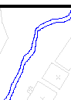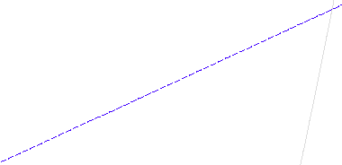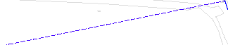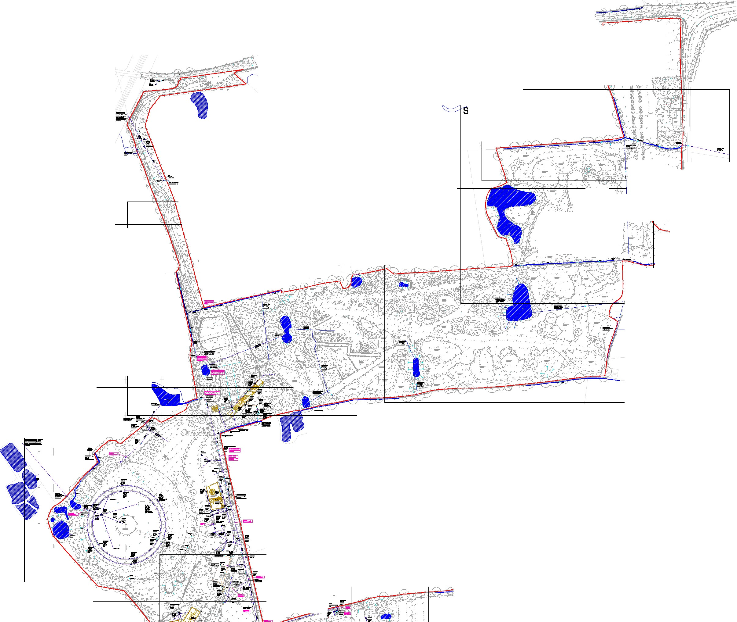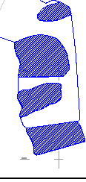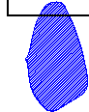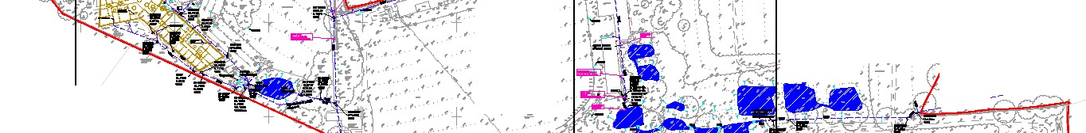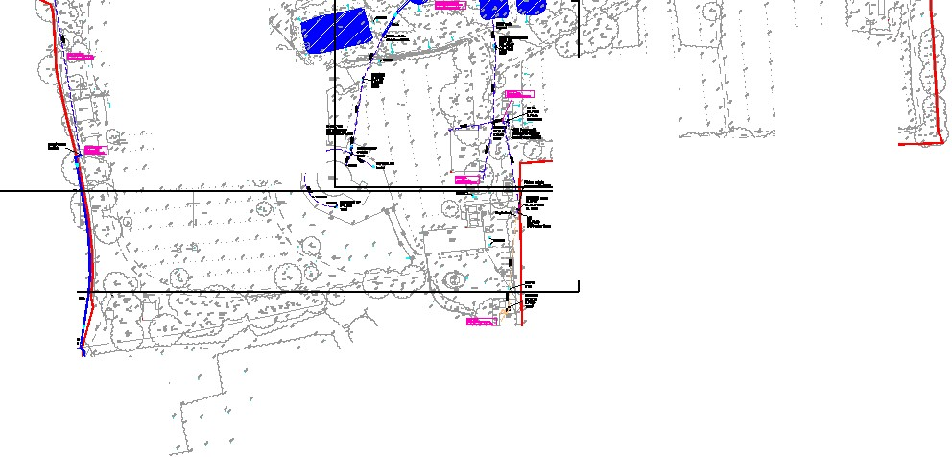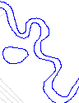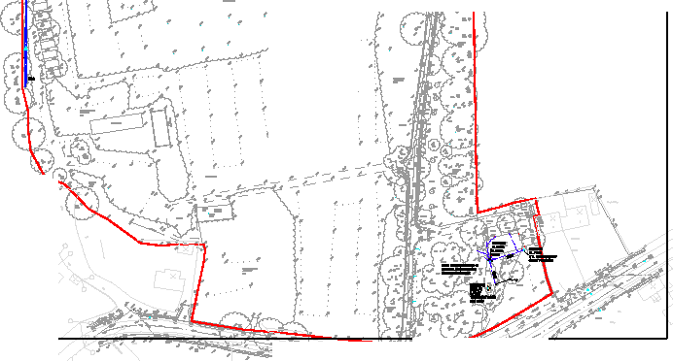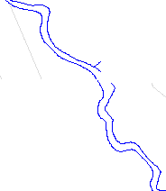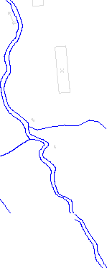Project No.: Drawing No.:
SS018709 200
Revision:
A

... :
..
:
/
..
.. i._ I

: '
:
... /
:

....

••
, .•

'• i
I

I...
I
I

...
I

I,...
I

... I
:
,'>,,

: i
: :
i

I i
....•
i
!...

i
!....
:
I

;'-
... .I....
...
I
J..
...
!:\·.
,. \
•
'
••

••.,

....

..

...

...

...
...

i..i

.... ...

...

....... ....
..
.. ...
••••
-/1 •·,.
.
•,.,. • .,.

.....

.. ....0..

V'l

c...
0
0
:m:0
r
c "'t-t---1---J
m<
z

0
11

cii: c: "
"'C
D a

I
I
••""
Gl

" D I I I I I
"
I
-

I
6. cpI
I

0
m
0 z
0s: -I
m
s:
en
z
en 0
-
0z m
-
z 0
G) r
0
m

G')
m z m

r
z
0
-I
en

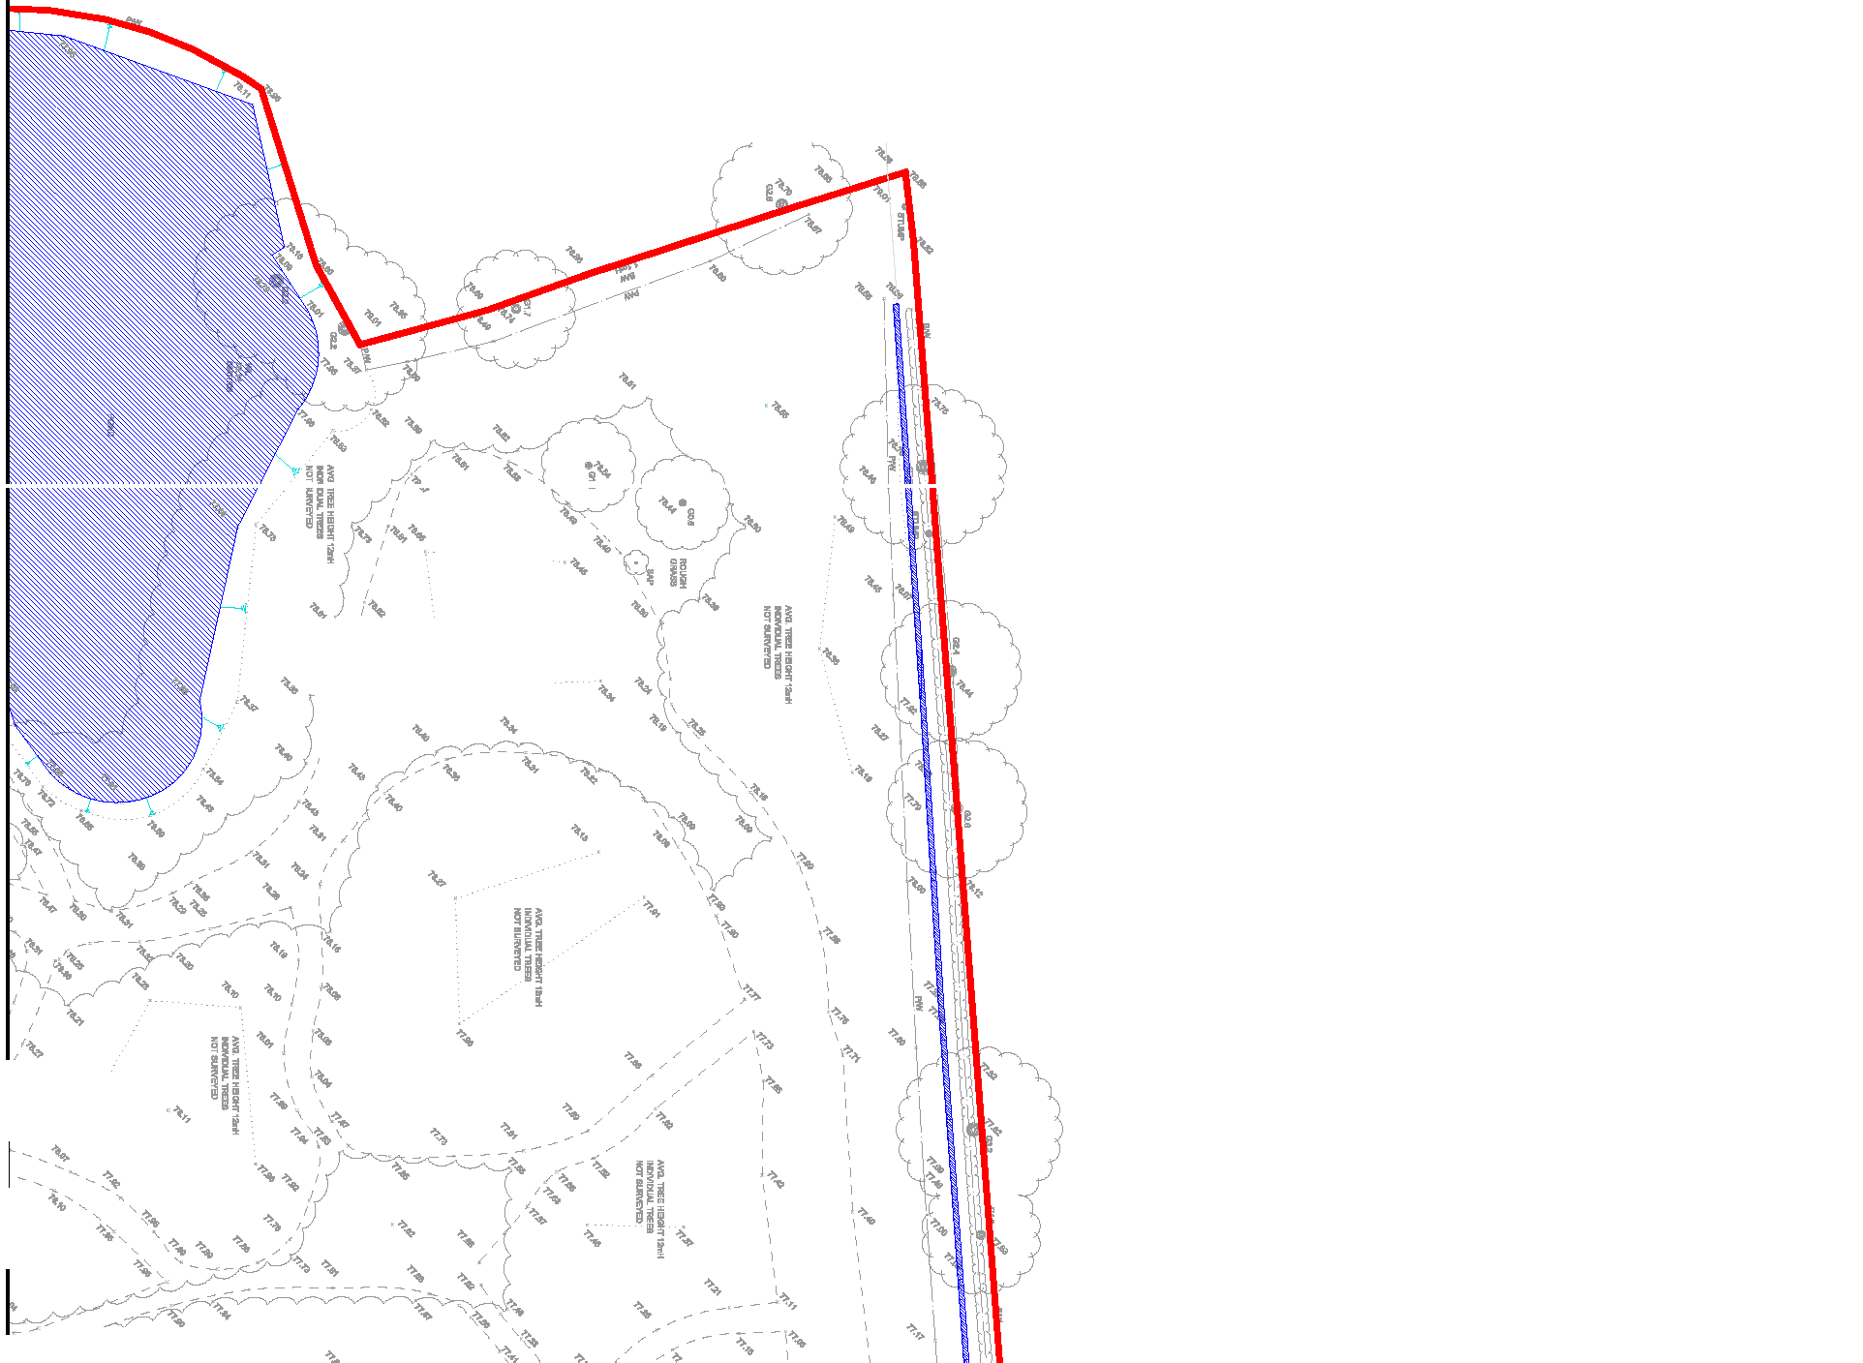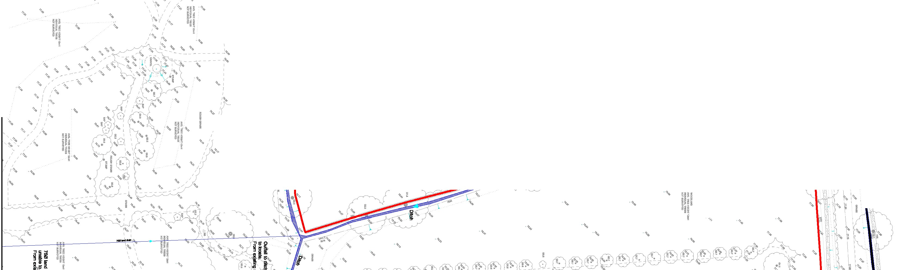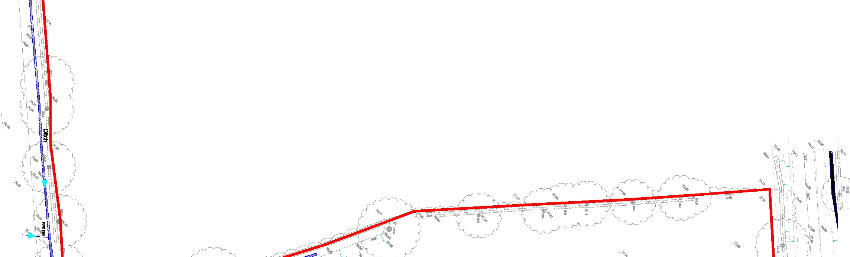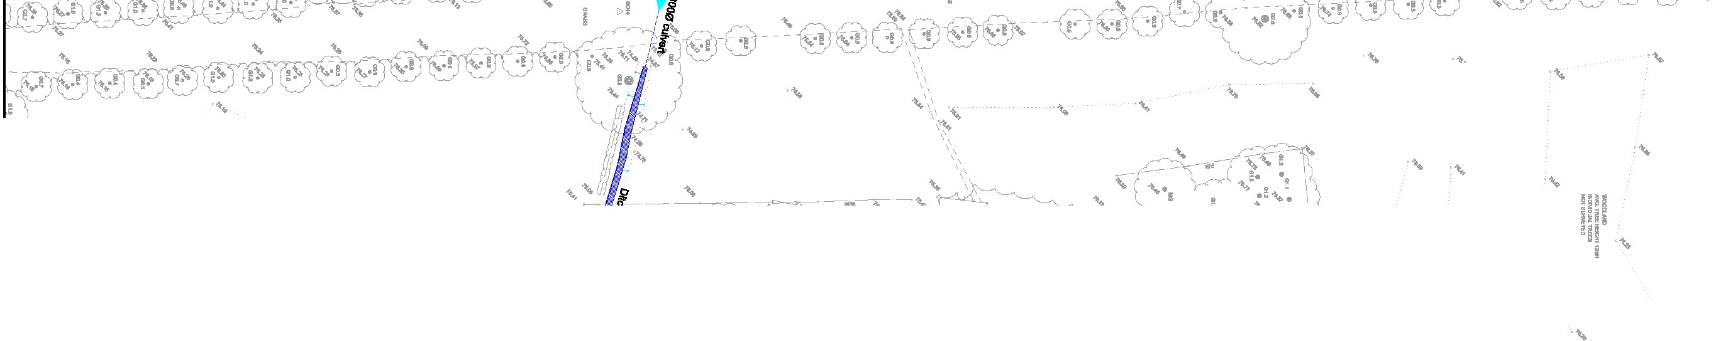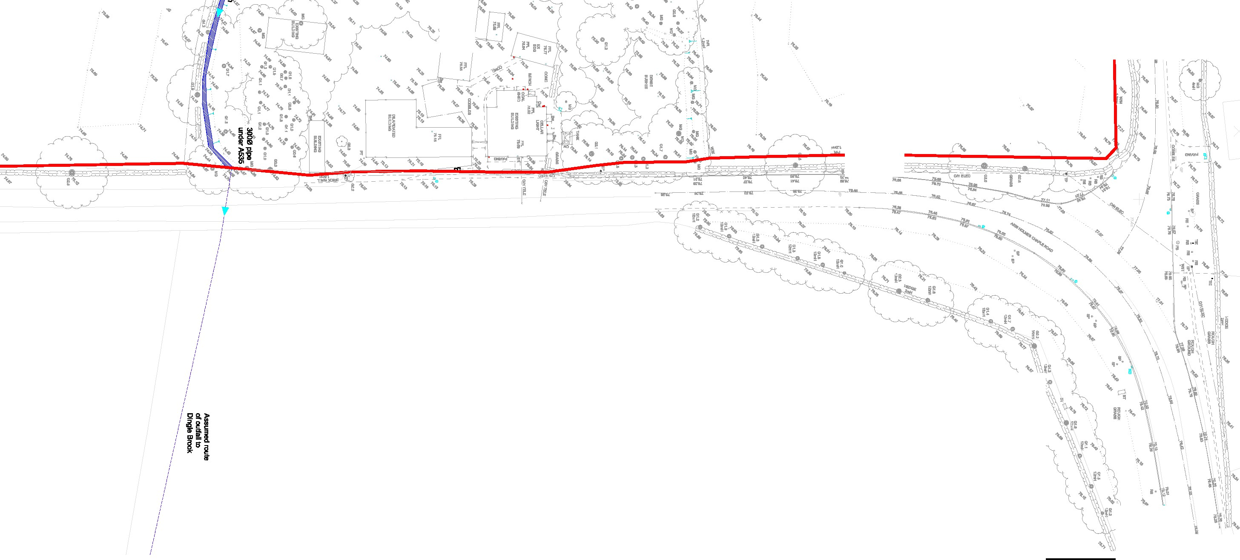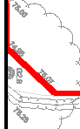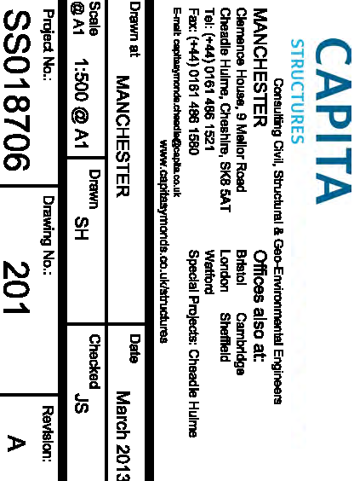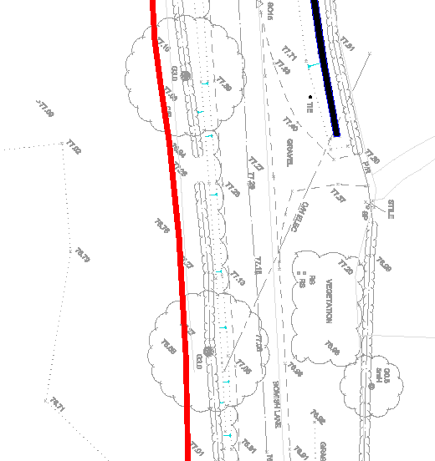-s<::
0z
c
V'l
r

z
::l\
z
()
I
m
m
:;o

en
:i:
Gl a;
i;; m
!( "
z
J!!

c:
8
ill
m

"
m
s: z
0 G)
r
:::!
0z

-:-•
0 ..
'I
..
i •
',

,' .... ...
' :
I Ill "
-•-
'
..
../

.. I
'
I

',..
'' ....
,',
.. ..
I
i
.
,

I !
I
·i1
·...\
, I
i
!"!\ ! i
I'I" .
..

'
'
,..

,,
0
!
...
I
' r ..
!
I

...

'
..
,\,

.. -....
..

- - - - - -'I; - - -..
...

'
'
,'..
...
...

... I

•••
'.... '
•• ' .

I ..

I
'
'
'
- - -"\
',°
i ..
i

,..

.., ',
,' .. ''
'
' '
' ,
.. ' .....-,
,'
..
I' '
I

- 'f
..

...
' i,
'
'

...
'"

,..
,..,

i,.. ...

,..

•'lo.

'\,. '
'
'
''
' '..
' ..
'
'I
'' '
,.._

•'lo.

... ..

',•.
'

'',•.
'
'
••••

'\. . •••
...,
!'i o !
'•
...
- ••- - - - - _ ,_0
.
- -..
•
-••
•• •• 0
\I. '

••• ...

•• ••
I

'',.. '

' ..
•
'
.'' ''
,.. '

I ...
.
,.
•.'',
' '
.•I '
' '
? I '
'
••'
. ,.
... ..
'' "

•1i
.1•I
i'..
•• i
i
...
'
·-.. .. I ..
i '
' i

..
••• ,
•
•
...

',
..
I
I ..'
,'
'
.. '
,\.

·•• i

.•...'
'
'
'
'
.. ,.•
••
'
I '
'" ..I '
'
' ...
'
...

j

i •
'
•• I I
'
i
0
I
"' •
'

••
I _
•• '•
•-•- - - - - - - - - - -

,.. ''lo. ...
...

i '
"·
':\.
i

...
'
.. ,:.-..
..
,'
I

...

..
..

....

...

....
..

,._

i
i

... ...

,..

....
.'-

- I

....
'

•
... ...

,.._
'•
...

,._

....

...
... ,,
..

!/

': -- "' ' · . - ii.
S:,i .

'
'
'
\\,
'''
''' ''
'
'
'\
!;;! 2. \
:::i olIS '\
f B' a \
.... It \

'''
'''
'''
\,\

''' I
''' I
'''
'''
''' ''
\,\,
'
 |  | c....  0 | c  z  <m |  | > |  | !il  0 | Gl  D  Gl c: r  !( | I  I  •l"  I I I I I  "  0  z  J!! | I  6. qI:i  I  "c:'  "'  "'  z  i1i  m |  | 0m  0  0s:  s: en en  0  z  -z  G)  0  m  s:  0  r-  -1  0  z | z  -mI  z  0-m  0  r-  z  G) | 0 | m  ;c en  0z>-,,  s: m  mz _::;!  :;! ::c  r- m  ->  z  -,, ::c  o;c >z  o  z | G')  m z m  r  z  0  -mI  en
 |  | 0
 |  | m::0  r r | 0  11
 |  | z  ;;ii;:; | z  ()  :c
 |  | z  ;;ii;:; | m
 |  | z  ;;ii;:; | m
 |  | z  ;;ii;:; | ;:o

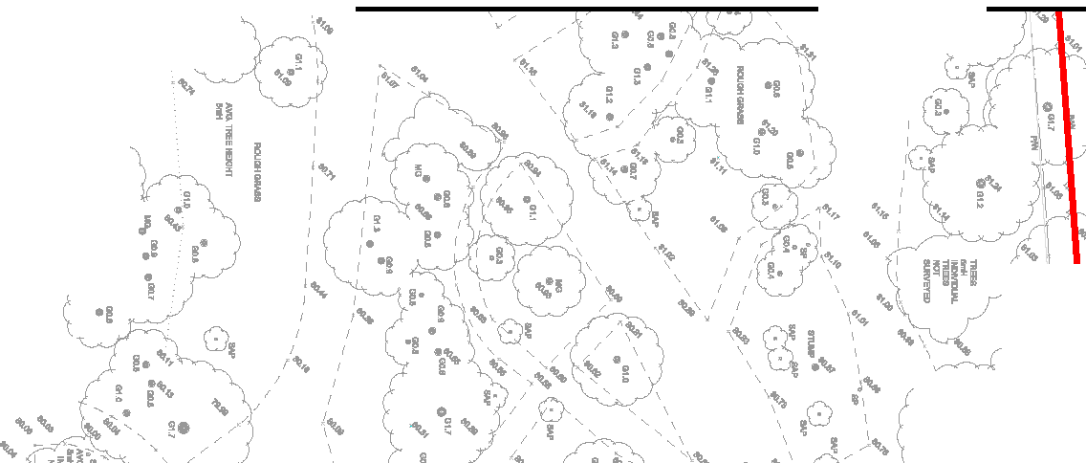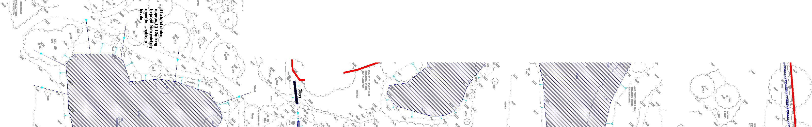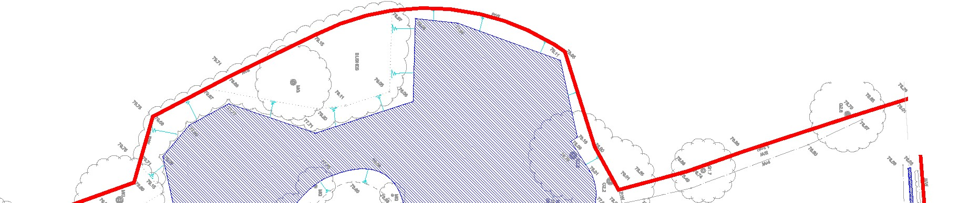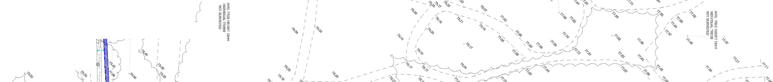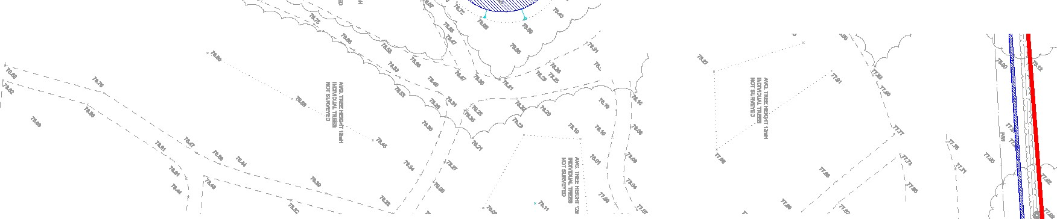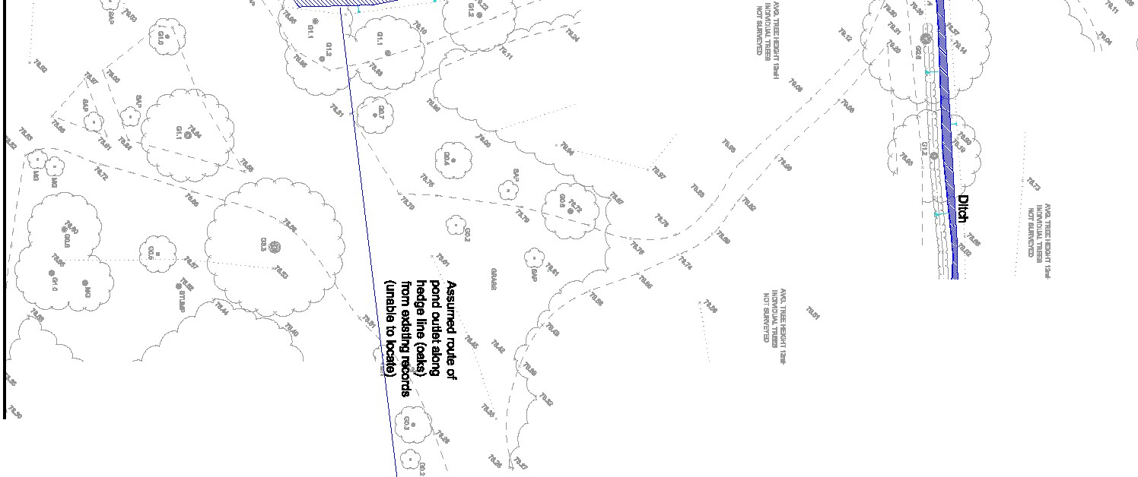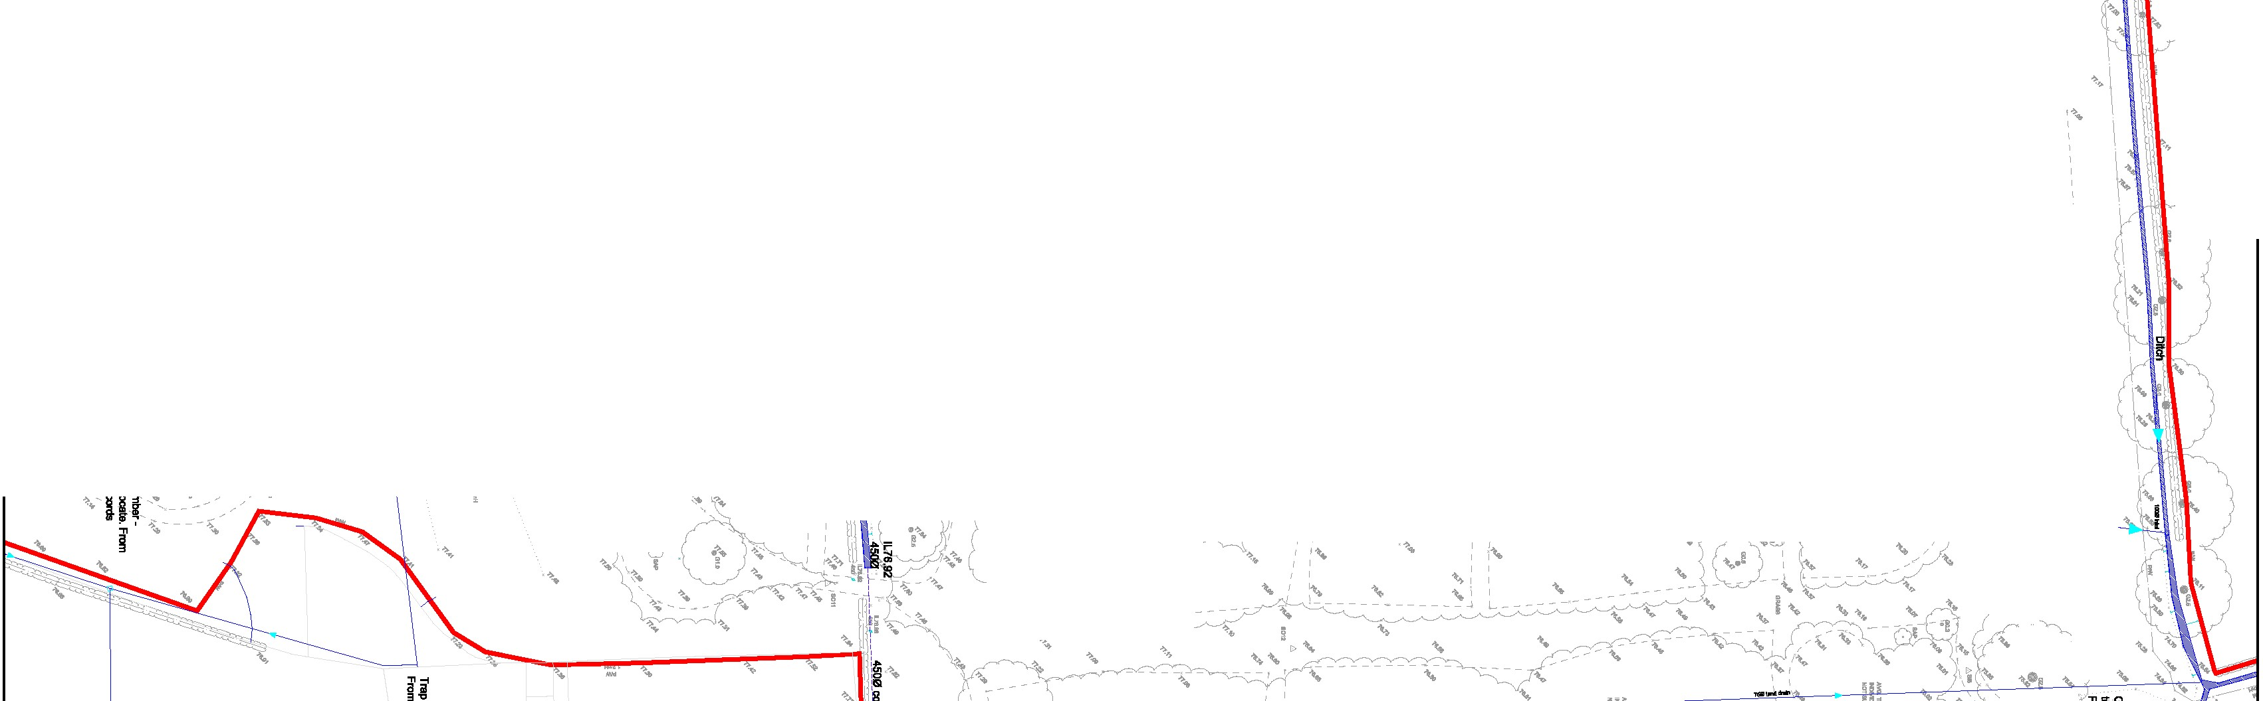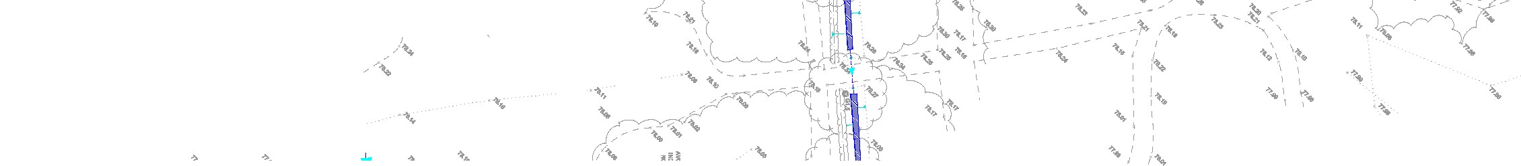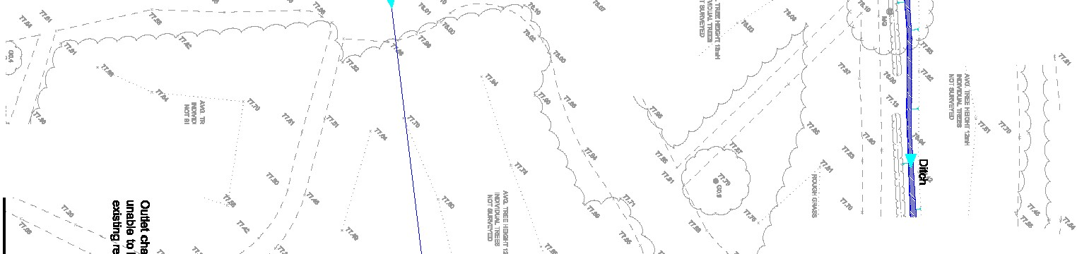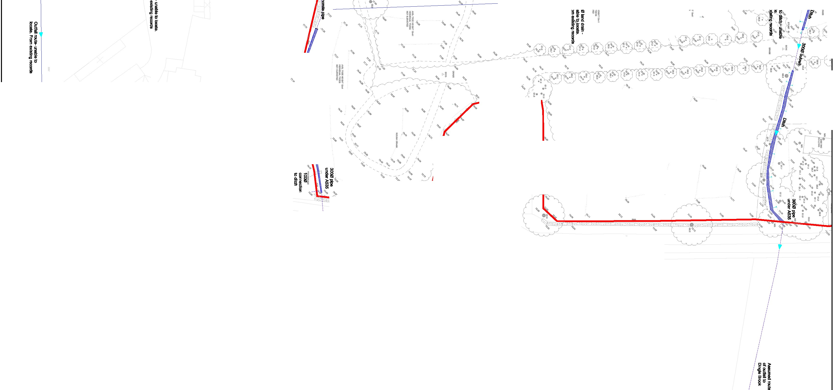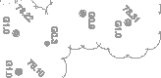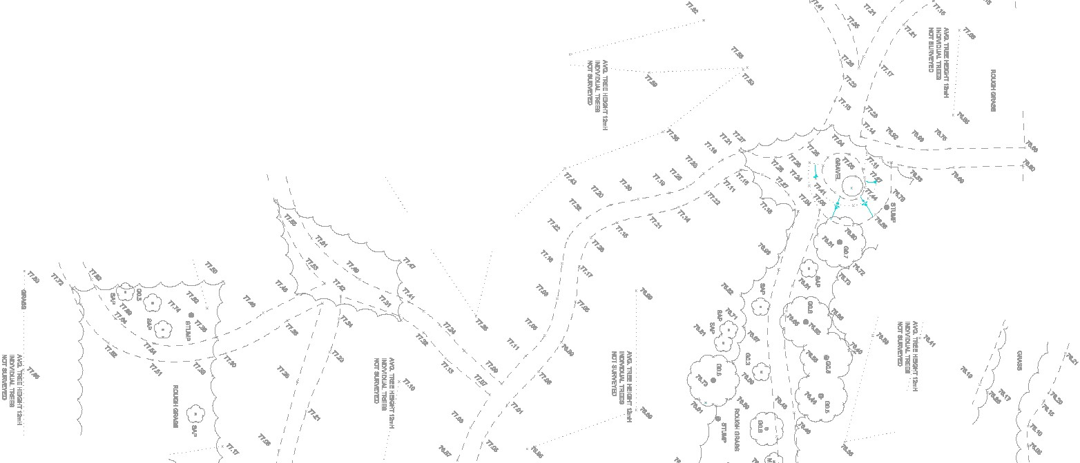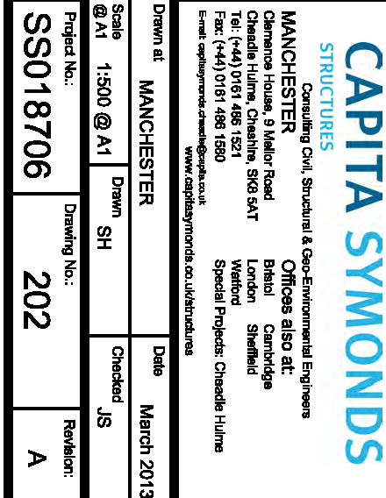

.. .. ..
.. },='.,P H

I ' 11(!. I
· ..
'
I·NO. 1"EEH-ll<ilfr1- .. ..
/ I <-fl" - - --..(.<_
.
,.

GENERAL NOTES

,,_
I I , '
'
/
_4;' ..'
'4' 14'•
I
I.(<'t /
I I ;
.

·- -
1..,...""""""
..
......_TREEIEW!T t­ I
l•l2VIO""'- 1REEll I I
..
-- - I ' ·<-"
,.,! {I I " "'

"' '·-I'

..
Nm"&u_,..o
..I I
I I
I 1.o
.. : ·

..
-t-.f '
.(< ,I'./ .\ \ -.
'

- - f. i', 'I
Do not scale from this drawing. Work from figured
dimensions only. All dimensions are in millimetres u.n.o.

;
I I ..
/ x \ -
..
- - - · - - -!_ _

' ' '
' '
§_! .. ...

-, - - - 0 ·, ..
..
' ' / '
.- - - - - - -
\ ' '
.. ....-
deta.lls shown
allowed without prior permission in writing.
drawing

/">':.- --z_JI _ -l_ _ _ -""./"m-'--i......., '',
', f- - <'- - - - -•! - - 'T• r '
I
I I
<-"
- 8
- - - - -1 •.,.,,
No devladon from the
on this
wlll be

·"' ,. v .• ' "') '
.. # I # {
I
<-"
·
<-"
'I ' \ -.,. (-!. :

../ I
I I
I ,( _. - f

..
, All
drawings
are to be read in
conjuncti
on with all architects,

- "• .4' #'
...
•!' II _ _
-
4'4' <'
I I
:
engineers and specialist drawings and details.
o-
\
--

1
/ ' I
#) (,'#
'I 1<'
/ '
I ,f #
/ ! J
..-
I

- -
- I I
'4.'. --

- - - -......_
,, <-' \ \('.,
<' !J """'"I I
<'1' I I
0 -0,'.,I..
",.I

.(:..,
,('
.. •
!<-.,.
I

'I
4'. \ ' - # - 4"'-' ,,
..
.. .. .. '
I I ·) I I
I
'
..
..
I
I
__
I
'
'
)<-"f'! I I
SAFETY, HEALTH AND
..

,/'/ I I
\
# \ - ... - - - - - - - - - -.... t.'I: fl'
""" .().. /fl'
ENVIRONMENTAL INFORMATION
INADDITION TO THE HAZARDS/RISKS NORMALLY ASSOCIATED WITH TI-IE TYPES OF WORK DETAILED ON THIS DRAWING, NOTE THE FOLLOWING

.!4'"'
I I j I
\ 4'• # <-"' - ,..... -.. s."_ -"' . <-

.. I I·
..
..
..'
. ..- ..

:..
#'I 1.•
I
I
I
I
,
....._TREE llEIOHT Ul!ft
' <-" I - -·- - -!<1' '
'
1# 4'" <-.,.
' I
'
AW.
'rRE• HEMIT12111H
;<-'
•• I'
I "
CONSTRUCTION
..

I
.. I I ....
Nm"&u_,..o
' .. ..
llDV1DUN.'llll!!!I
I {'or-
I '

- -# - - - _ _,
I#-
'
'
'
- - - - - - '
,,-
- "' - - - - ff'_
- _ {_ -
_},.(<.,
..' -

·- .. ..
·
..
.. ..
'
,P 4'"'
..- - ---- -:f'- - - - -•'.. - - - - <'._..,j
\ - -
<I

,/,#'
I
..
"
- -!_ _ _ _ _ _ _ _ )?.
AVG.TRl!l!IBalfT1-
_.f> ·-
{
..., ­ '
' '
'Ii
I
•
.•<'F
,
-·­
·
..
AVG. DI..HEIGHT Ul!ft

NOT 8lRllEYBl
MAINTENANCE I CLEANING

- Working In conftned spaces

1 1 1 1

I
I
7(# j "'
•• D
- Working with llve flows
- Contaminated materials

...
'J_ _ _._,-r- ' ) ' 'I
- -
,,
' -r ' ) ' ' k.
..
' .. ..
I"""

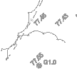DECOMMISSIONING I DEMOLITION
"..
•

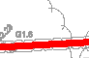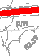.. .... · ..
..
=
-
.......
-·••.. -
'V .
.-
"'
·..-;e.-_-_ - - - -.. ..
& -•1\ \. ...,,_ ,£ _ _
..
- - - - --.t- - - - - - - - -
.. ..
..
' '
..
'
_ _ _ ..,,.. •
.. ..
..,OOOii<MAaa
.<-
1-<'tl' ••
•
•••

... .. · .. ..
•
- ·G-1 _£_\
....... •
...
801.1
•a1.1
-
· (a,_,
-
.
1••• \ \
-
'G;y_l , ..
•• •
,. ..

.. 9 ftO"- ,,... H_,,-10mH
"" ... -
- ..
.,,.GI..
""'" 'f'I \. \ -....
,(lo ', ',,!'
\. ',
.. ..
' l"
.. •'
.. . \

I•
f;a1.1
" """" =:--
... -
..
Y
0
'
·-
I BIA \
/ "' \(
'' ' ' .
.,.,_j..
..'

•• •
au ,_ fl..'.· - _?..: -J..- - - - ..
I'''""'"GMlll \
'' '
'-
- .,,·,,
\ ,,
' ••
'
,
'--<''"' - <-
"

.#'-a1n "'.... --
•' •
•·
.,
G1.1 .ti
.a1.1
-·
.. - ..0- '--' >-
"'- F \ 'r=" ' .
I ... ao'1'\

_ ,
'\.,P
AVG.TRl!l!IBalfT1-
#' \. ' ,
'' '
A- TREEIEBl<T1-
INCllllDLW. 1REE8
.. ;I$ ' ·.,. ..
- TREEIEBl<T1- ..
' '. <-;.....
j
- o- ..

-"",,.= -
T
- _;-- -- -"_ "' -- ',t .,,t,
..
  - r
.G1.1

.. .....,
.........

---" -z--
- - e--
- - - -- -v:: _- _·_._.,_-
,•'

-
f'
u
INCllllDLW. TREEll
,,.. ...
'' I '..
..
,
"" " -.....', ..
I ,..
I • 0 I •
INCllllDLW.1JIEE8'
'
' \. -". /. _,. -/<' ..
IT IS ASSUMED THAT ALL WORKS WILL BE CARRIED OUT BY A

...
• •• { _ _ _<!.,. - -< ( ' - - -#.""5 f
I
' • .... l-F' '
1-*'" (<-"'
COMPETENT CONTRACTOR WORKING, WHERE APPROPRIATE,

-w ..... ..... --:_..... :,, -·"" "...; ----
- /. - V- I \ \ $•'G-0 . .
• . .... -':;!, ,Q":) I \ :r ..._. "
QU •••
•01.1
-..:f ..... (;"
I :,. •
< 0--\.)! ', ',
..,'
' .(...
I ..
',"'
"\\

..
'
' '
....
'
\ 1'
•
# -,.::J •
' I ' •
'"'-<'.,. <-
•
.•- ••
-<'t /
•• I
TO AN
APPROVED METHOD STATEMENT

KEY

.. - - ,---..... r; ', • \w
... ·•
.. .._ .. '*-
!'- - - -;\ ...-" '
..' \
..,.,:-
' -.... - - - -·- -<'.; H •

_,. - l}' - - \ !'(l - · I

-
1,
.i::Q1.0
.. - - "'//
.-.
-F' ' \ ,/'
..
..
..
..
• ..
....
-8- -SURFACE WATER DRAINAGE

·"""-
- # ... •Gin Q \ \ ,1"' 1 • I.
I
1 ,.;...,a....
.
,/
'!,,. ',
· ''
• ••

- - .rmM.• .a... . \
, v -o \d ,. --

- - - .G1.2 .,/_ 8lPe;I\\ \ \ MG· - ' -f'- r.J.,,",'
,.._, _ .. •'·-• •• •• ,._ _ ,,,;·- '7:!5'- "
I

' '"
I

.. ,,..
.:,.. i'
{/ /
-
••
1r -f)

.. ..
.. .. -. .. -·- -
,? ,·- f • I - - : - ',<;" oO/_ </'
.. - · I\ II,? 'I !'.. I ,"'_ <'. - - - ' ,,,'•P,)_ ":
-.:-
,.,·
...
I '
, ..
..
'
',
..
"'1'l "
-
-"# ..
·
DRAINAGE

,- - GU 1111.1
G1.2 • ... .,. \ ... /'.)- .... •
'
· ' '
-"' -<', -
.
FOUL

":-iArW·-Tlll!! - ""-:,#-' - - #' o
_ _ _ _ _ _ _ _ _\ \\ \\ \ \ \Y- - - "
ii'
"°1.1
"' -"'k ' - - '
( I
.-; I
_.
,. .-<'!-
vz:z:z:z:z1 DITCH / WATERCOURSE OR POND

,. ...
-
. -....-·... \.
' .,. - I '
I I I
'
',,.,
- '
'
...
..
' ·:
llDV1DIW. TREEI

.. 0• .. r<:'
' '"" r v
,
'-
- ..
- ,,t, · -. -· \ -
- . •.•..._',
-o'" o- ..

.. ' .. ',', • .t;S
••• ',\ '•!I
' •"' ,' I'
' ;;.- -.-.
' • 0• -
,I"·'
<I ,..,

,_ ,.....
I.- ""f"r' 0;.".\.
U lY• '..' -. I
.
'Ji" • 9G1.3
•au
- ;.. .
..
'' I "'
AW HED!T1- ..
'
.# ( / G1..
•
I
, • I
"" ,-.... ..... .
·- ,,.
"""- 'IRl!! H!!IGHT11mH

I
'
DC
u From exl1
f-- ,
D
G

-" l>' l :n1 ) " .,,.r:''ilf . ' -.... '- '\. \
o- ·"·V-·. -" "'...._ ,_'\\,'-,
,gf, ( .
•a1.1 I I
INCllllOLW. TREEll
,.,
'¢' :
...
·\"
Trap·
DRAINAGE CHANNEL

,., . - --. - J
,.) " ,,. \.tf
.- "" - .,. j" !"' · -• ',' ',;
01.1
t
••
'
D1.1
I
, o Assumed route
-Q ...- -- 1
# - <-"'

1- -'r < ..... 'u:.,,, ..... ,,_
"'
· .. .­
.. ' '
of
' ,,,.
"'
.. .. .. ..
ROAD GULLY

RWP RAINWATER PIPE

\ I / . ( _,:. .: . { '- \. \ \ \"
•au
,.----L
,1-il,
•••· , - '
,,. :
,
# 'pond ouUet along - ..... ' ••

I Fl'B \.
'
'
'"'
8 OIAP -"
-o.,·,,., :••'
. ,,,.'
. MG "> \ \\.
lll&Ell
' -"''\
-
·-
'ei .
hedge line (oak§) _: at.a (.]
from existing rtlOcfrd- '
·.

J '-.
I I \ I
01.0 •
.. OQU \ '\.;

-.,,. · - .J>" "". .• ,.-" j _.. \
'-. "" " .,,. . ' ·· · .11 "" \ 1' "'
Q1 • · I
'-c
_A-.,....
.. .. .. ..
....,, \ &<. I
_ ,-'..
\"."-.:
/ .,. -'
(unable
to ' \

r
..
.. .-.- .
..1
f
..
DR o
DRAINAGE OUTLET
CATCHPIT MANHOLE

' IJ' • I I
/ / - \
- - -
- - -

( ., .. Qo o - r.;:, o· " '-".t. _ _ _ ....
1 /,,,. . - · ,1' 1 \ 1
- -,,
I '·•'•
I I
-. .:-t ""
' • I
#/ . .. 1
- ,t o-
•"I
-:} - - <-¢'
s'
CP D
UTL

.. .. '
,
· 1 .;
..
..
r • "'
.,. "'
"' ·'' ••
UNABLE TO RAISE COVER

" - . 141'
# I MP -• o.-if.llTIM' -o
_; 0 I I '
"' \ J.
,- '
UNABLE TO LOCATE

.. .. ..
.. ';,! llTIM' 0..
I 1 4"\
... .-
if'' r
-·-
' - ....

or 4"• ,r "\ • ..,. I I I
1 1 1 ",_
._ - ! ,,
w ,L
..
_<!.
- - ".
- - - - - - - - .!'_ _ - • --- - -,, · 21
- I w
.,..
  - I
__ ' '
UTR

· ' ',
...:
......
... ..
.. -
<of> '\ '\

.. o-.. .. ..
·
' I.
' I
..
.t- . ••

..
"""'
,t ·-/•f'
·­
•01.0
... ·
AVG.1REE HBGlfT
"'"'
•- u
••
I
·
"'\·, :
I
,- "
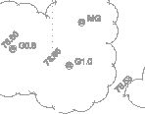....
-..- - .. ..
....
- c
- - '
,..
.. ...
-­ f
,',.•
,.,I
I
,
AVG. TR!I! ll!IGHT -
;
{'". I
'
'
\<o,
'
SITE BOUNDARY

SURVEY INFORMATION IS

- ,\.of0'" o·
" ••
.. ..
.. , I
I I
',
•"" MA - ..._

if

..
--- ,
Q1.0 }'·
..
'
''
)' I '\'
. ..
I I
.,.(llTIM'
AW:1REE HBGHl'1-
..
'
I NDTIUIOV!J'l!D
I
I
I I
-<''>! '<-"
NOTE. TOPOGRAPHI
CAL

.. .. ••
AW.1"'!1!HllGHl'1-
.:-'.
-, .:.'r-
I/ \
© "·' II I Q
NDT.8........,
t'
' <;P OuUet chrTI-
BASED UPON SURVEY OPERATIONS DRAWING No.

D1.1
..
.
-."'1 • 0
·­
,. \ I ..
!-<'"' ..
13A002/001 & 002
DATED FEBRUARY 2013.

.. ..
a•• •
.,_ ! I
. _ _0_
.. -
•••
•• •
......
· ; ':,'
" T''
.,,, _
'' -o. - I
o- .£_,,.. ,._-""a. /I,;-
'
..#'
'
<:- '
•
"' I
¢' ·- - - ,.,
I
unable tq locate. From
exlsUng,records
! I

" .. ·..:-' ""- """'
·
-
_ ,t_ -
...
,,. ••

·-.L
-
au _,,
"" "if
•• ..
.'V' I 1.,:.
I
"' - .t

..
'
..
.. ,
•'
{
..
---
c-.._·- ;:;,,_- -.-..-·- - - -

.. ..
f .A:. TREE IElllHT

.... ..
.. .. ..
..
'-'

......
.. • '
.. ...I
I{''!'

'

-.. ··
_!.,..•4'
! CllllOLW. TREEll
j _ -
o- ..
,"'/,,., (D...
w,.,,
\ rz
<op' j '

.1.....
,.,·) /
'<if!.- #'-" I I
..
-
I
- • I
.. - - - ._ _

.-0... "-'
""5.
I
-AW. 1REEH­B_1"_
.'1Q'<? ·

..
_ _ : • t' • Q?rm"""""
•=.
••! '11 J#
...,:.
..- .. ..
.. .. ..
.. ...
..\:-)­
• 1-
'
.!.<o'

-""
••
NDTRUD- ' I
-
.. __
•
-----""' 'W
..
..
' "'

.. .. ..
..
,,.
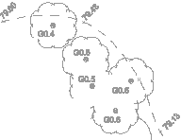..
"'..

..
,f!. '#
  - I

..
"".-' a.r1 • '

'\ I I
17!_- - '
(. I
\

.. 1J"GBU
I

'"..'t_,,, _L ... ..
- I I
'".
" ..
.. .. ·
<-ti' ""--
,,
i '.•.

'.'j '0'
',,
--,;r '"""1"""' '"'""'"'
(;" I
L .,:.f'
.. ..
, •
...
·
$

.. .. I • \.'.)' "°"'' lffi
·
I I. . "
  - f ·
,f 1 ' '/'
I 1. '"---. ..:-" I .\

....
•' I

8 -
•
. ' I
..JI :
,.' l<-"° \

I ··00 -a--;
_,..,I:." / I1,;,:. . \. .,:.
,., -,,.::. ' r r · ,
.i- ...- :.--\ .,.,.,.
...-".".'\ -G..\,?
0:.
_..,.-...--.-.._ ....---....•./ ..
_ _ {
<-' -<'?-

...
-01. ..
"' -.6.""/
, _,,, .. . .• ..:-"' '- ./

..
f' • "'..., '- '\.
'
AW-
TREE IEIGHT
Ul!f1 ..
,..,
.. / ..
I
'
•t.>- -
'
- _#. / - •
..
...
.. 0 ;.:..
.; ... 8';•''

"c;,_....-
I I • " '-
1
..
' .. ,.. .. ..
£-" eu
(.-
....
..(, ••

- • .., II f
· (;" .ii' '
/ 9BU

..
7
•
..
'
..
I
' ,o-
-' /;
;? ..
7 f - -
'
•
•
A
11.11.13

J 8 I , .I-. -- .,_ •- - - _..,;:..._ ' .,:.'f
,.- ""o < ,_. 8MB -"' I I
:--..""- "' ,f '
..
:;
' ...'
_,./ ,'
..
·
..
;
, ..
\ \.
,,., ,,.,
'
\#_
""-G1.0
.. ..
' .. "
j i-<'.,.

..
I
.. 9 I
Updated with Tower Surveys

1 • G1.1 •.., fr I
T a1.•.,.,., 0 o/ .., 1 I j
"1" G1.1 • • I I
•" t..
fr· ,t I
' ,t ' ..
!..
\ ooau
'
,
\ '- .:/' I
f I •
\ -<' ! ,,.,
survey data May & Oct. 2013 and
proposad remedial works. Surface
SH JS

> /If
.f' \ " G1,; ..t..,. I I I
' ,_.
"'...... ·-
·•-
., '
..
0,"'
.. -· -
\.\#,..
"' L'.1'/ I
,,!- - - - {'o-f- _ _ .,.Y / ,
...,
water outrall routas addad
Date ,..,,,.b"

_,, / \ ,&,,.. """ I I J.tf
'""
·
''
-
,,, --
• , .. ..
-·-
- -- \ I
Client:
By Chocked

,.. I / 1 " OJ J I ;..
.. - '·
__ '
'
"""-TREE "Btal!Tilm"
'
llDV1DIW. _ ..
AW. 1REE HB....-1- ..
'\ #" _ _ _ _ _ _ _ _
_ _ _ _ ...- ./
-AW.1REE H­BOHf1JI..,
<-' \
VERSITY OF MANCHESTER

..\,
/
.9" \. \."=' I f II
µ 1 .,,,
-:/. .t
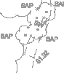..
-
I '
( ..' .. f ..
'
----
..,
' .. .1
! .· "..'.., •..... , T ,,. ,,
..
.. ..
..·
..:I
if.

I I '- '", • 1 1 / I
\
- - - -.
' ' '
# ,:,.
.
f'
.t ••

I '- \.
'- /."\ 1 1 •
\
.,}"' '
'
..' #, ' , 1
w · "• ', . .. ..
I UNI
I

/ '
/ / l!f AW.TREE HB....-1-
NCT&LllYEYBI
I I
I I
),/' /fl
'
..
,# '- ,#", I !j I
Y,1 I [
, .., 1 "'
..
,.,:.f'
..
.
'
' I
' . ..
,...- # #' \.
•
Aw_ TR!I! ll!IGHT -
.. ' -•
•..
I ...
.• . . <- -" I I J -
'- '' <-"'
1'
'
'

NlMDIMLTREBI
I f I (. f!.
J> '
G1& "" \

..
,
,<' ..
__..
'' :
' '
,
·
NDTIUIOV!J'l!D

..
.. ,.,'
.. - 1
,' ' •o
'
. ,'>
-<' "' <-" , --
'' I ',
'••
...
'"'r1 ,/'
Project:

I it
I "'""
I f I .,,, 1
I f ! I
,,f t.' I I '
#' \ \. \.,,; , ( \.
. / I
-<'.;:- - "" /
I •
••
,
BANK

.. ·-
..
±'_
..""'
I 1 .. .. .. ' •
• ' '"
' ... .
/ -(of' .{'
.. :f
<-<t -<'
,··'
JODRELL

.. f I
'*." ... ..
I
, ·•' ' ' ' I '
I
w< ; .O • , • /
-<''1 ..
- - - -·- - - - -
- ""{'
Tllla:

, , I ;
f , ;,•

-- •'- ""-
' _,. V;/
I/ I
f!. '
- . .. ..
, ,
', '
,' ,,•c / •

__ .. , \
-
,""" ""'
,
•
..
··
0
I

, ·- - - - - -·- - - - - - - - - - -- - - ··- . l..,''.. '

/ 1 1 r
.,,,
\'(.,:,-
.,},! / ,-''
AW-
• '
TREEIEBl<T
1:n1
' ; I ; ' ' •'
,<'
-- - - - - - -
-<'

.,.,,,._,..
, ·· ,Y- - - -
...,/ , /
I! I
_J> "1( I
I ,,,

..
·....G""--
j ,•
==-"-"-..:-.,. - .,.
.. '
' ' / " '

-;.-;.· ------.--1'_-_ f-_·;_ ''.--- •-..--- -;·- --;,''
•• ••

' ./ ' ,
1,1 \ '- .,f
' \.. · I I ; ;
+ ., h9
SITE DRANAGE

. I I
\,?
' ' - - - - -- - - - ,T - - ; ,.. ..
'
.._
. • ,.•
<f " ,;
-·.• , •,, I ,, ,,.
,, · · · · · - .. .
. ,,, E

'
/ ''
AVG. TREE IEIGHT _,
.·
I I

I I
r'1
• .. -
)< ,- " ' JO
"
·
.. .. ' '
.. " - - - - -
LAYOUT

I/;.,. t1 .. ..
I I
..,,, •
"
_'f-
- - --- ...-
.....
01.1

·
.. ' .. t
-- ::;:;z;v-

I '<
NDTIUIOV!J'l!D
#' r
.. -."" ·
- I - • - - - - I - - - - - - !-
..
SHEET 3 OF 9

·- -. _ "'
-
..
I '
' I
I
'

"" _., "'
of lalid drain

· .
"""-TREE HED!T11mH
llDV1DIW. TREEI

..•
*=
·r ! ! ,
. =.i..
. ." ...

/ /1.,,",
I / ,
L.r- - ,#' f -- fa ""
AW. 1REE HBGHl'1-
:"'-...:·
;.:-1' .I ·... ' "'· ti ...-
•f.o ' ' ·
BU ,./'

....- - - _-_ - --
4'
../_ - - -.::...:-
...-
"".,,.,:-
.,. •
"' G1.7
CAPITA SYMON DS

.. -·- - -
..
...
...-

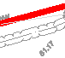. .. •
    - ;l&
·

'Gu ,,...:,..
,,... , G1

-·--: · .. ..
'
STRUCTURES
COnsuHing Civil,
Sb'uctural
& Gao-Environmental Engineers

= MANCHESTER Offices also at:

Clemence
House, 9 Mellor Road
Brtstol Cambridge

•• ••
Cheadle Hulme, Cheshire, SKB SAT
Tel: (+44) 0161 486 1521
Fax: (+44) 0161 486 1580
E-rnal:C11Pdl.-llQcllpltll.cnuk
London She!Held
Wa....
Special Projects: Cheacl le Hulme

.o.,..,., at
www.cepltesymonds.co.ukl&tructures

Dole
MANCHESTER

March 2013

@ A1 1:500 @ A1 I
0
"""
SH Checked JS

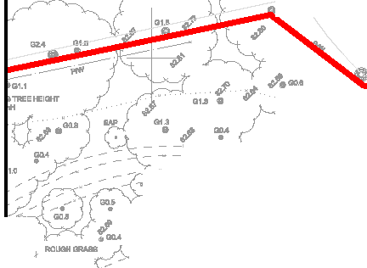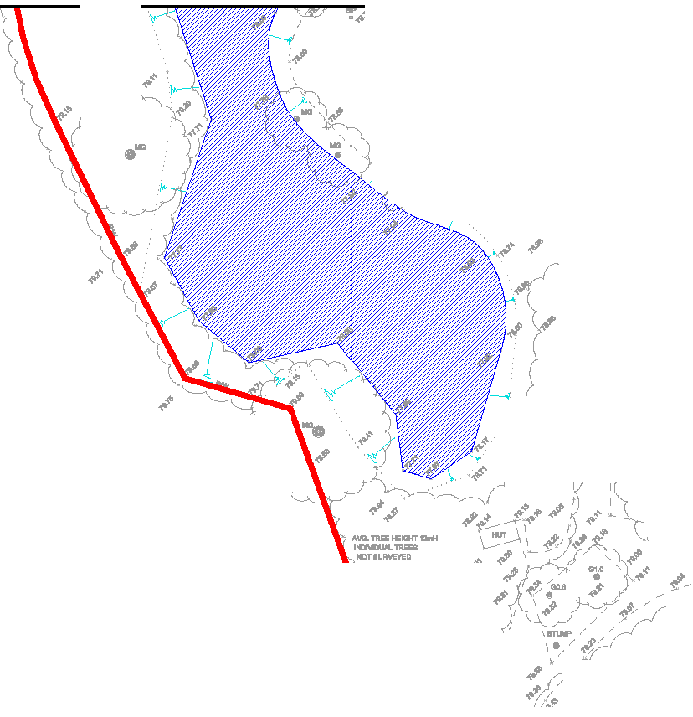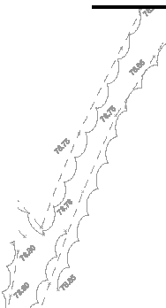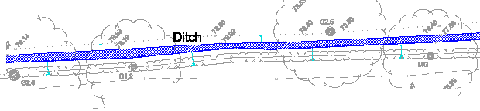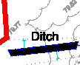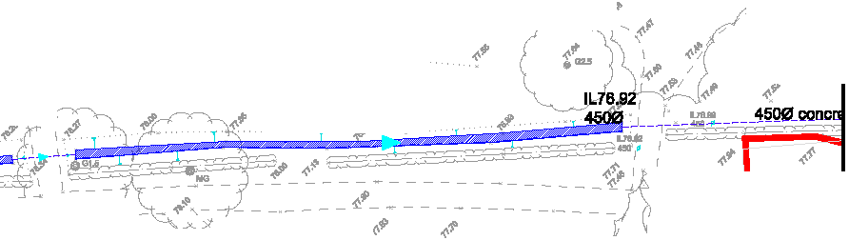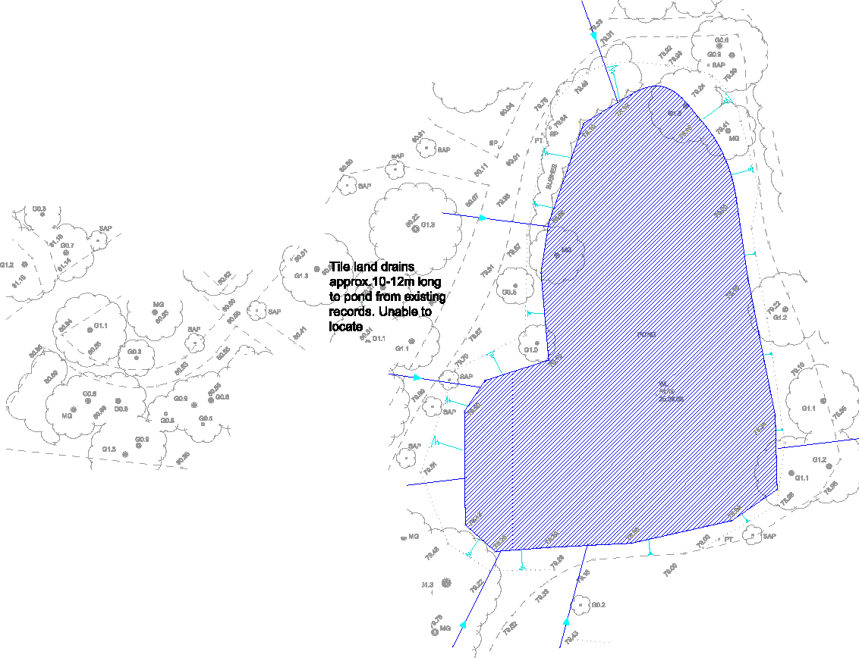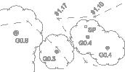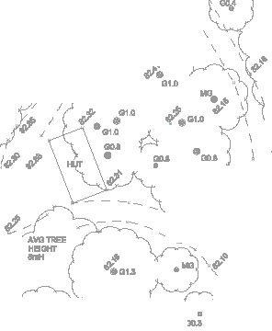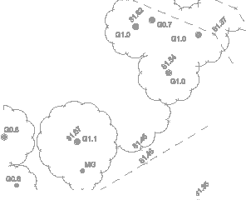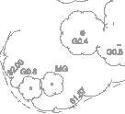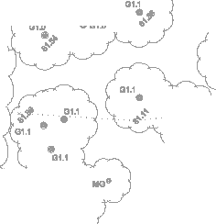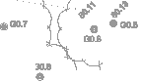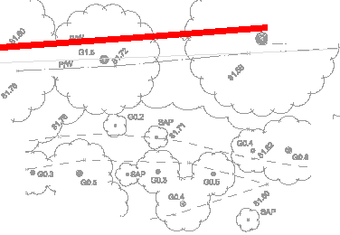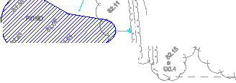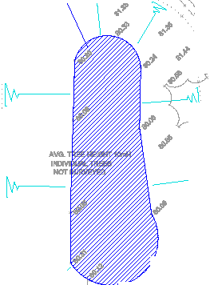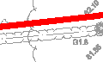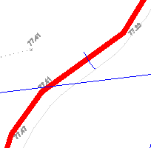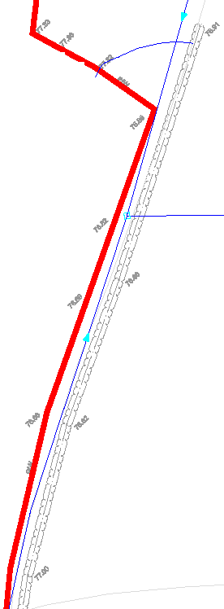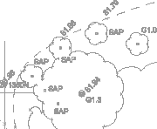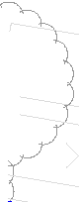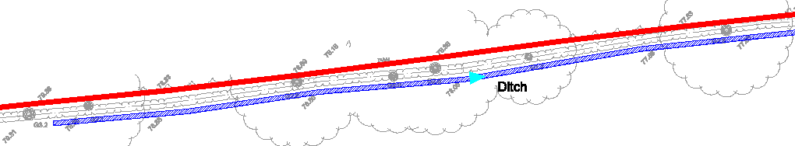Project No.: IDrawing No.:
- SS018706 I 203

Revision:
A

GENERAL NOTES
      - Do not scale from this drawing. Work from figured
dimensions only. All dimensions are in millimetres u.n.o.

· )"' '-",4,'('),
"1

No devladon from the deta.lls shown on this drawing wlll be allowed without prior permission in writing.

All drawings are to be read in conjunction with all architects, engineers and specialist drawings and details.

·----,._ -.-- --.-. ,
. . - ,--"- .•
-/- -- -----w+- ·-·.•.-- - ..---- -

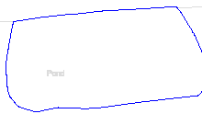- -.
••.:/·c---,·-'-_ ,
. - -_-_ - - - . - ,
--<.-.·• - - -".,,,,_,_.--"-'--'-.·",'-'''.
·-- - - ·-',--
- ,-

,_
·
w

SAFETY, HEALTH AND ENVIRONMENTAL INFORMATION

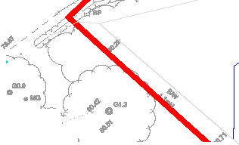..•- -. - .-- - ..- - ------. ---·---·------.--- _-- ,-•,-
.-- - ·- - .- ---- .. . . .. - "

CONSTRUCTION

-- ..·- .- - - - -·. . .
BOL "' '
- ----- -- --

_ 1-_,_- - ·- -- - -
__,_ ,- . c--
> - - - - - - -' " - : ,

-71m --- C..,--·-
, O ;. -
_ _ _ - •
-}-
INADDITION TO THE HAZARDS/RISKS NORMALLY ASSOCIATED WITH THE

,? • M- . - - -•- _.(' - ,
- -
•'" . . . • • - ' - , • • _ J - • • • '
TYPES OF WORK DETAILED ON THIS DRAWING, NOTE THE FOL.LOWING

s , - -_,•.•,-.-,--,,-,. • • •
.... ---
. -· - ,
'"-· .. •

,..
.,, - , -="'·- -,. ,. '

D=0.
- - -
- -· - "
•

/

--·' - ,

-·-·- ,. ..
-
- . .
NTENANCE I CLEANING

.;-- ,
- / -- "-' ,<";.,', ... ,.

- ,
, , , . ,
.
· -·--··-- -
MAI

- - - -' --::::::; J / ' " ·" ... ·

'p . -- ···- .• -/ :'"..':"'
  - Working In conftned spaces
  - Working with llve flows
  - Contaminated materials

DECOMMISSIONING I DEMOLITION

225mm squara brick outfall is assumed to
'X
connect to Network Rail 1
track drainage system
within compound. , Possible discharge from (­ railway to Peover Eye watercourse.
-
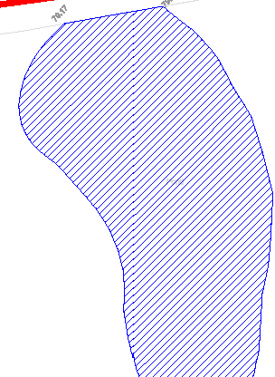",_
"
,,,0

IT IS ASSUMED THAT ALL WORKS WILL BE CARRIED OUT BY A COMPETENT CONTRACTOR WORKING, WHERE APPROPRIATE, TO AN APPROVED METHOD STATE.ME.NT

KEY
-8- -SURFACE WATER DRAINAGE
-f) FOUL DRAINAGE

vz:z:z:z:z1 DITCH / WATERCOURSE OR POND

DC
DRAINAGE CHANNEL
G D ROAD GULLY
RWP RAINWATER PIPE

DR o DRAINAGE OUTLET

G:i.,_d.oha'll;"ef i::_..'l_ l• - ,'$;1/ \
.. -l·'fa-1.1

'-"

CP D CATCHPIT MANHOLE
UTL UNABLE TO LOCATE
UTR UNABLE TO RAISE COVER
••-

\ ' "'---/
•

., \,
'''
·- ·

'\..
SITE BOUNDARY

NOTE. TOPOGRAPHICAL SURVEY INFORMATION IS BASED UPON SURVEY OPERATIONS DRAWING No. 13A002/001 & 002 DATED FEBRUARY 2013.

.,.\\ ..I
c;:.

'\
..(. \<(
MH2
t 78.08
IL 76.691000

·'·.':.\\ '"' l' /
j
- '-....._
1 ,_
.. ..
"\ :::, ' ' '

Updated with Tower Surveys
I Isurvey data May & Oct. 2013 and
11·11·13 I SH I JS
A proposad ramedial works. Surface
water outrall routas addad
..., I Date I ...,,,.b, I By IChecked
Client:

'J. . • ._.. J ,;-
...
{w-
UNIVERSITY

Project:
OF MANCHESTER

"-£
•
..'\ ..-1 fl Ji. .m.

Tllla:
JODRELL BANK

SITE DRANAGE

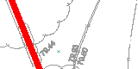,t
-
'
' 
)\ "'(,.. {
y
LAYOUT SHEET 4 OF 9

...\
.(0-1.1
CAPITA SYMON DS
STRUCTURES
COnsuHing Civil,Sb'uctural & Gao-Environmental Engineers
MANCHESTER Offices also at:

Clemence House, 9 Mellor Road Cheadle Hulme, Cheshire, SKB SAT Tel: (+44) 0161 486 1521
Fax: (+44) 0161 486 1580
Brtstol Cambridge London She!Held Wa....
Special Projects: Cheacl le Hulme

E-rnal:
( -
aipdl.-lllQcllpltll.a>.uk

www.cepltasymonds.eo.uk/struclures

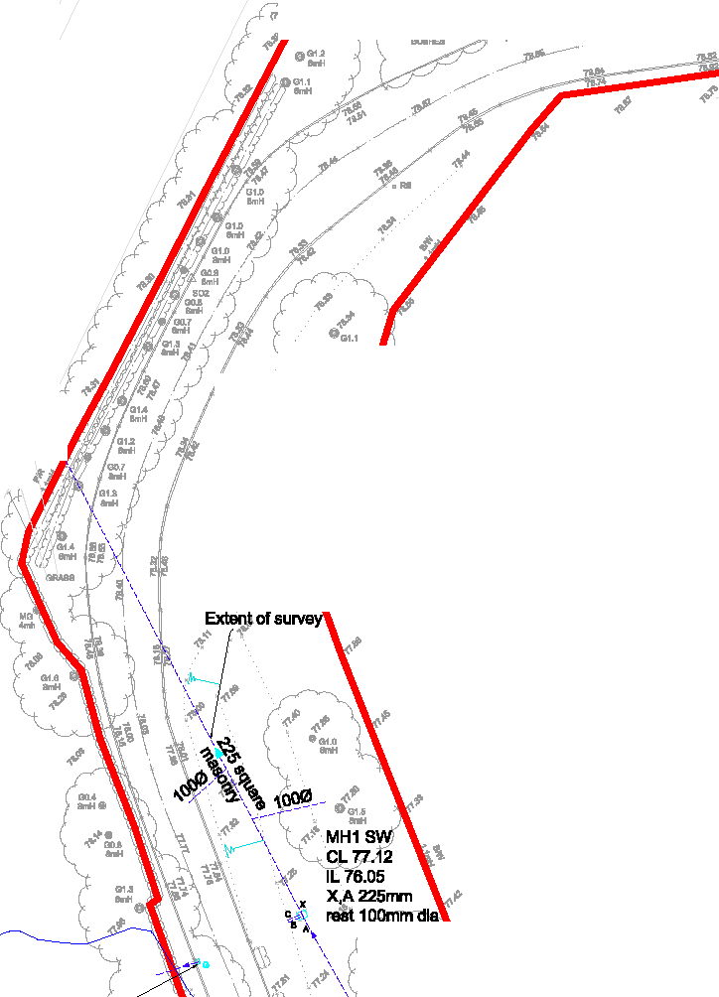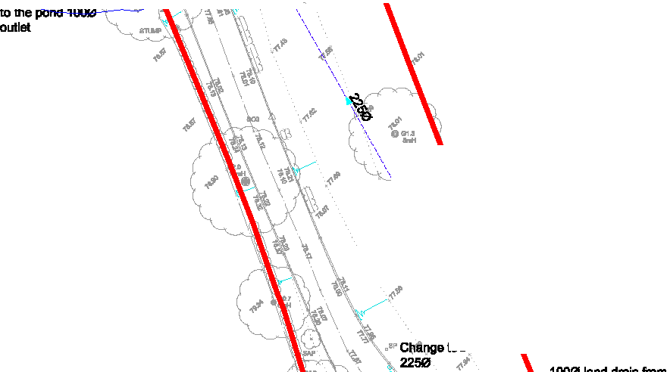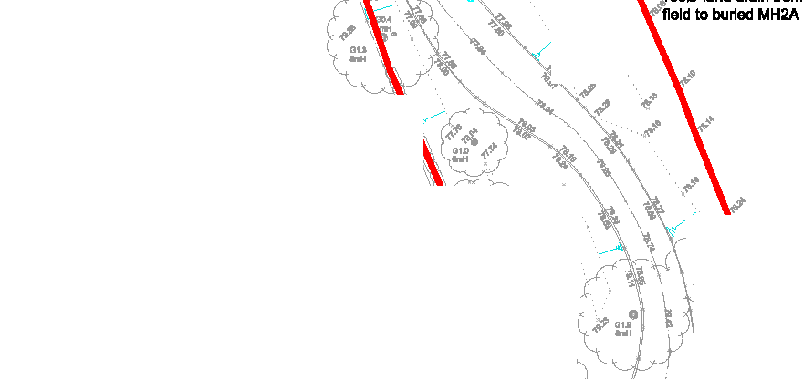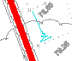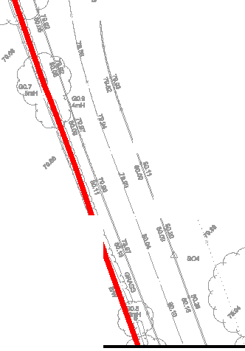
" '
'·'

Drawn et MANCHESTER
- I

Drawn
@ A1 1:500 @ A1 SH
Project No.: IDrawing No.:
SS018706 204

Dole
March 2013

Checked JS

Revision:
A

-+- -+- -+-
-+-

....
·' ,·
... ...
\

...
... 1

-+- -+-

-+-

...

.....
...

...
...

...

...
... 1

.. 1i

_..,,,
--,_:'-
ii r·..

..

...

...

....

...

...
I ... ..

-+-

-+-

"1'?r - ..
••
I'
•

1 ;.
•

I ;;:; 5!@
.. •

.' '' .
l!i '... "I.ti
....,.
I '•!!.
'
,
'
...
'
••
b •·

••

' .
.
·

-+-

'
'
1'1
...
I'
'\, I' I',.
'\, I 1 1!
1 p
,, 1
I \ \
' '
•
., i'
• ! •

' ' I •,
•

. .i\\
l"
'' i''<.;
'!''
\ '
'
·. ·..
'
,. ' ...
..

•••
..\ '\, ·10-
\ \.
1 '
'
·
·r!111U1

' ' ,. . fl! •••

-+-

.' ..
'
'...
......
.....
.....
i !

!I -+-
ii

'
'

...
!

'
.' '
' '
\ '
\ '\""-..
ur-,,.-,,._',' ''
'' '
""'"'
\
'
!

-+-

...
..

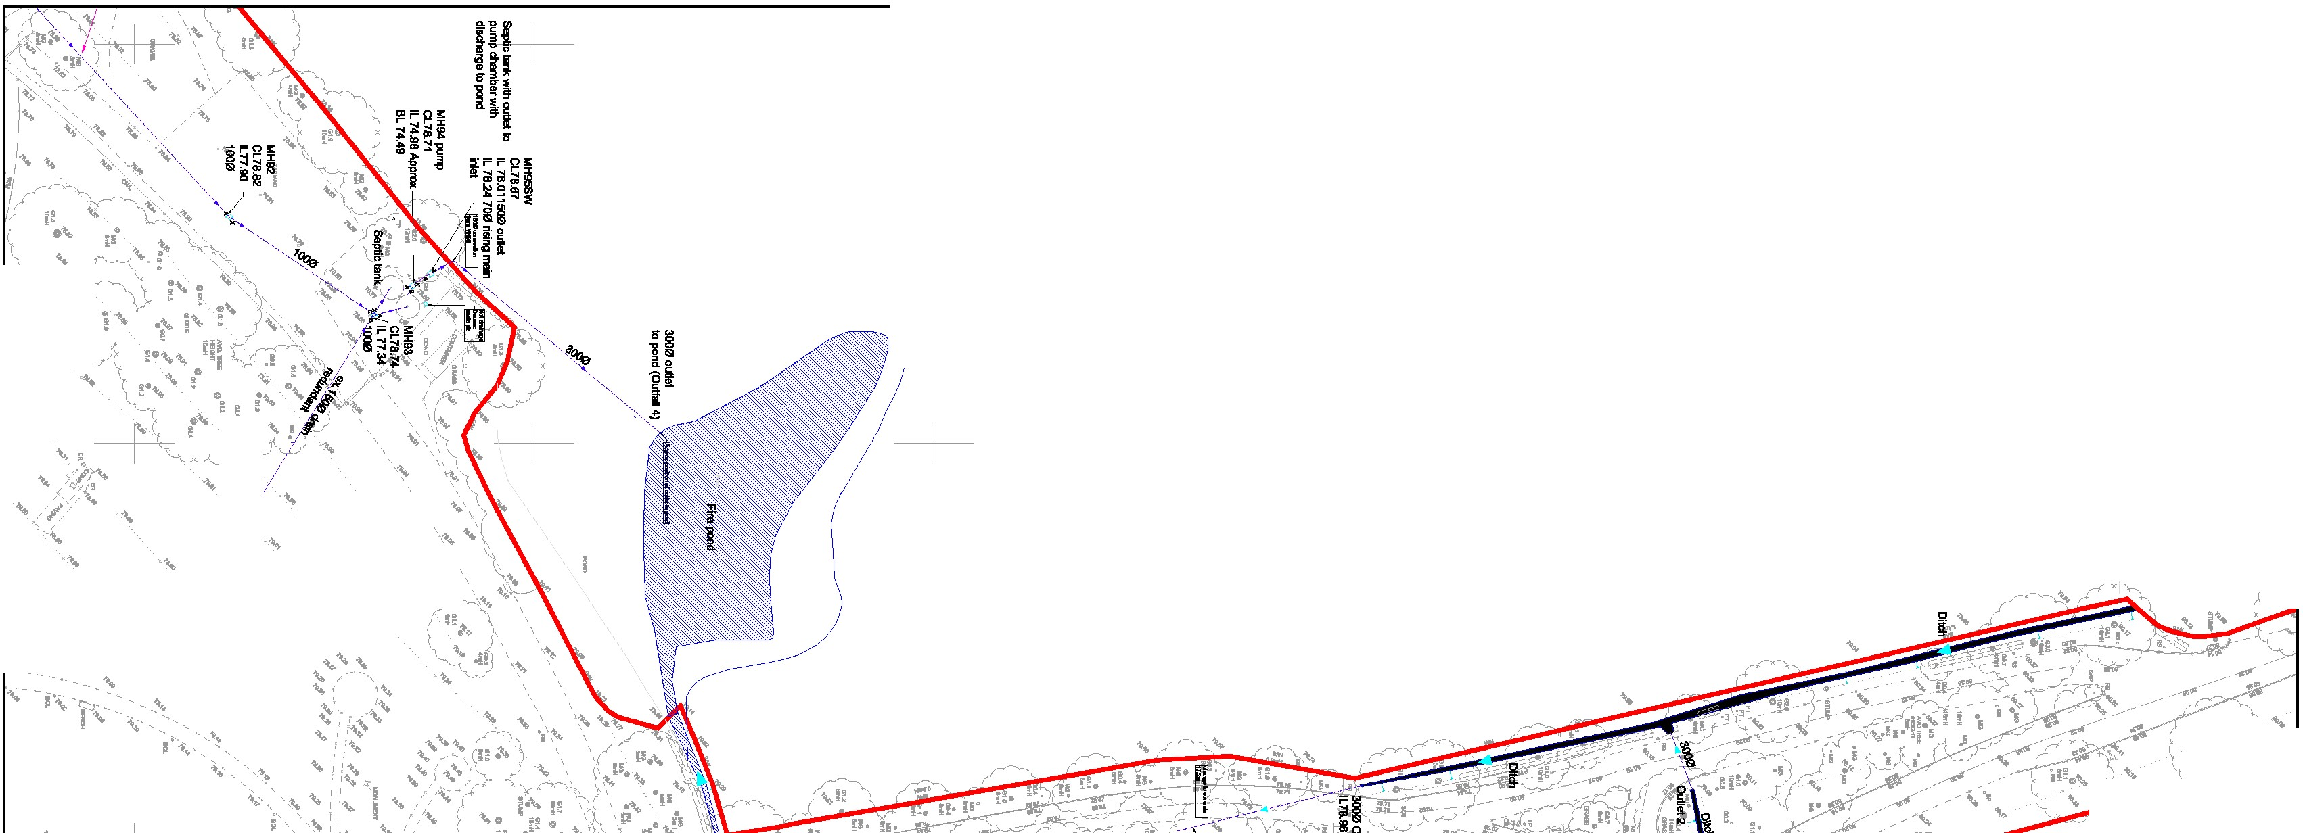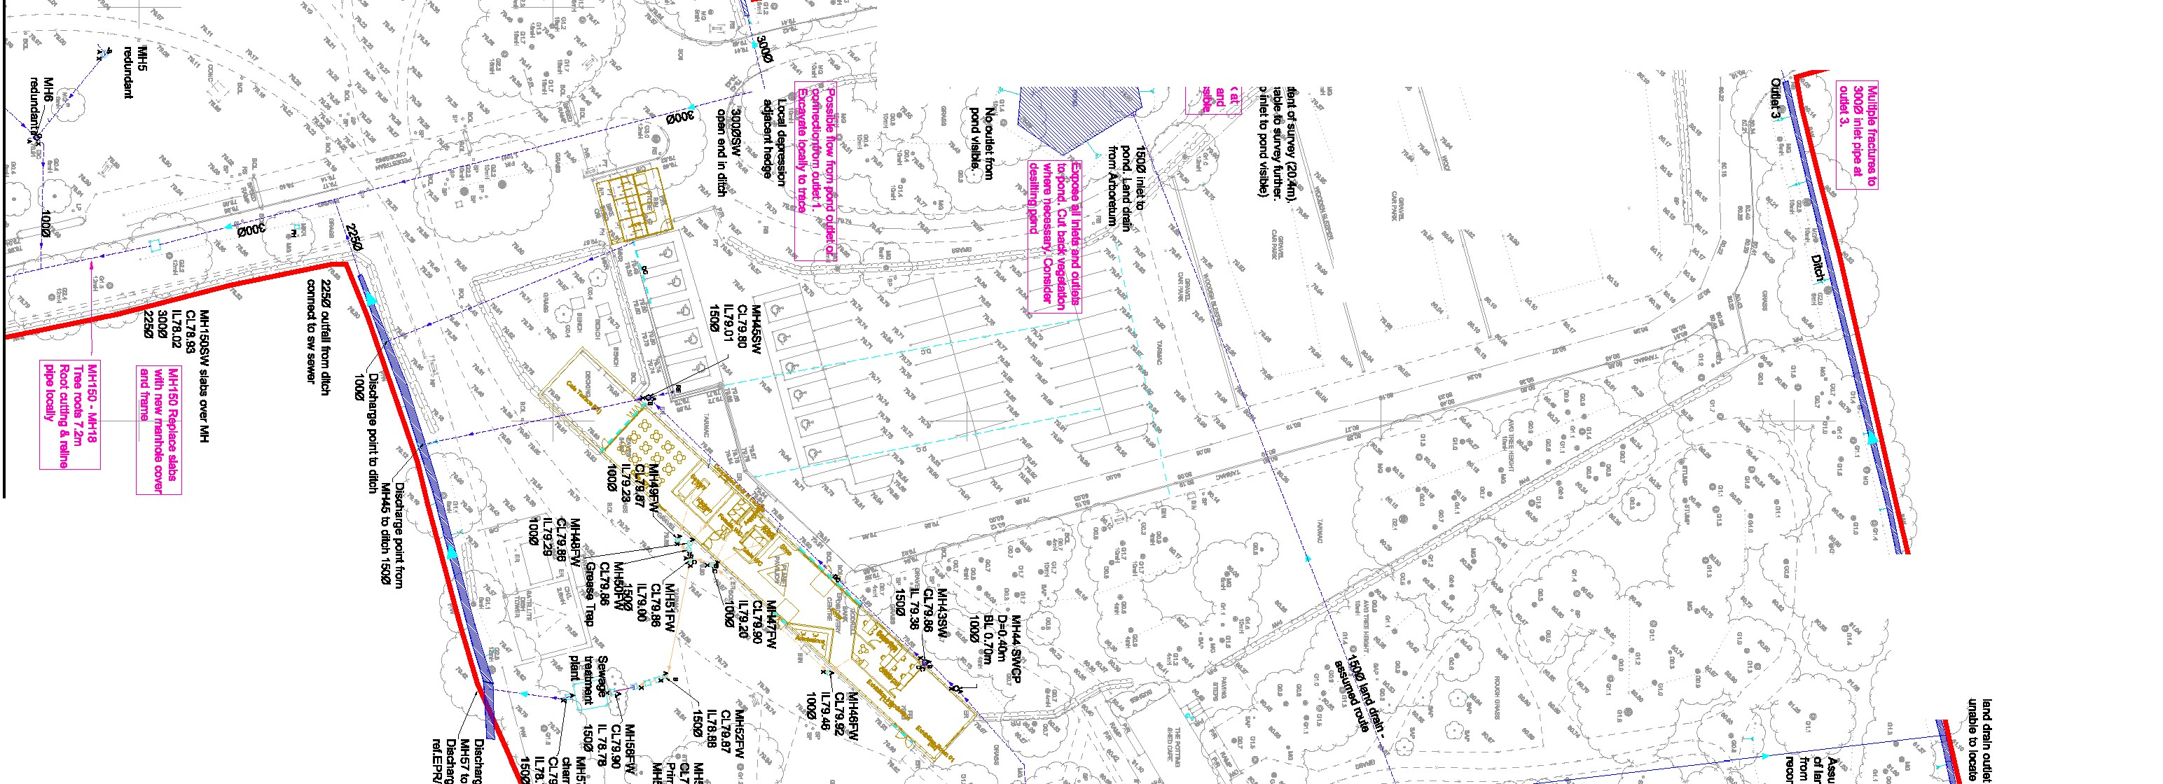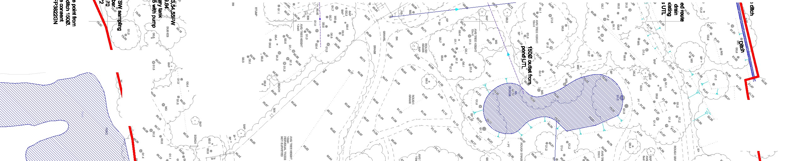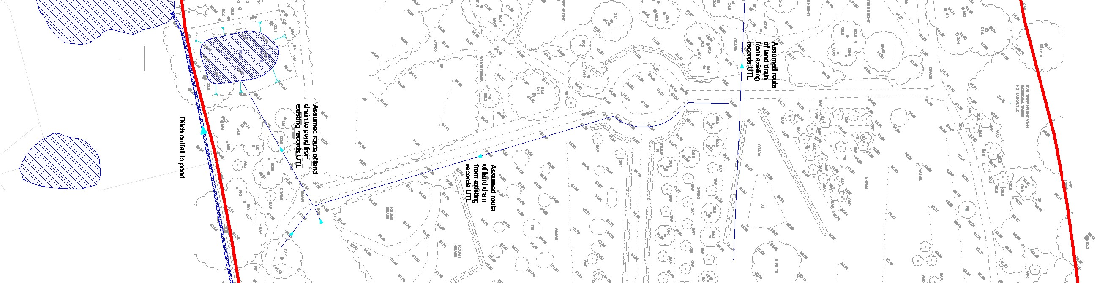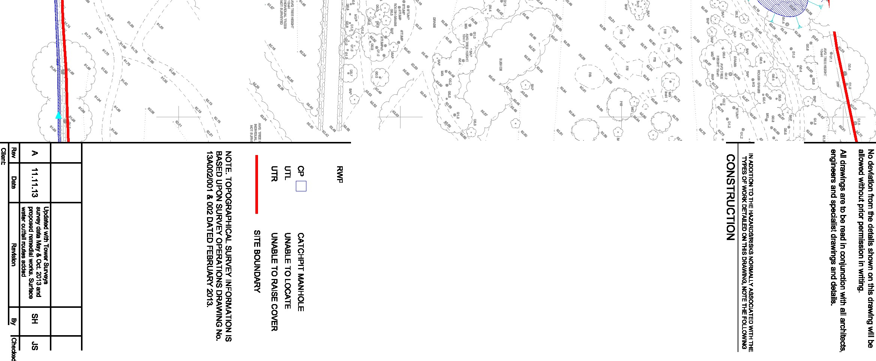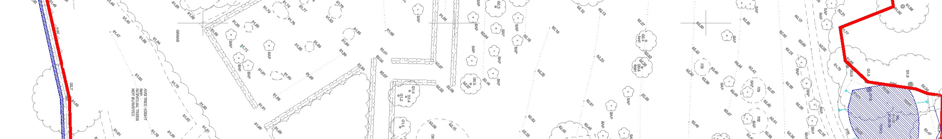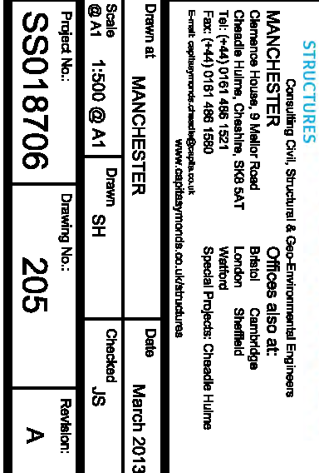
-+-
•

("')
.,,
)>
->

ti)
-s<:
0z
c
ti)

-+-

c....
0
0
:m:0
r r

z
;;ii;:;

c
z
<m

0
'TI

z
()
:c
m
m
;:o

1
v' •
1
1
.1.,
•• '

!il
0

I
I
••""
Gl

D I I I I I
"
Gl c: r
!( "
z
J!!

...

I
6. qI:i
I
"c:'
"'

"'
z
i1i
m

0
m
0 z
0s: -I
m
s:
en
z
en 0
-
0z m
-
z 0
G) r
0
ms: z
0 G)
r
-I
0z

m

;c en
0z>-,,
s: m
zm _::;!
:;! ::c
r m
-> z-,, ::c
o;c >z
o
0z

G')
m z m

r
z
0
-mI
en

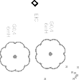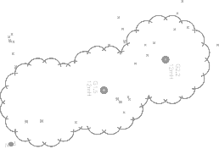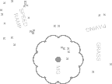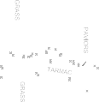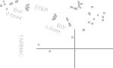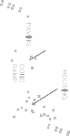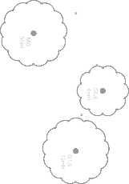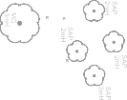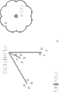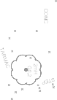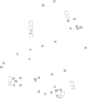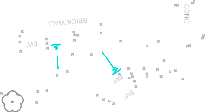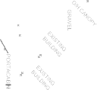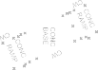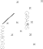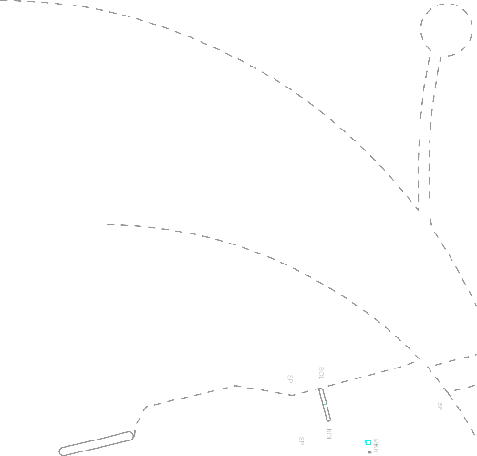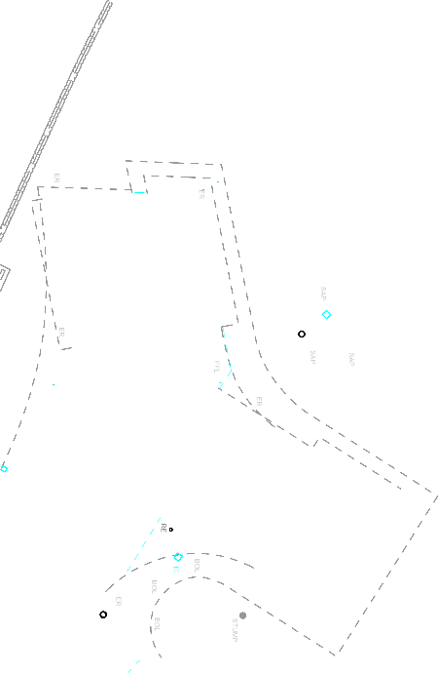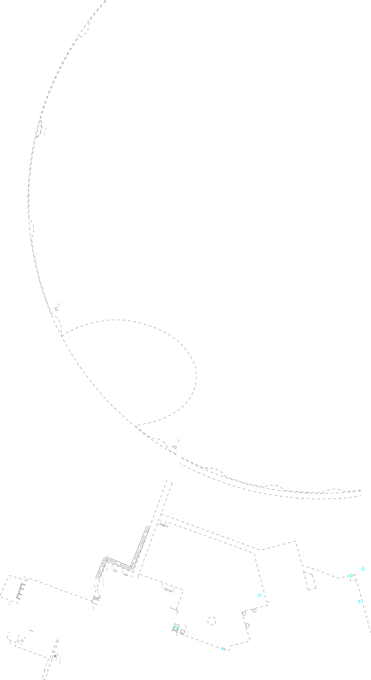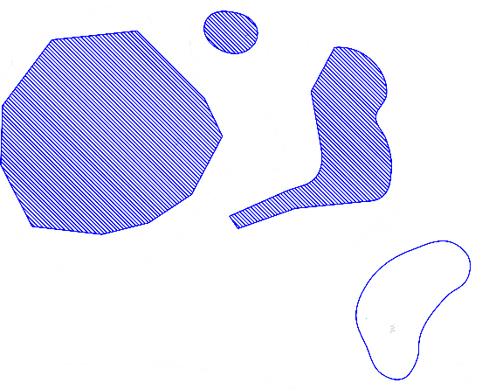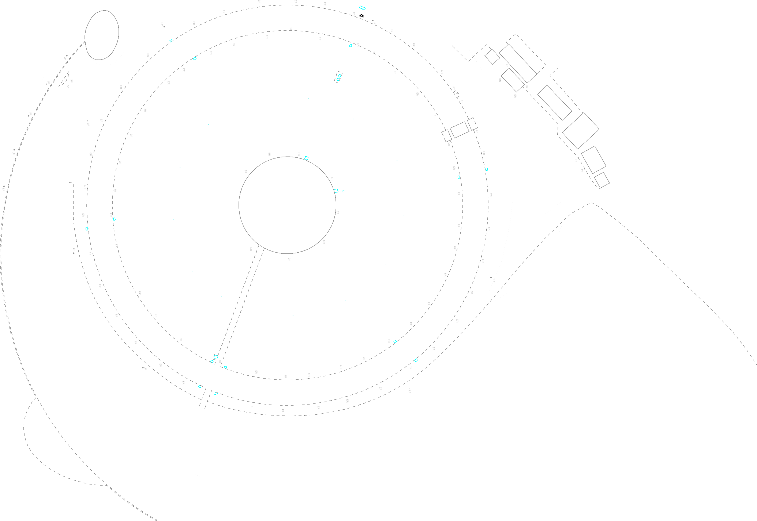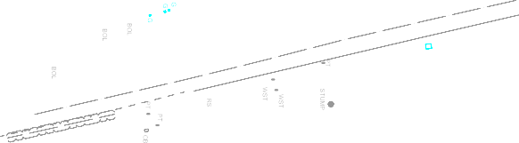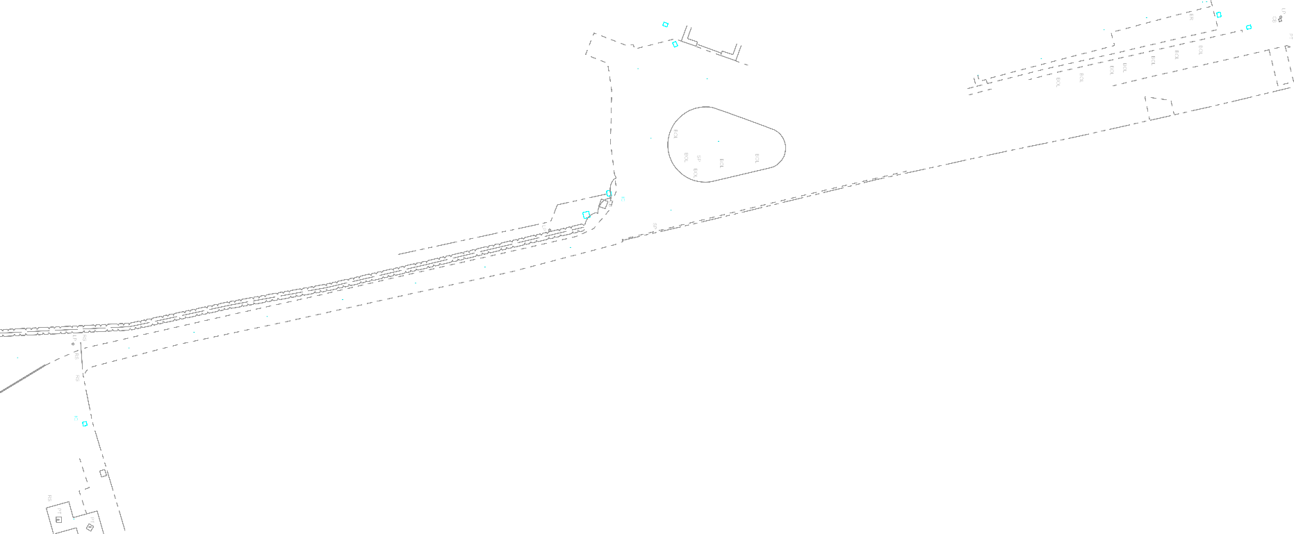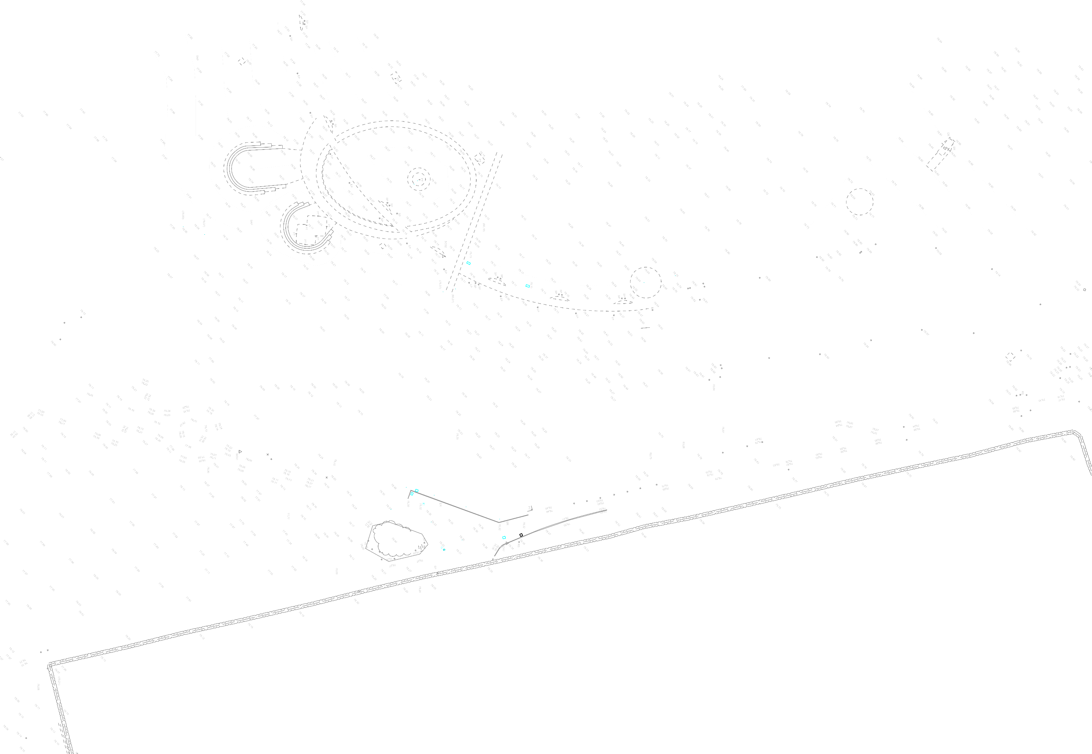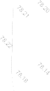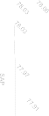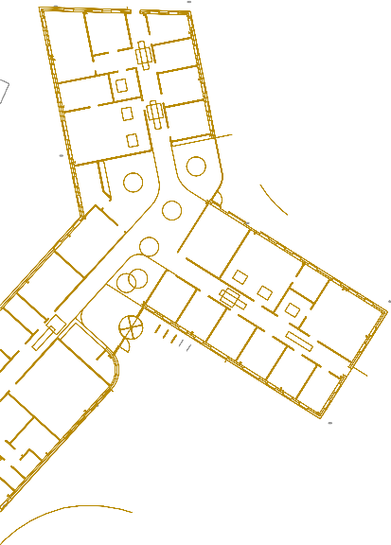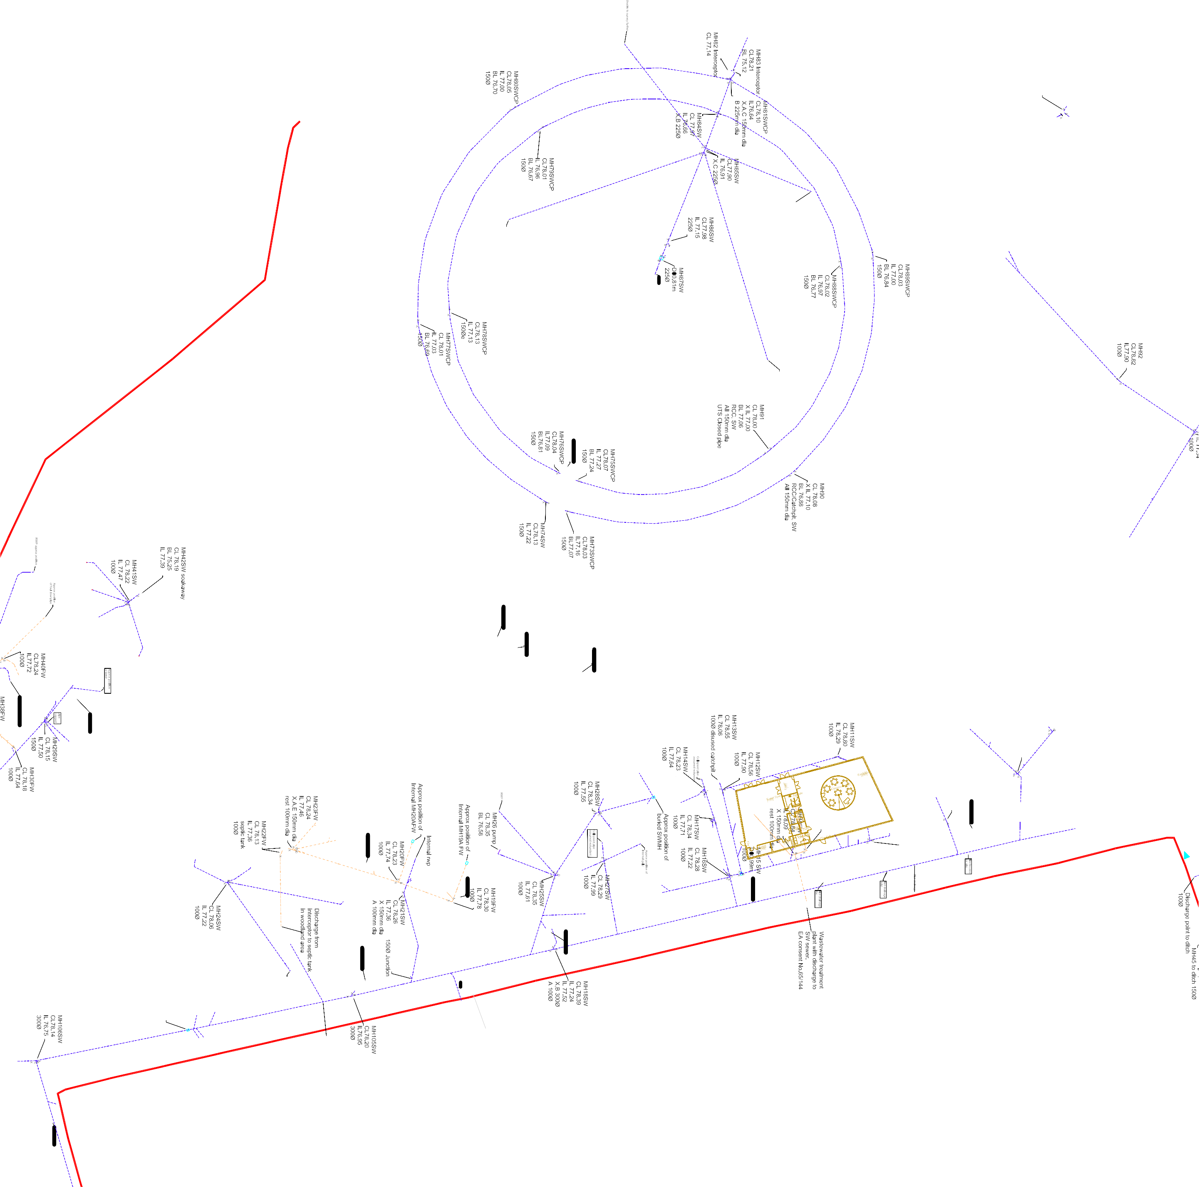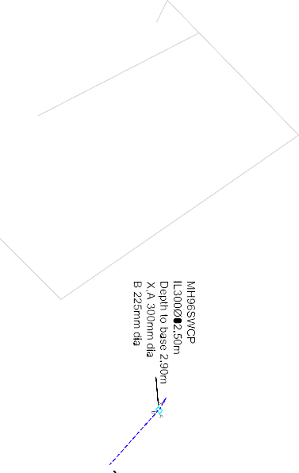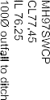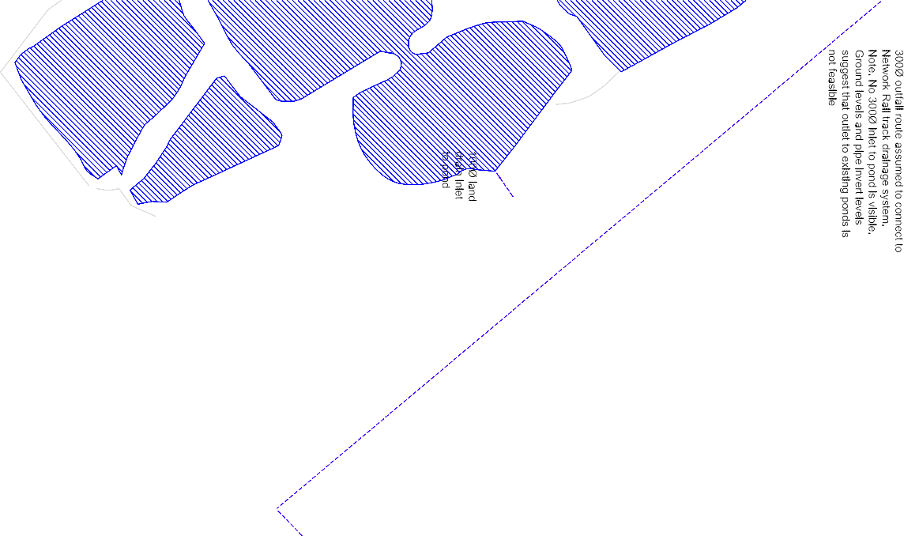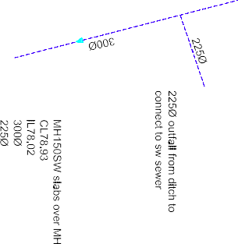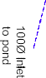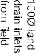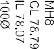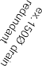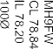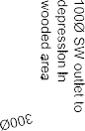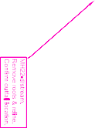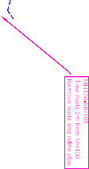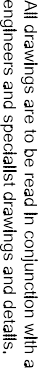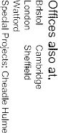

_o tOo­ -

-O i: ;;:,,

• •
t I•
,.
-
/ l _ 'I
.. Approx •• '

UTR
_..I \"<11J11! \ CJ\ ' ,
.... .<f• / /

0 o..JL
"' • • " -
.. poSnion of
- - # 'I ER .- - el '

"< 0-
77.39
. j •
- r I
buried SWMH
i l-MIO!-lllliiii-ricllll·>-IOI
,
..
..
\ ' , j\.;, ,
L._ . · ·
GENERAL NOTES

o- (jO-
\ '-.......-' -1-7,
,,_,,_
..
i' ,_
i' '
-. " .#' .
':i
.I
..
("- -
-< I
""""'
:I Do not scale from this drawing. Work from figured

/ o"' ----- f •.
.. , ..
!- - -,, ! t, " " - - - - <
mensi
mensi
metres

"' Q o- o-
- v)ir- ,,
l\1 (
• . \ a.,,.. .-

I IDG I
di ons only. All di
ons are in milli
u.n.o.

L 78.22 -0*'/ p1
. IL T7.47 / / / \ "'
10DIZI _/ /_ 11-..,,.,
,;;
.. , ..
i' ' . " •
"
·=-
- ,.. . ,
" \ '
-4" ..,_.M H -
No devladon from the detalls shown on this drawing wlll be
' allowed without prior permission in writing.
-

/ -'_ - I :$ \
- -;"- -1
, 1oJll! , CL7B.

/ ,, _ _ ---- !"'/- - I \
' , .. , ', IL 78.\ '

/r "c'--,--;,.-;
h,··· ; :·
...
,\
, --
...
,
· _.t - - .,., ..
- ,._. -
..
'
'
. "
\
.. 4 ....,
..
,
t ..
.
,,
,!_
All drawings are to be read in conjunction with all architects,

#/ -<e' o•.o ING. I I
"" , .
.. \
i ..·

'/,.T
•a1.1 Hatal!T I
r '=\"
,\
,\
,\ .._ ,-,,
...
• \ 1000 '"

':
- 0" ,..._,
engineers and specialist drawings and details.

• - (
'
,\
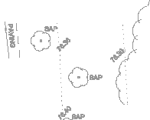,\ ,
, MH106SW

·- 1,-,.
• 1 .
.GU A- 1111!1!
••• ••
DU. • '
• ..

..
<:- CL78.14
IL 76.75
3000

..
..
...... "
-Jc
"

,,. .
..
:. ,,.
,,.
.. - "
, '" •\
,..
'
:,_
/
·--;.,
'
SAFETY, HEALTH AND
.; ENVIRONMENTAL INFORMATION

,, '
.,?"
"""-..+
,w,.•.
..
.. ..
,,
.
,,
,,.
.
,
\:g.,
':
,•
'"
'-- '
"
' ,

# 9 au

••
MH1Q8.MH1D7
,,T'r-m-m,o.la.o,ljo.l.0112irnplpo.

..
.iw
..
,
•..
#i f {}
,,.'"..,
._... '""'.-...
.
,,.
,,.
... ,,
.. " "
. .. ..
.
\ I
\ t- -
:
INADDITION TO THE HAZARDS/RISKS NORMALLY ASSOCIATED WITH THE
;( TYPES OF WORK DETAILED ON THIS DRAWING, NOTE THE FOL.LOWING

"

.. I"
.. '-'- <-"' • .
.t ,,/I ...
-{ t-1 tt " . ·
CONSTRUCTION

,§' ::'·, ' S..l.Ml . '
"41

.. ..
-­­
••
··
'.gr ;r:."

..
t-:!. I <-f' IT
,'&" I

..
..
,#" -"' '-,
, ..
,
'•
,
.. ,, ..
...
,,
... .

·lrlATIOO -
<-'
:· ' ......
;;.L
"
,,
..,
,,,
..
,,. ,,. "
·',(.."'
, oft>]

DRlllWtCl!IU!lm" '
8D1.i
·9-a1.1
·= .f ... # :
l'
I • '
''
t' -' "
••
',",..,
'" .
,,.
... ,,
....
··
..

MH37
-·--·­
,#" :-
.. ..
.. " -' "\,..• ' ,>'
...
...
...
.."
.. MAINTENANCE I CLEANING

CL 76.16
IL 77.31
150llJ

.. ..
.. ..
<'--
•
..
... ..
"\..,
'""',
..
"
.(:.,,.
...
" " , ,
-
••
..
f. .
-
''
''
\
.. .
- Working In conftned spaces
- Working with llve flows
- Contaminated materials

\'-
# .(:.,,.'"\,, , ,
"· .. w" t•

D=1.02m
150llJ
\' •'
'
','- ,,.
J' - -,...,,

lro&l'l .. , ' '(:' A
'•
• ..
.. .. ..
..
.. ...,.,, ..
.. .'""' - ..
"
"
DECOMMISSIONING I DEMOLITION

I + ·r _--_ · · · <-;- - - -"-}'' -'s -I '
-t
'"..,,, ..

•••
1 1 ',
'
""

I :::"'" I"" i1
.. •'

..
"" ..,

.
..
•• ,_ -
::
../!"fr
•• '" ..,_. • r r
" ii " It,...

• ,
&u•

\ I ND<M"rTOIOE !'J.O. ..
<:-"' ''-
,,.., <.-".'
'"""_)< /
!! • {...

·f ,,\
- _
,<-f'
_ _ _, I
I
.. .. ..
,,....

..
I \ G1.0 "

I ..,•"
IT IS ASSUMED THAT ALL WORKS WILL BE CARRIED OUT BY A

...-,,'<-" ..... <-' r BOI.
# I\ •SJl.W :.(:..,
1 \ (".... ' \
.. ..
.. ..
•
•
- - - I
..,,
,, <-f'
:\,
/ . ..
!t..,_..
COMPETENT CONTRACTOR WORKING, WHERE APPROPRIATE,
TO AN APPROVED METHOD STATEMENT

..

1 \ •
I""""
.. .. ..
"
.(:.,,. \ \ .,/ / / /
, '
•• •
...
KEY

'-- Ill\ - +I<:-+
.. ..
' _ _ _ _ , <:-9 : '
,·"QUI

l\H,
. ' '
!<:-11'

'
,- - _if' -
'
""'" ).·'-\ '• ,,
·.f
D1.Z
.
- -
..
-8- -SURFACE WATER DRAINAGE

' ', , .
-
..
'.r._, ,.. '-
,' .1'
..·/1,v,,,'(....," ·l·i
l <- - -

'
.. ••
" 1• ' ", • <1 1
"" 2250 o"Het lo
,,f

• • \ BU ,--,
Gau -
---E)
FOUL DRAINAGE

: 1 '<
',, / dltoh from MH64
.... .' ...
........ }- ·--, -e

-· ..
8 ', . , . ' •
.. ,,

1'
' ' .
9a1.1
&U

,..
""
..

' II f' II <-,
,. , •
II • JI<:-1'
-_,f,·
_<!_. -- ,(o,""Ai'
vz:z:z:z:z1 DITCH / WATERCOURSE OR POND

,, ' / 1 / --. _

\ \ --
..
.
=.i
,,..
..,.. ,_
· . ,
" ,... ' • •
, ,
"'' ,' .
.;.... ""
,,tc,
•l=-c
"
. ,
/i••
DC
DRAINAGE CHANNEL
••

1 \ '
• ' ...
rrt ...."" • '' •
...- - = = = -- -.-,. - -
..'' !'

= ..
' ''
.
" . ' « < "" ' / MH&isw
'!' f '\,< ,' --•
.•..• G
D ROAD GULLY

I \ <-" \

I : ''
, t '"" , • ,
,(-
CL77.75

+ + +
11 <- \ CID.I • \

I , a1.o
'.<-'

\ .
.' .
.. • ••• ' ••
' •l',•.• •--= -
- 1 " ••w• t 1,',.•-. I2L27"7'.15 ..

"\ \ I"f I
1 . f:' <-'
• • ' · • -·--· = =-.= - - • •' , - ) ... 1 •
RWP RAINWATER PIPE

\\ f' ,.
••• • ' "° .
•• - -- - =S-_----= = - -
<-•
<' "
- <-
' ••'
0- ./ / -,"•?" \ • I
•• t 1'
•
<l°
"' DR o DRAINAGE OUTLET

I<-
- ------:::0--3::-:::::.--:::::. -:::::_ .,,- - 'j> i
" I ·, ICI.
<-"

\ ', '!'...
'"- - - - = = ...,...= = = = - -·=-= = - -" 1I,' • I
• ••
• ''
' ',_,.-",.- '
.."..'.. "!OJ'
..., '·<:-
•.,,

= - - - - " I .. " • • •• • ' .. " I NJ
./!,,
CP D
CATCHPIT MANHOLE

­ 't'
••t'
•.•... .
.•.. .
•; ••
•' ""
.. • .. ''.••
.,''G·""
. ..\\'\,\<',-., ,••., •.,. 9 .1/.
. ••
...
UTL
UNABLE TO LOCATE

• " -
"
" ' .. ••
<-.;- ..

• "' ..
2' . ···
l
..
., '" n '
...
I' s' -'-.......tn.r . I
UTR
UNABLE TO RAISE COVER
SITE BOUNDARY

. • ..
. c• •"' • ,
- ,,•.
' ,,,, - '
,< '
150
# ·
.. .. ,

• · " '' '' ' " M 152,153 I
' •'
-·:±--

Q-t•
,. .
'
", 0,;r11ot o"'),J!•m:

.. .... •' <r • "..,• . , , • r"· ..
/
.. ..

----------
C,:"'"'"'"""' I\ <-*· .(:.°•"
<:-""" •
_ ..,. w• •I
t: ..'
<-'/ // _/ / I II <-""
' ... --
I---i.;'"' d"l=OJm •
.-.
13A002/001 & 002 DATED FEBRUARY 2013.

l ...,. 'I
_ _ T
•
•• ..
.. ,1'?,< ' / ,< .. '_===:_-J ff MHjs18»' CP
I
ow .. --'.. ' / '""'- '""""'
..
_,m
NOTE. TOPOGRAPHICAL SURVEY INFORMATION IS
BASED UPON SURVEY OPERATIONS DRAWING No.

.•. ' ' •

" 'f
..,.
@I I'
I:j ..

'\'!"

..
't' r-'-1 \/ - <-_' , ' .(:.t u' ." M_H154SWeVr!7" // /

..
+
1 ""'",''<> buri1&5t1A S'V

' •
•• •.'
<-' . . " - • •p <:-•
<-•' 'I I
d1.-p0or.z4im
. j "'E!:.:J
\ \ ••
'!'
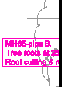"
-:!:

' •• •
i'- ""-" I l
=.. •

t" <-.. •.<-• I
,1 .,.... .,\,
-..._.,

• <- ..
.f \ I <:-1' . '\'
'!'.'

+ + +
-\B'>U.' ..
"
• ••
ft · · · • \ I '\, \ ..
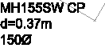•• .c-J!' ' ' \ ',, """"""1 ..
I \
E)\ \ \.(:..,

..

'
'

lli
.. ..
',----4-.D
<-' <-'
B..'8·L----r---n1

• • ...
fl '\ " '\ ,, -------------.--<-. /

' •

.-. .. ..
..
.. .(:.fl '"\. - .

' " 'Q.... ••
<- \ \ --------------- --------- •'

1 1 1 1 1 1
&<.1 • <.-""
<-" ,.

••
\ \ \
(:..9-"\
\
"
'
••
·

.. ..
.. -Ba.•
"' ..... Updated with Tower Surveys

"---\._ ,._/\
• . ", .,.,
"' A
11.11.13
survey data May & Oct. 2013 and
proposad ramedial works. Surface SH
JS
..
..

..'
••
\
••
..
..
OCH>-\ """"'D 1'
.
.
" "
,.
• ..
\ Rev I Dam Iwamr outfall = dad I By IChecked I

\ .(:.'1'
.. \
' .
<_' t' ·<0,
.. ..
•••
.. •• • .. m..

' ' <--"p1'
•
---... -:<-1'
' •
• 11o "-= dh> ==' d! ""I Client:
•

"" ...
/
• ···•'..
. ,_
• - ,,.
•• UNIVERSITY OF MANCHESTER

\<-9 '• >.(:..,

\ .._<:-9
\
. '9·.,·.of
• ..
• •
OU •.(:.iD°
-... ..
<:-_
••
- - - - ::.
_ _ _ ,(! _ _ _ _ - - .(:.. ,,.
••
"

•• •·
',.
••;,,..
.•.••
Project:

....­
"'

----
.
O "
. ..
•
_ - lP'
®
,
A,P -
.. ..

9a1.1
" ..
: --- ---
- -.-.- -
- c _ _ _ _ " - - - - - -
·· ·
.. GIA .(:.,,. 1•1•
•
"'
Tille:
JODRELL BANK

I, ··--
<-°' .J<-9
•...
<-t' @
.•..
•••
• • 9 au . . . , ..
SITE DRAINAGE

" .H
•
<-:••
- •
·-­-
..
<-°.' .•
aa.
"" 81.:1. "('.. ,

/ ea1.1
,
....
., ?.
••
•
aMB DIA au • "" •a1.1
,
..
I • 1

( t,!'.,,, •au
' '

'
  - •au
• ·· -----
<- - ..... ..---·----

!:<
G1.1
    - au

-
.---·---
<-' .....-
LAYOUT

1/ ,
'
.
I -
.....

au
Bl.I . .;­
-Q·&<.1
<-1' .(:. au
B1.fi Q Qau 8 Oau
·---- ---•--•---­
·---- <:-" #
•' "
·- ..._. ..
SHEET ? OF 9

300ftf>""'1-
plpe at ditch

::-;,
"

l!l!L-----' ---
..

..
••
<-,,.
..
....
.. ,,. .. " " •
,, "

3000 across field to -------------------
watercourse in trees -----
Jlinction

•
\-t1-' " <-' .;, 6 """' <-.;,
..
•'
•• f
CAPITA SYMON DS
STRUCTURES
COnsuHing Civil,Sb'uctural & Geo-Environmental Engineers
MANCHESTER Offices also at:

A_/ -
.."
.·-,•
;Ollch

..
•• ..
.. .. •• • •
••
••
Clarnanca House, 9 Mellor Road
Cheadle Hulme, Cheshire, SKB SAT
Tel: (+44) 0161 486 1521
"Lo"o"d"o'o
Wa­
Cambridge
She!Held

•• Nl!il1REEH'"""1"12ri<
Fax: (+44) 0161 486 1580
Speclal Projects: Cheacl le Hulme

l!1

..
.. IN12'110UAL 1.RE.Ell
.(:.
E-rnal: aiplao1c111111.-111Qcap1111.cnuk
- rawn at MANCHESTER
..
Dole
March 2013

·••-•
.. • ..
•• •
Nm"&u_,..o
• '<-.;,
••
••
.. ..
@ A1
www.cepltasymonds.eo.uk/struclures

1:500 @ A1 Drawn SH Checked JS

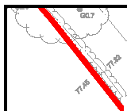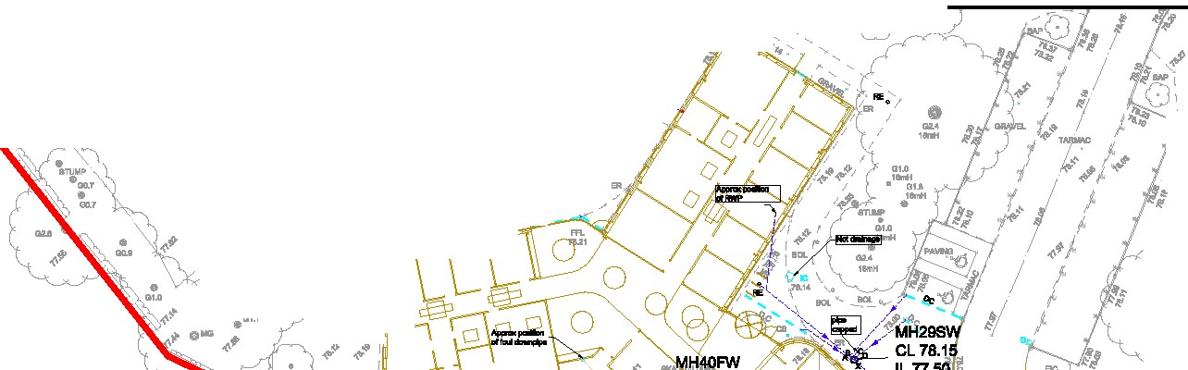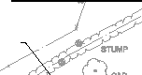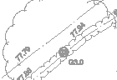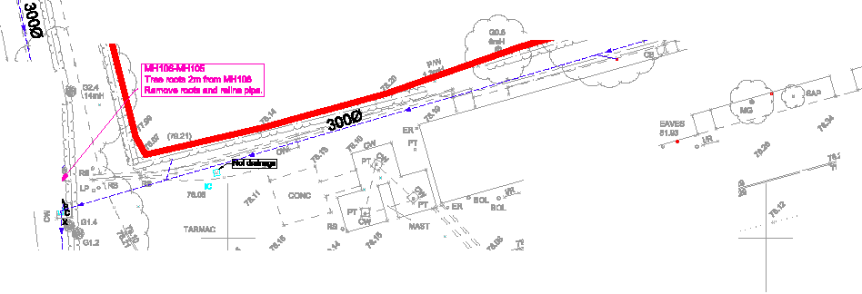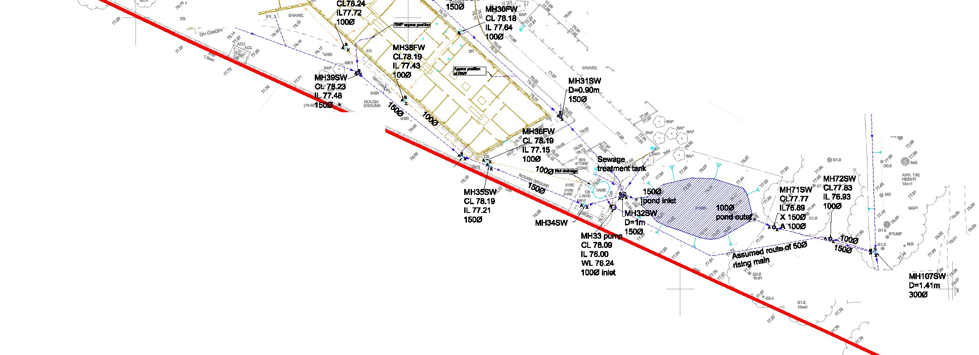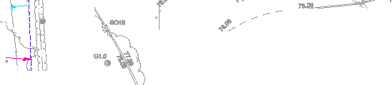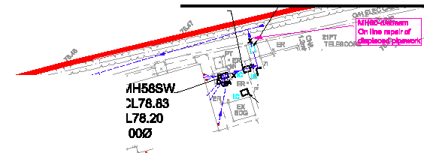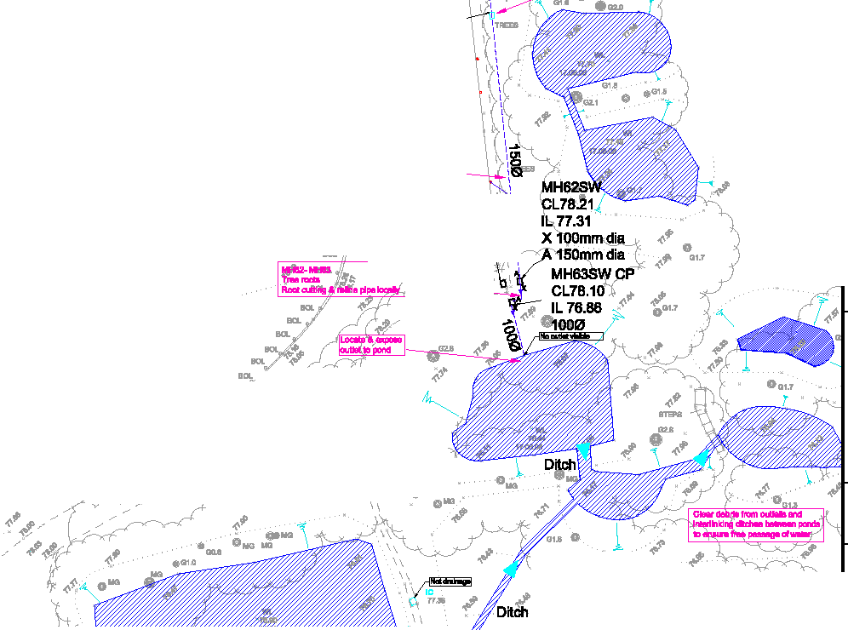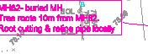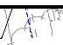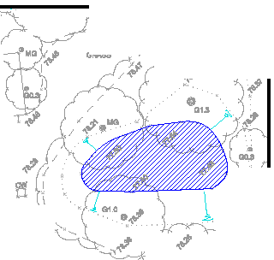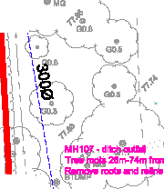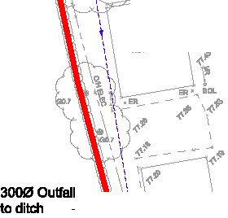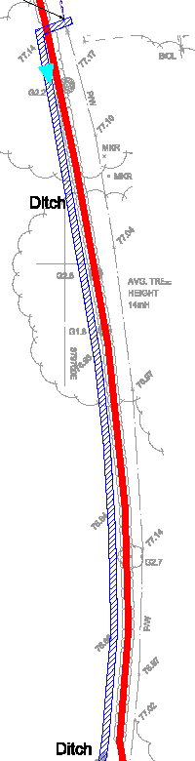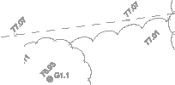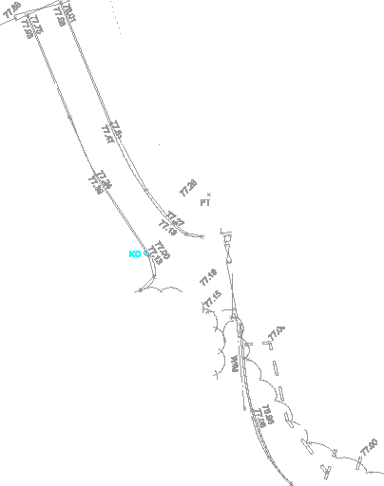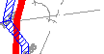Brook bibute1
•• · •
.. ••
...
!<-"'
••
Project No.: Drawing No.:
SS018706 207
Revision:
A

··-

GENERAL NOTES
Do not scale from this drawing. Work from figured dimensions only. All dimensions are in millimetres u.n.o.

No devladon from the deta.lls shown on this drawing wlll be allowed without prior permission in writing.

All drawings are to be read in conjunction with all architects, engineers and specialist drawings and details.

...
' ·- ,,
  - «• ; Drainage ditch terminates
field junction
SAFETY, HEALTH AND ENVIRONMENTAL INFORMATION
INADDITION TO THE HAZARDS/RISKS NORMALLY ASSOCIATED WITH THE

.,,
-- ·
'i'i2n .
· -·-· ·
Qi(

"'
.
,, Dltoh ,. ,;
.
.. ••
•
at local depression at
TYPES OF WORK DETAILED ON THIS DRAWING, NOTE THE FOL.LOWING
CONSTRUCTION

=-----c---c - .
' - - - - - - - - - --- - - ...
•• "'
'
•t ..

··-
='G ·,G1,3
,; .. .,_ _,z _ _ _ _ _,z _ ...
- - - .'.
·"'

,t " '...•- - - - - - - - - - 7 / - - -
-- - - - - - - -

<!_..
= - -
" .,.,.·- <!- - - - '·- - - - - - - - - - - '
"' 0 ,' ,, ,·"' .• ,-1 ;« " .. ,, ...
'
' •' ..
<- •-t

,, .. ' ..
..
..

,,, "'
"'
"' ... • '
..
0MB<-"
'

" ' <!'"
., ,- -'6J,',,,... "'

l.
I
, ',
' '
"' ••
... ·
I
<I
(
"'
..".' ..
MAINTENANCE I CLEANING

  - Working with llve flows

# ').l.i."9/ /
...,.._ a_
• lI I1# .(
''
',,.
,< o..:
    - Working In conftned spaces

'
r- "->- --\ = l ' '

"' .. "' "'
"'
,, .. ,, ..
1t ',
_ ,
'
..
'

f'll'
"• ,
I
,,
..
' '
' '
"' ' ' "'
"' t"' ,.
.. ' • ..
".
'
.. ,
  - Contaminated materials

·!, - ' ;- - .•
I ,:. I
- r)' ,
'' ',,, I
  - ' I
" ' '
' '
':.1. :.!'.." '- ,. ..
' ••
DECOMMI
SSIONING I
DEMOLITION

-aa.

'"
MH
- CL78.R
' -IL 78.3\1 ,
-..
.,, ' '
'
I '1 _.,.
' '
,, r"'
...,,..u-w;o
,•,
'
.• ''
VG1"EE tt.aGIIT12ft<
\:'m

-·,, "' "·
,, 4 ",·'1
"''
10DIZI l
'
t ,>'
-
"' ,., '
" :,•
..
.."

.,, , · ,,,
' '"
...
IT IS ASSUMED THAT ALL WORKS WILL BE CARRIED OUT BY A

,, ,,
"' '
'
" '
"''
,.'
'
J' -
(.'),?
/ G1.1
{au
:,1 ,, ,, '
,, ,,
"' • t•

..'
,, - ,,
,, ,,
',_
i1<' 0 ,, "'
,,I ,
"' ,,
''
'I 'I
TO AN APPROVED METHOD STATEMENT

.. ,, ,,
,,
,,•'
Ii' #
.;t
...
"\
'
'
'
"''
o-
'
I' '
'_,.,,
"'
(j)
'' '
,f I 1
.
...
.,,
.. •
t' ' t•
••
.. •• .. ..
COMPETENT CONTRACTOR WORKING, WHERE APPROPRIATE,

KEY
-8- -SURFACE WATER DRAINAGE

,, .- -\, ;
..- ','
,, ,,
• ••

,,.
... ,,
,, - · ,,
,, •
'' ''
"' I ...
' i
I
I ·
.. .... .
'
<-"
'
'
.
i
-f) FOUL DRAINAGE

!
.---- -- -----
"' ... 1,..---...
.
-

... ... ,,,
' ·
...
'."'
4.'f> I 1,q°,"
' '- .. ..
•... _ .·· .
- -- - - - - - - -- --··
•• ..

I' I'«t
.• - - - - - - - - S- - - - ..
,.- -i-<-f' I ,
vz:z:z:z:z1 DITCH / WATERCOURSE OR POND

...
. ,,,- · -·- -- - :, ' 1 •c 1.i , - '
----

.. "'
,
..
"' ,
. ·- . - -
. .. .
.
$-' -
'' ',..
Assumed route
1500 DC

,,
,;'
...

IH62
· .(>
.. • .. ,.

.. ..
of
outfall across field towards Beec:h Tree farm and discharge to tributary of
----
DRAINAGE CHANNEL
G D ROAD GULLY

..
"' ".. ..
-;i ;'h-!'
"
l ""
'pL78.5:1 1 77.31
X 1QOmm di <-'
f M,SHO6!'3QS.in diap. . . <.-• o"'·'
<-'!-
"
..

... ..
:<-'

••

I
'
<-9 I I
I !<-9
I I
I iI

< I
I

Note.
Tap roots at joints
within survey length

----
Dingle Brook to east of A535
-----
RWP RAINWATER PIPE

DR o DRAINAGE OUTLET

.. ..
,i. _ -
<-'
CL78.1'(/f .,_
.#G' U ••

IL 76.86 ..._ <-
i. ·
ei ""' 0 .
'*;t <-"'
< I
' ' ,< , ,-· ·'EXl.mo1 '
 |  | \ | -•

CP D
CATCHPIT MANHOLE

1 .,.
:-1\ .;- -----------
survey
47.5'.2- . 1
UTL
UNABLE TO LOCATE

- ..v/:fr
I · ,,
fo
-.-.... .... Dt.1
UTR
UNABLE TO RAISE COVER

- ..
/ ..,_. • r1
<-' If . ....
I I "t"
:· · , i ,;.·-r·
--M - - - -
--"'-
- BU

- -·- - - - - - - - - -

\, <-' ••
•.., ..
!J #
through , e
--".
liiie!' •"I -- ,_
1.....
-r--"-- ,
.... I .... - -- -" "'·'
t"- - - - - :._ - .. • • .. ..
SITE BOUNDARY

  - • Dltdi -
:; - -- l

P ,.,.. - ,. f '--D=1.30m .,
,,• - - - - --" -'-\- - - - ,.
.:::2" 1U<>O - - - - -• ..._ I - "\ °$

\\,, .'
'•,,
..
I ..•
I I G11,. ,•MD
L I MB@ .
"
--4\ <- m oi .(- GD.I <9' at.1 1j;00 ".i ...
' 'I M 1p1S P . <-"-
1 0=1. <-" ;.a ---'"
.,
'
- <-.p -'!:- - - - - - _ _ o - - - - 1;) 1_.,3Z!Jl _ f' ,,'f _,? I - - -t"..._ - -- - '. \ g_
- - - <-9 <-'' ,, ,_. I 5" <- ,,'f / j ,tf ' 1 ,!" I !1..J> i
NOTE. TOPOGRAPHICAL SURVEY INFORMATION IS
BASED UPON SURVEY OPERATIONS DRAWING No.

,,,
• ( 1500 .·· Gou <-op. - .,,
,_. <-" <- 1 1 .tt· - / n,,'f l 1 1

\ \ <-.,.
,·. ''- ,, ,
.
.
" ,<- 9. ' /
<- /

_,,._,.o"'..
<- ..... ' . :·
..
<-'I' #t_
,,J' I ..J' • / "' I \#° \ I
I I I """" / ,# 1 1 #
e ""1 I ..J' I #° I \ !
,,,
13A002/001 & 002 DATED FEBRUARY 2013.

\.\ \. "
./ / ,/
']« "
I I - -• .,
I"' I ! I _.

\
"':.J".:, / <- I
,Bt.8'
Gt.2 Q
;- -\ . l "<-' .I;_ ...
<-? / /
.. I I (1
1' '- I I l _A" <!'°
<- '-- '-- \ ...J' I f"
..
1
"' '
I
..
..
I
'I
w'
..

')".'."\\. ./ T
.!8..# Mal' ,
\ .#'
<-: ,
_ _•_
_!_ Y .....
4 ,. ••
I I/ . CJ)=.,'/ ,,., I \

15110 _ _ _
"' """"--- . ,

""" I \
·· .(- IJ'
•"'.2 OMD
.,. 1 -' r"? _,.
# _tf 'r--' I 1

<-f' / • ( '- 11"
OU - Tffi
oond
""'a.s:"""9 <II' • _,
<- ,. _,.., """'
t'!:_,. t,_. <- . (
9at.1
.,, ..
.. .. .. ,,

I I \'..
I',. .
"t_".('> 1'. Gau <-"- <:.--"----- -
1
1

67,GS-I
..... •
<-" " •
"' <!
" 'L --.. _J.. .. :

i<- r<-f'
..
I
I I
••
.
­
..
.II-., 2250 outlet to
-...... •·II,,,ditch from M•.H...6. 4
• •... • 0Gt.O \.. ·- _ -.: _-..."_'-... <-
QU - - <'-: • ...._--.._
-------_-_£'- .,,_- .,, .(-f' I au \\
r
I CL77.45 ,. / .,. ' .....
'
..
lGt.I - - -
X IL 76 7 _,. -.:au •.., ,
-A IL 76.51 <-1,. -' "<-? ..,_.
/ / <-" / <-" <-:
"' "
:r' ..
'I I
'
,,
..
"' "••' ••

\ "

150IZI " ..
.. •

I J.(-f' • •
,,
,.
.,. ,( 1....._..
<- / r , "":9
,_, - -
-,.:._

..
••
"."':: ;_,._/ .. l <-., '\\;,

••
/

't / ,,. / /.(-f'
'
I
' "'
·

' I ':... ..;:o-1
< I \\,\ . ·1
<-' fl <.-.p..,
•• .
<-
Gi.2.•.\\II
t / /
/ /
•.•..
,_,c_,,.YCxJ' "'
,, '·"' "'
-­
I
I GU
'
811\
w

!<-9 I 9
'
\1 L x\ _, · ----..- .,-
"' I .,. 11
\<-9
.
(
"' "' '
· "'
,,,,

' \ \'f,_' "/,,_
ft /'-'° /I<-• •.. I
(
..

' 'l\ <-'f' :' / ODNC /
,(:.'
•• i
., ",
.fT : ..
<- t
AVGTRE•IBIH1t2111H

<-f> \ " I <-' 1\ <-'t / MHs.fsW
4\ -::Jii"
i IWIKRC"f"- '
,. •••
• " $' .
"
-
-. t1· 5
<-
.. ,!'
( ..
..._.: .
Updated with Tower Surveys

l 'I' , - - _,. _,. """"''"" 1--..
i<-' 1
CLn.75 "•
,!' '

<- <- ;cc-- - <-9 ,,A • IL n:15
I i 1 ..,_.
...'
!,#
2013 and

, , ,,. , IU
..
I ( -f' '

-- ::::. ::::. ::::. ::::. ::t==
\ 'I" .......
<-' \
' ,.# .,./<-••·
22s·
",<-?
16iifOOIOatll.1

,.,. -
:
·""'"""_,1,R."ilOI
"' "' '
'
,, .
(
' '
,!'
r' ..
'..
...,

"( .··<-f' "I I ·,.t' _".. l
.r;
' " I
I IQ:1
"
•
A
I
! 11.11.13
survey
data
May & Oct.
SH JS

I·• .
<-• I . \ \..a<-a. 6 _,. _,. -.(-'_•,. /\ ..,. I
'I' <- +' '''
'·I
I : I CU11rt11. fllll
AWTREE HED!T12ri<
.. .. "'
works.
water outfall routes addad
Surface

'
,.·9 I " "·'
. <-f>_,. _,.
,'<-' \\ I
<' ;_
...., '<-9'
"!. BtA I

'! _,: -
I ,.. ( " J--:
"
t i

'' '
L76AB ..
,
.. ' ..
"-
-
,,
"' .. ,,
proposed remedial
...,,,.b,

-(!f> 11 " -....
_ _,,, 'fa ,. <-9 I \ 11 •,' f'
6 - <- ••
1 I I
'
at.I e
Dote
By Chocked

'1<-•
f G•'""
,\,I , I
'""-'
',. # ..
•• tt' ' '

.., iej
! MH66 +

.. .. .. ..
Client:

I " 9 f ,\ I I <-' .(- j t
<to : CL7729 <-
.,.,,. '
"#'' .!' ' ;'
VERSITY OF MANCHESTER

-(!f> I \ \.(- i{I T
" .;:-
' ' """" t1'

(. I ,.&..
I \ \ t .. ..
,• I """
<-" • <- I
,
' ',,..
I
l UNI

"!' I <- 1 'I' <- 1 1 1 i'
-J.
"-GJ.:;I . . . ,,
1,,

1 9 11 ••
-10-- -:.:
1--'1 .
redundant
'
- ,';..

'. M, ,152,153 . /
.,,
# p ..... /<-"' \.0,00 • .,. ,_
[to ex.·1
, -- -- --· -·-

Pif1p ouU ·1

I I°<- 'f' I I 5 interoeptor J
I , <- I I1500.J let dI
.. ..
...."
i /.
conne +
down- MHB6 .. • ;
-- l '
- /J - - • » •
Project:

• ,. • ·-
I - •" <-1'.:,.
' :l:i' ,. "1: ,.§
,< . ' ..- - - -...- -,;;- -
- -- - <'.
- ·- - .-..- - - - - - - - - - - --------- --------- -
- - - - - - - - - -
- - - - -- - - - - - ---...-...- - - - - - - - - - - - - - - - - - - - - -·· '· •• -

/ I I \ r •
·-· ' . 0 -- - - - - - - - - - .0 • • .. ,, °'' .. " °'·' ... .. - ,, •"'-" gGi.3 Gt.O 0 •
JODRELL BANK

••,•
I 't <- .-, <-f>

' / / / '1'°"'"
.. ' ' ... ..
. ...
.. .. " . . ..
Tllla:

<-"' /"•"•
(<-'I' <-
==:_ _-J f). 1S_y.v CP
=. < ' / ". o· ' • .. ,f "·' ·· • .. w• -> o•• "o•• •=
0 • •= .. =

-_--_,.
,.,
d=0.4m
/ /'\-- .?"' }", d=Cl.Sm •

( 1 ,, MH\11:1A SW
" ' · i
•"'
....
<' ••• - •
f .. T .... f
9 ·•

' <-" j
''
I<-' MH154SW I//' !f ,

I <'
_ •,
.. S
,
'
' <-" '"
...... -\
•
...
SITE DRAINAGE
LAYOUT

1_p<>0 r1 "O bu'ri
<-""
"'11· \ "'

,.@
,,.
I i =- \
.(-
,J _& I
' -··
'•Rising main to
SHEET 8 OF 9

u/ \ .-,

..
connected to 1000

,1 jll '
'
I • IOI.
'/ \\ =
\<\ '
....
ot.o I ,.,;;,. '\
- i'
'

"<(!.! '' , '\,_
· '\ \ f'
\ '•,, MH155:
'
·r-·- - - - .. , '
B

•'
Q\ \(_'---- -.ii :;7m
<-, '---a,!'_
··-
I <' 1
au
' I "c
' MH695W pump
' CL77.37
IL 74.37 inlet
CAPITA SYMON DS
STRUCTURES

.. .
..
io !! '.J.9Septi
. 77.09

<-1' I • \
' ••
p/ ••
I <Ill
••
Er-:'"'.rI
' ,•,_ - - -
BL 73.62
MH
COnsuHing Civil,Sb'uctural & Gao-Environmental Engineers

' '
.'..' -
•' D
<-' <-11' .,. .......Ba.• <-:I' """"
CL
'',;''-
MANCHESTER Offices also at:
London She!Held

.<-9 '\;: ' I i
••
·- ..
'

'\ ' <-,
· ..
.. '

..
....
L---J ••
--
.:I' UTR under fence
,
Clemence House, 9 Mellor Road
Cheadle Hulme, Cheshire, SKB SAT
Tel: (+44) 0161 486 1521
Fax: (+44) 0161 486 1580
E-rnal: aiplao1c111111.-111Qcap1111.cnuk
Brtstol Cambridge

Wa-
Speclal Projects: Cheacl le Hulme

,.. ..
'. '<·.-""'
••••
'- --.... .:<-1'
llTIM' ..
....
•• •
ER

11,. = db =- <d-l 11. = Jl
'
., ...- ?"-.. - = "
<-'
...
www.cepltesymonds.eo.uk/struclures

.,1:-1'
.. .
Drawn at MANCHESTER Dole
March
2013

.. •
•
..
•
·-••··••• ·-
<- <-'
<-• •
­ ,,
•• \ . .
···\'·:-:_·I_­,'
@ A1 1:500 @ A1 I
0
"""' SH
Checked JS

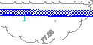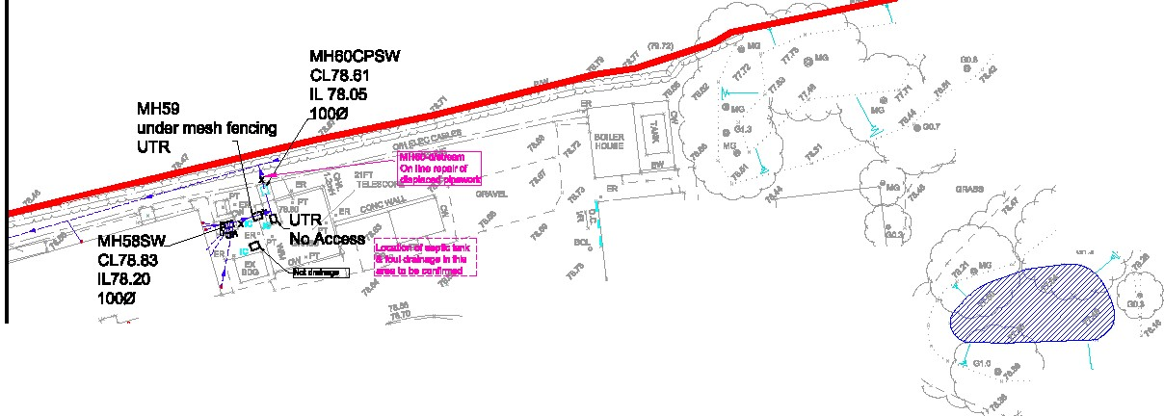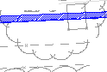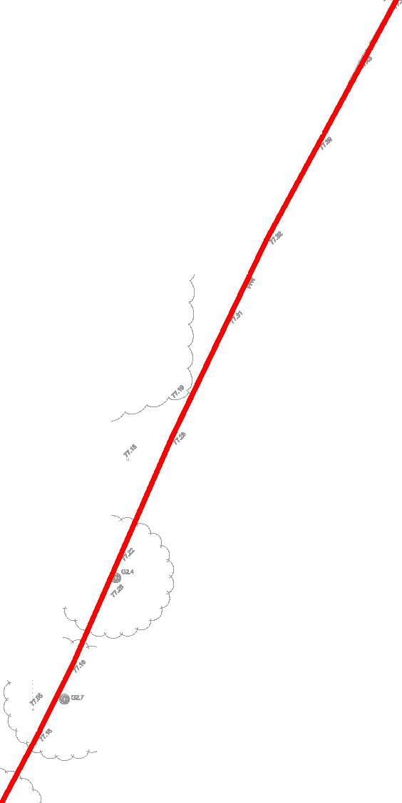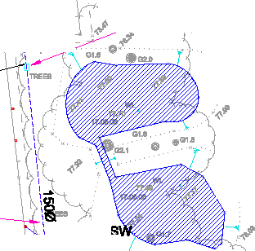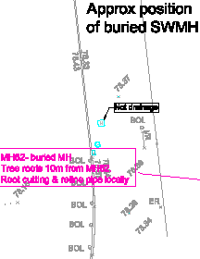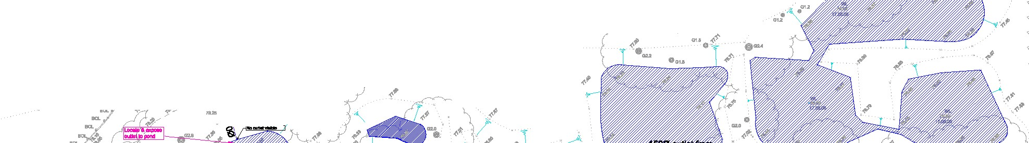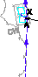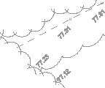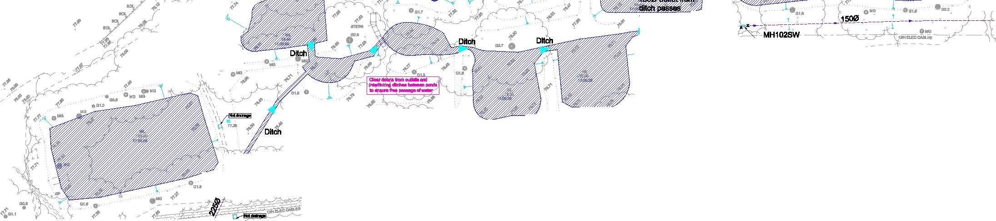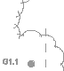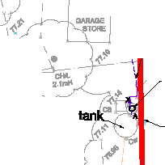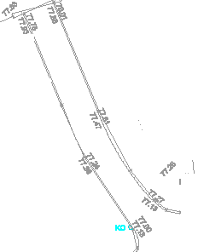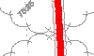• ··
au•.(-p '
1-

•• !'- - - -
...
au •••
9
<'
·• •
4' I I
9' & ""'' ··- ''
Project No.: IDrawing No.: Revision:
SS018706 I 208 A



I

I



! •
j!

·{>•- ­

!"'•....•.....
....

- -.-I·{>-. ':>....,
!!
'11 ...... '- . ..
....

..-.':.' ll!i
'"•1
''
-
I
.... ••

·••
• ••
••
·••

.. ·••
...
.... \ !
\ t.... '
\ ..,
.

...

•
•••
.•'•
..• \
I .•., •?"""

••
.. ••
'
•• • • \
.!.!.. .
'
.
!!.

·'

"' .•
.. ..
.-- _.._.
..••
•
··
•..••
•• •• ••
• \ • •
•• ••

\
...
"' I
'

I < ?
..
\

I!

...

\
...
\
\ i\
\ !\
\,.,, \
,..
\
\
\

\

•
I ... ....
I

•••

•••

•••

•••

..•
..
• •• ..
••
? •
' \

•• •
•••

\ \
\
\ \
\ \
\
\
\ ...
\
\
,
...
••
·•.. ••

\ ..
.... ·•..
.. \

\... \
\
\...
•.
.. ....

..
... 1?'1>
\
\
I

...
\
....
...
....
....
\ \
... \ . · .
I

\.... \
. ..
,.,
.;.
.\ \

\ \
\ \,...
...
....
?...._ ·?

•
..., · ... I
\\

... ...
\
\ \
\.... \
...
....
.. •••
·•..

.. ..
? '.

\
.... .... \ \\
\ \
.. . \

• ...
\ \

..

....
\ \,...
\ \
\
...
...
...
... ....
..•

..

...
\
.9 I
l
\

•'\,
.. ... ...

.. ..
\ \
',·\\
\
,
\... ..
.. ..
....
..
...
••
I ••
.. ••
\
\
••• \
••

....
.. ....
...
..\ \
.
...
\
\
\
.
...
...
...
... - (

!
•• •• '
' ! ! !
... .
! ... ••
...

.. ..

-'--·
..
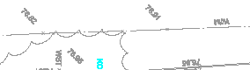!
.. -
\
I
..
\

. ' I ..
"
...

I QI 0I
.1 ..
... •

•• I
• .
·- ---T'"'if§"I--­

,,
'
J_
••
0

... ?... ;

.... !
•,....
...!.... !
\ ?
II

.•..'•
!.... •
- i I
10 I ' } A

;;; ....
..j!
·-1·...
I
\
r- - - - - - - -
I
.. ••

i

en .. en t
0 i..f §
il-f-+_>_+ 1
<m
c: c: o c
"'C ;:o
ii

I
I
I
Gl ••""

G')
0
m m
m
0 z z

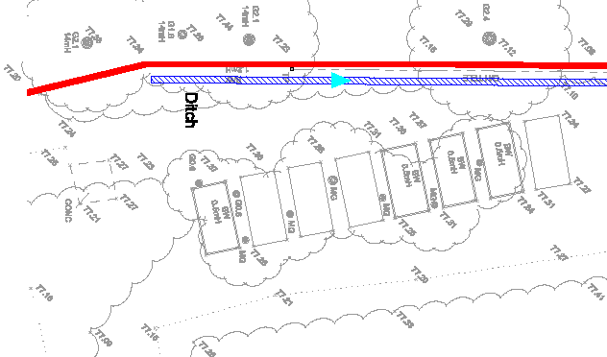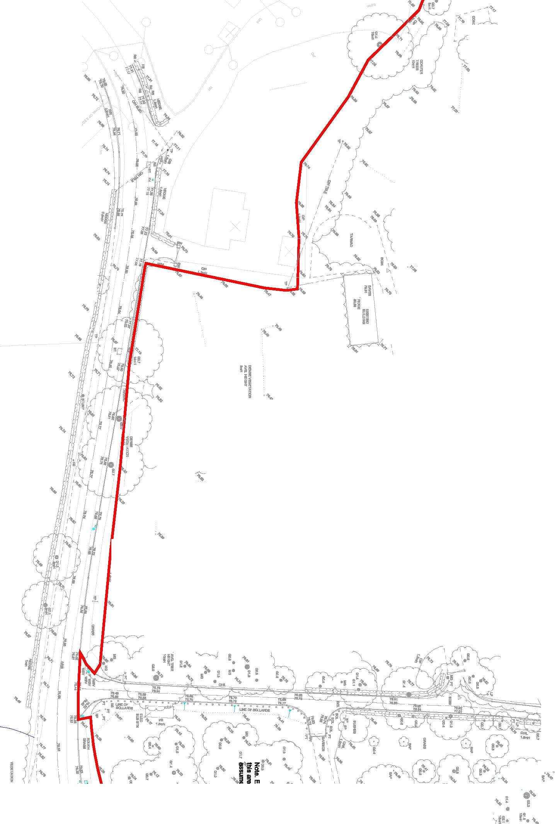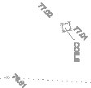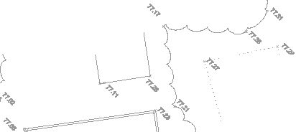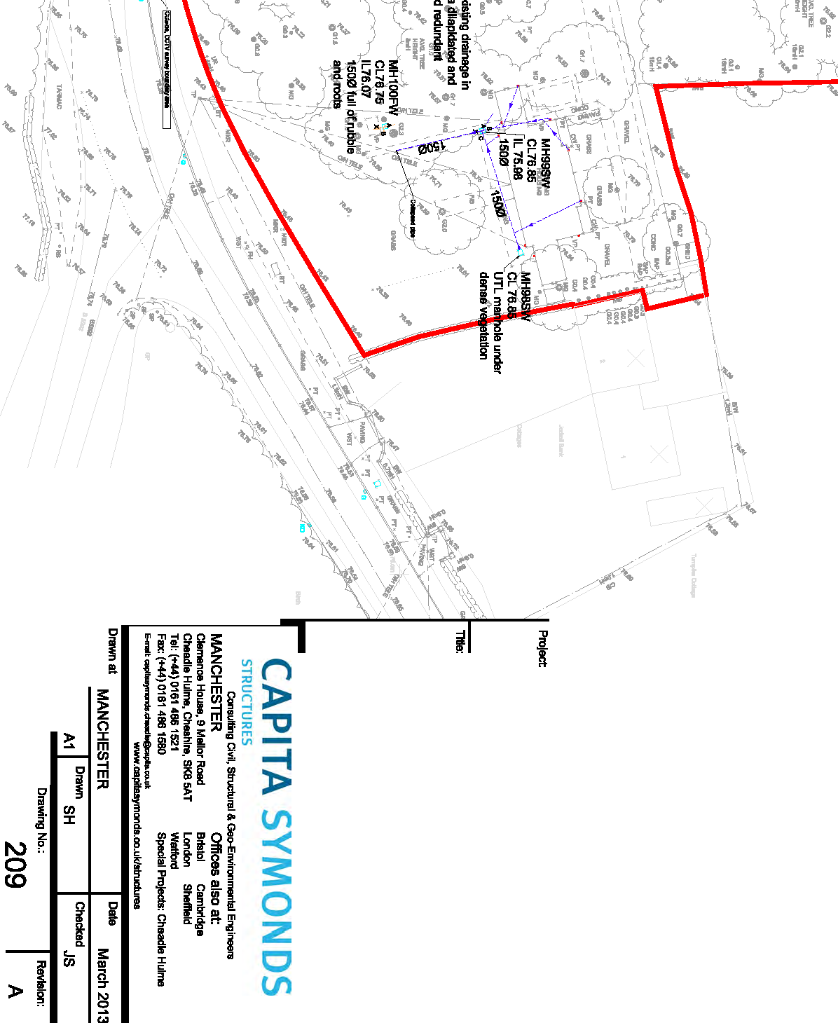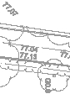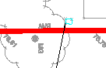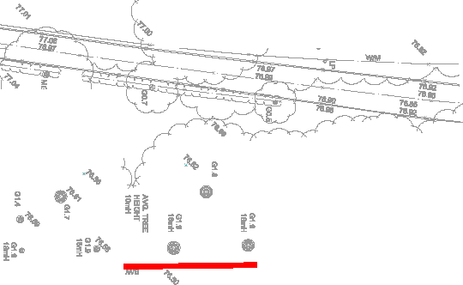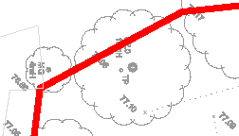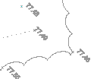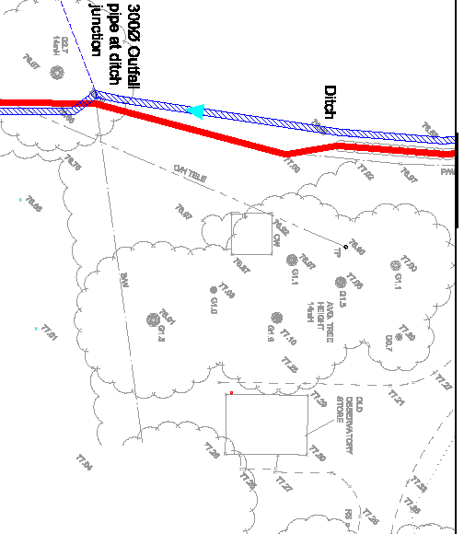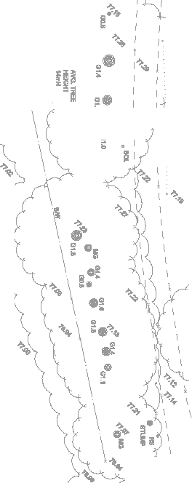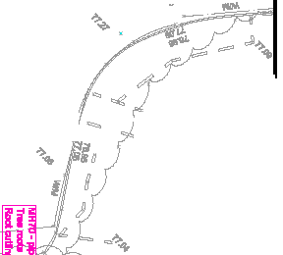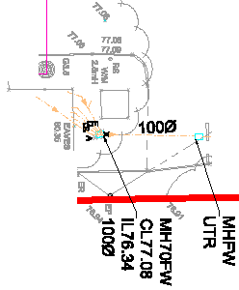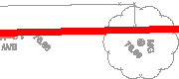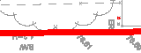0...0... @
0co
c....
0
0
:m:0
r r

z
;;ii;:;
-
0
'Tl

z
()
I
m
m
;:o

en
:i:
D a " D I
I I I
I

Gl c: r
!(
6. qI:i
I
0s: -I
s:
m
en
z
en 0
-
0z m
-
z 0
G) r-
0
m
s: z
0 G)
r-
-1
0z
;c en
0z>-.,,
s: m
zm _::;!
:;! ::c
r- m
-> z-.,, ::c
o;c >z
o
0z
m
r
z
0
-mI
en

Capita Symonds Structures
Clemence House 9 Mellor Road Cheadle Hulme Cheshire SK8 5AT

Tel +44 (0)161 486 1521

www.capitasymonds.com

