2018/19 Carbon commuter survey summary

Introduction
Since 2012/13 the University of Manchester has estimated the carbon emissions generated through staff and student travel within their commute, these are known as scope 3 emissions. This exercise is completed by surveying participants on their travel behaviours once every two years over the same period in April/May. This paper assesses the trends identified in the most recent study within the 2018/19 academic year.

2019 Survey
Staff and students were surveyed for two weeks from 29th April 2019. Students were either interviewed on campus by field researchers or completed the survey online publicised via the students’ union, and a sample of 1500 staff were invited via email to participate in the online survey. A total of 870 staff and 1,130 students responded to the survey which, based on a student population of 40,241 and staff population of 12,356, met the necessary sample sizes to generate significant results with 5% error at 95% confidence level. Response rates were much more successful than 2016/17 participation rates with 136% more student and 65% more staff responses.

Scope 3 emissions
Total emissions generated by staff and students travelling to campus have decreased by 9% since 2012/13 (Figure 1 and Table 1).
Figure 1: Staff and student total commuter emissions (tonnes CO_{2e})
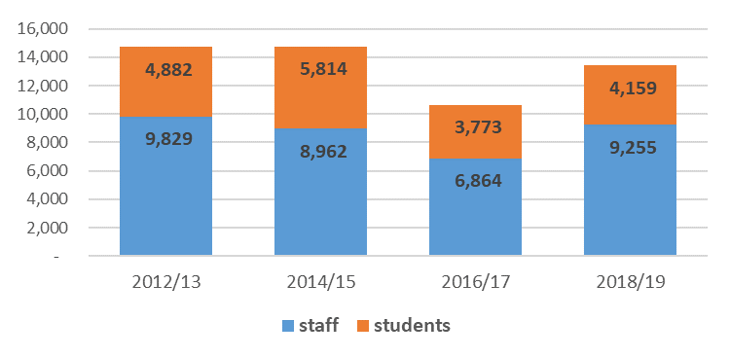

Table 1: Total commuter emissions (tonnes CO2e) per year
Year | Total commuter carbon emissions (tonnes CO2e) | % difference to 2018/19 carbon
2012/13 | 14,650 | +9%
2014/15 | 14,776 | +10%
2016/17 | 10,637* | -21%
2018/19 | 13,414 | -

*note this is adjusted from previous reports to account for more accurate total staff and student population data for the academic year. Similar adjustments to previous year’s data are unable to be made due to insufficient available raw data.
An investigation to explore why carbon emissions have increased from the previous study, have identified the following:
- Whilst carbon factors have marginally improved since the last survey, and no significant changes in transport choices have occurred, the total distance commuted is a third greater resulting in this increased carbon impact overall. Assessing the mileage of previous year’s commuter studies, the current distance is more comparable to 2012/13 and 2014/15 suggesting an under-estimation from the sample participants in 2016/17 impacting the overall results (figure 3.).
- The increased commuting distance can be mainly attributed to staff, with their average weekly commute 47% greater than in 2016/17. The average staff commute per week is 96 miles, and this increase is shown in varying degrees across all modes of transport (table i. in appendix A).
- Students have had a more modest increase of 13% average distance in relation to 2016/17 behaviours. The average student commute per week is 27 miles, however this varies across modes with car, bicycle and bus increasing in average distance, and rail, tram and walking decreasing in average distance.

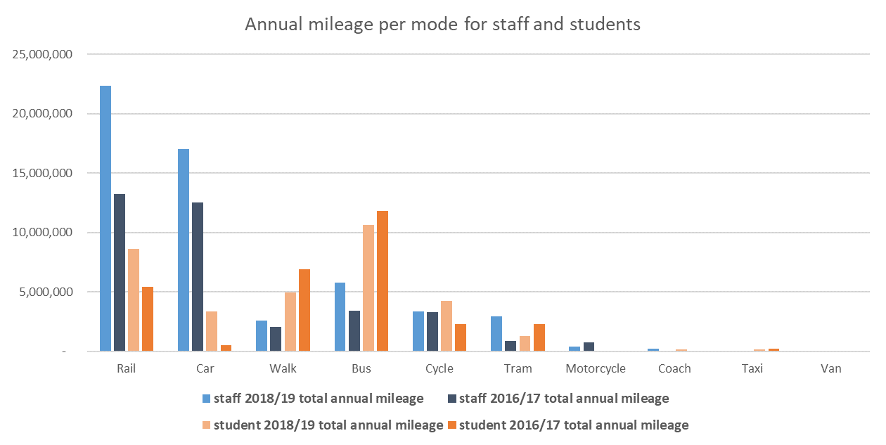
Figure 2. Annual mileage per mode for staff and students 2018/19 and 2016/17 comparison.
Figure 3. Annual total mileage for staff and student commute over 4 previous studies
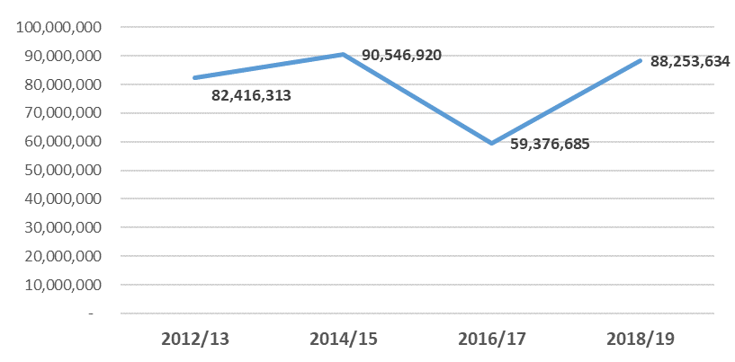

Travel behaviour
By capturing the mode of travel used most frequently by individuals, an analysis of the main mode illustrates general travel patterns of staff and students. However with more flexible working arrangements for staff and students, it is also useful to review the proportion of all modes used, to capture multi-modal journeys and alternative modes used to a lesser extent throughout the working week. A detailed comparison to 2016/17 trends can be viewed in the appendix.

Student travel behaviours identify that sustainable options remain the most common:
- Active Travel (walking and cycling): 48% main mode and 53% for all modes
- Public Transport (bus, rail, tram, coach): 46% main mode and 41% for all modes
- Personal Vehicle (car, motorbike, taxi): 6% main mode and 6% for all modes
There has been a small shift in student travel behaviours with fewer walkers (down 3%) but more cyclists (up 2%), and fewer bus users (down 6%) but more car use (up 3%), rail use (up 3%) and tram use (0.4%).
Figure 4. Student main mode of travel Figure 5. Student all modes of travel
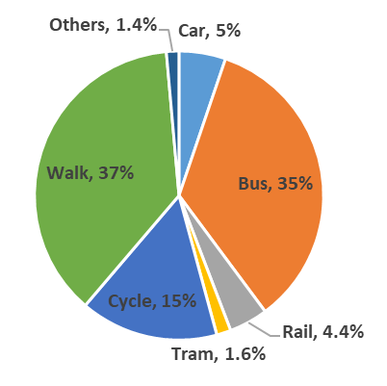
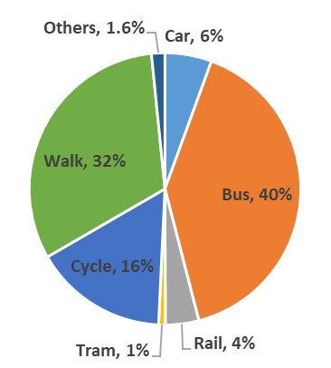

Staff travel behaviours identify that personal vehicle use is the most popular followed by public transport, although this is more changeable when accounting for all modes:
- Personal Vehicle (car, motorbike, taxi): 38% main mode and 26% for all modes
- Public Transport (bus, coach, rail, tram): 37% main mode and 38% for all modes
- Active Travel: (walking and cycling): 25% main mode and 36% for all modes
There is much greater variability in modes for staff than students when incorporating all modes used, this demonstrates how staff are more likely to have multi-modal journeys and have different options for commuting to work throughout the working week. Modest changes are seen when comparing travel behaviours in relation to 2016/17, active travel has reduced (walking down 2% and cycling down 2%), public transport up (rail 2%, tram 2%, bus 0.5%), and car has decreased marginally (by 0.3%).

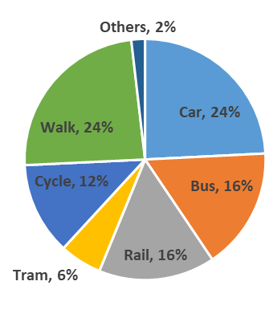
Figure 6. Staff main mode of travel Figure 7. Staff all modes of travel
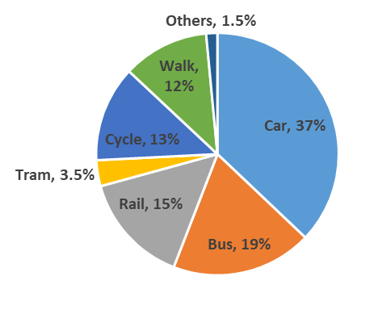

Travel distance
To complement the analysis of travel behaviours demonstrates what proportion of people are opting for different modes, reviewing the relative distances provides more insight to understand the cumulative environmental impact and potential for substitution to more sustainable travel choices.
Figure 8. 2018/19 Annual distance travelled by mode (miles)
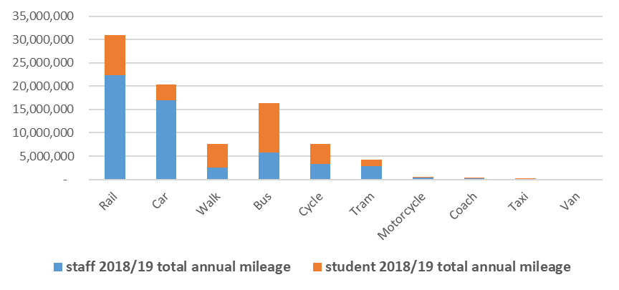

- Despite less than 20% of the University community utilising rail as part of their commute, this represents the highest proportion of all commuter miles (35%) demonstrating this is most popular for those with longer commutes where active travel or other public transport options are not viable.
- Staff car users travel the second furthest of all modes (79 miles per week), potentially being less viable for active travel, but could explore public transport for some or all of the week as a more sustainable alternative.
- Student car users are driving more than double the distance recorded in the previous study (now 39 miles per week), this is however less than the average distance travelled by tram, suggesting there may be potential to substitute part of all of the journey to public transport.
- Greater average distances are recorded active travel demonstrating greater health benefits than the previous study for those walking or cycling.
- Average distance for students commuting by bus and bike are very similar, potentially highlighting an opportunity for students to swap bus for bike for some or all of the week.
Conclusions
The effect of the Oxford Road cycle lane continues to have positive impact on student cycling habits with greater numbers opting for bike as their main mode of travel, and facilitating a longer commute by bike. For staff however cycling trends have marginally fallen since the last study with fewer cyclists using bike for their main mode, or alternative mode of travel. This may reflect the longer commute staff are experiencing, however is likely compounded by the absence of readily available storage, changing and drying facilities to support cyclists across the University estate. When participants were asked why they opt for their given mode of transport, convenience was stated the most frequently by both staff and students, supporting the need for convenient on campus facilities to enable higher rates of cycling (see table iii appendix B).

Flexibility in travel arrangements is particularly important for staff members, a third of which choose their mode of travel to satisfy personal commitments. It’s positive that the proportion of car users is not rising, however with increasing journey distance the environmental impact of this mode continues to rise, therefore efforts to reduce this substantively should look to encourage car users to substitute part or all of their journey to public transport or active travel some or all of the week.

It's acknowledged that whilst this analysis identifies potential substitutions based on suitable distances, there are external barriers within the transport network and ticketing system which may currently prevent more flexible sustainable travel. Greater Manchester developments over the next year including potential bus franchising and re-introduction of a city wide bike hire scheme could provide more convenient, flexible and affordable sustainable transport options for the University community. Engagement with Transport for Greater Manchester on these issues as well as the connected air quality agenda (looking to reduce car and van use) will continue to be made via the Oxford Road Corridor Sustainable Travel Group.

Recommended actions
Continued research to further understand the reasons why staff and students are opting for their given mode of transport
Improvements to staff cycling facilities (storage, showers, drying rooms) to support a greater proportion of staff cycling some or all of the time.

Appendix A
Table i.) Staff modal change and distance travelled
 | Staff main mode – the primary mode of travel stated only |  |  | Staff all modes – incorporating modes used in multi-modal journeys |  |  | Average weekly mileage per  mode per staff
 | 2018/19 | 2016/17 | % change | 2018/19 | 2016/17 | % change | 2018/19 | 2016/17 | % change
Car | 37% | 37% | 0% | 24% | 25% | 0.3% | 79 | 53 | 48%
Bus | 19% | 19% | 0% | 16% | 16% | 0.5% | 40 | 23 | 75%
Rail | 15% | 14% | 1% | 16% | 14% | 2% | 161 | 99 | 63%
Tram | 3.50% | 1.80% | 2% | 6% | 4% | 2% | 58 | 26 | 121%
Cycle | 13% | 16% | -4% | 12% | 15% | -2.3% | 30 | 23 | 30%
Walk | 12% | 10% | 2% | 24% | 26% | -2% | 12 | 8 | 48%
Others | 1.50% | 1.90% | -0.40% | 2% | 1% | 1% | 59 | 45 | 30%

Table ii.) Student modal change and distance travelled
 | Student main mode - the primary mode of  travel stated only |  |  | Student all modes travel – incorporating  modes used in multi-modal journeys |  |  | Average weekly mileage per  mode per student
 | 2018/19 | 2016/17 | % change | 2018/19 | 2016/17 | % change | 2018/19 | 2016/17 | % change
Car | 6% | 2% | 4% | 5% | 2% | 3% | 39 | 15 | 163%
Bus | 40% | 48% | -8% | 35% | 41% | -6% | 19 | 14 | 28%
Rail | 4% | 2% | 2% | 4.40% | 1.40% | 2.90% | 120 | 190 | -37%
Tram | 1% | 1% | 0% | 1.60% | 1.20% | 0.40% | 48 | 99 | -51%
Cycle | 16% | 9% | 7% | 15% | 14% | 1.6% | 17 | 8 | 102%
Walk | 32% | 37% | -5.7% | 37% | 40% | -3% | 8 | 9 | -7%
Others | 1.60% | 0.50% | 1.10% | 1.40% | 1.00% | 0.40% | 27 | 13 | 101%

Appendix B
Table iii.) Reasons for choosing mode
 | student | staff
Convenience | 77% | 76%
Cost | 52% | 52%
Time savings | 47% | 53%
Environmental reasons | 29% | 38%
Fitness reasons | 28% | 32%
To satisfy personal needs/commitments | 15% | 30%
To satisfy work needs/commitments | 11% | 18%
Disability that impacts on travel decisions | 1% | 2%

