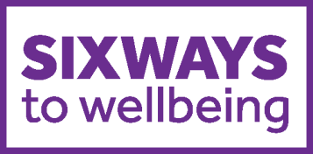

Event Planner
Please remember all events must be approved by the Wellbeing team first!
Once you are confident that you have fully planned the event, please complete the following form at least 14 days before the event is due to take place:
http://bit.ly/WBCevent-proposal-form
Event/ activity name: | Which way does the event / activity link to?
Aim of the event:  (What would a successful event look like?) | Date and time of event:
Target audience & estimated number of attendees: | Proposed venue:
Catering: YES/NO  Details: | Expected cost of event:  (If more than £50, please provide a breakdown)
Key contacts/organisers/champions (name and number/email) and what are their roles? | Room layout AND/OR resources required:  (E.g. banners/ furniture/ blankets etc.)
How will this event be communicated/advertised? (e.g. posters, social media – if so, which?):

Things to consider:
Audio visual requirements: | Accessibility considerations:  (E.g. wheelchair access, gender neutral toilets, visual considerations etc.)
Sustainability considerations:  (E.g. minimal waste, recyclable materials, reduce printing, energy usage etc.) | Timeline:  (E.g. X weeks to go, promotion; day before, reminders/final prep)
How often will organisers check in/meet before the event: | Deadlines:
Do you need to contact any key people to get them on board? | Anything else? E.g. name badges, photos, decoration, signage etc.

