KEY COLLECTION FOR WRIGHT ROBINSON HALL

MAP
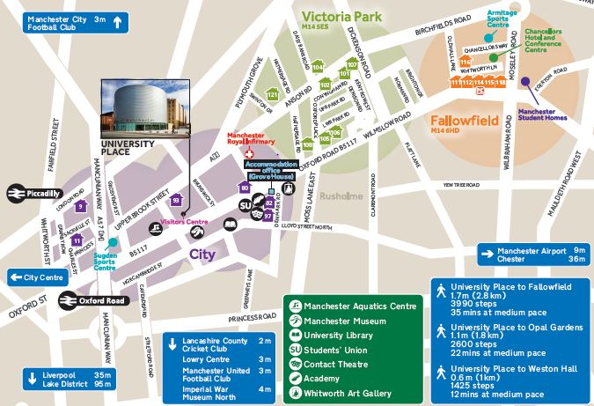
Wright Robinson Hall
(Building 9)
ULC
Samuel Alexander
Building (67 not shown)
rosvenor Halls
(Standard
Accommodation)

Location of the hall of residence can be viewed using Google Maps
In enquiry box, enter MANCHESTER M1 7JA for the UNITED KINGDOM and press FIND.
To get directions from the hall to the University of Manchester, use post code MANCHESTER M13 9PL.

KEY COLLECTION
Check in is available after 12pm on the scheduled date of arrival.

PRE SESSIONAL AIRPORT COLLECTION
If you have booked the Airport Collection Service on either 29th June or 27th July you will be transferred by coach directly from the Airport to your Hall of Residence. The Halls of Residence will have a list of expected arrivals. Please note that students arriving between 6:00am and 12:00pm may be asked to wait in the welcome rooms until your room becomes available. Further information regarding the Airport Collection Service will be sent to you prior to arrival.

ARRIVING IN HALL
To gain access to Wright Robinson Hall Reception you need to go onto the Sackville Street site, which can be accessed, from the Security Lodge on Sackville Street. Walk past the Barnes Wallace Building until you see the sign for Wright Robinson Hall. Wright Robinson Hall is a high-rise white building and the entrance is operated by an intercom. During office hours, you can press the intercom and a member of staff will open the door and meet you at reception in the foyer.

OUT OF OFFICE HOURS
The reception is not open from 1800hrs to 0800hrs Monday to Friday and all day Saturday and Sunday. At the entrance, press the intercom for assistance from Security who will contact the Duty ResLife Advisor to arrange your access and key collection.
The Duty ResLife Advisor phone number is 07917 213265.

BY ROAD Wright Robinson Hall is situated off Sackville Street within sight of the Mancunian Way (A57M) which links into the M56, M6, M60 (Manchester Orbital Motorway), M61, M62, M66, M67 and M602 Motorways. From the A57M, follow the signs for the University of Manchester.

PARKING: There is no parking on site.

BY AIR Manchester International Airport is 12 km to the south of the city. Taxis cost around £20 - £25 from International Arrivals to the hall. There is also an express Rail Shuttle running every 10 minutes or so from the Airport Station to Piccadilly Station. Taxis are cheap and available from Piccadilly to Wright Robinson Hall. A bus runs from Oxford Road to the airport.

BY RAIL Piccadilly main line station is approximately a 5 minute walk away from Wright Robinson Hall.
National Rail Enquiries: 08457 484950, National Rail Enquiries from overseas (Please note: International rates apply): +44(0)20 7278 5240 or web link: http://www.nationalrail.co.uk/contact

Wright Robinson Hall, The University of Manchester, Altrincham Street, Manchester, M1 7JA
Telephone +44 161 306 3131 Fax +44 161 306 8993
Email: northadmin.citycampus@manchester.ac.uk

