KEY COLLECTION & ARRIVAL FOR WHITWORTH PARK

MAP
Whitworth Park
(Building 82)
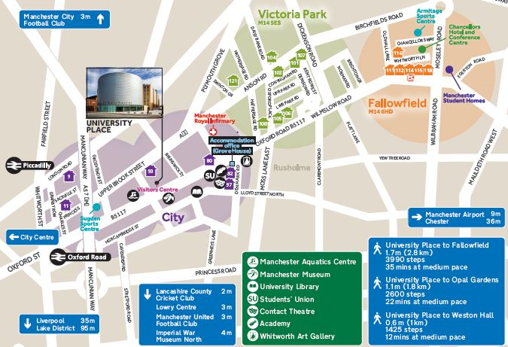
ULC
Samuel Alexander
Building (67 not shown)
rosvenor Halls
(Standard
Accommodation)

Location of the hall of residence can be viewed using Google Maps
In enquiry box, enter MANCHESTER M13 9WJ for the UNITED KINGDOM and press FIND.
To get directions from the hall to the University of Manchester, use post code MANCHESTER M13 9PL.

KEY COLLECTION
Check in is available after 12pm on the scheduled date of arrival.

PRE SESSIONAL AIRPORT COLLECTION
If you have booked the Airport Collection Service on either 4th July or 1st August, you will be transferred by coach directly from the Airport to your Hall of Residence. The Halls of Residence will have a list of expected arrivals. Please note that students arriving between 6:00am and 12:00pm may be asked to wait in the welcome rooms until your room becomes available. Further information regarding the Airport Collection Service will be sent out prior to arrival.

ARRIVING IN HALL
To gain access to Whitworth Park Reception you will see a white building on the end of a row of shops, opposite a McDonalds and Subway on Oxford Road. During office hours, you will be able to open the main door and walk down the corridor past the Mailboxes to the end of the corridor and the office is on the left hand side.

OUT OF OFFICE HOURS (EXCEPT FOR 4th JULY & 1st August)
During the hours of 18:00hrs to 08:00 hrs Monday to Friday and all day Saturday and Sunday out of hours key collection is managed by the ResLife Team. To collect a key during these hours use the yellow telephone at reception and press the button. Alternatively you can telephone from a mobile the Duty ResLife Advisor on the following numbers(s) 07774 995351 or 07789 480917. Please note that if you are arriving between hours of 08:00 – 09:00 or 17:00 – 18:00 you must inform the Hall Administration Office at Whitworth Park.

BY ROAD Whitworth Park is situated on Oxford Road within sight of the Mancunian Way (A57M) which links into the M56, M6, M60 (Manchester Orbital Motorway), M61, M62, M66, M67 and M602 Motorways. From the A57M, follow the signs for the University of Manchester. Please note that there is no parking on site.

BY AIR Manchester International Airport is 12 km to the south of the city. Taxis cost around £20 - £25 from International Arrivals to the hall. There is also an express Rail Shuttle running every 10 minutes or so from the Airport Station to Piccadilly Station. Taxis are cheap and available from Piccadilly to Whitworth Park. A bus runs from Oxford Road to the airport.

BY COACH
Whitworth Park is a 25 minute walk from Manchester International Express Coach terminal on Chorlton Street. Taxis are cheap and available from the bust station to Manchester Gardens.

BY RAIL Piccadilly main line station is approximately 2 mile away from Whitworth Park.
National Rail Enquiries: 08457 484950, National Rail Enquiries from overseas (Please note: International rates apply): +44(0)20 7278 5240 or web link: http://www.nationalrail.co.uk/contact

Whitworth Park, University of Manchester, 316 Oxford Road, Manchester, M13 9WJ
Telephone +44 161 275 4950
Email: southadmin.citycampus@manchester.ac.uk

