

This example of an easy access participant information sheet has been developed by Mary Hargreaves, Project Support Officer in the Division of Cardiovascular Sciences, who has kindly given permission for us to share for best practice.

Mary has also developed an easy access version of the research privacy notice, a copy of which can be found on our website.

The NIHR provide information on enabling people with aphasia to participate in research which you may also find helpful.

Division X
Institute of X, University of Manchester, CSB, Address

- Study title: X

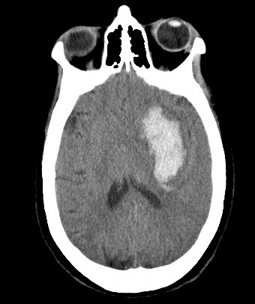
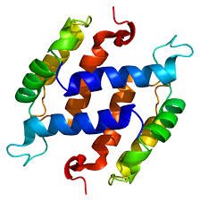


- The invitation. You are invited to take part in a research study

Before you decide, it is important for you to understand why the research is being done and what it will involve.

Please take the time to read the following information.

Ask if anything is not clear or if you would like more information.
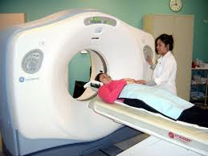
and an extra brain scan
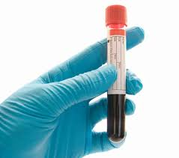
To have a blood test

++

- What is the purpose of the study?

We want to take a blood test taken soon after intracerebral haemorrhage (stroke)
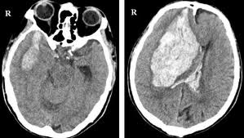

so we can check for a link between the proteins in the blood and risk of further bleeding (haematoma expansion).

If we can identify patients at risk earlier, it can be treated sooner,


+

+
leading to improved recovery from stroke and shorter hospital stay.

- Why have I been chosen?

You have had a stroke caused by a bleed on your brain
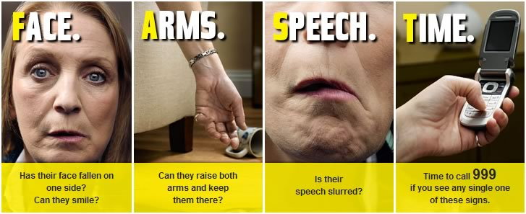


You will be closely monitored over the next few hours for signs of deterioration



So doctors can treat you quickly

- Do I have to take part?

No. It is up to you to decide whether or not to take part.



The standard of care you receive will not be affected in any way







The result of the brain scan will be available to the doctors looking after you. If you feel uncomfortable at any time, the research will stop.

You will also undergo an extra brain scan at 12-36 h after your stroke to look for changes in the amount of blood in your brain.
&
We would like to take an extra blood test. This will have been taken already when you were first admitted. We will not use this without your consent to participate in the study

A research nurse will also record information about your health, including medication you currently take and details of your stroke




- What will be involved if I agree to take part?

Soon after your admission to hospital

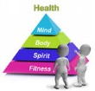


The research nurse will call you in 3 months to see how you are.

She will record how well you have recovered since you were discharged from hospital




This will end your study participation

7. What are the benefits of taking part?

Taking part in the study will not benefit you but you will help increase our understanding of haematoma expansion




8. What are the risks of taking part?

The risks of participation include:

-exposure to radiation during the extra brain scan and
-discomfort from the extra blood test.

You may pause or stop the assessments at any time.

You are free to withdraw from the study at any time.


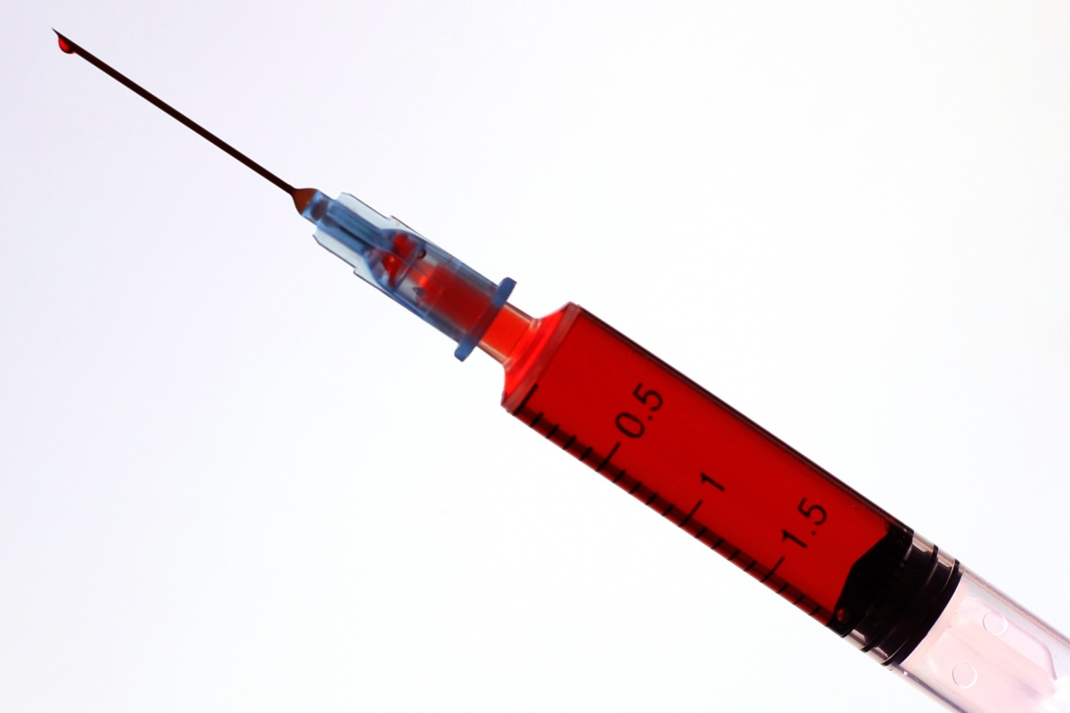



11. Who is organising and funding the research?

This study is organised by the X Division at the University of Manchester

The study is funded by X

This study has been approved by an NHS Research Ethics Committee
If you withdraw, we will use the information already collected in the final analysis.

If you do not want us to use your information or retain your samples, please tell us and they will be confidentially destroyed.
You are free to withdraw from the study at any time
10. What will happen if I do not want to carry on with the study?

9. Will my taking part in the study be kept confidential?

Your name will not be shown You will be identified by a number

Only authorised people will be allowed to see your information.

John Smith


and securely stored at X
All your personal information (name, address and telephone number) will be kept confidential

C131

12. What will happen to the results of the research study?
We will publish the study results in an academic journal.
The results may be presented at conferences.
The results will be part of an educational project for Dr X, Profession Here. You will not be identified in any publication.

13. What if I need more information or there is a problem?

If you need further information

or have any concerns about the study please contact the research team on:
XXXX XXX XXX

If you decide you would like to take part, please read and sign the consent form.

You will be given a copy of this information and signed consent form to keep.

Please take time to decide whether you want to take part.

Thank you for reading about this study.

Please now turn the page to read information about your privacy.
The law says that we must have a legal basis to collect your data.

This means we need to have a particular reason for collecting your data. We can collect your data under two legal bases:
1) A task carried out in the public interest
2) A process necessary for scientific research purposes

The University of Manchester is the data controller for this research.

This means the University of Manchester is responsible for making sure your data is:
1) Kept securely and confidentially
2) Only used in the way the researchers tell you it will be used

Your data will be anonymised as soon as possible. This means any personal information which could identify you will be removed.

The data remaining will be kept for X years.

Your anonymised data may/will not be shared with other researchers. (Delete where appropriate: ) These researchers will be investigating stroke.

Anyone who wants to use your anonymised data to research stroke will need to get ethical approval.

You can learn more about your data privacy by reading The University privacy notice

