Welcome to Horniman House
2018/2019

An information booklet for newly arrived residents

A very warm welcome to you and your family to Horniman House Hall of Residence at The University of Manchester.

The aim of this information booklet is to help familiarise yourself with Horniman House, The University of Manchester and living in Manchester. The information booklet is in addition to your arrival guide, crucial guide and residence guide. If your question is not answered in this information booklet it may be answered in one of the above publications that you will have been sent in advance of arrival or at registration. We hope that this information pack is a useful resource and would welcome any feedback on the document and suggestions on what could be added in future to help other new arrivals to Manchester.


Join us on Facebook:

https://www.facebook.com/groups/2062598073783597/

Our ResLife Team

Residential Life Officer
Wayne Boyle
Contact Details: wayne.m.boyle@manchester.ac.uk

Non-Residential Life Advisor
Justyna Drobnik-Rogers
Email: justyna.drobnik-rogers@manchester.ac.uk

Life Advisor
Sarah Amirah Sheaik Fareeth
Email: sarahamirah.sheaikfareeth@manchester.ac.uk
In case of emergency such as medical emergency, serious maintenance problems, e.g. flooding, concern for welfare of another resident and reporting a crime or fire incident and flat lock outs/lost keys please contact

Whitworth Park ResLife Team
07774 995 351
6pm – 8am weekdays, all day weekends/University closure days

University of Manchester Security –
0161 306 9966 (24 hours a day)

It may be a good idea to save the above numbers on your phone.

Welcome Curry Night (Free!)

Sunday 28th October, 4.15pm

(we will meet outside Horniman House and walk together to a restaurant in The Curry Mile for 4.30pm)



You are invited to come and meet, eat, drink and socialise with your flatmates, neighbours and members of Residential Life Team. We will be going to a curry house in Rusholme – there will be plenty of food for people who like mild flavours, as well as for those who like more exotic tastes!

This is an Indian restaurant and most of the food is vegetarian so people of all religions and none should find plenty to eat. If you have any special dietary requirements, please contact us at justyna.drobnik-rogers@manchester.ac.uk

The food and soft drinks are free for all residents; you will need to pay for alcoholic drinks should you wish to drink alcohol.

The meal is free, but you need to register every individual (including children) that is coming so we can reserve a table.

Please click on the link below to register your interest by no later than Tue 23rd October:
https://doodle.com/poll/zeh7bvkr3zvahgyd

All children are welcome!

Another date for your diary…

Horniman House’s City Trip on 18th November 2018

We will soon ask for your vote on your favourite city destinatation. The details of how to vote will be advertise on Facebook.

Health and safety

Children and Accident Prevention

Kitchen Safety – Burns and Scalds

The kitchen is often at the heart of family life, but it is a challenging space to make safe for your child. There are many potential dangers in the average kitchen. Here are some simple burns and scalds prevention tips you can follow:
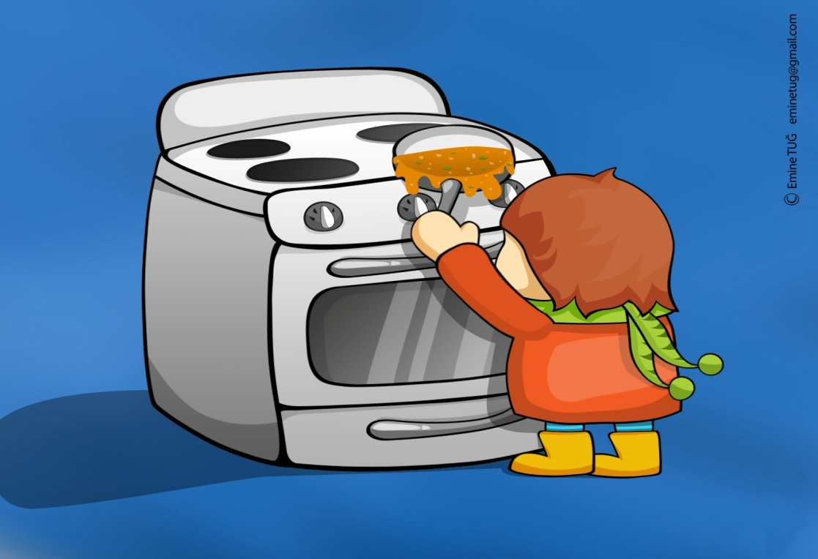

Childproof Your Electrical Outlets and Appliances
- Keep appliance cords out of children's reach, especially if the appliances produce a lot of heat.
- Cover electrical outlets so that children are unable to insert metal objects, such as forks or keys.
- Make sure you turn off the hob, oven, iron and other appliances as soon as you have finished with them.
- Don't carry or hold a child while cooking on the stove. Instead, move a high chair within reach or sight before you start. Then talk to your children so they know what's going on.

Use the Back Burner and Oven Mitts
- Kids love to reach, so to prevent hot food or liquid spills, simply use the back burner of your stove and turn pot handles away from the edge. Keep hot foods away from the edge of your counters.
- Use oven mitts or potholders and keep hot foods and liquids away from table and counter edges. Be careful if your oven mitt is wet; when combined with heat, the moisture can cause scalds.
- Keep the oven door closed at all times.
- Slowly open containers that have been in the microwave, as steam can burn little fingers and faces.

Be Careful With the Microwave
- Microwaves can heat unevenly and create hot spots, so avoid using them to heat baby formula or baby milk.
- Heat bottles by placing them in warm water, and make sure they have cooled to the appropriate temperature before feeding your baby.

Also

Put your baby down before picking up a hot drink and make sure she is not underneath you when passing it to someone. Don't have a hot drink while feeding your baby and always put hot drinks out of reach of babies and toddlers.

Blind cords

Window blind cord danger to small children

Small children have died after becoming tangled in looped blind cords. If you have window blinds with looped cords or chains, see the steps which can be taken to minimise this strangulation risk.

How to reduce the risk of strangulation
To reduce the risk from window blinds with looped cords and chains, the actions listed below are recommended:
- pull-cords on curtains and blinds should be kept short and out of reach of children
- tie up the cords or use one of the many cleats, cord tidies, clips or ties that are available
- where cords cannot be cut or tied down, a tension device can be used to pull the cord tight and secure it to the floor or wall
- do not place a child's cot, bed, playpen or highchair near a window where a child can reach a curtain or blind cord
- keep sofas, chairs, tables, shelves or book cases away from windows to prevent children climbing up and reaching curtains or blind cords.
It is not recommended that cords are cut short as a temporary solution. Instead it is recommended that preventative action is taken which results in a permanent fix that will keep the cord out of the reach of children. In addition, do not hang toys or objects that could be a hazard on the cot or bed and do not hang drawstring bags where a small child could get their head through the loop of the drawstring.



Socket covers and electrocution risk

Parents - keep your children safe from electricity
There are a few simple steps that you can take to ensure the safety of your children and the whole family.

Keep your children safe around electricity
- Don't rely on socket blanking plugs for your child's safety. Regular sockets are generally safe and socket covers will not prevent electric shock if the installation is not safe.
- Keep appliance cords out of the reach of children, especially those connected to hot items such as kettles, irons, hair straighteners or hairdryers.
- Never leave an unconnected appliance cord plugged in and switched on (for example, a mobile phone charger). Young children may be tempted to put the end of the cord in their mouths.
- Appliances should be switched off when not in use.
- After a bath or shower, you should make sure your children are dried off thoroughly before they go anywhere near electrical things like games consoles – water and electricity can be deadly.
- Keep drinks away from TVs, DVD players, stereos, speakers, computers, games consoles and anything else electrical.

Risks of poisoning or getting hurt

Children love to put things in their mouths. It's how they explore and learn about their world. This is one reason why accidental poisonings and swallowed objects are common among young children.

You can prevent your child accidentally poisoning himself by locking away harmful substances, such as medicines and cleaning products. It's also important to keep small objects out of your baby's reach, especially potentially harmful ones such as batteries and magnets.
Even if you've taken these precautions, you should still find out what to do if your child swallows something he shouldn't.
The best way to protect your child is to be extremely cautious about what you leave lying around the house. Any of these could be dangerous:
- household cleaning products
- small batteries (known as button batteries or watch batteries)
- make-up
- pills and medicines, both over-the-counter and prescription
- magnets
- sharp objects such as glass
- house plants
- paint, paint remover and other decorating products
- garden pesticides
- aromatherapy oils
- perfumes, aftershave, and deodorants
Keep liquid detergent capsules well out of reach, too. Store the liquid capsules in a locked cupboard. Young children may mistake them for sweets, or unfrozen ice lollies, and bite into them. There is also a risk that your child could squeeze the capsule and squirt detergent into his eyes.
Here are some other things you can do to keep your child safe:
- Go through all the harmful items in your house. Make sure they're clearly labelled and out of reach of your child.
- Put locks on cupboards and drawers where you keep dangerous items. Or, you could put them in a large cabinet or box with a lock on it, and store it where your child can't get to it. Don't put items in an unlocked cupboard or box, even if it is high up. If your child is walking, he may be able to climb on a chair to reach things in high-up cupboards.
- Don't rely on child-resistant containers. They aren't childproof. No bottle top can be made so safe that it's impossible for a child to get it off. It is not unusual for a two-year-old, left alone for a while, to break into a pill bottle.
- Don't leave medicines in a room as a reminder to take them. Write yourself a note instead.
- Don't carry medicines in your pocket or handbag. And don't allow your child to play with empty medicine containers. He may just end up teaching himself how to open the child-resistant lid.
- Keep medicines, pesticides, and cleaning products in their original containers. Never put poisonous or toxic products in containers that were once used for food and drink, as your child may mistake it for something he can eat.
- Never pretend that any sort of medicine is a sweet. Even if you are trying to get a reluctant toddler to take his cough syrup, don't treat it as something good to eat. Your child learns by imitation, so take your own medicine when he isn't watching.
- Rinse out old medicine or cosmetic containers and throw them away safely.
- Buy cleaning products that contain a bittering agent. The horrible taste will encourage your child to spit it out if he tries to drink it.

Falls and staircases
Babies reach, grasp, roll, sit, and eventually crawl, pull up, "cruise" along furniture, and walk. At many stages in the first 2 years or so, they're able to move around, tumble over, and get into things in one way or another. And toddlers will try to climb but may not have the coordination to react to certain dangers. They'll pull themselves up using table legs; they'll use bureaus and dressers as jungle gyms; they'll reach for whatever they can see.
So the potential for a dangerous fall or a tumble into a sharp edge can happen in nearly every area of your home.
Here are ways to help prevent kids from getting hurt in your home:

Walkers
- Don't use a walker for an infant. Babies in walkers can fall over objects; roll into hot stoves, pools, and heaters.
- Instead of a walker, consider a stationary activity saucer.

Windows
- Don't rely on window screens to keep kids from falling out of windows.
- Open windows from the top or use window guards to prevent your child from falling through screens or open windows (kids can fall from windows opened as little as 5 inches, or 12.7 centimetres). Make sure window guards are childproof but easy for adults to open in case of fire.
- Move chairs, cribs, beds, and other furniture away from windows to prevent children from climbing onto sills.

Stairs
- Never leave a child unattended around stairs.
- Teach your toddler how to go down stairs backward — your child's only example is you going down forward.

Around Your Home
- Don't keep loose rugs on the floor. Put specially designed pads under rugs to hold them securely to the floor's surface.
- Never put babies in child safety seats, infant seats, or bouncer seats on a countertop or atop furniture. The force of the baby's movements could propel the seat over the side and cause serious injuries.
- Make sure all pieces of furniture a child might climb on — tables, bureaus, cabinets, TV stands, etc. — are sturdy and won't fall over. Be particularly careful of top-heavy pieces like overloaded bookshelves that can fall on your child.
- Attach protective padding or other specially designed covers to corners of coffee tables, furniture, and countertops with sharp edges.
- Clean up any spills around the home immediately.

Cribs, Beds, and Changing Tables
- Never leave a baby unattended on a changing table or bed. If the phone rings while you have your baby on the changing table, bring the baby with you while you answer the call. If you must leave for a moment, put the baby in a playpen or crib.
- Use changing tables with 2-inch (5-centimeter) guardrails.
- Always secure and use safety belts on changing tables, as well as on strollers, carriages, and highchairs. Be sure to strap a small child securely into the seat of a store shopping cart.
- Keep side rails up on cribs.
- Crib bumpers are not recommended, but if they are used remove bumpers from cribs once your baby starts to pull up and stand to prevent him or her from using the bumpers to try to climb out of the crib.
- Don't put a child under age 6 on the top bunk of a bunk bed. Attach guardrails to the side of the top bunk.
- Remove tablecloths and keep cords or other dangling objects out of reach.

Building Maintenance
All residents are requested to report their own building maintenance issues through the Internet. The computer terminal that will link directly to the site is situated at the Reception of Grove House. It can also be reached through any computer with access to the Internet, meaning that you can log problems from the library, any computer cluster or your own bedroom! You will need your University username and password to log in.
To report a problem, please go to:
https://bm.stars.manchester.ac.uk
In case of emergency maintenance problems, please contact Grove House (office hours) or the Whitworth Park Duty Tutor (outside office hours).

Health and Healthcare: What you need to know

The most important thing you need to know about all healthcare in the United Kingdom is this:

It is all free, at all times, and so you should never be afraid to use it.

So – how do you use it? This section is divided into five parts:

- Emergencies: a real crisis, where life is in immediate danger
- Illnesses and Injuries: problems which occur, but when no-one’s life is in danger in the next 24 hours
- Maternity care and young children
- Dental Care: how to get it, what to pay, and how to get it free
- Medications and Prescriptions: how to get them free of charge

1. Emergencies

If life is in danger and the patient cannot move or be moved, dial 999. Speak clearly and calmly, and answer all the questions you are asked with courtesy and accuracy. You will be asked many questions; becoming angry with the person asking the questions will just delay the dispatch of the ambulance. An ambulance will attend.

OR

If you or the patient can move freely and without causing harm, then walk across the road to the Manchester Royal Infirmary and look for the ‘Accident and Emergency’ department (‘A & E’). All treatment will be free.

2. Illnesses and Injuries

We all get ill from time to time, and many of us have ongoing medical problems that require management and intervention. In this case, and if life is not in immediate danger, you need to see a General Practitioner (GP, also sometimes called a ‘Family Doctor’). This GP will manage all your healthcare needs, from arranging to see specialists in hospitals to supervising your children’s immunisation programme.

You may choose any doctor’s surgery you like, and any doctor within that surgery, but you must always go to the same medical centre until you formally change to another. It is free to change surgery; you just have to fill out a form at your new surgery of choice.

However, if you want a rapid appointment (i.e., in the next 24 hours), you will not get to choose which doctor in the surgery you see; you will see the ‘duty doctor’. If you wish to discuss a longer term problem with the same doctor each time, you may have to wait until that particular doctor is free.

You should register with one of the following local surgeries. Visit them in person, and they will explain how to register with them. You will then be able to use their services. This list is in order of proximity – use maps.google.co.uk to find them, and ring before you go to make sure they are open and taking on new patients:

- Vallance Medical Centre, Brunswick Street, Manchester M13 9UJ - 0161 274 1500
- St Bee’s Surgery, 34-36 St Bees Close, Moss Side, Manchester M14 4GG 0161 226 7615
- Boundary Medical Practice, 63 Booth Street West, Hulme, Manchester M15 6PR 0161 227 9785
- Surrey Lodge Group Practice, 11 Anson Road, Victoria Park, Manchester M14 5BY. 0161 224 2471
- Robert Darbishire Practice, Walmer Street, Rusholme, Manchester M14 5NP, 0161 225 6699
- St. Augustine's Surgery, Cambridge Hall North Court, 41 Cavendish Street, M15 6TT. 0161 247-3522
- Moss Side Health Centre, Monton St, Manchester M14 4GP 0161 226 1894
- The Arch Medical Practice, 175 Royce Road, Hulme, Manchester M15 5TJ 0161 226 0606

If you don’t like your doctor, change by registering with a different doctor. You can – you are a ‘customer’, and they are providing a service.

All of these GPs have male and female doctors. You may request to see a doctor of either sex. It is perfectly normal for surgeries to deal with such requests. However, if you request an emergency appointment, it will not always be possible to guarantee a doctor of a specific sex.

3. Maternity Care

All maternity care should be managed by first having a discussion with the midwife (a medical professional specialised in childbirth, almost always a woman) at your doctor’s surgery. She will then put you in touch with the relevant services at St Mary’s Maternity Hospital.

Remember: all maternity services are free, so make good use of them.

If there is a major problem during pregnancy or immediately after childbirth, then either:
- If it is not a crisis, and the baby’s or mother’s life is not in danger, and you are not in pain, phone your GP or your midwife or your health visitor.
- Phone 999 if either mother or baby seem to be in real distress. An ambulance will attend OR
- Visit the Emergency department of St Mary’s (for pregnant women and newborn babies) or the Children’s Hospital (for children) – they are both opposite Horniman House on the Infirmary campus.

4. Dental Care

Dental care is a service which you do sometimes have to pay for BUT the costs are fixed, and are low, with a large subsidy from the state. Make sure you register as an NHS patient at any of these dentists, and you will only ever pay one of the following charges:
- Band 1: £20.60. This charge includes an examination, diagnosis and preventive advice. If necessary, it also includes X-rays, scale and polish and planning for further treatment.
- Band 2: £56.30. This charge includes all the necessary treatment covered by the £16.50 charge, plus additional treatment, such as fillings, root canal treatment or extractions.
- Band 3: £244.30. This charge includes all the necessary treatment that is covered by the £20.60 and £56.30 charges, plus more complex procedures, such as crowns, dentures and bridges.
Ring the dentist’s surgery to ask if they are taking NHS patients at this time:
- Rusholme Dental Practice 300 Great Western Street, Rusholme, Manchester, M14 4LP 0161 226
- Howard Mellor 38 Brunswick Street, Ardwick, Manchester, M13 9TQ 0161 273 5998
- Family Dental Practice 177a Princess Road, Moss Side, Manchester, M14 4RL Tel: 0161 226 8432
- M S Umar Dental Practice 126-128 Dickenson Road, Rusholme, Manchester, M14 5HT Tel: 0161 224 8127
- Kath Locke Dental Practice 123 Moss Lane East, Hulme, Manchester, M15 5DD Tel: 0161 455 0219
- Fallowfield Dental Centre 306 Platt Lane, Fallowfield, Manchester, M14 7BZ Tel: 0161 224 2532
If you are having difficulty in obtaining NHS dental services in this area please call 0161 230 6011 during office hours.

Many groups, however, qualify for FREE NHS dental treatment:
- Many (but not all) students and their partners, based on their income – you have to apply for this. See http://www.nhsbsa.nhs.uk/1125.aspx.
- All pregnant women, and for 1 year after birth – ask for form FW8 from your midwife, health visitor or GP.
- All children under 18
- All people over 60
- Have certain long term conditions

For more information, consult the guidance at
https://www.nhsbsa.nhs.uk/nhs-help-health-costs

5. Prescriptions and How Not to Pay for Them

All prescriptions for adults attract a charge of £8.60 per item, payable to the Pharmacist. If you need a lot of medication, it is cheaper to buy a year-long exemption for £104, or a three month exemption for £29.10. This is true whatever the item costs the State; a medication costing £150 will cost an adult £8.60 – so will a medication costing 50p. This is to stop people using the doctor frivolously.

But many groups can obtain their prescriptions free, as of right. They include:

- Many (but not all) students and their partners, based on their income – you have to apply for this. See http://www.nhs.uk/NHSEngland/Healthcosts/Pages/nhs-low-income-scheme.aspx
- All pregnant women, and for 1 year after birth – ask for form FW8 from your midwife, health visitor or GP.
- All children under 18
- All people over 60
- Have certain long term conditions

For more information, consult the guidance at
http://www.nhs.uk/NHSEngland/Healthcosts/Pages/Prescriptioncosts.aspx

Education and Childcare

Local information can be found on the Manchester City Council website at: http://www.manchester.gov.uk/childcare

Childcare vouchers

Childcare voucher schemes are a flexible way to meet the costs of your childcare.

For University of Manchester staff, there is a scheme called Kiddivouchers which you can join:

http://documents.manchester.ac.uk/DocuInfo.aspx?DocID=24782 or call 0800 612 9015.

Another scheme is Busy Bees, for more information about this, please visit:
http://www.busybeesbenefits.com/childcare
Customer Service 0330 333 9100

Preschool – playgroups, day nurseries and nursery schools
When it comes to thinking about preschool childcare for your toddler or child it can be quite confusing. Playgroups, preschools, nurseries - it is hard to know what the difference is between them and which is best for your child. Information online is also very confusing!
Preschool playgroups accept children aged between two and five, and are short sessions where children stay and play with other children their age.
http://www.kidsguide.co.uk/toddler_&_pre-school/pre-schools_Manchester.htm
A day nursery is a childcare centre that cares for children from birth to four or five years old.
The number of children attending a day nursery may vary from a very small group of about 20, to a very large group of over 100. Children are usually grouped by age, so your child will do activities suitable for his stage.
http://www.daynurseries.co.uk/day_nursery_search_results.cfm/searchcounty/Greater-Manchester
Nursery classes and schools (not to be confused with day nurseries) take children aged 3 and 4 years old, usually for the year before they start the first school year. They are sometimes attached to a primary school. Both types intend to provide a grounding for the child to start school, offering a range of structured educational experiences based on learning through play. Please be aware that having your child at a nursery school attached to a primary school does not guarantee that your child will be able to attend the primary school.
http://www.manchester.gov.uk/directory/84/school_finder/
Free childcare for 3 and 4 year olds.
Do remember that all three and four year olds in England are entitled to 15 hours of free early learning for 38 weeks of the year. This applies until they reach compulsory school age (the term following their fifth birthday). The early education can take place in nurseries, playgroups, preschools or at their childminders. Free early education is now delivered flexibly over a minimum of three days. More information is available at: http://www.manchester.gov.uk/info/200016/children_and_childcare/6467/free_childcare/2
From September 2017, some families will be able to get an extra 15 hours a week – 30 hours in total. Here you will find further details: http://www.manchester.gov.uk/info/200016/childcare_and_nurseries/6467/free_childcare/4
Statutory education
Statuatory education starts in the UK when a child is 5 years old although a child can attend reception class while they are 4 years old as long as they reach the age of 5 within the same school year. For example, a child who has their 5th birthday in January 2015 could start reception class in September 2014 while they are 4 years old as this is within the same school year. The school year runs from September to August.
The Local Education Authority will provide a place, free of charge, for them in a school near your place of residence. A number of schools have special English classes available for children whose first language is not English. Normally, children go to a primary school near where they live.
To locate schools in your area, visit: Manchester Schoolfinder (Manchester City Council website) http://www.manchester.gov.uk/site/custom_scripts/school_finder.php
To apply either for a reception class place, or a primary school, you need to apply via Manchester City Council: http://www.manchester.gov.uk/info/705/school_admissions

In-year admissions
In-year admissions are those requests for a school place in any year group that are made outside the normal timescales, that is, after the beginning of the autumn term.
To apply for a place for your child at a Manchester primary school, you should contact a member of the School Admissions Team who will send you an application form.
Please send completed forms to:
Integrated Admissions
Manchester City Council
P.O. Box 532
Town Hall Extension
Manchester
M60 2LA
For further information on admissions, please visit: http://www.manchester.gov.uk/admissions
Tel: 0161 245 7166
Email: school.admissions@manchester.gov.uk
Calendar for the school year
The school year starts in September and ends in July the following year. School hours vary between schools but are usually 9am to 3.30pm or 4pm. The main summer holiday is from mid-July to early September. Children also have 2 weeks holiday at Christmas and at Easter, plus a week in mid-October and in mid-February. Exact dates vary between each education authority.
Information on Manchester school term year can be found on Manchester City Council website: http://www.manchester.gov.uk/site/scripts/documents_info.php?categoryID=36&documentID=1258
Secondary School
Can I choose which secondary school my child will go to?
You can't choose your child's secondary school, but you can let the Admissions Service know which schools you prefer. You should put down three choices of schools, in order of preference, with number 1 as your most preferred school.
It is important that you look around and consider several schools in your area in case you don't get your first choice. Make sure you are happy for your child to attend your second and third choices of school. Only putting down one school will limit the chances of your child getting a place you and they want.
In-year admissions
To apply for a place for your child at a Manchester high school, you should contact a member of the School Admissions Team who will send you an application form.

List of Supplementary Language Schools

It is likely that there is a Supplementary (usually Saturday) School where your child can continue to learn your native language. There are many ethnic minorities schools in Manchester – e.g. Bangladeshi, Ghanaian, Chinese (Mandarin), Polish, Farsi, Sinhala, etc.

For further information about Supplementary schools, contact: Manchester City Council
Tel: 0161 223 3158
Adult Learning:

If you want to brush up a foreign language, improve your English, computer skills or learn something new (e.g. cake dressing, embroidery, pottery or signing), look for some details on Adult Education Courses:
And: http://www.manchester.gov.uk/site/scripts/documents.php?categoryID=200004
University of Manchester Language Centre offers various English and foreign language classes (19 languages on offer!) – please visit the website for further details: http://www.langcent.manchester.ac.uk/

Sports and Physical Activities

There are substantial sporting facilities all around, most of which offer large discounts to students.
Swimming Pools, Water Slides and Gymnasia: the Aquatic Centre. This large building is located to the north side of the campus, and offers extensive facilities for fitness swimming, leisure swimming, play swimming, fitness classes and gymnasium usage. It is open from 7am to 10pm. There are classes and other group activities. For regular use, a monthly pass or membership is usually much cheaper. Visit the centre for details.
http://www.manchestersportandleisure.org/venue/manchester-aquatics-centre
Remember: there is a gym here too, with extensive classes – because it is small, it is sometimes cheaper than the alternatives.

Gym, Squash Courts, Badminton Courts: the Sugden Centre. Located about 200m closer towards the city centre than the Aquatic Centre, this is a very large ‘dry gym’. It has much bigger gymnasium facilities for all sorts of workouts; there are rooms where you can learn dance, yoga and other activities; and it offers indoor racquet sports too – especially badminton and squash. Again, monthly and annual membership deals are available. https://mcractive.com/

Gym, Badminton, Squash and Outdoor Sports: the Armitage Centre. A short walk/bus ride south from Horniman House, this centre offers a range of indoor facilities, as well as fields that students can book for football (11 a side and 5 a side), hockey and rugby. Full details at: http://www.sport.manchester.ac.uk/

Ardwick Sports Hall. This small sports hall is owned by the City, not the University. It offers a range of activities, from martial arts for children to ladies only badminton. For a full list of activities for children and adults, go to: https://mcractive.com/, where you can download timetables and prices. It’s marked on the map below, and is about 10 minutes’ walk.

Open Spaces and Parks

There are 2 open spaces and play areas within a short distance of Horniman House. They’re listed below. If you want to go further afield (a bus ride away), to bigger parks then Debdale Park is particularly pleasant – Google it. You’ll need to get a bus (201, 203, 204 – ask for a ‘family ticket’, which will cover 2 adults and 3 children for a day) from Hyde Road, but there are gardens, playgrounds, walks around lakes, a donkey sanctuary (for donkeys too old to work), water sports, a small public golf course (you usually have to take your own clubs/balls, but sometimes you can rent them) and many other activities.

Look at for details on local parks and activities:
http://www.manchester.gov.uk/info/200073/parks_and_open_spaces

Nearby, though, these are the main facilities:

- Longsight Adventure Playground (actually in Ardwick...). An adventure playground is a supervised play area with lots of physical activities for children and young people. They offer play activities in the evenings during the school year, and during the day times in the school holidays at Easter and in summer.
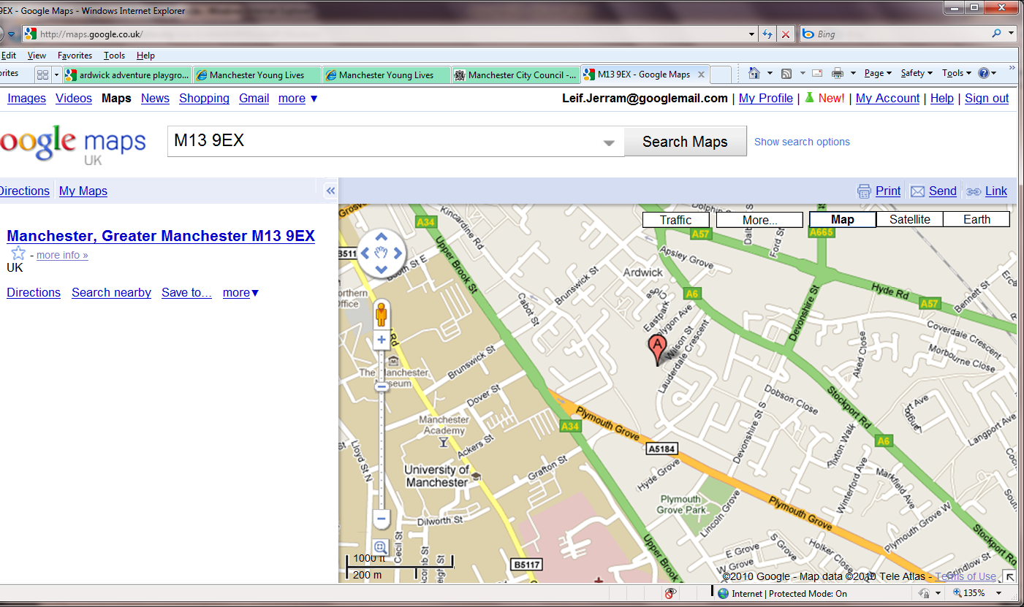
Horniman House
Longsight Adventure
Playground
Plymouth Grove Park
Ardwick Sports Hall
- Plymouth Grove Park. This is a small park with a playground, requiring adult supervision, grassed areas, and basketball courts. This park is marked as Plymouth Grove Park on this map, and so that is what I’ve called it – but everyone local calls it Swinton Grove Park.

We hope that you enjoy your stay at Horniman House!

This section has been prepared based on the following website: http://www.safekids.org/safetytips/ and http://www.babycentre.co.uk/a755/kitchen-safety#ixzz4LyaZdp12
Information based on: http://www.bromley.gov.uk/info/402/trading_standards_-_product_safety/607/window_blind_cord_danger_to_small_children
http://www.electricalsafetyfirst.org.uk/guides-and-advice/for-parents/
Based on: http://www.babycentre.co.uk/a415/accidental-poisoning-and-swallowed-objects#ixzz4Ls5Eqtga
Based on: http://kidshealth.org/en/parents/safety-falls.html

