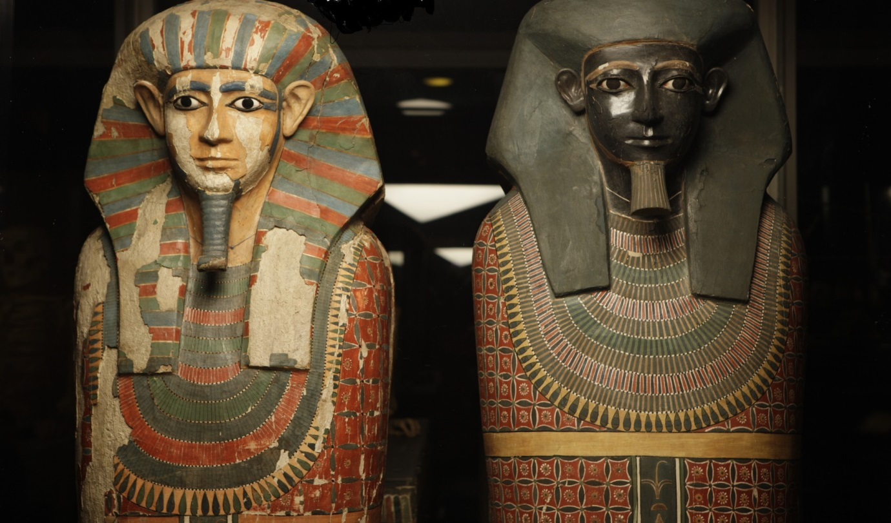
It’s a Wrap
We know that our Ancient Egypt gallery is very popular and that certain objects will be missed. While the gallery is closed, Manchester Museum would like to offer visitors the opportunity to host an Ancient Egyptian artefact.
We are looking for imaginative proposals to host an object that is personally meaningful or that will connect with others.
To apply* please return your completed form by Sunday 14th October:
- Hand this form to a member of museum staff at the reception desk.
- Post it to: Domestic Liberation Team, Manchester Museum, University of Manchester, Oxford Road, Manchester, M13 9PL
- Download the form from http://bit.ly/ItsaWrapFeedback and send it to museum@manchester.ac.uk with the subject: FAO Domestic Liberation Team
Proposals will be reviewed by a panel of museum staff and if your proposal has been selected, we will be in touch in the New Year.
*We welcome proposals from all of our visitors, whatever age. For applicants who are less than 18 years old, please ensure that you provide contact details for a parent or guardian.
Your name:
Under 18’s please also provide the name of a parent or guardian
Home address:
Telephone number:

Email address:
What is your chosen object?
Please provide a photo or drawing of the object and tell us what it is:

Please feel free to provide any additional information from the label or display that will help us to identify your object.
Why have you chosen this object?
What does it mean to you?
Why is it important to you?
What is special about this particular object?

Max 250 words
Please tell us what you propose to do with the object:
Where would this take place?
Who would be invited?

Max 250 words

