School of Social Sciences Law Department
Welcome Week September 2019
Induction for new Postgraduate Taught students in Healthcare Ethics and Law

Thank you for choosing to study your postgraduate degree with our School and a huge welcome to you all. The welcome week activities are designed to give you a better understanding of the degree programme and the options available to you to help you settle in.
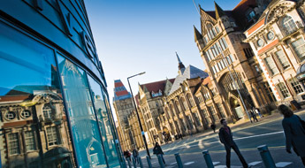

Thursday 19 September 2019
Time | Event | Location
9:30am – 10:30am | Registration and Welcome Bag collection | Student Common Room,  Williamson Building room 3.34
10:30am – 11:00am | Welcome and Introduction to the Programme | Williamson Building,  room 4.08
11:00am – 11:30am | Library Session (incl. Lexis Nexis/Westlaw) | Williamson Building,  room 4.08
11:30am – 12:15pm | Introduction to Essay writing | Williamson Building,  room 4.08
12:15pm – 1:00pm | Lunch break (sandwiches, tea and coffee) | Williamson Building,  room 4.08
1:00pm – 2:00pm | Introduction to Philosophical Bioethics | Williamson Building,  room 4.08
2:00pm – 3:00pm | Introduction to Legal Methods | Williamson Building,  room 4.08
3:00pm – 3:15pm | Break | Williamson Building,  room 4.08
3:15pm – 3:45pm | Options Information Session | Williamson Building,  room 4.08
3:45pm – 4:45pm | Ethics Case Studies | Williamson Building,  room 4.08
4:45pm – 6:00pm | Social | Brew Dog

Friday 20 September 2019
Time | Event | Location
2:00pm – 4:00pm | Help selecting options using MyManchester | Williamson Building,  room 3.59

If you have any queries regarding your course, please contact a member of the Professional Services who will be happy to assist you:

Email: tlseo.law@manchester.ac.uk Tel: +44 (0) 161 306 1260

