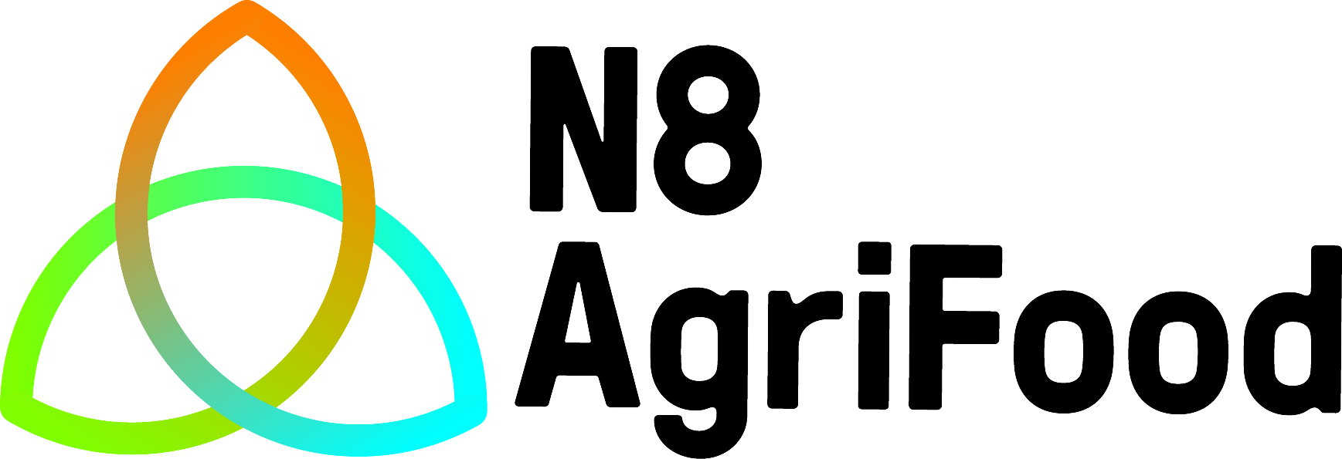

N8 Agri Food Programme
Academic Outreach Funding Application Form

1. Project Title (information in Section 1 will be put in the public domain) Number

2. Project Executive Summary (150 words max. Information in Section 2 may be put in the public domain)

Project public summary (150 words max. Explain the project in terms that could be understood by the public)

Applicable Theme(s) - delete as appropriate: | 1. Sustainable Food Production: 2. Resilient Food Supply Chains: 3. Improved Nutrition and Consumer Behaviours:

Academic Partner
Principal Investigator:
Contact Details: | T: E:
School / Institute & Research Group:
Main Research Interests:
Start date: |  | Duration:

Lead Collaborating N8 Partner
N8 Partner - delete as appropriate: | Durham, Lancaster, Leeds, Liverpool, Newcastle, Sheffield, York
Research Group(s):
Main Research Area(s):
Academic Partner Contact Name(s):
Contact Details: | T: E:

Additional Collaborating N8 Partner(s)
N8 Partner - delete as appropriate: | Durham, Lancaster, Leeds, Liverpool, Newcastle, Sheffield, York
Research Group(s):
Main Research Area(s):
Academic Partner Contact Name(s):
Contact Details: | T: E:

Additional Company or non N8 Institution Support (if applicable)
Company Name(s) and / or Non N8 Institution(s)

3. Project Background

i) Project Overview. Please include brief description of the academic outreach to be delivered; the Manchester and other N8 partner(s) combined research base on which it is based; and its current stage of development. (250 words max.)

ii) Please outline the intended beneficiaries of the project, and potential for impact (250 words max.)

iii) Please describe why the project / activity requires a partnership between Manchester and the other N8 Partner(s) to achieve its goals and how that partnership will achieve more than could have been delivered by the group(s) at Manchester alone (150 words max.)

4. Project Work Plan

i) Please detail the project work plan, including a Gantt chart (amend as required)

Task Number | Task Description |  |  |  |  |  | Effort (months) |  |  |  | Outputs and Key Decision Points
Project Stage 1.
1.1
1.2
Project Stage 2.
2.1
2.2
Project Stage 3.
3.1
3.2
Project Stage 4.
4.1
4.2
Gantt Chart
Task Number | Months
Task Number | M1 | M2 | M3 | M4 | M5 | M6 |  | M7 | M8 | M9 |  | M10 | M11 | M12
1.1
1.2
2.1
2.2
3.1
3.2
4.1
4.2

ii) Please summarise the expected outputs of the project / activity (150 words max.)

5. Project Evaluation and Follow-on

i) Please detail how the project outcomes and impacts will be evaluated, and associated timescales (150 words max.)

ii) Please summarise any anticipated benefits for knowledge exchange, research and / or teaching activities, and any implementation / exploitation / future funding plans (250 words max.)
6. Budget
(i) Total Project / Activity Costs

 | Fund Heading | Description/detail | Costs (£)
Directly Incurred | Staff salary costs
Directly Incurred | Travel
Directly Incurred | Equipment
Directly Incurred | Consumables
Directly Incurred | Other (please specify)
Directly Allocated* | Investigators (up to 10%)
 | Technician
 | N8 Agri Food Contribution (max £10,000) (A)
 | Total Direct (invoiceable) Company Contribution(s) (B)
 | Total Project Cost (A+B) = (C)

*Please note that Indirect and Estate charges can not be applied to the project

(ii) Direct Company Contribution(s)

Company Partner Name
Total Funding Offered

(iii) Equivalent Total Funding Contribution(s) from N8 Partners

N8 Partner Name
Total Funding Offered

(iv) Additional In-kind Contributions from Collaborating Company (ies), if applicable

Company Name
Staff Time
Equipment / Consumables
Travel
Other (please specify)
Sub Total
Total N8 Partner & Company Contributions (ii + iii)

7. Submission

This proposal is submitted by Principal Investigator (University of Manchester):
(Print name) | (Sign here) | (Date)
Jointly with (insert N8 Partner(s) name):
(Print name(s)) | (Sign here) | (Date)

A Research Proposal Approval form, signed and authorised by your Head of School, together with a copy of the pFACT costing report (please see guidance notes), should be submitted with this application form to confirm that the proposal is supported by your School and is in line with School policy for the costing of collaborative research projects. A signed letter of support from the collaborating partner should also be submitted with the application documents to confirm the company contribution.

Completed applications should be submitted by 12 noon on the deadline date to:

N8 Agri-Food Programme Manager
University of Manchester
C39 Sackville Building
Sackville Street
Manchester M13 9PL
Email: N8AgriFood@manchester.ac.uk

Electronic submissions are acceptable for application deadline purposes but a signed paper application should follow (signed and dated by all partners) no later than 7 days after the deadline date.

Once completed, all sections of this application form, except sections 1 and 2, will be treated as Commercial in Confidence.

