In the event of an accident or medical emergency
Contact the NEAREST First Aider without delay!

Your nearest First Aider in the BUILDING NAME are:
Name |  | Location | Phone
If you cannot get hold of a First Aider contact Security: 69966
To phone an ambulance dial 9 999 and contact Security on 69966
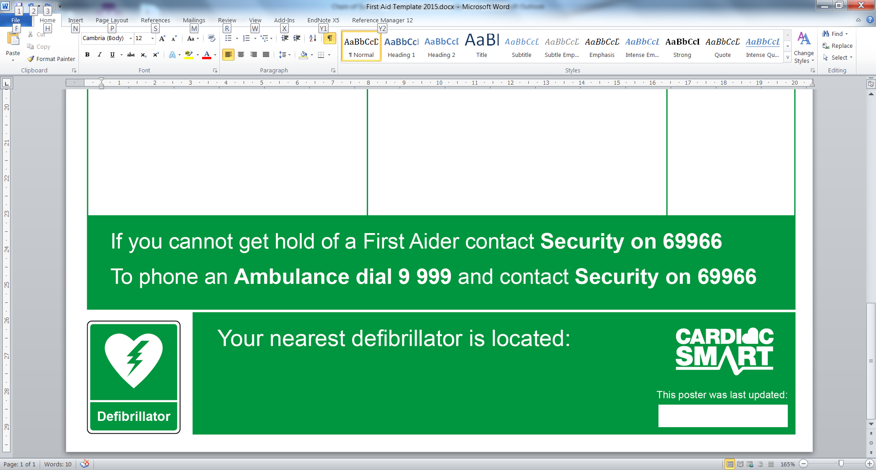 | Your nearest defibrillator is located:  ENTER LOCATION HERE  This poster was last update on: 16th February 2017

