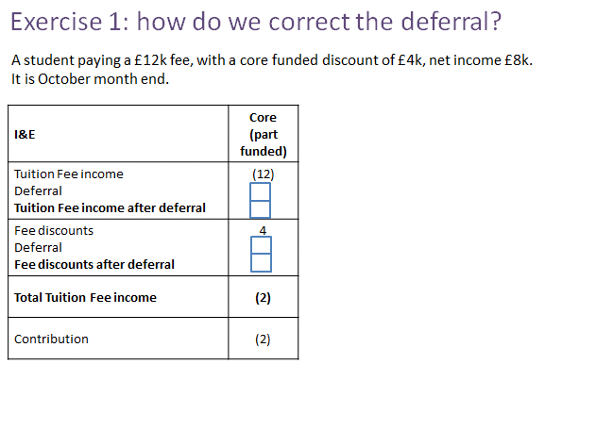
Fee Discounts – Training Exercises

Exercise 2

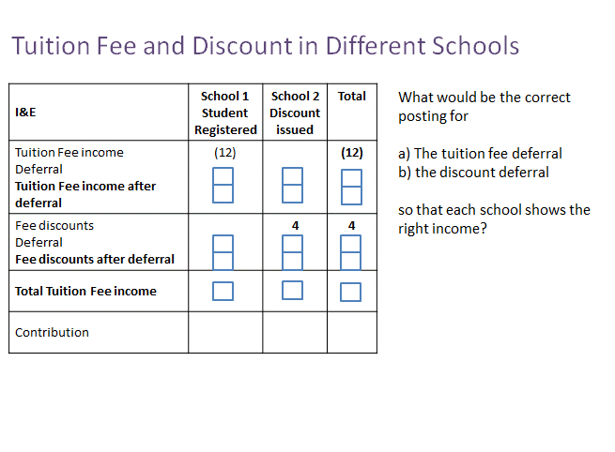
Exercise 2
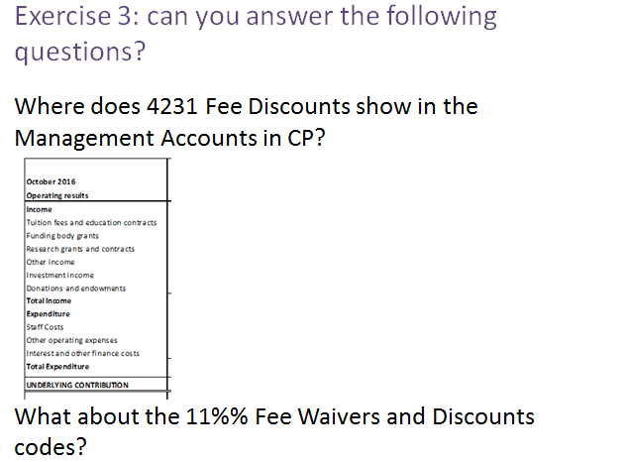

What is the double entry for deferral of a tuition fee discount?
DR…………………..
CR…………………..

Which I&E code is used for the SOCI side of the monthly journal?
……………………………………………………………………………

You check your 201 at interim year end and the balance on 4231 is zero!
What should you do?
- Call the systems team
- Flag to your HoFFRA or equivalent
- Post a correcting journal
- Nothing
What do you think has happened?

