
Excel Training
ROUND

The ROUND function rounds a number to a specified number of digits. For example, if cell A1 contains 31.9146, and you want to round that value to two decimal places, you can use the following formula:

=ROUND(A1, 2)

The result of this function is 31.91.

ROUND Example:

To give a whole number when deriving a number of months remaining on a project.

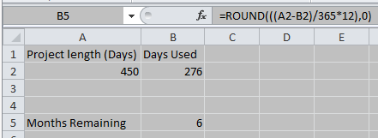

- For the above formula we want to give whole months to get an estimate of overhead recovery. We had a run rate per month and needed to multiply this by the number of months to give a figure which would fall into 1617.

- The content in the inner brackets can be a single cell or a formula (as above).

- Here we are rounding to 0 decimal places, but this can be amended depending on the number you wish to show.

Additional example - Workings for Upload journals:
Useful for rounding down values before cutting and pasting large journal uploads as anything more than 2 decimal places on a web ADI journal upload file will cause the upload to fail.



FinanceHelpdesk
Finance.helpdesk@manchester.ac.uk
www.finance.manchester.ac.uk/financeonly/trainingandcommunication/

