
Excel Training
Pivot Tables – Filling in the Blanks

Tidying up the Pivot Table – Filling in the Blanks
Filling in the blanks
By default, the pivot table will summarise information like this:
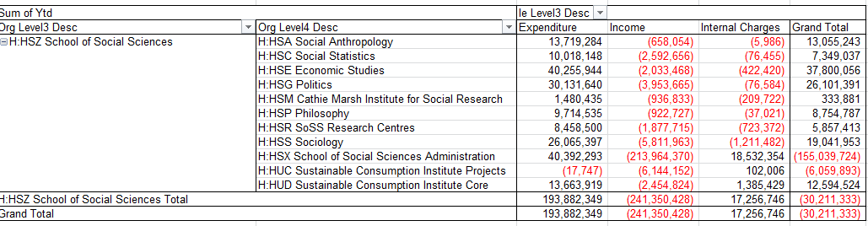
All the ‘Level 4’s’ under this ‘Level 3’
Sometimes, you may want the pivot table to put the ‘H:HSZ School of Social Sciences’ in every row, for example if you are planning on copying the pivot table to another excel sheet and then sorting the information in a different way.
To do this, click on the ‘Design’ tab and then click ‘Report Layout’
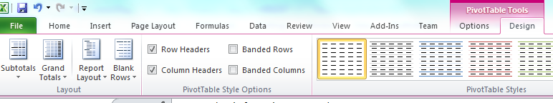
From the dropdown, select ‘Repeat All Item Labels’
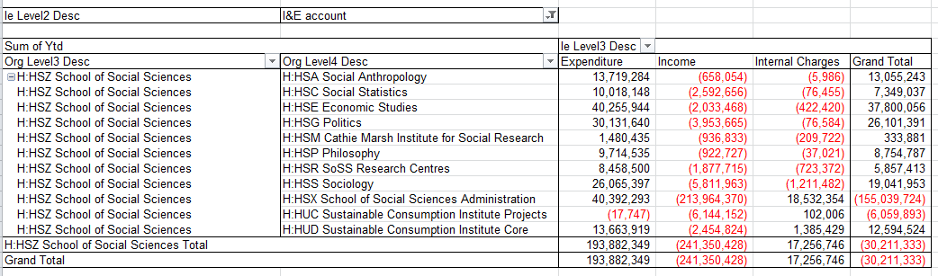
The pivot table has now populated each row.



FinanceHelpdesk
Finance.helpdesk@manchester.ac.uk
www.finance.manchester.ac.uk/financeonly/trainingandcommunication/

