
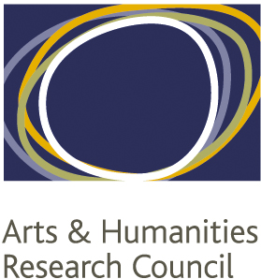
NORTH WEST CONSORTIUM
DOCTORAL TRAINING PARTNERSHIP

Research Networks Fund

2019-20

Network Name:

Applicants:
Name up to three applicants. The first-named (must be a DTP student) will be the contact for the grant if you are successful.
 | Name | HEI | Pathway
1
2
3

Estimated number of students in the network:
Please provide an estimate of the total number of students you hope to attract. Give names of students and institutions (other than the applicants) who have indicated their interest in the proposed network.

Elevator Pitch
Tell us, in no more than three sentences, what is distinctive about your proposed network and what it will add to the NWCDTP.

Background and Rationale
What existing links exist among members of the planned network? What is the network’s rationale? (300 words)

Plan of activities
Outline a plan of activities covering the first six months of the proposed network (300 words)

Budget
Provide the budget for the proposal, broken down by type of support required e.g. travel and subsistence for visiting speakers, catering costs, travel for students etc. Please note that we normally expect travel for students to be included and to take the form of public transport at economy/advance fares. Please include any support from institutions or other partners, including support in kind (e.g. use of rooms, use of photocopiers etc.).

Sustainability and Legacy
How do you intend to ensure the sustainability of the proposed network beyond the current academic year? What do you expect its legacy to be? (300 words)

