Manchester is first carbon literate university – and museum – in the world
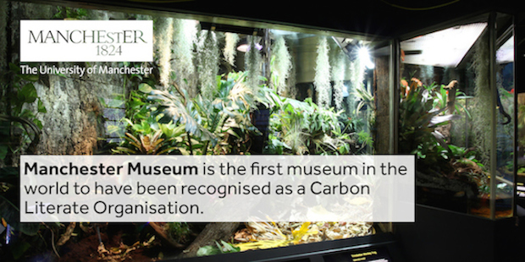
University wins bronze and museum wins gold in Carbon Literate Organisation Awards

Manchester is celebrating after being named the first carbon literate university and museum in the world.
The University has been awarded a bronze Carbon Literate Organisation award for its 10,000 Actions project, which is asking every member of staff to take part in collective, measurable improvement towards sustainability. Each member of staff has been given the opportunity to learn about the key issues of sustainability such as travel, responsible purchasing and energy, and the actions they can take to make a big difference.
Manchester Museum, part of The University of Manchester, won a gold award as the great majority of staff have undertaken carbon literacy training and has written carbon literacy into its review and performance processes. Two museum staff developed and delivered bespoke training helping all staff understand the impacts we make, and the difference we can make. The Museum will be rolling this training out to other interested museums in the North West.
Lucy Millard, Environmental Sustainability Manager, Emma Gardner, Head of Environmental Sustainability and Julian Skyrme, Director of Social Responsibility, were presented with the awards at a ceremony on the Coronation Street set. The Coronation Street team were the first TV production team anywhere to undertake Carbon Literacy training.
James Thompson, Associate Vice President for Social Responsibility, said “this is a fantastic achievement for the University and brilliant recognition for the staff working on 10,000 Actions and carbon literacy at the Museum. The awards ceremony was held on the set of Coronation Street as carbon literacy should be as normal part of everyday life as watching Coronation Street is to millions of people around the world. This ethos mirrors the University’s aims and was the reasoning behind 10,000 Actions; sustainability should be a normal part of peoples’ lives at the University of Manchester.”
The unique awards recognise employers who have committed to becoming Carbon Literate Organisations (CLO) – that is, having a substantial number of people who are Carbon Literate and having a commitment to support its Carbon Literate people and maintain its low carbon culture.
It will typically experience decreased in-house energy and resource consumption, improved organisational profile, healthier and happier staff, a healthier working environment, a safer supply chain, lower variable costs, enhanced competitiveness, and reduced commercial risk.
More information
For more information, visit:
- Carbon Literate Organisation [HYPERLINK]
http://www.carbonliteracy.com/organisation/

