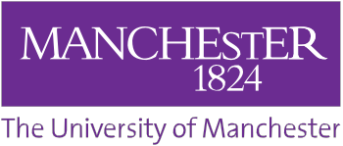
IMAGE & QUOTE RELEASE FORM
Photographer/interviewer:
The University of Manchester often takes photographs or video film and collects student quotes for publicity purposes. These images and quotes may appear in our printed publications, on our website, or both. We may also send them to the news media. We require your permission to do this.

Please read the information below, circle yes or no, then sign and date the form where shown.

I agree to the use of my image(s), audio and quotes in printed publicity or promotional literature produced by The University of Manchester and our partner organisations, including leaflets, posters, newsletters and other display material; on The University of Manchester’s website and other social media sites, including Facebook, Twitter and YouTube; and in any publicity material about our services sent to the news media and our partner organisations.

I understand that websites and other online media can be seen throughout the world, and not just in the United Kingdom, where UK law applies.

Signature
I have read and understood the above. Yes / No (circle)

First name Surname

Subject or course Year of study

Email address

Date

Our reference

Why did you choose to study here?

Please provide us with a quote about your time at The University of Manchester

What is the best thing about your course/programme / what aspect are you enjoying the most?

What are you hoping to do following your studies (please state career aim / further study)

Would you recommend your course/programme to others? If yes, please state why.

All photographs and video material is copyright to The University of Manchester

