Using My Placement to Monitor the Attendance and Wellbeing of UG Students Abroad
NB: This guidance is intended for staff who manage the attendance and wellbeing monitoring of undergraduate students on international placements.

All students on overseas placements are required to complete a number of simple questionnaires to confirm their attendance and wellbeing. These questionnaires are attached to all student records in My Placement by the International Programmes Office. They include:

- Confirmation of Arrival
- Progress and Wellbeing Check (one for each of the following census points - March 31st, October 31st and June 30th)
- Confirmation of Completion

In order to review questionnaire completion rates by your students, you should set up the queries and reports outlined below before the start of any international placement activity in your School or Service each year. You should do this in advance of the academic session in Manchester as some students can start their international placements as early as June.
This guidance explains how you can:
- Set up queries to identify students who have not completed the questionnaire
- Use follow up questionnaires to track your actions
- Set up reports to manage the information
It is strongly recommended other staff in your team have access to the queries and query watches in case of staff absence. If you have a general team email you should request that this is added to My Placement by emailing myplacement@manchester.ac.uk. You will then be able to use this to log in using the NON-Manchester login option on the welcome screen.
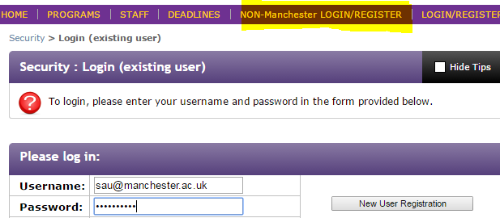

Setting up queries
The following queries should be created to provide you with a list of students who have not completed the questionnaires at each stage:
- Incomplete Confirmation of Arrival
- Incomplete Progress and Wellbeing Check (+ October 31st, March 31st and June 30th)
- Incomplete Confirmation of Completion
Incomplete Confirmation of Arrival query
The Query will show all relevant students who are currently abroad but have not completed the Confirmation of Arrival Questionnaire.
On the toolbar, go to Applicants/ Advanced Search. Select Application Parameters and Complete/Incomplete Submissions and click next.
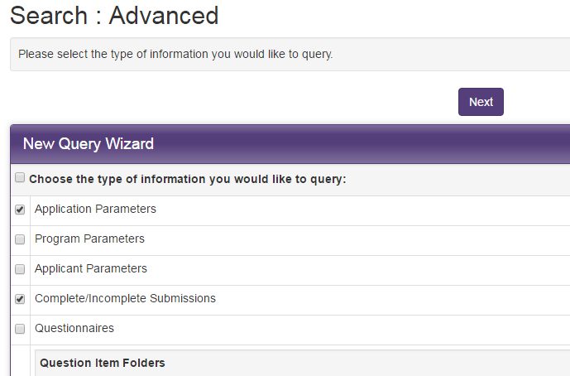
In the next screen select the relevant Application Cycle in the Application Parameters field. If you have students going abroad in more than one application cycle (e.g. full year, semester 1 and semester 2) multiple options can be selected while holding down the control key. If you are responsible for any short-term programmes, the short-term and/ or summer application cycle should also be included. In the Application Phase field, select ‘On Placement’. Ensure that in the Application Status field, ‘Accepted’ is ticked as well as ‘Committed’, as some students may not have committed to their placements but still be abroad.
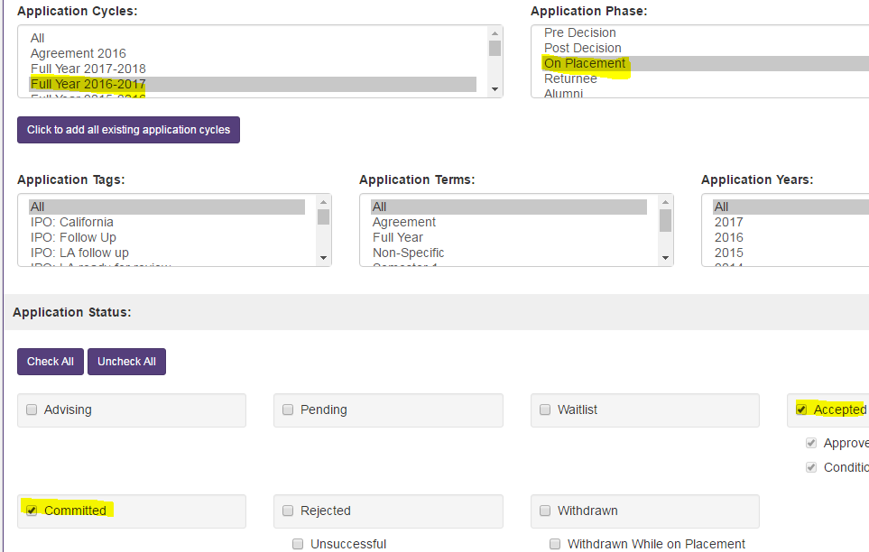

Scroll down and select the relevant programme(s) or programme groups(s) for your school.
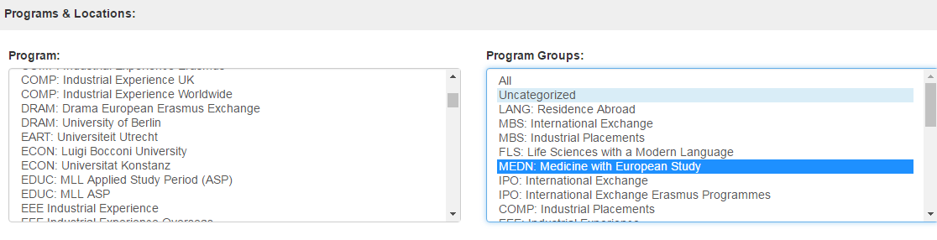
If your Program or Program Group includes placements in the UK, you need to exclude UK placements by selecting all countries excluding the UK. This can be done by selecting use CTRL-A to select all countries and then using the control key to deselect the UK.
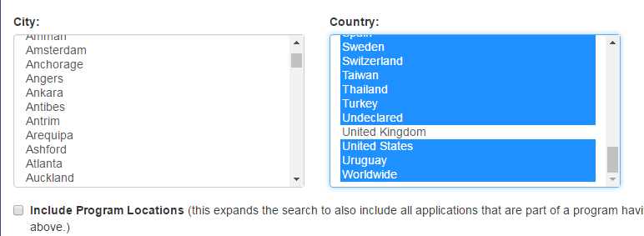

In the Complete/Incomplete Submissions field, go to the Questionnaires section and scroll down to select the questionnaire UNIV: Confirmation of Arrival and then select the ‘incomplete’ radio button 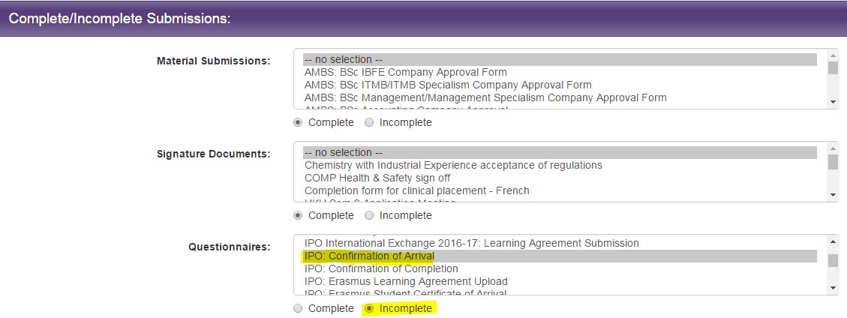

Click Next. This Query should be named and saved as ‘Incomplete Confirmation of Arrival’.
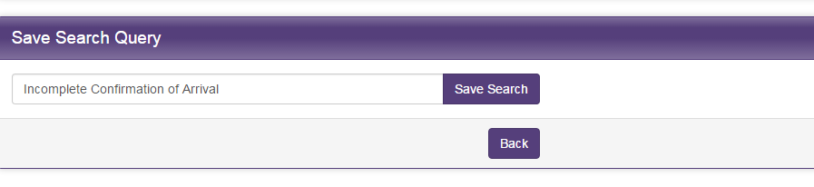
Incomplete Progress and Wellbeing Census Queries
There is a questionnaire for each of the three census points throughout the year so you should create queries to track completion rates for each one i.e. Progress and Wellbeing Check (March 31st, June 30th and October 31st) for the periods when your students will be abroad.
Follow the instructions as for Confirmation of Arrival but in the Complete/ Incomplete Submissions field, select the questionnaires ‘UNIV Progress and Wellbeing Check’ (+ relevant date) before selecting the ‘Incomplete’ radio button.
Save the queries with the names ‘Incomplete Progress and Wellbeing Check (+ March 31st, June 30th or October 31st as relevant)
Incomplete Confirmation of Completion Queries
Follow the instructions as for Confirmation of Arrival but in the Complete/ Incomplete Submissions field, select the questionnaires ‘UNIV Confirmation of Completion’ and click the ‘Incomplete’ radio button.
Important: In the Application Parameters select ‘Returnee’.
Save the query with the name ‘Incomplete Confirmation of Completion’.
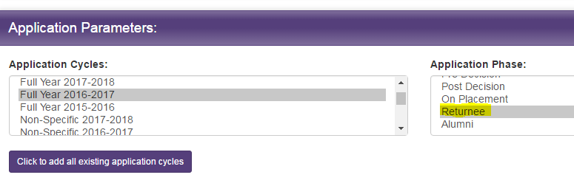
Queries and query watch reminders
Your admin home page should now display some or all of the following queries:
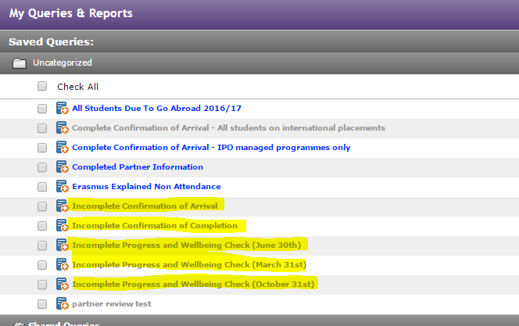
Schools, especially those with larger groups of students, can set up a query watch to send reminders to administrators about any students who are in a query. This will provide a list of names and destinations although as a query cannot include itinerary details, a query watch cannot show the start date.
In order to do this, you should go to ‘admin home’ by clicking on the house icon on the top left of the screen and selecting ‘administrative’. Click on the query watch at the top of the page then select ‘new query watch’. The frequency can be set to daily or weekly. In Actions Taken on Update select ‘email’, in Records Included in Actions select IN, ALL and OUT and choose an email to send it from. In Email recipient list add the email of the administrator who should receive the emails. Do NOT select ‘send email to addresses in the query watch list’. In ‘include list of records in email’ select ‘yes’.
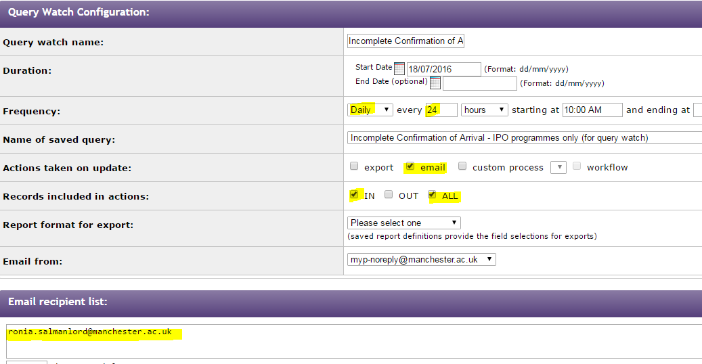

Using Follow Up Questionnaires
‘Follow up questionnaires’ are designed to keep a record of actions taken for each individual student as required. These include:
- ‘UNIV Monitoring Follow Up Steps - Arrivals’
- ‘UNIV Monitoring Follow Up Steps – Progress and Wellbeing Census’.
They are not visible to students and are intended only for administrative use. They are held against each student record and provide a record of the steps that should be used to make contact with a student who has not completed a questionnaire within the required timeframe i.e. within 7 days of arrival or within 14 days of the Progress and Wellbeing census point. They are not required for any student who has completed the questionnaire on time. They should be completed as information becomes available. Only question 1 is compulsory once the questionnaire comes into use and indicates that the student has not completed the relevant questionnaire within the required period and that follow up monitoring has begun.
Press Submit and not Save when completing a follow up questionnaire. If you press save, the questionnaire will NOT be visible to other users in the system.
A Follow Up questionnaire is NOT provided for the Confirmation of Completion as follow up steps are not required for students who have concluded their placement although these students will continue to receive automated reminders through the My Placement system.
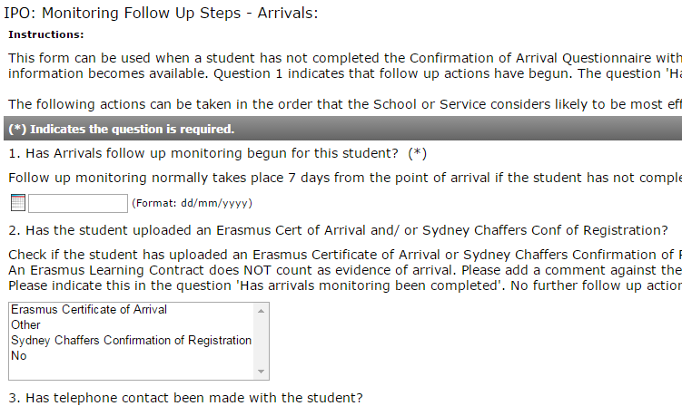
The question 'Has Arrivals follow up been completed' or ‘Has Progress and Wellbeing Monitoring been completed?’ should be answered once confirmation of safe arrival or continued wellbeing has been received and no further follow up action is required.
The actions outlined in the questionnaire can be taken in any order that the School or Service considers likely to be most effective. However, the emergency contact should ONLY be used after all viable steps have been attempted.
If the student completes the relevant monitoring questionnaire after the follow up questionnaire has been started they will no longer appear in the queries being monitored. In this case the required action on the part of the student has been completed and there is no need to complete the follow up questionnaire.
Using Reports to manage monitoring
Reports can be used to more efficiently manage the monitoring process. Reports provide a way to collate and view information in one place and provide a wider range of information than is available in the query. The Excel version of a report allows for easier manipulation of data such as the ability to sort by start date. This is especially helpful when dealing with larger groups of students or students with many variable start dates.
As Excel reports are dynamic based on information as it changes in My Placement they should be run as new reports each time a monitoring check takes place. In order to re-run Excel reports go to Admin Home/ Reports and click on the excel icon next to the report you wish to run as an Excel spreadsheet. N.B. Make sure you click on the excel icon in Reports and NOT the excel icon in Queries.
Running an Incomplete Confirmation of Arrival report (quick and easy)
Go to your Admin homepage in the My Queries and Reports section and scroll down to Stock Reports. Click on Stock Reports to view all reports available and click on ‘rpt AppItinerariesExport’. In Select a Query choose the query that you have set up for monitoring incomplete questionnaires and click Generate Report.
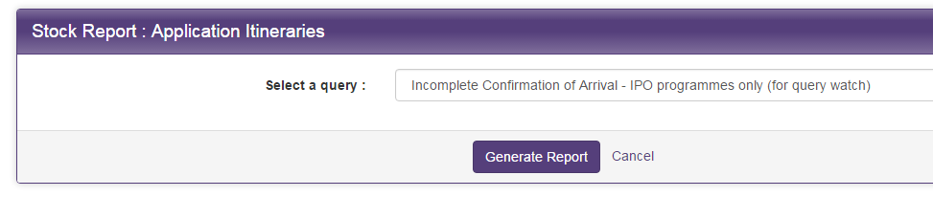
This will create a spreadsheet that includes the students in the query above showing their start dates. This provides a quick and easy way to see the start dates of students with incomplete questionnaires so that administrators can see which students they should be prioritising.

Setting up an Incomplete Confirmation of Arrivals Report (advanced)
These reports include more detail about students with incomplete questionnaires, including whether they have uploaded other documents confirming their attendance and information about the follow up questionnaires.
Go to your Admin homepage and find the Query ‘Incomplete Confirmation of Arrival’. Click on the ‘New Report’ icon to the right of the query name. In Programs and Terms, deselect ID# and Label. Then select elect Program Name, Term, Year, Program Date Record: Start Date and Program Date Record: End Date. In Applicant Parameters select Email, Partner Institution, Current Telephone Number and all the Emergency contact details. In Applicant Address select Home, Term and Emergency. Scroll down to the Questionnaires and Questions section. Click on the triangular icon next to the following questionnaire to select the individual questions to include:
- Erasmus Student Certificate of Arrival - select ‘Erasmus Certificate of Arrival’
- UNIV Monitoring Follow Up Steps – Arrivals - select ‘Has Arrivals follow up monitoring begun for this student?’ And ‘Has arrivals monitoring been completed?’
Save the report as ‘Incomplete Confirmation of Arrival Questionnaires’. If you wish to view the report in excel select ‘export as excel’ and ‘export essay content’ (NB: If you do not select ‘export essay content’ you will not see if an Erasmus Certificate of Arrival or other documents have been uploaded).
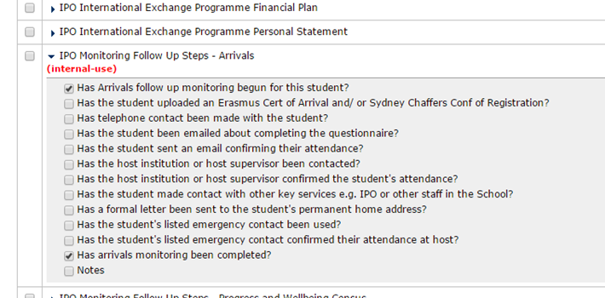

Setting up Progress and Wellbeing Census Reports:

These can be created for each Progress and Wellbeing check where your students will be abroad.
Find the query ‘Incomplete Progress and Wellbeing Check (+ relevant date)’. Follow the same instructions as for the Incomplete Arrivals report but in the Questionnaires and Questions section click on the triangular icon next to the following questionnaires to select the individual questions to include:
- UNIV Monitoring Follow Up Steps – Progress and Wellbeing Census (+ relevant date) – select ‘Has Progress and Wellbeing monitoring begun for this student?’ and ‘Has Progress and Wellbeing monitoring been completed?’
Save the report as ‘Incomplete Progress and Wellbeing Questionnaires (+ relevant date)’. If you wish to view the report in excel select ‘export as excel’ and ‘export essay content’.
Using Queries to contact students with reminders to complete the questionnaire
The queries set up to view incomplete questionnaires e.g. Incomplete Completion of Arrival etc can be used to contact groups of students with personalised emails. You can do this by opening the query and selecting ‘Send Email’ from the options dropdown list. In the new window choose the email of the member of staff in your school (NOT myplacement@manchester.ac.uk). If you have received a general team login, the email associated with the general login will be displayed instead of your personal email.
Troubleshooting

Students cannot see the questionnaire
- All students must have an applicant itinerary against their record as soon as possible after they have been accepted onto a placement in order to receive the monitoring questionnaires. For study students, this itinerary will populate automatically from the program itinerary so no further action is required. For work students and for study students whose placement dates differ from those in the program itinerary, the applicant itinerary must be manually populated. Please see section 26 of the Application Management Guide (pp. 50-51) for detailed guidance on how to populate or amend an applicant itinerary.
- The program or program group that a student is on has not been added to the questionnaire.

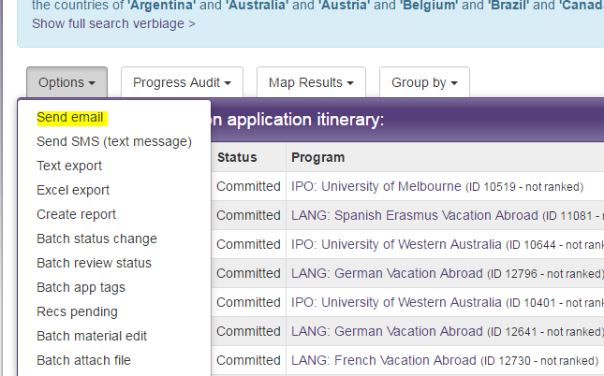

Further information can be found about the process in the ‘Guidance of Monitoring the Attendance and Wellbeing of Undergraduate Students Abroad’.
For an introduction to Queries and Reports, including information about how to set them up, please see pages 62 – 70 of the My Placement Application Management Guide
Saved queries can subsequently be accessed from the Admin Home Page.
e.g. if you only send students for Semester 1, you would only need to create a Progress and Wellbeing query for October 31st. If you only send students for Semester 2, you would only need to create Progress and Wellbeing queries for October 31st and June 30th. If you send for the full year or both semesters, you would need to create all three.
The use of the emergency contact is under review by the University. Before taking this step please contact Paul Redmond, Director of Student Life, to discuss whether it is appropriate to use.
If the students have itinerary dates that are different from the inputted programme date, such as work students with variable start dates within the same programme, then select Itinerary in Additional Information to see the actual start date for each student.

