Course Marketing: Explanation of the tabs in the Marketing Information section in Campus Solutions
Tab name in CS | Content fields in CS | Example of how it displays online
Fact File | Basic Academic Plan information (e.g. subject area, duration, qualification, etc.) | 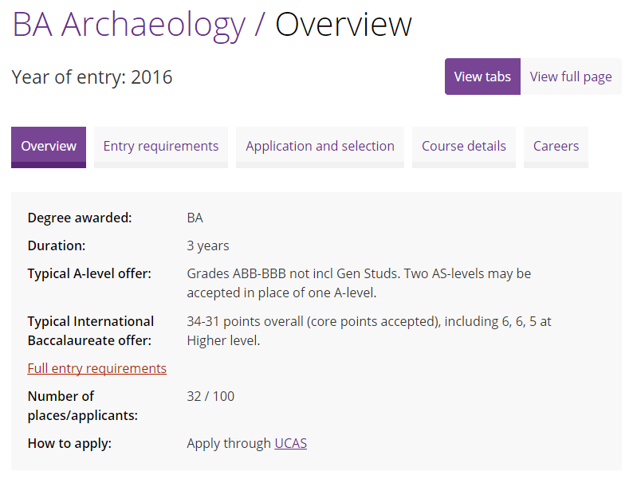
Fact File | Typical A Level Offer
Fact File | Number of Places/Applicants
Fact File | How to Apply

Tab name in CS | Content fields in CS | Example of how it displays online
Fact File | Course overview | 

Tab name in CS | Content fields in CS | Example of how it displays online
Fact File | Text on banner |   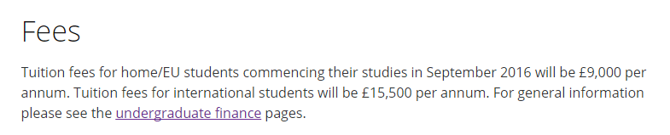
Fact File | Course Fees (Short Version)

Tab name in CS | Content fields in CS | Example of how it displays online
Fact File | Open days | 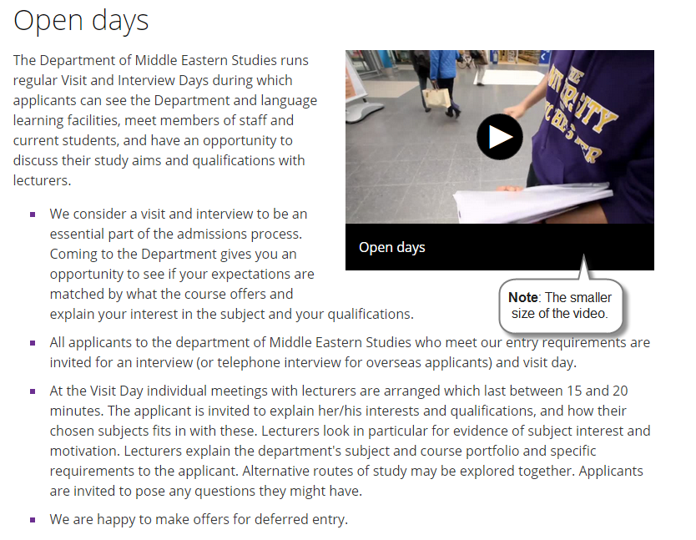

Tab name in CS | Content fields in CS | Example of how it displays online
About the Plan | Special Features |   

Tab name in CS | Content fields in CS | Example of how it displays online
About the Plan | Career Opportunities | 

Tab name in CS | Content fields in CS | Example of how it displays online
About the Plan/Plan Content/Study Details | Course description | 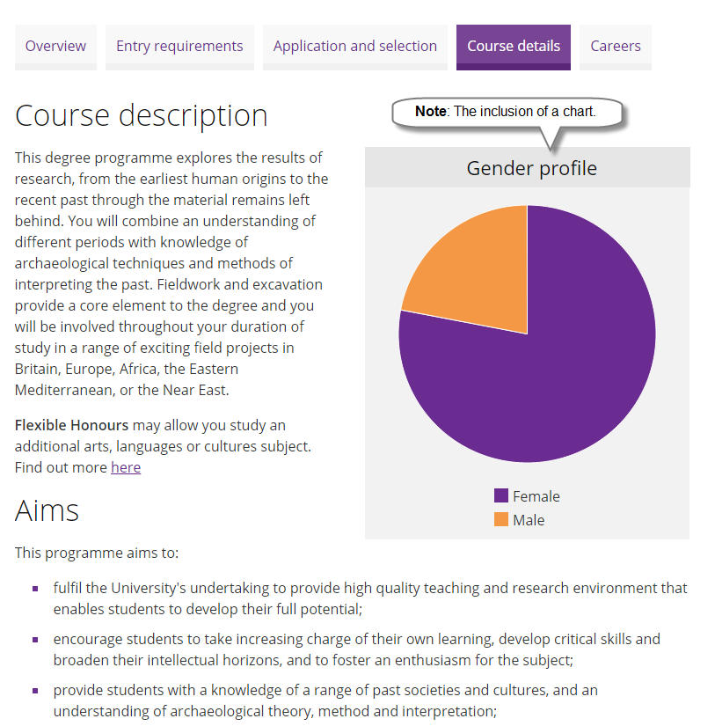
About the Plan/Plan Content/Study Details | Aims

Tab name in CS | Content fields in CS | Example of how it displays online
About the Plan/Plan Content/Study Details | Teaching And Learning | 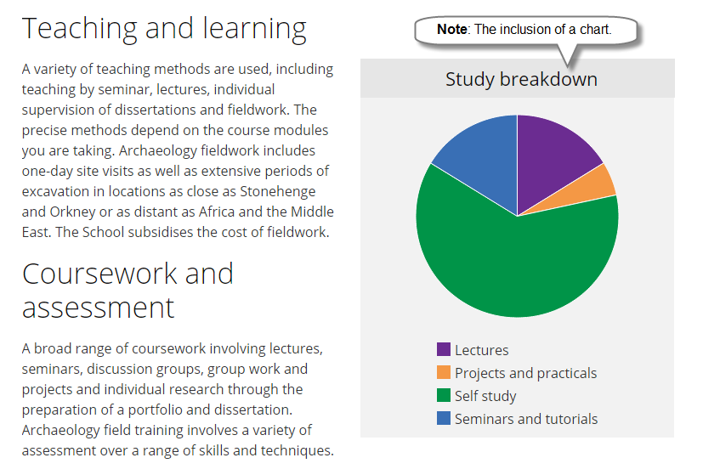
About the Plan/Plan Content/Study Details | Course Work and Assessment

Tab name in CS | Content fields in CS | Example of how it displays online
About the Plan/Plan Content/Study Details | Course Content in Year (1-5) | 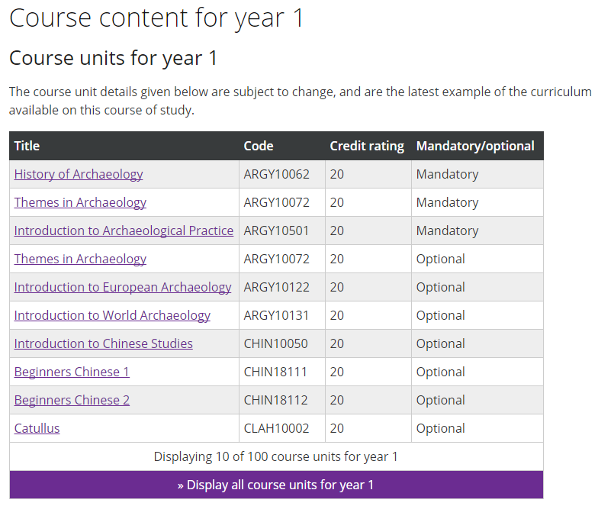

Tab name in CS | Content fields in CS | Example of how it displays online
About the Plan/Plan Content/Study Details | Student Opinions | 
About the Plan/Plan Content/Study Details | Facilities
About the Plan/Plan Content/Study Details | Disability Support

Tab name in CS | Content fields in CS | Example of how it displays online
Entry Requirements | GCE A-Level | 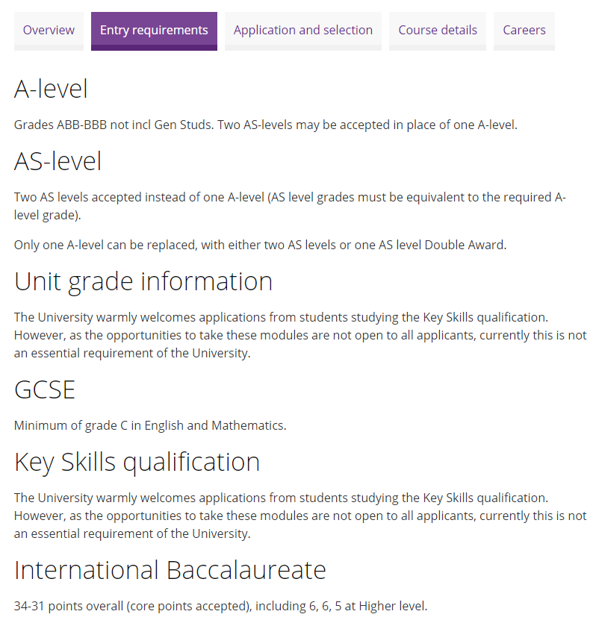
Entry Requirements | GCE AS-Level
Entry Requirements | Unit Grade Information
Entry Requirements | GCSE/SQ Standard Grade
Entry Requirements | Key Skills
Entry Requirements | Intl. Baccalaureate Entry Req.

Tab name in CS | Content fields in CS | Example of how it displays online
Entry Requirements | Alternative entry requirements includes a range of entry requirement fields | 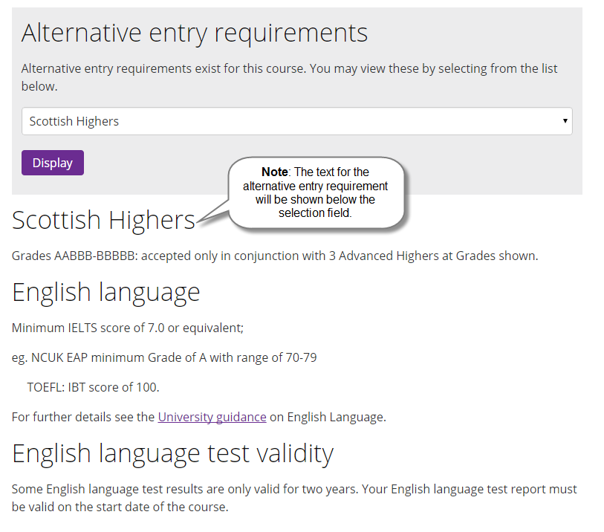
Entry Requirements | English Language Requirements
Entry Requirements | English Language Test Validity

Tab name in CS | Content fields in CS | Example of how it displays online
Selection Criteria | How to apply (found in Fact File tab) | 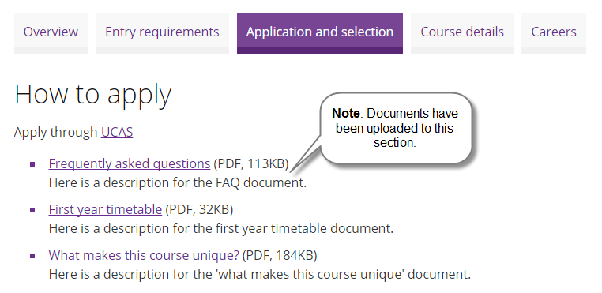

Tab name in CS | Content fields in CS | Example of how it displays online
Selection Criteria | Advice to applicants | 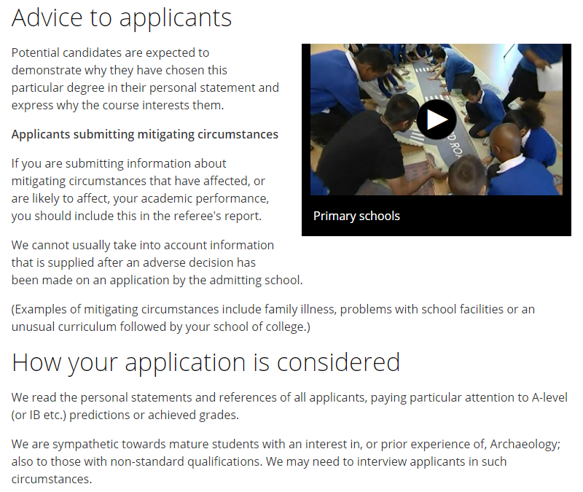
Selection Criteria | How Apps are Considered

Tab name in CS | Content fields in CS | Example of how it displays online
Selection Criteria | Interview requirements | 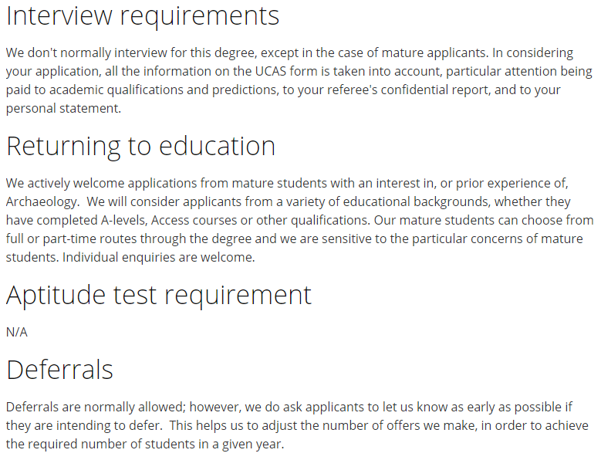
Selection Criteria | Returning to education
Selection Criteria | Aptitude test requirement
Selection Criteria | Deferrals

Tab name in CS | Content fields in CS | Example of how it displays online
Selection Criteria | Re-Applications | 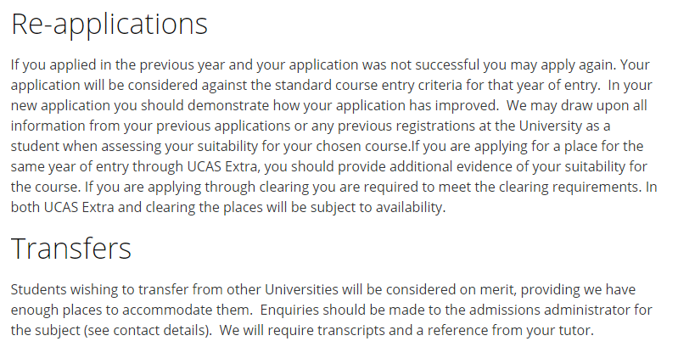
Selection Criteria | Transfers

Tab name in CS | Content fields in CS | Example of how it displays online
Contacts | Academic Plan Contacts |   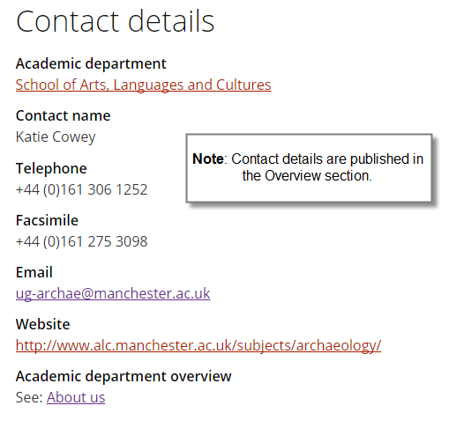
Tab name in CS | Content fields in CS | Example of how it displays online
Additional Information | Linked Academic Plans | 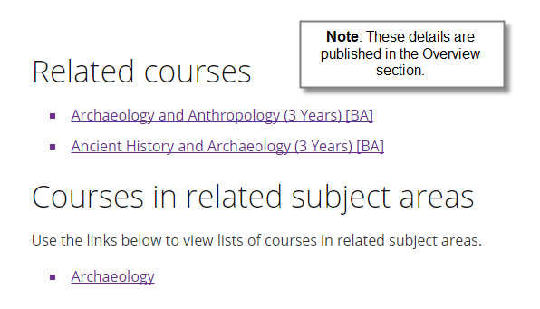
Additional Information | Other Related Academic Plans

