Welcome to the Arthur Lewis Building Graduate Teaching Assistants

Address

The building address is – Arthur Lewis Building, University of Manchester, Oxford Road, Manchester, M13 9PL

Locations

The building is shared by SoSS and SEED and the locations are as follows:

Ground Floor

- SoSS Undergraduate Admissions Office
- SoSS Undergraduate Support Office
- Shared teaching rooms
- Granada Centre for Visual Anthropology library, edit suite, viewing room and technician
- Shared PGT study suites and UG/PGT resource centre
- SEED laboratories
- Staff showers
- Arthur’s Brew Café
- SoSS Head of School
- SoSS Head of School Administration

First Floor

- SEED – Geography, IDPM and Planning and Landscape academic staff

Second Floor

- SoSS Postgraduate Support Office
- SoSS – Social Anthropology
- SEED Head of School and Head of School Administration
- SEED Student Information
- SEED Administration
- Faculty Research HUB

Third Floor

- SoSS – Economics
- SoSS – Sociology
- SoSS – Morgan Centre

Fourth Floor

- SoSS – Philosophy
- SoSS – Politics
- SoSS Postgraduate Admissions Office
- SoSS e-learning technologists
- SoSS/SEED Accountant and Finance Office

Access

The building front entrance is open from 8.00a.m. - 6.00p.m. Monday to Friday. At all other times, the building can be accessed via the door at the side of the main entrance doors using your University ID card. This means that the building is available for you to use 24 hours a day, 7 days a week.

SoSS Undergraduate Students

SoSS undergraduate students have access to the Resource Centre on the Ground Floor, Monday – Friday 8.00a.m. – 5.00p.m. except for Wednesday afternoon. There are several notice boards located in this room for use by student societies.

Postgraduate Taught Students

SoSS postgraduate taught students have access to the Postgraduate Study Suites and the Resource Centre on the Ground Floor (24 hours). To visit the Postgraduate administrative team, you will need to report to the Postgraduate Reception on the Second Floor. To visit any member of the academic staff, you can either book time through the SOHOL system, or you can report to any of the reception points on the second, third or fourth floor.

SoSS Postgraduate Research Students

SoSS postgraduate research students have access to the floor where their Discipline Area is located. To visit the Postgraduate administrative team, you will need to report to the Postgraduate Reception on the Second Floor. To visit any other member of the academic staff in another Discipline Area, you can either book time through the SOHOL system, or you can report to any of the reception points on the second, third or fourth floor.

TAs Not Registered in SoSS

Please contact Lucy Shanahan (lucy.shanahan@manchester.ac.uk) for access rights to Arthur Lewis in order to complete your teaching duties.

Café – Arthur’s Brew

Arthur’s Brew is open daily – 9.00 – 3.00 during the semesters and 10.00 – 2.00 during the vacation. It offers a similar service to the Coffee Bar in Humanities Bridgeford Street.

Computers

There are computers located in the Atrium areas for use by Postgraduate Taught Students 24 hours per day, seven days per week. All PGT students from both Schools have access to this area as a shared resource. Please do not store data on the hard drive.

On the upper floors in the open plan areas, there are computers for use by Postgraduate Research Students. At first, there may not be a computer on every desk, but the School is negotiating more. In addition to the hard wired computer facilities, there are wireless access/roam points located on all floors in the open plan areas for students or visitors to hook up to.

Email

Most communications in the University are via the email system, please make sure you check yours regularly.

Emergency Exits

The emergency exits are signed throughout the building. There are three staircases, one in the central area and one at the north and south sides of the building. On the north and south staircases at each floor level, there are Emergency Refuge Points. Staff, students or visitors who have mobility difficulties should wait there in the event of an emergency. There is a Refuge Assistance call button on each level so that help can be summoned.

Fire Action

If you discover a fire
  - Sound the alarm by breaking the glass at the nearest call point
  - Call the Fire Brigade by dialling 9-999 from any internal
telephone On hearing the alarm

  - Evacuate the building by the nearest available exit
  - If you are unable to use the stairs, use the Refuge Area provided
  - Close all doors behind you and report to the Assembly Point
  - Do not collect personal belongings
  - Do not use the lifts
  - Do not run
  - Do not re-enter the building until authorised to do so

Fire Extinguishers

There are fire extinguishers situated around the building but do not use one unless you have been trained to do so.

The fire alarm will be tested weekly on Monday at 1.00pm.
Fire evacuation
The Fire Evacuation point for the Arthur Lewis Building is Bridgeford Street
between the Museum and Humanities Bridgeford Street Building. There are several Fire Evacuation Marshalls in this building who will direct you to the nearest exits, they can be identified by their yellow high visability vests (see Appendix for current list of staff).

First Aid

There are several First Aiders located in this building, their names and extension numbers are on the First Aid notices which are located throughout the building (see Appendix for current list of staff). In the event of an emergency, if you can’t see one of those notices, just call Security on 52728. There are First Aid kits located in all Reception areas in the building.

Kitchen and Breakout Areas

At each end of each floor (with the exception of the Ground) there is an Oasis area with a kitchen and a seating area. In each Oasis there will be:

Fridge – please make sure that you remove any out of date food, wipe up any spillages and don’t eat or drink anything that doesn’t belong to you. There will be lots of people sharing the fridge but the food is not communal.

Boiler – boilers have been provided in all oasis and kitchen areas. These provide instant hot water and there is therefore no need for additional kettles.

Microwave – instruction booklet located close to the machine. Please put a cover over your food when heating it.

Dishwasher – instruction booklet located close to the machine.

The School has purchased a small amount of crockery, cutlery and microwave dishes for each kitchen area but assumes that most people will bring their own cups. Please do not leave dirty pots in the sink for other people to wash, the dishwasher has been provided to avoid this.

Please do not assume that the School administrative staff will be responsible for loading and unloading the dishwasher or cleaning the fridge or the kitchen areas. Please clear up after yourself as the Building Attendants are not responsible for these areas either.

Waste and recycling bins have been provided close to all kitchen and oasis areas, please use them.

Lockers

There is a bank of 70 lockers on the Ground floor near the showers for use by Postgraduate Taught students.

There are locker pods in each quadrant of the second, third and fourth floors for use by Postgraduate Research Students.

All lockers are coin operated (£1.00). If you lose the key there will be a £10.00 charge for a replacement.

Phones

If you work in an open plan area, please put your mobile phones to silent so that they do not disturb your colleagues.

There are phones on all the link bridges and outside the School Administration and Resources Suite to enable visitors to gain access to the floor in event that there is no-one on Reception or if the visit is out of core hours. Phones on the link bridges are for internal and emergency services calls only.

Photocopiers

The photocopiers are located in the Office Service Areas next to the pigeonholes on second, third and fourth floors and are available for staff use only. Graduate Teaching Assistants will be able to access these machines for teaching purposes. There are additional photocopiers in Humanities Bridgeford Street in the Kantorawich Library.

Power Supply

In almost all areas of the building, the power is supplied through floor boxes which contain electrical points and telephone and data points. Power cables should be channelled through the sections on the side of the box which will enable the box to close and lie flush with the floor.

Printers

There are several network printers which will be relocated in the Office Service Areas and will be accessed via a queue system which will be charged at the usual University rate. Credit can be bought at print robots throughout the campus. Teaching Assistants will have free access to network printers for teaching purposes and will be given instructions for accessing this system once they have signed their contracts.

Recycling in the Arthur Lewis Building

Staff will have the opportunity to recycle a number of materials in the new Humanities Building.

As a trial, all offices will be supplied with a new style of waste bin (see below) bought specifically for the new building.
Plastic Bottles
Plastic Bottles

Cans

Cans
General Waste
General Waste

The bin will have 3 compartments. Staff will be encouraged to separate their waste at source by putting food & drink cans in one compartment, plastic bottles in another, and any general waste in the third. This allows materials to be collected separately and recycled.

In addition, Recycling Stations will be located in each of the communal or “Oasis” areas that are located at the end of each of floors 1- 4. An additional recycling station will be located on the ground floor. A picture of a recycling station is shown below.
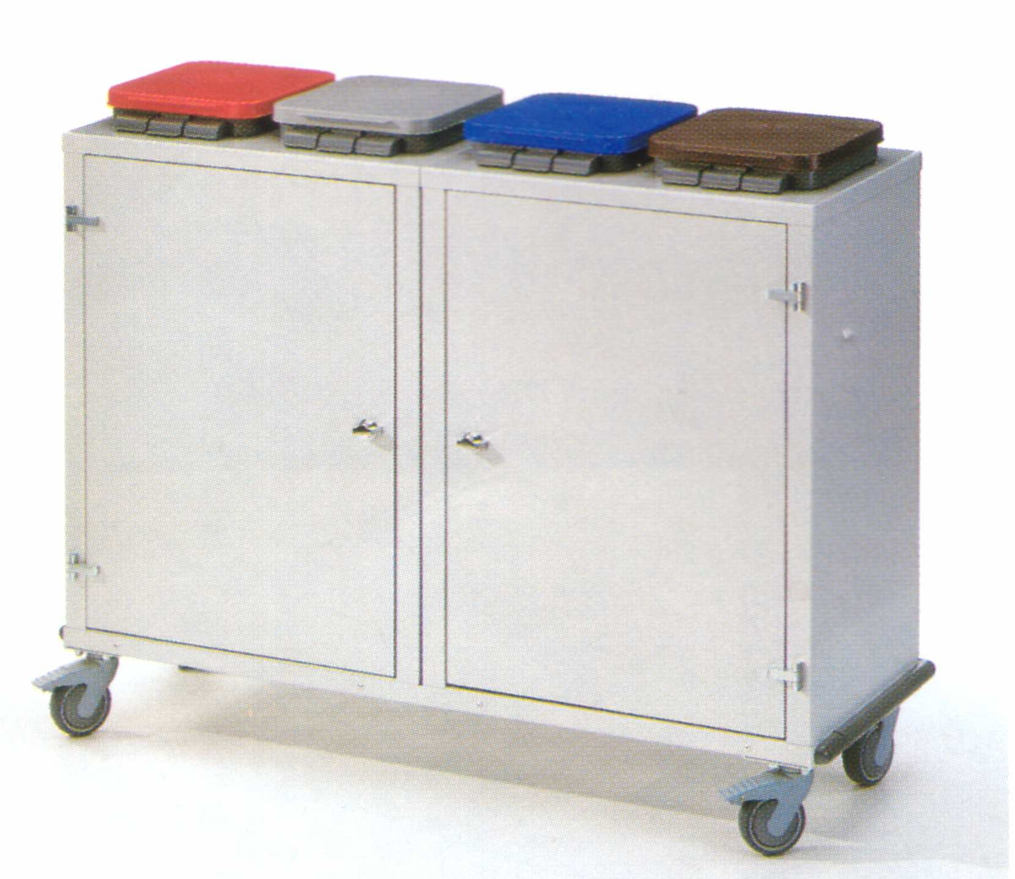

These will be colour coded and marked up so that waste can be separated into different waste streams such as plastic bottles, cans etc, to allow them to be recycled using standard signage as follows.



As well as being encouraged to separate out their waste, staff should continue to use the office paper recycling scheme that has been in place throughout the University for a number of years. This already means that the University recycles around 375 tonnes of waste office paper each year. A paper recycling container (see picture below) will be located in each office and close to photocopiers etc to maximize usage.

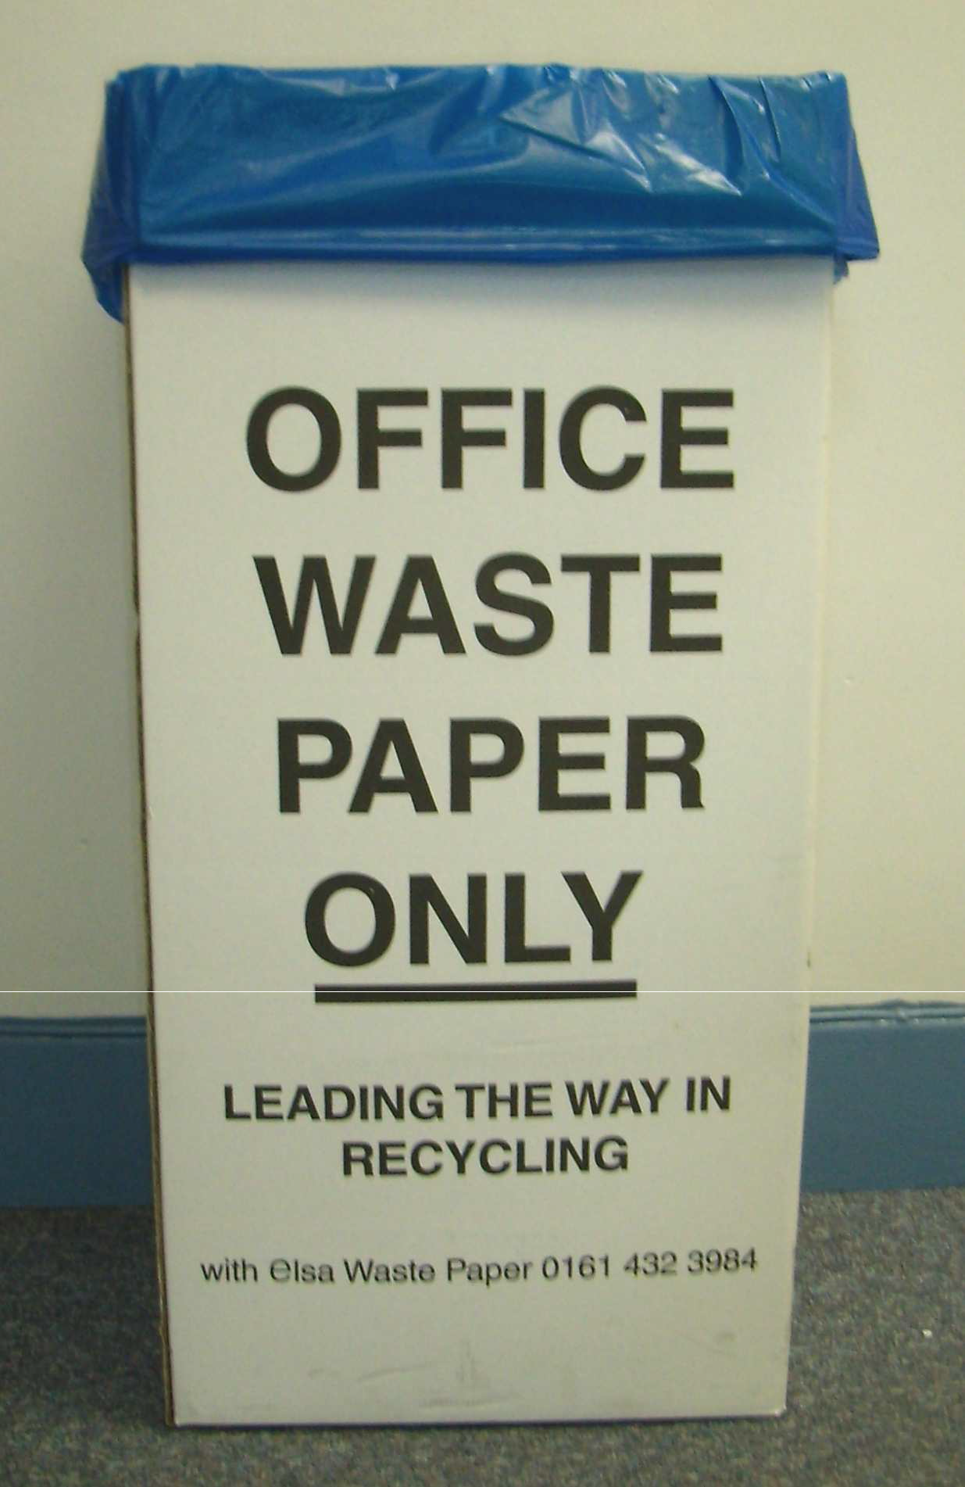

Recycling other waste types
- Due to current contractual arrangements it is only possible to recycle plastic bottles. Other plastic items will have to be placed in the general waste for the time being. If you are able, please squash your plastic bottles and then secure the lid before depositing them.
- Separate collection of glass bottles has not been included due to Health and Safety issues and the fact that most beverage containers are now made of plastic. However, staff are encouraged to use the glass bottle banks situated around the campus, details of which are soon to be published on the Estates website. Currently the nearest glass bottle banks are alongside the Humanities Building, Bridgeford Street.
- Any cardboard can be collected separately by House Services Staff. This
is then collected by Campus Cleansing from the building on a daily basis and sent for recycling.
- Any redundant IT related Electronic Equipment can be disposed of through IT Services in the Kilburn building. This is then re-used or refurbished where possible through a contractor. Contact IT Services on x56084.
- Used toner cartridges and inkjet refills can also be returned to IT Services at the Kilburn Building from where they are sent for recycling.

- Other electrical items can be collected by Campus Cleansing (24hr answer-phone x52246).
- The University does not currently recycle household type/ alkaline
batteries (AA, AAA etc), although this will be considered in the future. Currently, alkaline batteries can be disposed of in general waste as they are not classified as hazardous. Lead acid, nickel cadmium, and batteries containing mercury are however hazardous and need to be disposed of separately. The Estates Directorate already has procedures in place to do this. Contact x65963 should you need to dispose of any of these types of batteries.
- Fluorescent tubes and sodium lamps are now classified as hazardous
waste. Contact Operations and Maintenance (helpdesk x52424) to arrange removal, as procedures are already in place for the correct disposal of these items.

Security

Security should be much better in this building now that access is more restricted but you should still be careful, particularly if you work in the open plan areas and don’t leave wallets and mobile phones in view when you leave your desk.

Teaching Rooms

There are a number of teaching rooms in the Arthur Lewis Building which are available for booking via sossresources@manchester.ac.uk.

Toilets

There are male, female and disabled toilets on each floor adjacent to the lift area.

Walls and glass panels

Please do not stick anything to wall surfaces, use the notice boards.

Wireless Access

There are Wireless Access points throughout the building. For information about these points and how to access them go to the Humanities ICT website A- Z list at http://it.humanities.manchester.ac.uk/atoz/index.html

Choose wireless – this goes to ITSD site with the required information
http://www.itservices.manchester.ac.uk/roaming/howdoigetconnected/

but they recommend that you go via the indirect Humanities route as they will provide a Faculty specific information page before linking to the ITSD site.

Appendix 1 Frequently Asked Questions

Here are a few of the most frequently asked questions.

How do we deal with students with disabilities?
In most cases you would be notified that you have a disabled student in one of your groups. Our Disability Co-ordinator is Melanie Legge (Room G.001 Arthur Lewis, ext: 54868) and she will be able to give you help and advice on these matters.

Do we get staff car parking?
You can apply through the Car Park Permit Office (see the University web pages) in the same way that all members of staff do. There is however a long waiting list and there is a sliding scale of payment according to your salary.

Is the TA timetable fixed at the beginning of term or is it flexible?
The timetable has to be fixed in advance due to logistical problems like booking
rooms etc which we are required to do during the summer months.

What would happen if there was a case of a clash of dates due to a conference or similar academic commitment?
If this happens then you should first either try to rearrange your class (perhaps put an extra session on at the end, or change to a different day if that’s convenient for your students); or, you could swap a session with someone teaching on the same course.

Who do you report to if ill?
You need to report your illness as soon as possible to the Discipline Area
Administrator in the Undergraduate Office who can then try to alert your students that you are ill. You could also try to swap with a colleague so that they cover your class that day and you cover for them at a later date. If the illness is prolonged, then you need to contact your Discipline Area TA Co- ordinator and alert them to the problem.

What day do we get paid?

The day before the last banking day of every month.

Do we get paid extra for marking exams?
Some Discipline Areas will ask TAs to help out with marking at exam times and this does attract extra payments which have to be claimed on an expenses form PR5. Karen Egan will authorise these payments only after receiving instruction to do so from the Discipline Area TA Co-ordinator.

Do we get charged income tax?
This depends on the amount of teaching that you are doing and whether you have additional work outside the University as well. Check with Human Resources.

Where do I get a National Insurance Number from?
You need to contact the local Job Centre who will help you. Also check the GTA webpage on the School Intranet.

Where can I find out more information about the Trade Union?
Check the University website.

