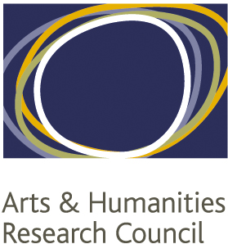

NORTH WEST CONSORTIUM
DOCTORAL TRAINING PARTNERSHIP
Cohort Development Fund

Collaborative Skills Development Call
Application Form
(September 2019)

Proposal title:

Participating NWCDTP Member HEIs:
The minimum requirement for a proposal is three. List others below if applicable.
 | HEI (lead first) | Contact name | Staff or student
1
2
3

Other participating organisations:
There is no requirement to involve other organisations. This section simply helps us to identify which organisations are working with our members.
Organisation | Contact name and position

Estimated number of students attending training:
If more than one event is involved, please break down numbers by event.

Elevator Pitch
Tell us, in no more than three sentences, what you want to do, how you want to do it, and how it will contribute to doctoral training in the arts and humanities.

Aims
Tell us, in no more than 250 words, how the proposal meets the aims of the funds.

Rationale and outcomes
Tell us, in no more than 500 words, what gap in training or cohort development this proposal is addressing; any evidence for this; what you plan to deliver through the training; and how any outputs will be communicated.

Recruitment plans
Tell us, in no more than 200 words, how you intend to publicise this training opportunity across the NWCDTP. For existing networks, please detail your membership and any previous experience of developing and delivering training.

Cost
Provide the budget for the proposal, broken down by type of support required e.g. travel and subsistence for visiting speakers, catering costs, travel for students etc. Please note that we normally expect travel for students to be included and to take the form of public transport at economy/advance fares. Please include any support from institutions or other partners, including support in kind (e.g. use of rooms, use of photocopiers etc.).

Timing
Please include an outline timetable for the planning and delivery of your training, taking into account that decisions should be made within three weeks of the application deadline.

Evaluation
How will you evaluate the success of the training? Please note that all successful bids will be required to submit a post-award report within 4 weeks of the completion of the training.

Statement of Support (e.g. from supervisor of lead applicant, or from a pathway lead)
Required for student-led proposals only.

Please confirm in no more than 250 words the training need, the proposed method for addressing it and the support arrangements provided by the participating HEIs.

