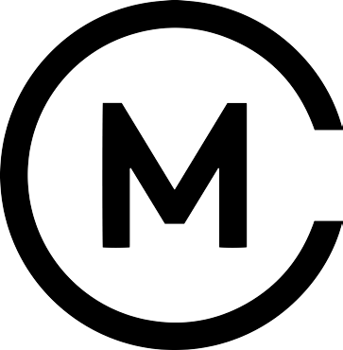

Soft drinks

Fentimans
Botanically brewed dandelion and burdock, ginger beer, Seville orange £2.05

Lovely ‘100% Hand pressed juices from England’s orchards & hedgerows:
Apple, rhubarb & ginger, sparkling elderflower, sparkling lemonade £2.05

Classic Coca Cola / Diet Coca Cola £2.05
Freshly squeezed orange juice £2.50
Cheshire spring water: still / sparkling £1.50
Pips organic hand-pressed fruit juice
Child Friendly £1.50

Ale, beer and cider

The Whitworth Pale Ale
Citrus and floral, brewed in Manchester! £4.00
Brooklyn Lager
Dry hopped aroma, smooth caramel malt £4.00
Red Bank Cider
Medium sweet, crafted from English apples £4.50
Red Bank Seasonal Fruit Cider
Wild blueberry £4.50
Aspall Suffolk Cider
Dry and fruity, established 1728 £4.00

