Corporate Planner Help Sheet
How to Directly Enter Forecast (Q1) Figures into CP
The recommended approach to entering forecast figures is different depending on whether you are entering Research numbers or Core & Matched numbers.
Steps 1-4 are common to both approaches
- Navigate to Table Reports
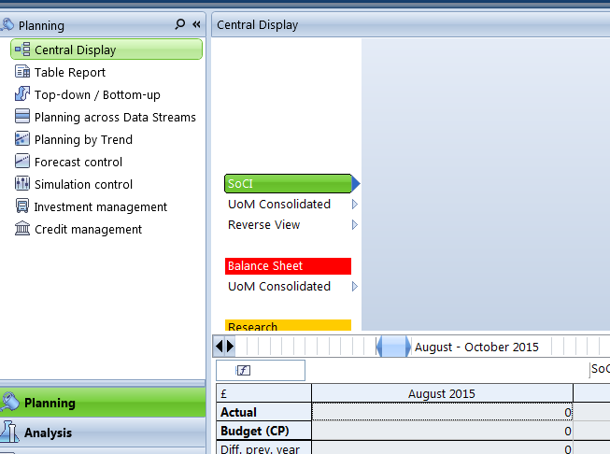
Select Table Report from the Planning menu
- Select Timeline View
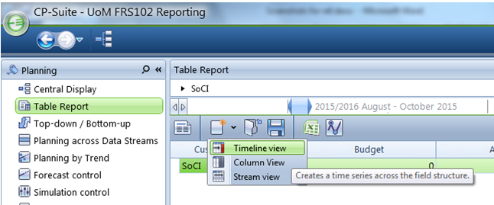
Select New View ( icon) and then Timeline View

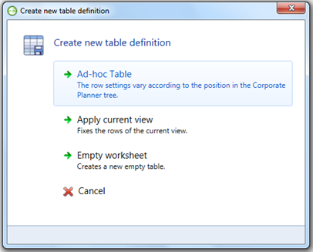
Click ‘Ad-hoc Table’

- Ensure the Time span is set to FY 2015/16

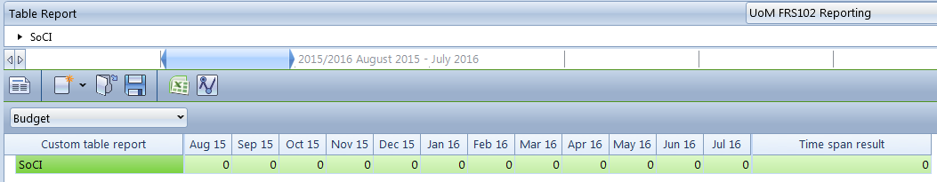
Extend the timespan by using the  and in the slider if required

- Select the Forecast (Q1) Datastream
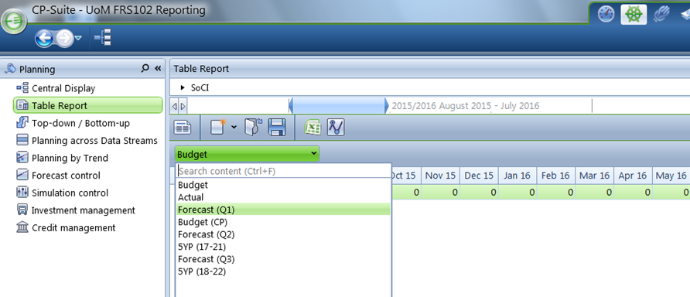
Click the and select Forecast (Q1)

Method for Entering Research Forecast
When entering the forecast for Research income and expenditure, it is recommended that this is done in the ‘Research’ branch within the ‘Reverse View’ of the tree. This will enable you to enter total Research and Expenditure for each School in a Faculty in one view.
It is recommended that you export the current forecast from CP to Excel and use this as the basis for making forecast changes. Once happy with the updated forecast, copy and paste them as values into your Excel template and from here copy them into CP.
The below example shows you the recommended method for entering Research Other Operating Expenditure for EPS.
- Navigate to the Research branch in the Reverse View
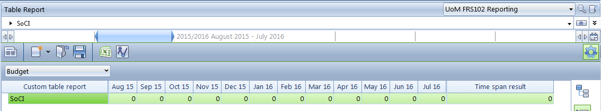
Click the icon to make the tree visible

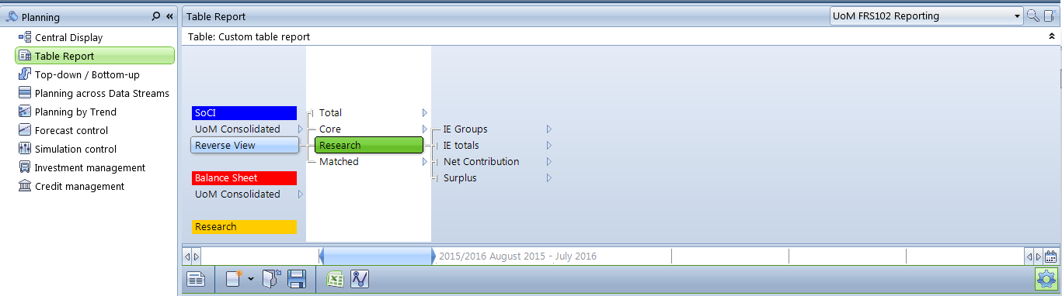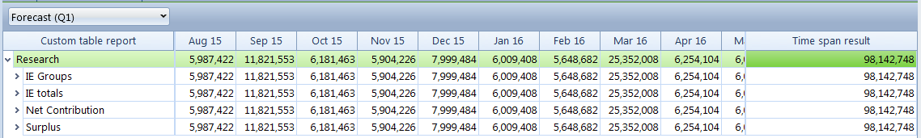

- Navigate to Other Operating Expenditure
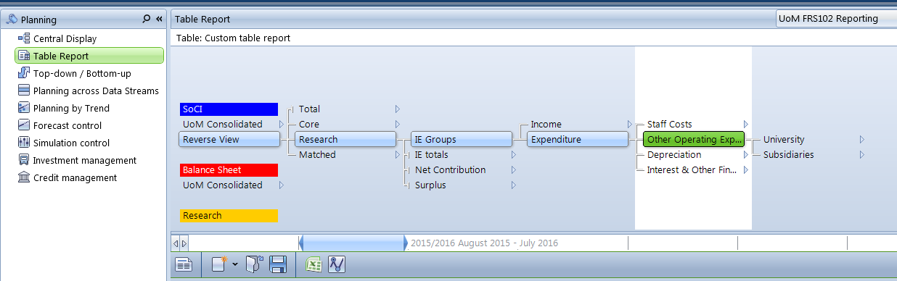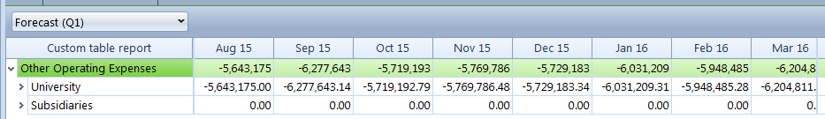

- Navigate to the relevant Faculty in the UoM Hierarchy

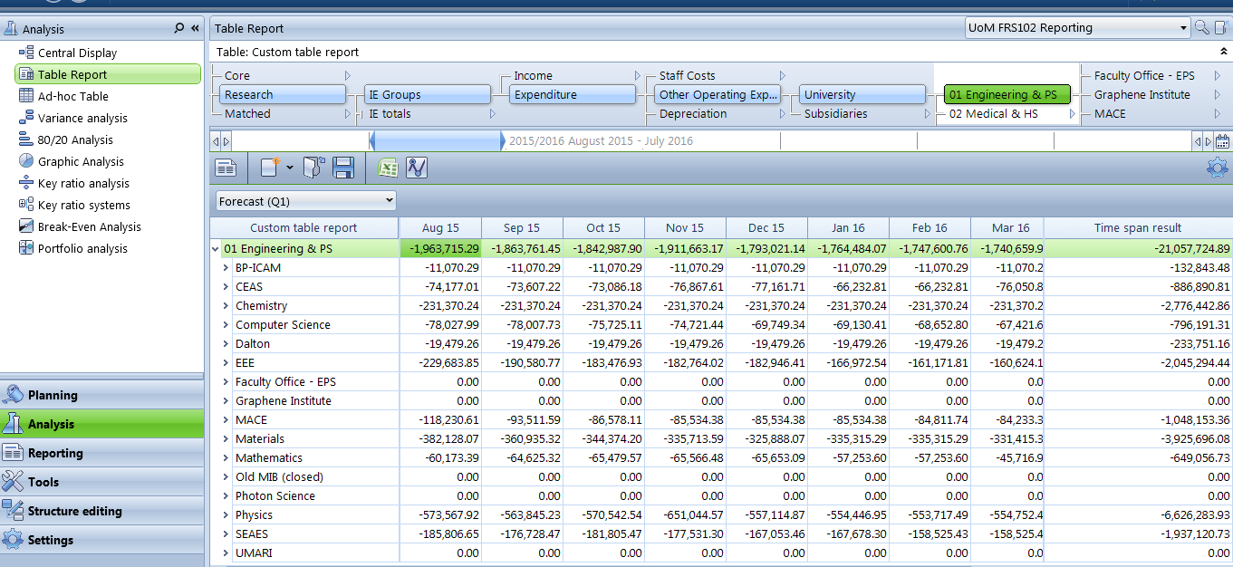

The Table Report lists all Schools in that Faculty

- Export the Forecast (Q1) to Excel by clicking the ‘Excel Export’ icon

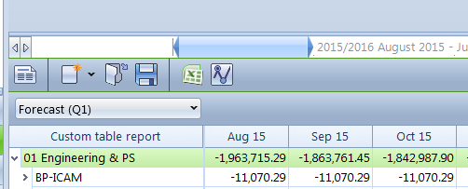

- Amend the numbers in this spreadsheet for your forecast. Remember to be consistent with the signage (ie income = positive, expenditure = negative).

Note

- You are only required to change the forecast totals in the ‘Time Span Result’ column. CP will profile the forecast across months in the same way as the previously populated budget numbers. You can amend the profiling across months if desired.

- It is recommended that you copy and paste values your amended forecast into your Excel template.

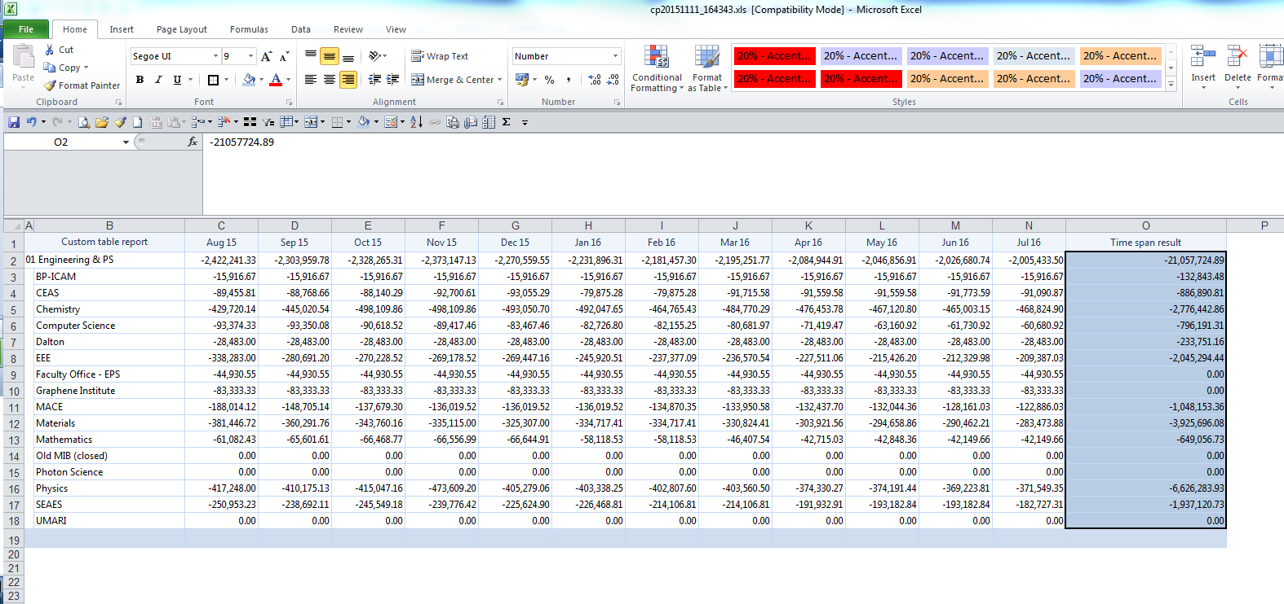
You can amend the profiling across time periods if desired – otherwise CP will apportion the new total on the basis of the previously populated budget figures.
You are only required to change the totals in the ‘Time Span Result’ column
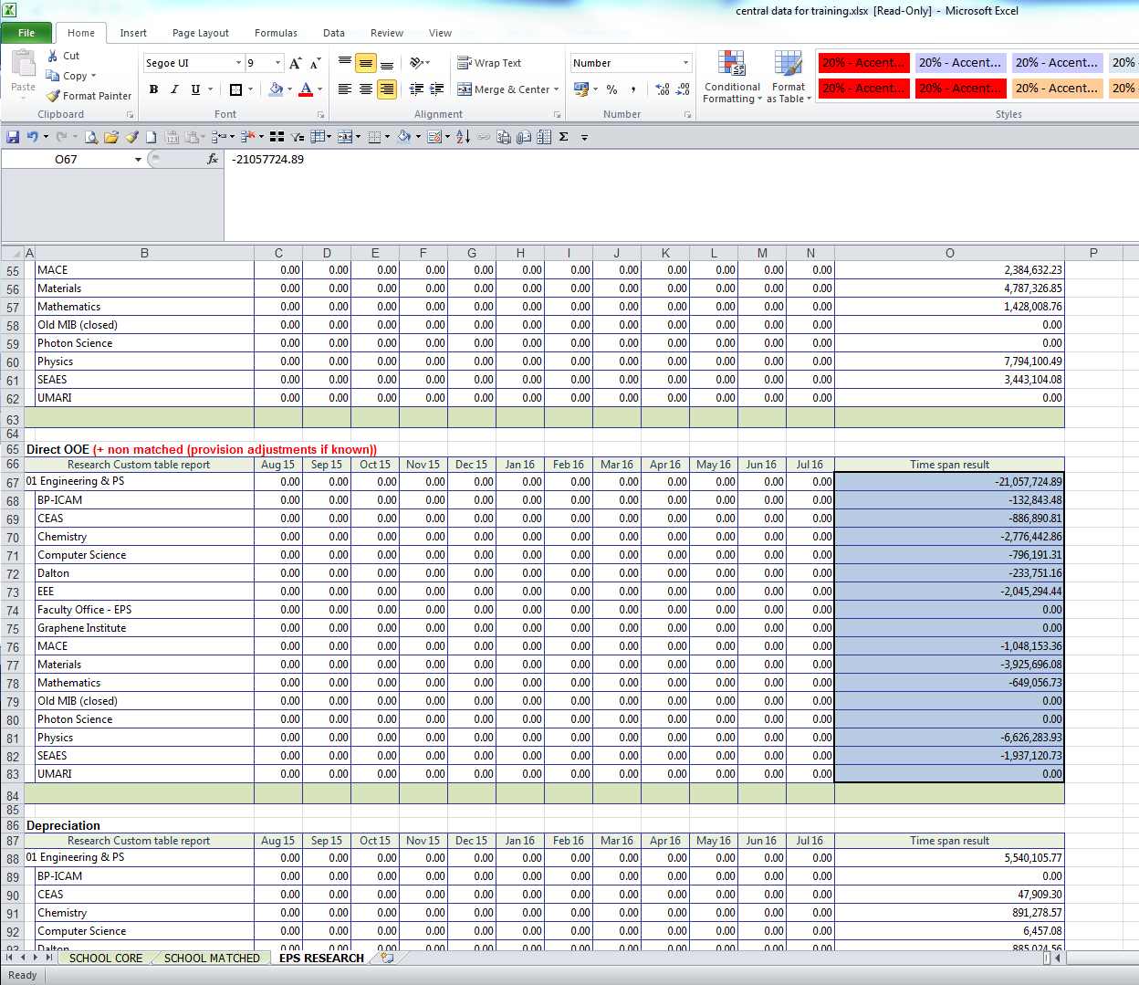
Paste as values into the Time Span Result column in the Excel template

- Paste data into CP using the command ‘Ctrl + V’

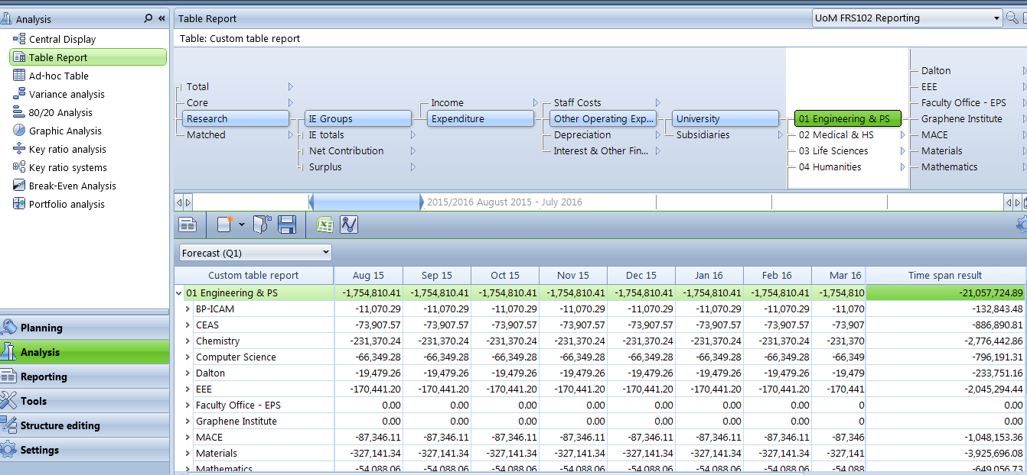
Click in the top cell and paste from the template by using ‘Ctrl + V’ command
Total apportioned across time periods on the same basis as the previously populated budget figures.

- Follow the same methodology for populating Research Income, Staff Costs, Other Operating Expenses and Depreciation.

Notes
- CP will profile the total across the timespan in the same ratio as the previously populated budget numbers. The profiling can be amended if desired – but be aware that changing the number in a time period will change the total.

- CP will profile the total to the L4 sub-schools in the same way as the previously populated budget numbers. The profiling can be amended if desired – but be aware that changing a number in a sub-school will change the total for that school.

- CP will profile the total to the sub-analysis within each heading (eg Revenue Income, Capital Income etc) in the same way as the previously populated budget numbers. The profiling can be amended if desired – but be aware that changing a number in the sub-analysis will change the total for that analysis.

- The Excel export contains numbers only (not formulas) – CP will automatically calculate the new totals after the numbers have been copied in (so in the above example, the total is £20.4m in CP versus £21.1m in the Excel template).

- HEFCE QR income cannot be entered in the same way as Research income (the tree stops at ‘Funding Body Grants’). Therefore HEFCE QR income is to be entered in either Core or Matched using the Core/Matched method.

Method for Entering Core/Matched Forecasts
It is recommended that this is done by each HoSF for their school only in the usual ‘UoM Consolidated’ view in the tree.
The below shows you the recommended method for entering Core Tuition Fee income at Level 4 (MACE).
- Navigate to your School in the UoM Consolidated Tree
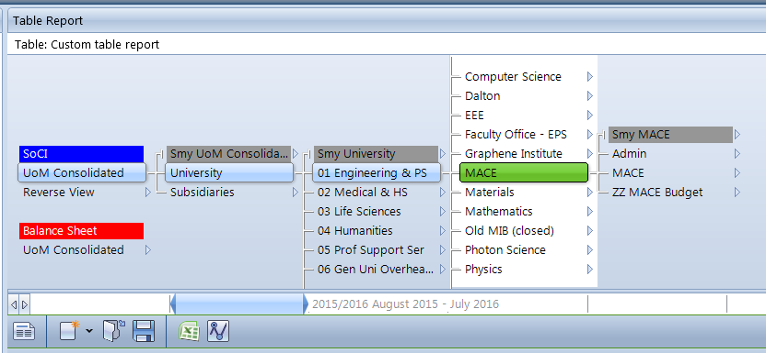
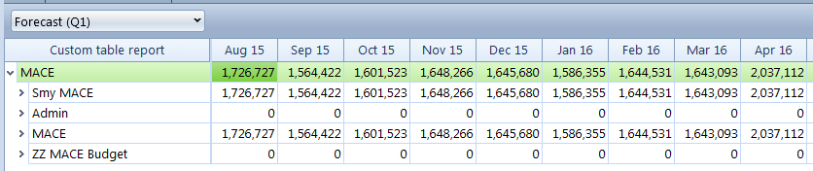
You have a choice to which level you forecast at. The forecast is required at School Level (L3) at a minimum, but you can forecast at sub-school (L4) if desired.
You can enter figures into the ‘Smy’ node in the tree to forecast at L3

Otherwise, select a sub-school to enter the forecast at L4

Note
- If you enter forecast figures into the ‘Smy’ Level, CP will profile the total to the L4 sub-schools in the same way as the previously populated budget numbers. The profiling can be amended if desired – but be aware that changing a number in a sub-school will change the total for the school.

- Navigate to the relevant Core or Matched branch.
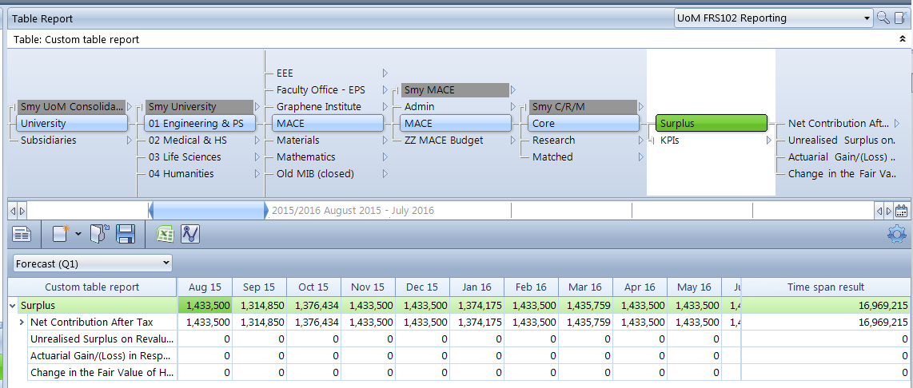
- Navigate to the SoCI branch in the tree where the forecast is to be entered (eg Tuition Fees & Educational Contracts).
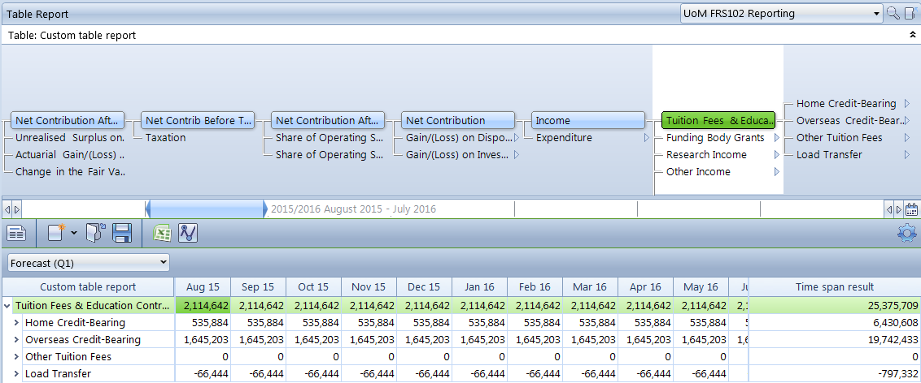
- Expand the sub-analysis in the Table Report to show the detail for this branch. Expanding to 10 levels will show all branches in the tree. Fewer can be selected if desired. This is done by right-clicking on the heading > Expand.

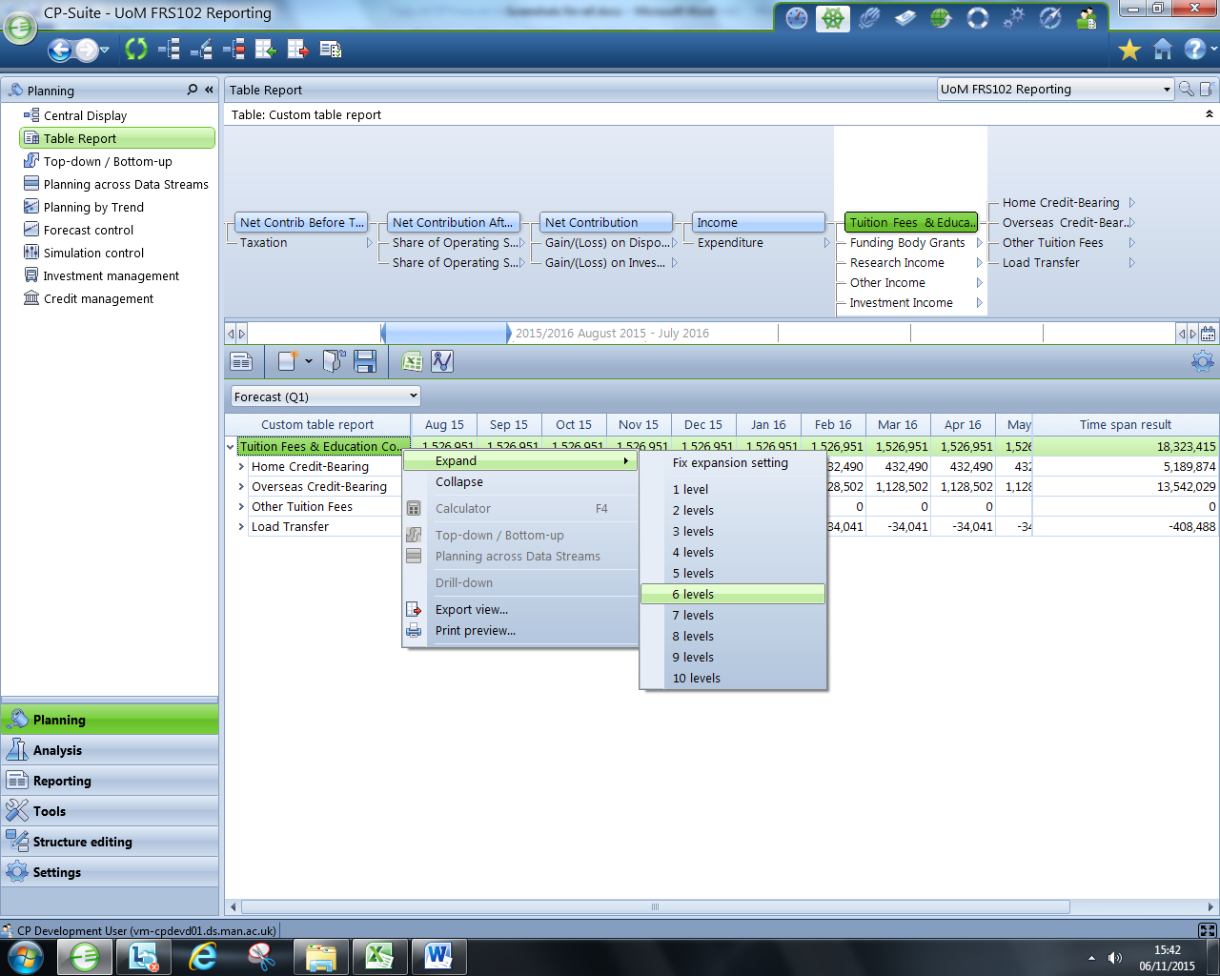
Right click

- Export the Forecast (Q1) to Excel by clicking the ‘Excel Export’ icon
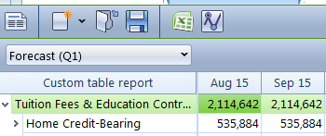
- Amend the numbers in this spreadsheet for your forecast. Remember to be consistent with the signage (ie income = positive, expenditure = negative).

Note

- You are only required to change the forecast totals in the ‘Time Span Result’ column. CP will profile the forecast across months in the same way as the previously populated budget numbers. You can amend the profiling across months if desired.

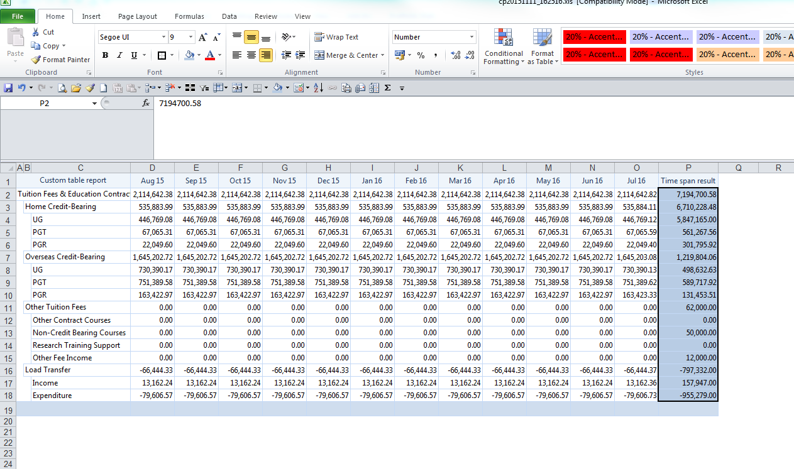
You are only required to change the totals in the ‘Time Span Result’ column
You can amend the profiling across time periods if desired – otherwise CP will apportion the new total on the basis of the previously populated budget figures.

- It is recommended that you copy and paste as values your amended forecast into your Excel template.
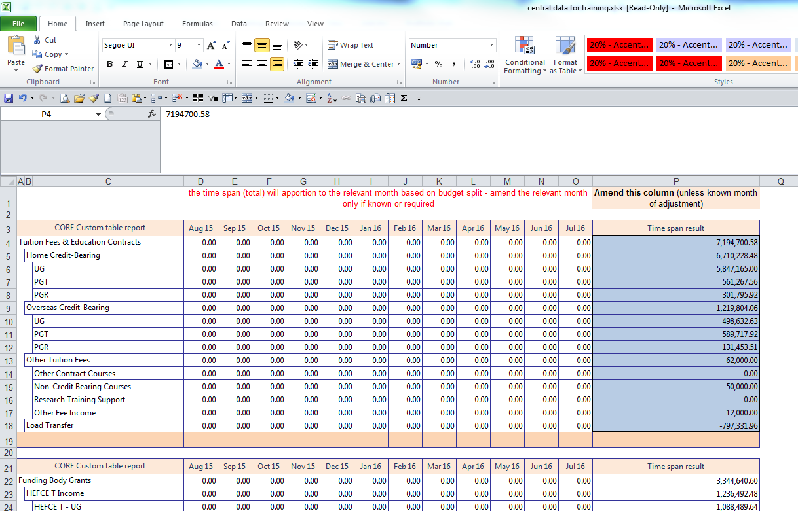
Paste as values into the Time Span Result column in the Excel template
- Paste data into CP using the command ‘Ctrl + V’
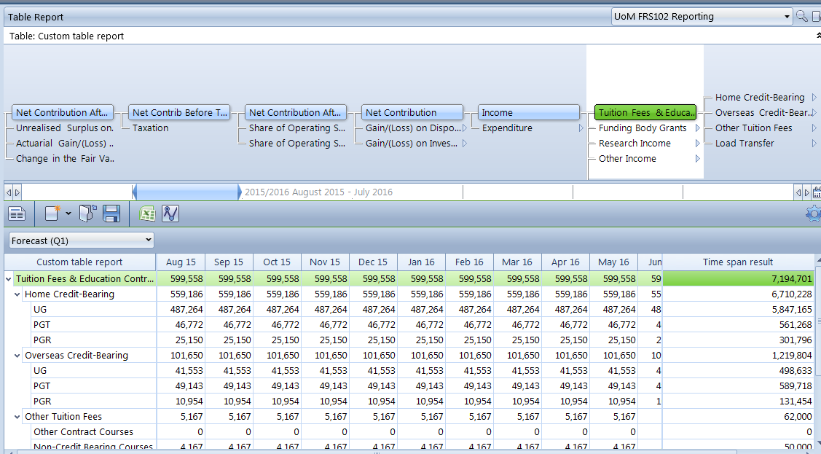
Click in the top cell and paste from the template by using ‘Ctrl + V’ command

Total apportioned across time periods on the same basis as the previously populated budget figures.

- Follow the same methodology for populating:
  - Funding Body Grant income (including HEFCE QR)
  - Other Income
  - Investment Income
  - Donations & New Endowment Income
  - Staff Costs
  - Other Operating Expenses
  - Depreciation
  - Interest & Other Finance Costs
for both Core and Matched.
Note

- CP will profile the total to the sub-analysis within each heading (eg Building Maintenance, Equipment & Lab Supplies) in the same way as the previously populated budget numbers. The profiling can be amended if desired – but be aware that changing a number in the sub-analysis will change the total for that analysis.

