

Communications with Offer Holders 2015-16
Date: | October 2015
Version:  Author: | Version 1  Marieke Mollitt – Student Communications and Marketing Manager  (pre-registration), DSE
Enquiries: | marieke.mollitt@manchester.ac.uk – 57591
Summary:  Distribution:  Contents: | An overview of central conversion communications and the proposed schedule for 2015-16  Student Recruitment Marketing Group (SRMG)  Recruitment and Admissions Management Group (RAMG)  - Introduction  - Overall schedule of offer holder communications  - Schedule of e-advantage newsletters  - Appendices:  Appendix 1 – Conversion communications timeline  Appendix 2 - e-advantage examples  Appendix 3 - e-advantage headline statistics – UG and PGT  Appendix 4 - e-advantage headline statistics – PGR
- Introduction

A great deal of effort goes into communicating with our offer holders - both to give them the key information needed to enable them to make the right choice about where to study, and to share the benefits of studying at The University of Manchester. This takes place across the University, from the Student Communications and Marketing team, to academic Schools and University Marketing and Communications.

This paper outlines when and what is received by offer holders, and the planned schedule for the upcoming recruitment cycle, 2015-16. Please note that in most cases there will be supplementary communications sent by Schools that are not captured here.
Any enquiries should be directed to studentmarketing@manchester.ac.uk.

- Overall schedule of applicant communications

Time from when offer is made | Communication | Format
1 week | Head of School letter | Print or email
1 week (from November onwards when publication is printed) | Manchester Advantage (Home and international versions)  Details the benefits of studying at Manchester, including the facilities, city and insight from current students. | Print
2 weeks (from November onwards when publication is printed) | Living in Manchester guide  Showcases our accommodation and provides need-to-know facts on each type as well as the city and private accommodation. | Print
From December – September | e-advantage – please see table on pages 3-5 | Email (HTML)
From February - July | Manchester calling campaign (international only) –  Telephone contact between current students and those in overseas markets of the same nationality to answer any questions. *Please note this process is currently under review. | Phone
From April | Arrival Guide (International and EU)  Essential information specific to international offer holders in order to help them prepare for coming to Manchester | Print
From April | Pre-CAS communications to UF offer holders | Email
From May | Good luck postcard (home and selected international offer holders at present–to be reviewed)  Personalised post card wishing offer holders good luck before their exams | Print
From May-August | Pre-departure visits – visits from International Officers to key overseas markets to give important information | Face-to-face
From June | Welcome pack (home version and international/EU version) – includes:  -Get Ready guide – All the actions needed to get to Manchester and register as a student. Int’l version includes Orientation events  -Manchester Welcome Guide- a calendar of all events taking place over Welcome  -Luggage label (international/EU only) | Print

Key
Academic School
Student Communications and Marketing Team

Marketing Team
International Office

- Schedule of e-advantage newsletters
3.1 UG and PGT e-advantages
Month | Date | Issue home | Issue – International / EU
Dec 15 | 1 Dec | School e-bulletin | School e-bulletin
Dec 15 | 14 Dec | e-advantage issue 1  Welcome to the e-advantage, plus  Accommodation | e-advantage issue 1  Welcome to the e-advantage, plus Accommodation
Jan 16 | 8 Jan | School e-bulletin | School e-bulletin
Jan 16 | 15 Jan | e-advantage issue 2 - Student finance | e-advantage issue 2 -Careers and employability
Feb 16 | 1 Feb | School e-bulletin | School e-bulletin
Feb 16 | 15 Feb | e-advantage issue 3  Careers and employability | e-advantage issue 3  The city
Mar 16 | 1 Mar | School e-bulletin | School e-bulletin
Mar 16 | 14 Mar | e-advantage issue 4  Teaching & Learning | e-advantage issue 4  Finance
Apr 16 | 1 Apr | School e-bulletin | School e-bulletin
Apr 16 | 14 Apr | e-advantage issue 5  The city | e-advantage issue 5–  Teaching and Learning
May 16 | 2 May | School e-bulletin | School e-bulletin
May 16 | 16 May | e-advantage issue 6  Campus facilities  (Fitness and wellbeing, faith) | e-advantage issue 6  Campus facilities  (Fitness and wellbeing, faith)
Jun 16 | 1 Jun | School e-bulletin | School e-bulletin
Jun 16 | 14 Jun | e-advantage issue 7  Prepare for your results | e-advantage issue 7  Prepare for your results
Jul 16 | 1 Jul | School e-bulletin | School e-bulletin
Jul 16 | 14 Jul | e-advantage issue 8  Getting involved (Students’ Union, societies and social responsibility) | e-advantage issue 8  Getting involved (Students’ Union, societies and social responsibility)
Aug 16 | 8 Aug | Confirmation and Clearing special | Confirmation and Clearing special
Aug 16 | 22 Aug | e-advantage issue 9 - Get Ready | e-advantage issue 9 - Get Ready
Aug 16 | 26 Aug | School e-bulletin | School e-bulletin
Sept 16 | 1 Sept | e-advantage issue 10- Welcome | e-advantage issue 10 – Welcome
Academic School
Student Communications & Marketing Team

Marketing Team

Key

Segmentation
Please note, there are up to six different versions of each e-advantage, depending on the topic – for example finance would have to be segmented very specifically to each different audience. The six audiences are:
- Home UG
- Home PG
- EU UG
- EU PG
- International UG
- International PG

There is also a separate Postgraduate Research e-advantage. Please see next page.

3.2 Postgraduate Research e-advantage schedule
There is a separate PGR schedule, as fewer issues are sent per year. 2014-15 was the first cycle where a standalone PGR e-advantage was sent, and due to its success will be repeated for 2015-16.
As this is a new concept, we are not directing Schools to do the same, although this would only be of benefit if there is resource. Please talk to the Student Communications and Marketing Team if you wish to create a school-level PGR e-newsletter and we will try to provide some guidance if needed.

Month | Topic
Dec 16 | Your research journey starts at Manchester - Funding, accommodation and the city
Mar 16 | Your research experience
May 16 | Make a difference at Manchester
June 16 | Reach your potential at Manchester
Sept 16 | Welcome to The University of Manchester

4.1 Appendix 1 – Conversion communications timeline
4.2 Appendix 2 - e-advantage examples
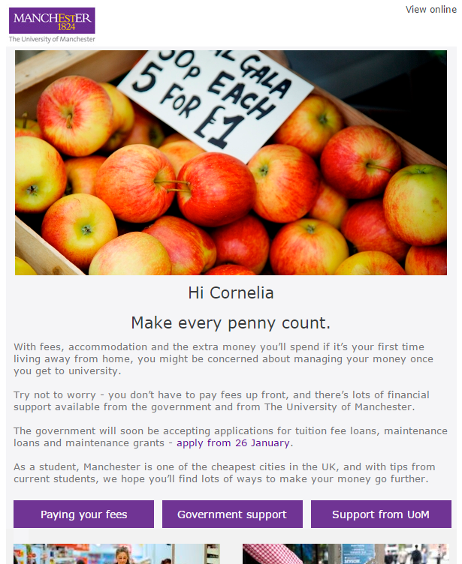
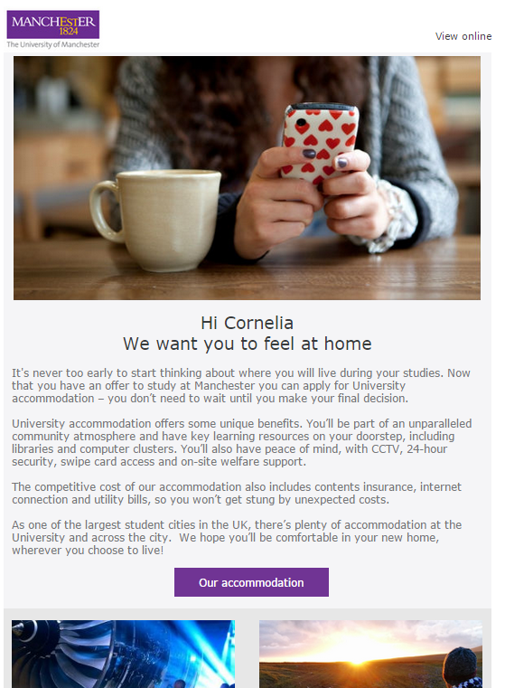
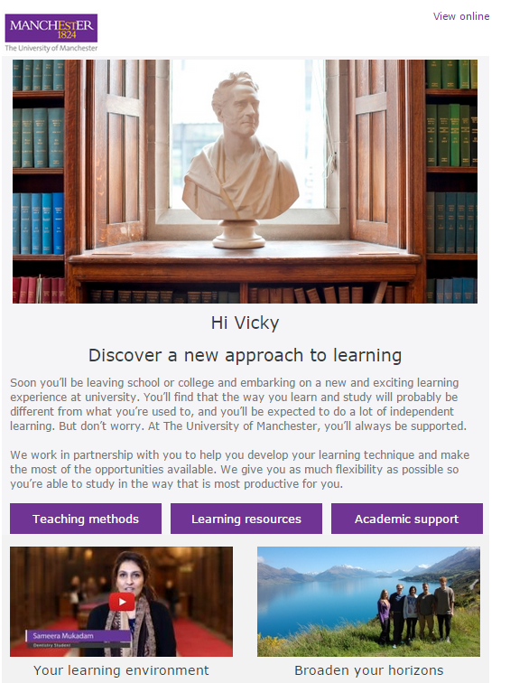

4.3 Appendix 3 - e-advantage headline statistics – UG and PGT
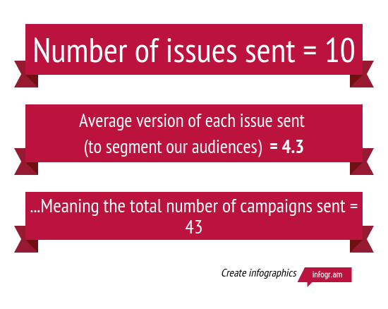

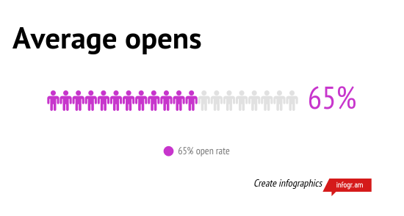

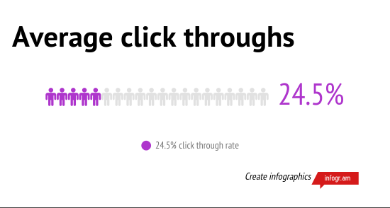

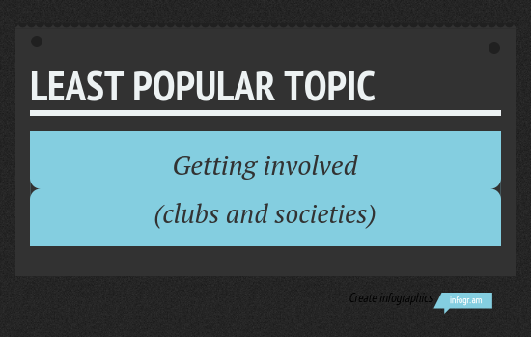


4.4 Appendix 3 - e-advantage headline statistics - PGR
