[University logo]

Pension information for casual staff

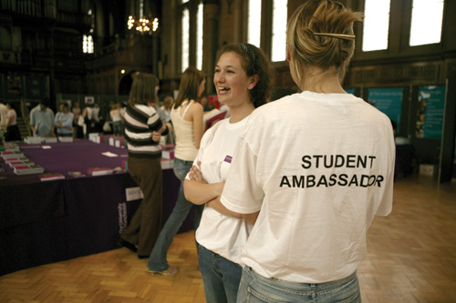
[NOTE: Image above is not available for use in this context]

Been meaning to start saving? Now’s your chance. Whether you’re a student ambassador or an exam invigilator, a Museum visitors’ assistant or an events assistant, your casual job at the University could provide you with a pension and the opportunity to save for the life you want after you stop working.

You don’t need to do anything: if you work with us for longer than three months, we’ll assess you for auto-enrolment into NEST, the Government-approved pension scheme. NEST aims to grow your money more than if you leave it in a bank account.

Will auto-enrolment apply to me?

Yes, if you are an Eligible Jobholder - which means that you:

- Are between 22 years old and state pension age; and
- Earn over £833 a month in the 2014/15 tax year; and
- Are currently not in a pension plan.

If you meet the auto-enrolment conditions at the first assessment, we’ll enrol you into NEST and let you know that we have done this.

If you don't meet the conditions at the first assessment, we shall continue to assess you and, if you become an Eligible Jobholder at a later date, we shall then auto-enrol you. Alternatively, you may join NEST voluntarily at any time.

These examples show how members of our casual staff might be affected by auto-enrolment:

  Mary works as an Exam Invigilator  She earned £200 each month for the first three months.  In the fourth month, she also earned £200.  She is not an Eligible Jobholder and doesn’t need to be auto-enrolled.  However, she can ask us to enrol her into NEST. | Alex works as a Student Ambassador  He earned £200 a month for the first three months.  In the fourth month, he earned £850.  He is an Eligible Jobholder and will be auto-enrolled into NEST. |   Hannah works as a Museum Visitors’ Assistant  She earned £850 a month for the first three months.  In the fourth month, she earned £600.  She is not an Eligible Jobholder and doesn’t need to be auto-enrolled.  However, she can ask us to enrol her into NEST.

What will I pay and what will the University pay?

If you are auto-enrolled, you will pay contributions of 1% of your earnings above £481 in each period and we will match this contribution.

The table opposite illustrates how contributions are calculated for two colleagues:

Name | Monthly earnings | Total contribution | University share | Your share | Tax relief from the government
Becky | £850 | £7.38 | £3.69 | £2.95 | £0.74
Sam | £1,200 | £14.38 | £7.19 | £5.75 | £1.44

To find out how much being in a pension scheme will cost you and how much you’ll get from the University, you can use the Money Advice Service’s free calculator:

- www.moneyadviceservice.org.uk/en/tools/workplace-pension-contribution-calculator

This is only a short-term job - surely it’s not worth the bother of setting up a pension?

Auto-enrolment is easy: there is no paperwork for you to sign and we will send your contribution and ours to NEST.

Once your first contribution has been taken, NEST will contact you directly and you’ll be able to see your NEST account online and keep track of your savings.

Your account will remain open even after you stop working at the University, so you can save with NEST wherever you are.

What if I really don’t want to start a pension now?

You can opt out of NEST only after you’ve paid your first contribution and activated your account: you’ll then be able to opt out by telephoning NEST.

Where can I find further information about NEST?

Visit their website at:

www.nestpensions.org.uk

Who can I contact with further queries?

Please email your question(s) to the University’s Pensions Office at:

auto-enrolmentpensions@manchester.ac.uk

