Crucial Guide 2014: Get Ready

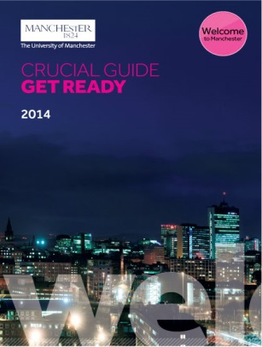 | You will have already received, or will shortly be receiving your Crucial Guide 2014: Get Ready booklet; this guide contains important information to help you prepare for your new life in Manchester, and so it is important to read it thoroughly.  If you haven’t received your booklet yet, don’t worry – it will be arriving with you soon! In the meantime, you can see the electronic version of the guide at: http://bit.ly/1rgYfL1 .
Welcome Pack

If you have a confirmed place starting in September 2014, you will soon be receiving your welcome pack in the post. This pack contains your confirmation letter, a welcome pack from your subject area, and other useful information you may need in your early weeks with us. If you are expecting a confirmation letter, and don’t receive this by 1st September, please contact salc-reception@manchester.ac.uk and we will send you the information you need.
Coming Soon - SALC Survival Guide



Alongside the Crucial Guide, we have our own School of Arts, Languages and Cultures (SALC) Survival Guide. This gives you lots of useful information, including how to register, view your timetable and choose course units, as well as lots of information about support services you will be able to access during your time here. You will find the SALC Survival Guide here (URL on welcome week site) shortly

Becoming a Member of the University

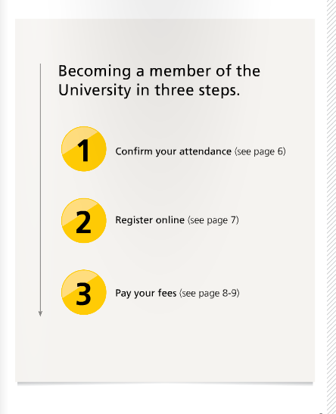 | Your Crucial Guide will take you through the important steps of becoming a member of the University. Please go to page 6 of the Crucial Guide 2014: Get Ready booklet to find out how to:  Register Online  Pay your fees  Activate your IT Account  You can do all this at home, before arriving in Manchester, and it will mean you can start to access our online services.
Registration

You can start to register online from 1st September – 30th September.

Registration is a crucial part of becoming a student of the University. It’s an online process that requires you to confirm personal details, check course information and pay – or make arrangements to pay – your tuition fees. You are not a member of the University and can’t access any of our services, including attending lectures, until you register. You will need to register at the beginning of each academic year of your degree programme with us.

All the information you need to register online is contained in the Crucial Guide 2014: Get Ready – try to make sure that you have done this before you arrive in Manchester to make your transition as smooth as possible.

If you have any problems
If you have any difficulties, you can speak to a member of the University’s registration helpline on +44 (0)161 306 5544 – weekdays between 1st and 30th September.
My Manchester

Following activation of your IT account (page 6 of Crucial Guide 2014: Get Ready), you will gain access to My Manchester. This is your personal student portal, and you will use this to gain access to on-line resources and services, including timetables and emails - (https://my.manchester.ac.uk/). You will use My Manchester regularly in your studies, so please take the time to familiarise yourself with how it works.

SALC Intranet – School and Programme Information

Once you have activated your IT account, you will also be able to access the Student Intranet pages of the School of Arts, Languages and Cultures.

http://www.alc.manchester.ac.uk/studentintranet/

These pages are updated regularly throughout the academic year and contain information on your degree programme’s policies and regulations. Bookmark this page, to ensure that you have access to up to date School and Department information whilst at Manchester.
Welcome Week

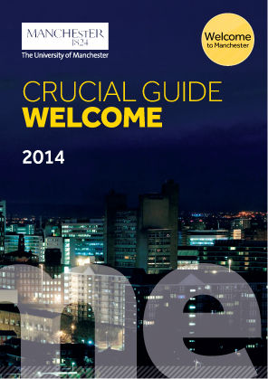 | Welcome Week for the department of begins on Monday 15th September, and full itinerary of events will be available here (insert URL) from 1st September. The week can be a challenging and exhilarating one, where you will be meeting both academic and support staff and will enjoy a range of social events. You’ll need to absorb and process a great deal of information in a relatively short period of time – so try to be as prepared as possible before you arrive – but don’t worry, all the information will be available for you in our Survival Guide, or you can always ask our teams of support staff on hand!  If you can’t find your Welcome week schedule after 1st September, or are unsure where to come in your first week, please contact us on salc-reception@manchester.ac.uk and we will help.
Your Academic Advisor

You will be allocated an Academic Advisor and will meet them during Welcome Week. Your Academic Advisor, who will normally be allocated to you for the duration of your degree programme, is concerned with your general welfare, and is available to give you help and advice on all matters, whether academic or personal. You are strongly encouraged to meet with your Academic Advisor at all planned meetings, normally twice in the first semester of your first year and once a semester thereafter.

