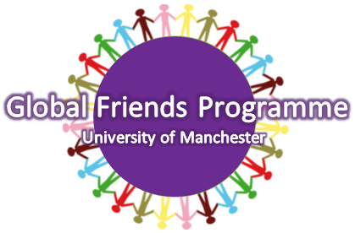
GLOBAL FRIENDS PROGRAMME
MENTOR APPLICATION FORM 2014/15

The Global Friends Programme requires you to mentor a group of 3-5 students to aid them in their transition to life here in Manchester by supporting them academically, socially and culturally. If you would like to participate, please fill in the application form below.

NAME
DATE OF BIRTH
STUDENT I.D.
DEGREE PROGRAMME (BA, BSc, MA etc.)
DEGREE COURSE
YEAR OF STUDY
YEAR OF GRADUATION
NATIONALITY
CONTACT TELEPHONE NUMBER
EMAIL ADDRESS
LANGUAGES SPOKEN
HALLS OF RESIDENCE/MANCHESTER ADDRESS
IF YOU HAVE STUDIED ABROAD, OR YOU ARE GOING TO STUDY ABROAD, PLEASE STATE THE UNIVERSITY YOU WILL BE ATTENDING AND THE DATES ATTENDING/ATTENDED.

WHY WOULD YOU LIKE TO PARTICIPATE IN THE GLOBAL FRIENDS PROGRAMME? (300 words max.)
PLEASE STATE ANY PREVIOUS VOLUNTARY OR WORK EXPERIENCE THAT YOU HAVE UNDERTAKEN THAT WOULD BE BENEFICIAL TO THIS ROLE (300 words max.)
PLEASE TELL US AS MUCH ABOUT YOURSELF AS YOU CAN SO WE CAN MATCH YOU WITH APPROPIATE MENTEES. (e.g. interests, hobbies, music, sports, societies involved with, countries you are interested in/have visited, subject preferences, halls of residence you lived in etc.) BE AS SPECIFIC AS YOU CAN!

All forms must be submitted to global/friends@manchester.ac.uk by MIDNIGHT on Tuesday 12th August 2014. You will be contacted about this role in late August.

