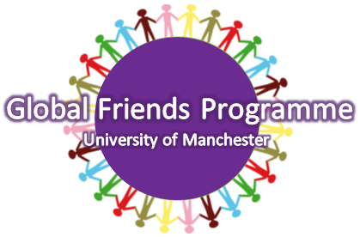

GLOBAL MENTEE HANDBOOK 2014/15
SUPPORT & GUIDANCE NOTES

WHAT IS THE PURPOSE OF THE GLOBAL FRIENDS PROGRAMME?
The aim of The University of Manchester’s Global Friends Programme is to support incoming study abroad students – that is, exchange students or fee-paying students that are here for up to a year. The International Programmes Office, who are responsible for you whilst you are here, have set up this programme to support you academically, socially and culturally during your first weeks in Manchester. The International Programmes Office also aims to use this programme to foster cultural exchange between you, the international student, and our Global Mentors, the Manchester students. This programme aims to be beneficial to both mentees and mentors – as much as you will learn from them, they will be learning from you too.

WHAT IS A GLOBAL MENTOR?
Upon signing up to the Global Friends Programme, you will be assigned a Global Mentor. This is a student who has volunteered to help you settle in at The University of Manchester. They will be a returning student who has just been studying abroad, or they will be a student that has already spent a year abroad. They are matched with you based on common interests, so hopefully you will be happy with your mentor and mentee groups! Your mentor can direct you to places that can provide you with support – from registering at the university to finding part time work. Your mentor is also a good point of contact if you just want to know simple things about living here, like which bus to take to the city centre, or where is good to eat on campus. Don’t be shy – they expect you to ask these things!

WHAT IS A MENTORING GROUP?
We think the best way for you to benefit from a mentor is by assigning you to a small mentee group. We will try to match mentors and mentees with based on similar interests, so you’ll all have something in common which hopefully will make the meetings fun and interesting! You will be grouped with 2 to 4 other like-minded students, and your mentor will ask to meet you in these groups or one-on-one.

WHEN WILL I HEAR FROM MY STUDENT MENTORS?
The first contact with your mentors should happen before you arrive in Manchester. During the weeks before your arrival, your mentor will introduce themselves and send any information that needs passing on via email. Your first in-person meeting with your mentors will be during your first two weeks at the University of Manchester.

HOW DO I GET INVOLVED?
All you have to do is sign up via the application form we have sent you by email – Simple!

CONTACTS

global.friends@manchester.ac.uk

SUSANNA LARMINIE
INTERNATIONAL PROGRAMMES ADMINISTRATOR
+44 161 306 5626

INTERNATIONAL PROGRAMMES OFFICE
THE UNIVERSITY OF MANCHESTER
RUTHERFORD BUILDING
OXFORD ROAD
MANCHESTER
M13 9PL

FAX: +44 161 275 2106

