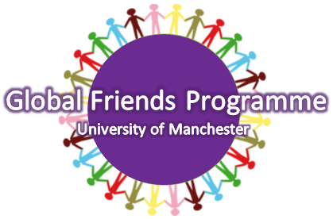
GLOBAL FRIENDS PROGRAMME
MENTEE APPLICATION FORM 2014/15

The Global Friends Programme provides you with a University of Manchester student mentor who will aid your transition to life here in Manchester. If you would like to take part in this programme, please fill in the application form below.

NAME
GENDER
DATE OF BIRTH
HOME UNIVERSITY
HOME COUNTRY
NATIONALITY
WHAT ARE YOUR MAIN SUBJECT INTERESTS?

MAJOR?
CONTACT TELEPHONE NUMBER
EMAIL ADDRESS
LANGUAGES SPOKEN
HALLS OF RESIDENCE/MANCHESTER ADDRESS
(Leave blank if not known)
HOW LONG WILL YOU BE AT THE UNIVERSITY FOR?
(e.g. semester 1/semester 2/full academic year)

WHY WOULD YOU LIKE TO PARTICIPATE IN THE GLOBAL FRIENDS PROGRAMME? (300 words max.)
PLEASE TELL US AS MUCH ABOUT YOURSELF AS YOU CAN SO WE CAN MATCH YOU WITH AN APPROPIATE MENTOR AND MENTEE GROUP. (e.g. interests, hobbies, music, sports, societies involved with, countries you are interested in/have visited, subject preferences, halls of residence you lived in etc.) BE AS SPECIFIC AS YOU CAN!

All forms must be submitted to global.friends@manchester.ac.uk by MIDNIGHT on Tuesday 12th August 2014. You will be notified of your mentor allocation in late August.

