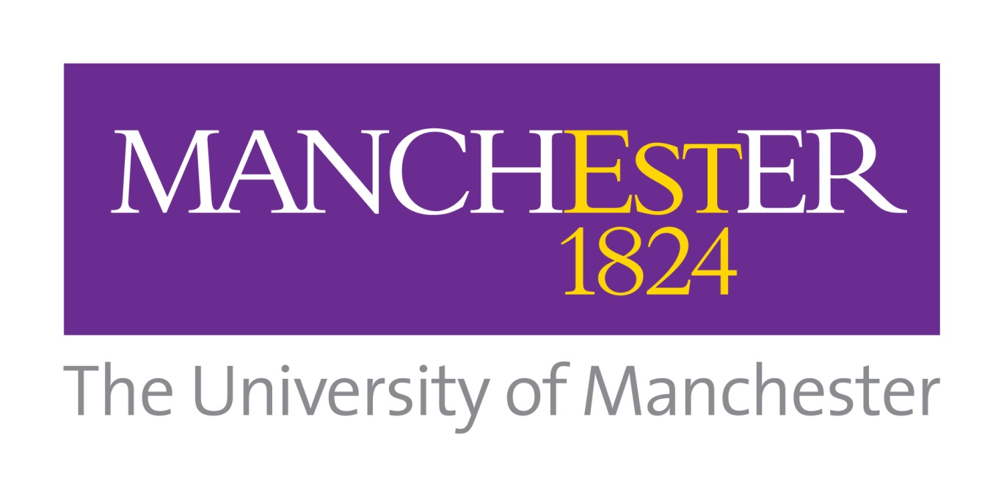

Conversion Communications Working Group
Terms of Reference
 | Circulation |  | -Conversion Communications Working Group  -SRMG Membership
 | Summary |  | Outline notes on terms of reference, role, membership, schedule of meetings, etc.
 | Date/Version |  | V1 March 2014 | Filename | CCWG TOR March 2014
 | Enquiries |  | marieke.mollitt@manchester.ac.uk, ext67998

1. Introduction

The Conversion Communications Working Group(CCWG) was formed in late 2013, originally with the purpose of auditing the current conversion communications publications, and providing a proposal for how these could be streamlined and improved. While the group continues to deliver on this aim, it now also focuses on wider conversion communications where needed, namely the scoping of the My Manchester for Offer Holders portal project.
Whereas this project may later be subsumed into the existing My Manchester Group, or necessitate the need for a distinct My Manchester for Offer Holders working group, the initial discussions of how it will be scoped and developed in the initial stages will be discussed at the CCWG, then reported to SRMG.
The group is a subgroup of SRMG, and a standing item around its work will appear on the SRMG agenda. In order to keep the membership to a minimum, and due to the fact that SRMG has faculty representatives from all four areas, we have not extended the membership to faculty reps at this time.

2. Role of CCWG

- To provide an integrated approach to the provision of information to our offer holders, no matter what their level of study, discipline or nationality.

- To focus on how we can improve our conversion publications, from point of offer through to arrival in two areas:
i) Through design, so we have a suite of publications that are all immediately recognised as being related but distinct.

ii) Through the copy (tone and style) so that again, they are more recognisable as Manchester publications, and to ensure they reach a minimum standard of clarity and ease of use.

- Where necessary, reflect on how conversion communications work with e-communications, namely the e-advantage, and where links can be improved.
- To better understand the communications being sent from academic Schools, to establish any overlap or supporting activity taking place. This may be via an audit in order to collate accurate and detailed information.
- To begin to scope the My Manchester for Offer Holders portal, so that we can begin the process of working with colleagues across the University to create a site plan.
- To work in partnership with the University Communications and Marketing team, to ensure all recruitment communications are within University brand guide lines

- To report back to SRMG in order to ensure we are meeting the needs of all areas of the University.

3. Accountability of the CCWG

- The Conversion Communications Working Group will report to the Student Recruitment Marketing Group (SRMG).

4. Role of the Group members

- To attend the scheduled meetings of the Group, or provide an alternatewhen necessary;
- To represent the views of the respective teams attending the group;
- To feedback developments and progress to the respective teams;
- To fully engage with the process of improving our conversion communications through the group and related projects;
- To deliver on specific tasks or projects as requested by the group.

5. GroupMembership

See attached Appendix 1.

6.Meeting Schedule

Meetings will take place as and when are needed (approximately every 6 weeks), to proceed scheduled SRMG meetings where possible.

Appendix 1

Name | Email | Team and Title
Karen Badat | Karen.badat@manchester.ac.uk | Student Recruitment and International Development Division – Senior International Liaison Officer
Laura Cragg | Laura.cragg@manchester.ac.uk | Student Recruitment and International Development Division – Undergraduate Recruitment and Widening Participation Officer
Susannah Crossland | Susannah.crossland@manchester.ac.uk | Student Admissions and Administration Division – Student Communications and Marketing Officer
Rebecca Duffy | andy.simmons@manchester.ac.uk | Student Recruitment and International Development Division – International Relations Intern
Jayne Golden | jayne.golden@manchester.ac.uk | Student Admissions and Administration Division - Student Communications and Marketing Officer
Liz Green | Liz.green@manchester.ac.uk | Student Recruitment and International Development Division – Senior International Officer
Fran Halliwell | Fran.halliwell@manchester.ac.uk | Student Recruitment and International Development Division – Senior International Officer
Marieke Mollitt | Marieke.mollitt@manchester.ac.uk | Student Admissions and Administration Division – Student Marketingand Communications Manager (pre-reg)
Pete Morris | Peter.w.morris@manchester.ac.uk | Student Admissions and Administration Division – Student Marketingand Communications Manager (post-reg)
Victoria Root | victoria.root@manchester.ac.uk | Student Admissions and Administration Division – Student Communications and Marketing Intern

