Advice to UV equipment users

You are using equipment as part of your lab work which emits UV radiation.

The following regions of the EM spectrum have been classified as UV radiation:

UV-C (100 nm to 280 nm)
UV-B (280 nm to 315 nm)
UV-A (315 nm to 400 nm)

This equipment may be
- UV reactors
- Transilluminators
- Mercury lamps
- Bactericidal lamps
- Fluorescence equipment
- Sterilizing equipment

Health hazards from UV exposure

The eyes

The eyes are very susceptible to damage from ultraviolet radiation. Some damage is irreversible, and eyes are as yet, non replaceable! It is therefore of crucial importance to observe safety recommendations when working with UV sources.

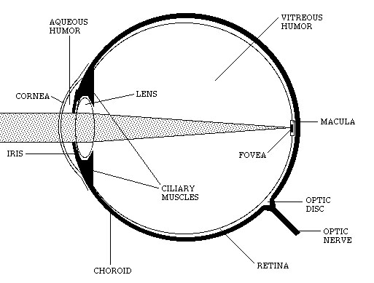

Even if only a small part of UV-A photons get to the retina, they can still start the damage process. This is particularly relevant for younger people whose lenses are more transmissive for this region of the spectrum.

- Examples of damage to the eye, specifically the cornea include photokeratitis, or ‘flash burn’. Damage is usually to the epithelial cells of the cornea and exhibits a 6-12 hour dormant period.
- Symptoms then appear, including intense itching, lacrimation, photophobia, a feeling as if like sand is in the eye. Treated with lubrication, it will heal in 24-36 hours, although it may feel irritating and very painful. The damage depends upon the intensity of the exposure.
- UV radiation can damage the corneal stroma. It can also cause swelling of the iris.
- Previous exposure to UV can render the cornea more susceptible to damage. (It takes about 0.4 times the energy to burn the cornea if it had been damaged by UV within the previous 8 hours).
- UV-B can damage the endothelium. This can lead to corneal thickening (edema), with the damage peaking about 44 hours after exposure. It is possible that is may also cause long-term damage to the cornea and the keratocytes. UV exposure also alters oxygen uptake and ATP concentrations in the cornea.

Damage to the skin

UV radiation is a known human carcinogen. Short term skin damage from UV equipment includes ‘flash burns’-intense reddening or erythema to a localized area.
This will be painful and long term can present toughening or skin ageing symptoms.

Personal Protective Equipment

As a short exposure time is sufficient to cause severe damage, do not be complacent about wearing PPE!

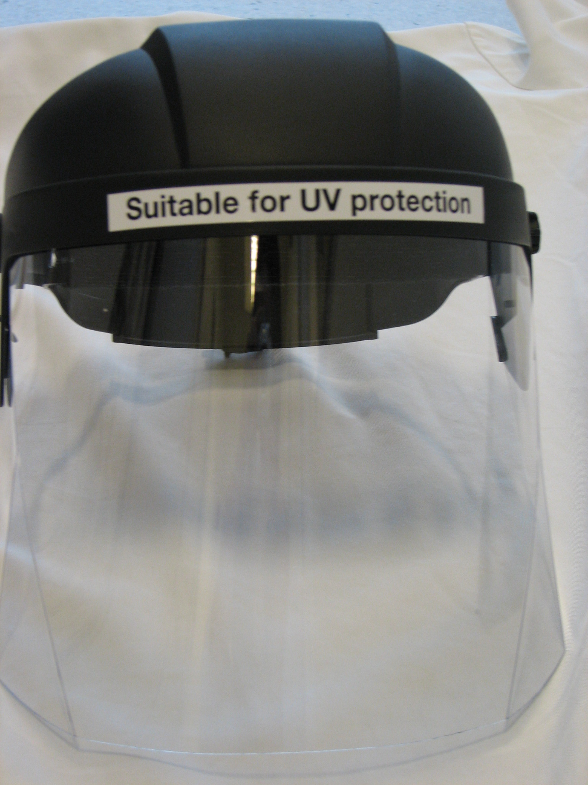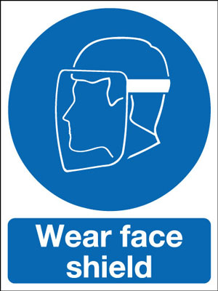

All laboratory work with UV sources necessitates the use of full face shield with visor (to protect the neck and face area fully) and gloves to protect the hands and wrists, to the BS EN 170 standard.

Advice on safe practice

- Following the safety guidelines given with the experiment is important, and adhere to the local rules. If in any doubt; ask for advice from your supervisor.

- Always wear eye protection when working with UV sources.

- Do not remove protective shields or visors to ‘get a closer look’ even for a few seconds - this is sufficient to cause injury.

- Remember that only a visor is appropriate as this shields the neck from reflectance (e.g. from lab coats). Ensure that any exposed skin is covered adequately.

- If interlocks are available, make sure they are used or close gaps which would allow transmission of the UV source.

- Contact the manufacturer of the source where in any doubt about replacement parts.

Should you require any advice or assistance regarding safe practice with UV, contact The Radiation Safety Unit: 0161 275 6981

References

1 National Radiological Protection Board. Advice on Protection against ultraviolet radiation. (Documents of the NRPB Vol 13, No 3, 2002)

2 International Non-Ionizing Radiation Committee/International Radiation Protection Association. Proposed changes to the IRPA 1985 guidelines on limits to exposure to ultra violet radiation. Health Physics 1989:56; 971-972.

