Briefing note for Prof Dame Nancy Rothwell
Media Monitoring
Prepared by Jon Keighren, January 2014
AURORA: Aggregated University Online Reputational Assessor
www.theworld100.com
Aurora was developed in 2009 as a response to the fact that there was no reliable way for World 100 universities to assess their media and reputational impact (some might call it brand image) on the international stage, other than through the league tables themselves.
The full Aurora report contains two sections. The first is a quantitative assessment of the total number of international media mentions during the assessment period carried out for all 150+ institutions who are ranked in the top 100 by the SJT, THE or QS world rankings and helps to set the monthly context for overall media volume.
The second aspect is a qualitative study carried out for the participating World 100 members that provides an in-depth comment on the media impact each month.
In the latest monthly survey (Nov 2013), after Oxford & Cambridge, LSE and Manchester are the next British universities with the highest volume of coverage – in 4th and 6th place with 81 and 64 stories apiece. Sheffield and UCL are next.
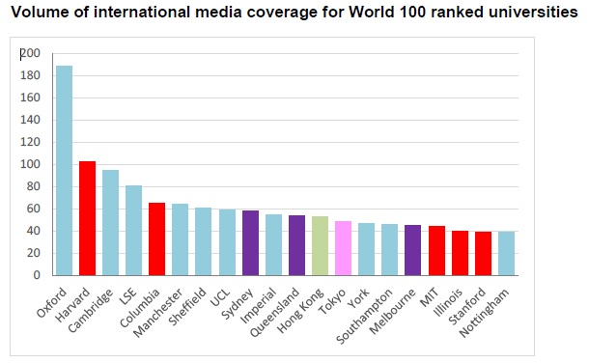

Looking at the qualitative element of the survey, which only surveys participating World 100 members, Manchester achieved the highest total impact and average impact scores in November 2013 (and October) by a wide margin – 152,263 total impact and 3,172 average impact per article in November (see P2)
