Graduate Teaching Assistants

Andrew Davies
University of Manchester
2011/2012
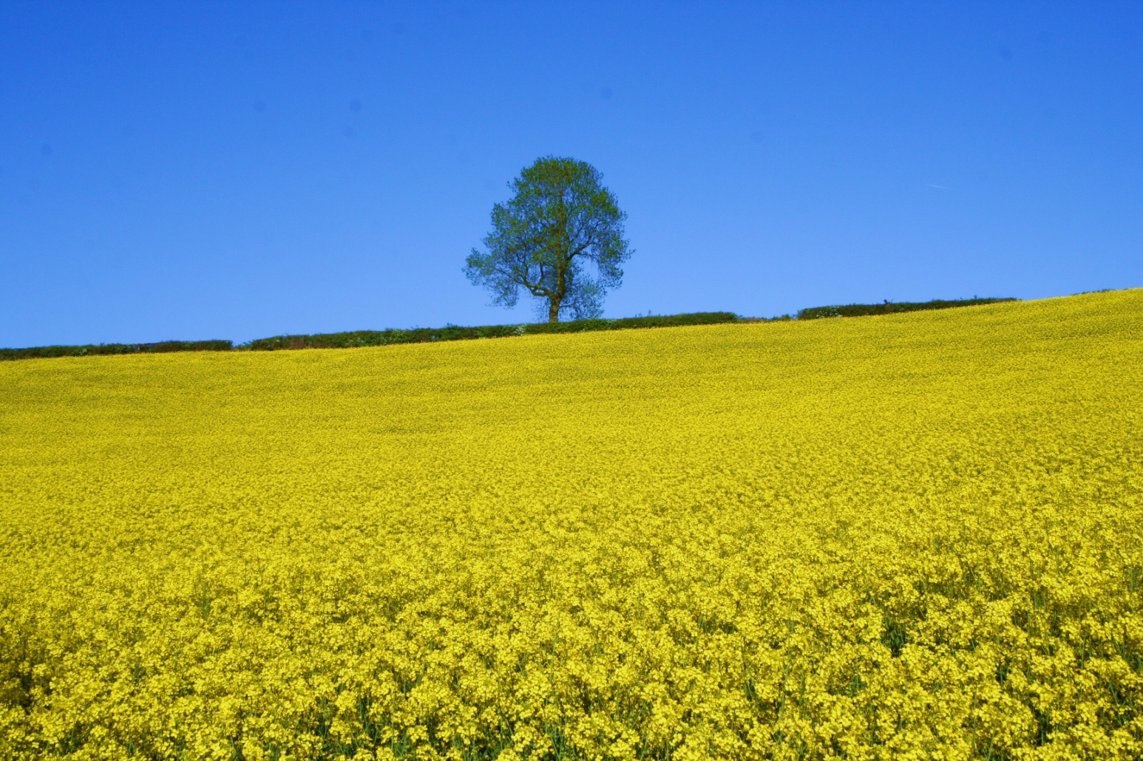
Session 1

Reflective Practise

Task 1a
Spend 10 minutes thinking about a teacher who has positively influenced your learning. Ask yourself the following questions:
1. What did they teach?
________________________________
2. When was it?
________________________________
3.What made them special/good/standout from the rest of the teachers at that time? _________________________________________________________________________________________________________________________________________________________________________________________________________________________________

Task 1b
Working in pairs, explain to your partner what it was about that teacher that makes them stand out.
Write notes about your partners choice:
___________________________________________________________________________________________________________________________________________________________________________________________________________________________________________________________________________________________________________________________________________________________________________________________________________________________________________________________________________________________________________________________________________________________________________________________________________________________________________________________________________________________________

Task 1c
Spend 10 minutes thinking about a teacher that negatively influenced your learning. Ask yourself the following questions:
1. What did they teach?
________________________________
2. When was it?
________________________________
3.What made them poor/bad/different from the rest of the teachers at that time? _________________________________________________________________________________________________________________________________________________________________________________________________________________________________

Task 1d
In pairs, explain to your partner what it was about that teacher that makes them standout.
Write notes about your partners choice:
___________________________________________________________________________________________________________________________________________________________________________________________________________________________________________________________________________________________________________________________________________________________________________________________________________________________________________________________________________________________________________________________________________________________________________________________________________________________________________________________________________________________________

Task 1e
Look at your notes, are there any similarities with those of your partner or others on your table? As a group, see if you can come up with 10 traits that you think make a good teacher.
1. _________________________________________
2. _________________________________________
3. _________________________________________
4. _________________________________________
5. _________________________________________
6. _________________________________________
7. _________________________________________
8. _________________________________________
9. _________________________________________
10. ________________________________________

________________________________________________________________________________________________________________________________________________________________________________________________________________________________________________________________________________________________________________________________________________________________________________________________________________________________________________________________________________________________________________________________________________________________________________________________________________________________________________________________________________________________________________________________________________________________________________________________________________________________________________________
In your pairs, explain your experience to your partner. Listen to their experience. Discuss what you think is going on, how did that happen, what was it that let the penny drop. Write down some ideas:
___________________________________________________________________________________________________________________________________________________________________________________________________________________________________________________________________________________________________________________________________________________________________________________________________________________________________________________________________________________________________________________________________________________________________________________________________________________________________________________________________________________________________
Think about how you would present your findings to the group as a micro teaching exercise.

The reflective practitioner – reflection-in- and –on-action
One of Donald Schon's contributions was to bring ‘reflection’ into the centre of an understanding of what we, as teaching professionals do.
The notions of "reflection-in-action", and "reflection-on-action" were central to Schon’s efforts in this area. The former, "reflection-in-action", is sometimes described as ‘thinking on our feet’. It involves looking to our experiences, connecting with our feelings. It entails building new understandings to inform our actions in the situation that is unfolding.
The teacher reflects on the phenomenon before them, and on the prior understandings which have been implicit in their behaviour. They carry out an experiment which serves to generate both a new understanding of the phenomenon and a change in the situation (Schon 1983: pp68).
We have been concentrating on the latter: "reflection-on-action". We have seen that the act of reflecting-on-action, be it ours or that of others, enables us to spend time exploring why we acted as we did, what was happening and so on. In so doing we develop sets of questions and ideas about our activities and practice.
Practitioners build up a collection of images, ideas, examples and actions that they can draw upon. Schon saw this as central to reflective practice.

Learning styles

Learning cycle by Andrew Davies. Adapted from Kolb, D.A (1984)

Learning styles

In exploring how reflective practice can support and aid learning it is important to look at how we learn. The following points can be made about the process of learning:
- Learning is Individual: All students start from their own position of knowledge and have their own set of experiences to draw upon.
- Learning should be Contextual: Students need to understand that the context in which they learn and operate affects how and what they understand.
- Learning is relational. In order to make sense and achieve a deep understanding of material and experiences students need to relate new information to existing knowledge and experiences.

VAK visual-auditory-kinaesthetic learning styles
The VAK learning styles model provides a very easy and quick reference inventory by which to assess people's preferred learning styles, and then most importantly, to design learning methods and experiences that match people's preferences:
Visual learning style involves the use of seen or observed things, including pictures, diagrams, demonstrations, displays, handouts, films, flip-chart, etc.
Auditory learning style involves the transfer of information through listening: to the spoken word, of self or others, of sounds and noises.
Kinaesthetic learning involves physical experience - touching, feeling, holding, doing, practical hands-on experiences.
It is easy to begin to assess your own or another person's learning style within the Visual-Auditory-Kinaesthetic model.

VAK visual-auditory-kinaesthetic learning styles indicators

Here are some common indicators.
Tick the statement which best applies to you. (See example).
Let's say, for example, you want to bake a cake. Your preferred method would be to:
"ask a cook", you would tick as follows:
 | A |  | B |  | C
Bake a cake | Read recipe book |  | Ask a cook |  | Have a go

Each tick equals 1 point. Total each column to indicate dominance.
Remember, there are no right and wrong answers.

Task | A |  | B |  | C
1. Operate new equipment | Read instructions |  | Listen to explanation |  | Have a go
2. Travel directions | Look at a map |  | Ask for spoken directions |  | Follow your nose and maybe use a compass
3. Cook a new dish | Follow a recipe |  | Call a friend for explanation |  | Follow your instinct, tasting as you cook
4. Teach someone something | Write instructions |  | Explain verbally |  | Demonstrate and let them have a go
5. You'd say.. | I see what you mean |  | I hear what you are saying |  | I know how you feel
6. You'd say.. | Show me |  | Tell me |  | Let me try
7. You'd say.. | Watch how I do it |  | Listen to me explain |  | You have a go
8. Faulty goods | Write a letter |  | Phone |  | Send or take it back to the store
9. Leisure | Museums and galleries |  | Music and conversation |  | Playing sport or DIY
10. Buying gifts | Books |  | Music |  | Tools and gadgets
11. Shopping | Look and imagine |  | Discuss with shop staff |  | Try on and test
12. Choose a holiday | Read the brochures |  | Listen to recommendations |  | Imagine the experience
13. Choose a new car | Read the reviews |  | Discuss with friends |  | Test-drive what you fancy
 | A |  | B |  | C
Total ticks
12

Task 3
Based on the VAK learning style indicators, what type of learner are you and are there any occasions when that could change?
_______________________________________________________________________________________________________________________________________________________________________________________________________________________________________________________________________________________________________________________________________________________________________________________
Read back through your notes about your partner and see if you can identify their learning style from your notes.
___________________________________________________________________________________________________________________________________________________________________________________________________________________________________________________________________________________________________________
Discuss your efforts with your partner. Now, look at the others on your table and see if you can guess what their learning style is. Discuss with them when you have all made your choice.
Were you correct? Yes No Some
How many of you have the same learning style? ______________
What are the implications of this?
______________________________________________________________________________________________________________________________________________________
How would you address this when planning teaching sessions?
_______________________________________________________________________________________________________________________________________________________________________________________________________________________________________________________________________________________________________________________________________________________________________________________
13

Task 4
Using the information gained today, prepare a outline programme for a 1 hour teaching session entitled "How to access the library" taking into account all learners needs.

Time | Activity | Resources | Student activity | Learning styles covered
14

Learning/reflection log
This log is a vital aid to recording your own learning and to developing your own skills as a reflective practitioner. I need not be shown to anyone. This is only an example and could be adapted for your PPP.
What have I learned? |  |  | What am I going to do about it?
Experiences/Actions  What were the main experiences for me or the main things that I did since the last checkpoint. | Reflection  How did I feel during these experiences? | Learning  What did I learn about myself or about other people. | Goals  What do I want to do about this? What ideas would I like to test out? What skills do I want to develop? | Planning  What can I do to help me achieve goals?
15

Recap:
16
Know who you are teaching
What do they already know
Their preferred method of learning
Keep a reflective diary
Reflect, reflect, reflect

References
Boud, D. Cohen, R. Walker, D (1993) Using Experience for Learning, Milton Keynes, SRHE/Open University Press.
Kolb, D.A (1984) Experiential Learning: Experience as the Source of Learning and Development. Prentice-Hall, Englewood Cliffs, N.J.
Minton, D (1997) Teaching Skills in Further and Adult Education. City & Guilds, London.
Schön, D (1983) The Reflective Practitioner. How professionals think in action, London: Temple Smith.

Further reading:
Argyris, C. Schon, D. A (1974) Theory in Practice: Increasing Professional Effectiveness, San Francisco, C.A. Jossey-Bass.
Brookfield, S. D (1995) Becoming a Critically Reflective Teacher, San Francisco, CA, Jossey Bass.
Bruner, J (1986) Actual Minds, Possible Worlds, Cambridge M.A. Harvard.
Claxton, G (1998) Hare Brain Tortoise Mind. Why Intelligence Increases When You Think Less, London Fourth Estate.
Dewey, J (1933) How We Think: A Restatement of the Relation of Reflective Thinking to the Educative Process, London, Heath.
* Schön, D (1983)The Reflective Practitioner. How professionals think in action, London: Temple Smith.
Usher, R. Bryant, I. Johnston, R (1997) Adult Education and the Postmodern Challenge. Learning Beyond the Limits, London, Routledge.
Morrison, K (1996), Developing Reflective Practice in Higher Degree Students through a Learning Journal, Studies in Higher Education, Vol 21, No 3, pp 317-332.

* Influential book that examines professional knowledge, professional contexts and reflection-in-action. Examines reflection-in-action and studies the process involved in various instances of professional judgement. This has become a core reading in most teacher training programmes.

